1 July 2016

Mr Phil Bowen
Parliamentary Budget Officer
Parliament House
CANBERRA ACT 2600

Dear Mr Bowen

I formally request the following revenue proposals be costed by the Parliamentary Budget Office for public release.

- Digital Rights: Abolish Data Retention
- End Compulsory Income Management
- Public and Community Housing Boost
- Increasing Rent Assistance
- Flourishing and Independent Arts
- Alcohol and Drug Treatment
- Re-indexing Medicare Benefits Schedule
- Hospital Funding we Deserve
- Tackling Obesity: Sugar Sweetened Beverages
- Safe Schools
- Sustainable Water Institute
- Community Infrastructure Fund

I appreciate you may require further information from us to complete the request. Should you require any further clarification, please contact Jay Tilley from my office on 0408 473 379

Yours sincerely
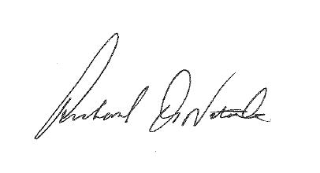
Senator Richard Di Natale

