28 June 2016

Mr Phil Bowen
Parliamentary Budget Officer
Parliament House
CANBERRA ACT 2600

Dear Mr Bowen

I formally request the following revenue proposals be costed by the Parliamentary Budget Office for public release.

- Loss Carry Back and GST Threshold for small business
- Towards a republic
- Managing Chronic Disease
- Harm Reduction Innovation Fund

I appreciate you may require further information from us to complete the request. Should you require any further clarification, please contact Jay Tilley from my office on 0408 473 379

Yours sincerely
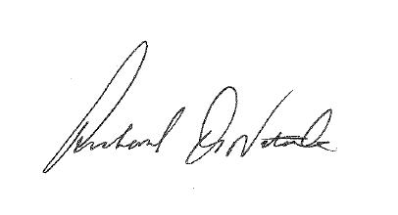
Senator Richard Di Natale
Leader of the Australian Greens & Senator for Victoria

