Policy costing
Changing the definition of “fuel efficient cars” in Section 25.1(4) of the Luxury Car Tax Act 2008
Person/party requesting the costing: | Dr Monique Ryan MP, Member for Kooyong
Date costing completed: | 16 August 2022
Expiry date of the costing: | Release of the next economic and fiscal outlook report
Status at time of request: | Submitted outside the caretaker period
 | ☒ Confidential | ☐ Not confidential
Summary of proposal:
The proposal would amend the definition of a ‘fuel efficient car’ for the purposes of the luxury car tax to include vehicles with a fuel consumption of no more than 4 litres per 100km (the current definition includes vehicles with a fuel consumption of no more than 7 litres per 100km).
The request also sought an assessment of the behavioural impact of the proposal on the sale of luxury cars.
The proposal would start 1 July 2023.

Costing overview
The proposal would be expected to increase the fiscal balance by around $411 million and increase the underlying cash balance by around $401 million over the 2022-23 Budget forward estimates period. The increase in the budget balances is entirely due to an increase in luxury car tax (LCT) revenue. The fiscal balance and underlying cash balance impacts differ due to the timing difference between when LTC liabilities are recognised and when the associated cash transaction occurs.
The proposal would have an impact beyond the 2022-23 Budget forward estimates period. A breakdown of the financial implications (including separate PDI tables) over the period to 2032-33 is provided at Attachment A.

Sensitivity analysis
The financial implications of this proposal are sensitive to sales volumes and prices of vehicles with fuel consumption between 4 and 7 litres per 100km over the period to 2032-33. These volumes and prices depend upon the assumed future uptake of fuel-efficient vehicles. This costing is based on an assumption that the proportion of new passenger car sales that would be electric vehicles (EVs) increases to 39% by 2032-33, with an estimated $109 million revenue raised in that year. Under an assumption that the proportion of EVs increases to 90%, the revenue impact in 2032-33 would only be $18 million (see Figure 1 below).
The financial implications of this proposal are also sensitive to assumptions around how vehicle sales respond to the increase in LCT. For instance, this costing assumes that for every 1% increase in the price of luxury cars, sales of luxury cars will decrease by around 1.15%. Under the proposal, it is estimated that purchases of luxury cars with fuel consumption between 4 and 7 litres per 100km would decrease by around 3% in 2023-24. In the absence of a behavioural change, the estimated impact on the fiscal balance in 2023-24 would be $161 million, around $5 million higher, as shown in Figure 1.
The behavioural response to this proposal could also have flow-on impacts to goods and services tax (GST) and fuel excise. This is because GST is included in the purchase price of vehicles, and GST and fuel excise is included in the purchase price of fuels for passenger vehicles. However, these effects are expected to be small and have not been factored into this response.

Figure 1: Fiscal balance impact of proposal under various assumptions
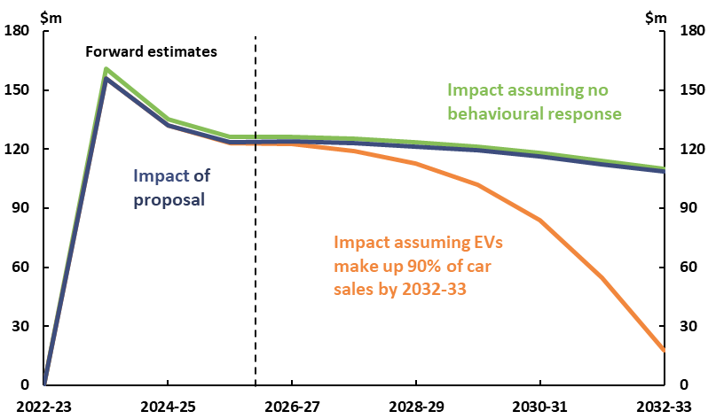
Table 1: Financial implications ($m)^{(a)(b)}
(a) A positive number represents an increase in the relevant budget balance; a negative number represents a decrease.
(b) PDI impacts are not included in the totals.
- Indicates nil.

Key assumptions
The Parliamentary Budget Office (PBO) has made the following assumptions in costing this proposal.
- Other policy settings regarding luxury car taxation and EV incentives are consistent with those at the 2022 Pre-election Economic and Fiscal Outlook.
- Sales of EVs would increase to 39% of total passenger car sales by 2032-33. This means that the proportion of vehicle sales affected by the proposal would decline over time.
  - This is consistent with projections from the Department of Infrastructure, Transport, Cities and Regional Development (2019).
- Total vehicle purchases and the national stock of passenger vehicles would continue to grow in line with historical trends.
- For every 1% increase in the price of petrol or diesel luxury cars, sales would decrease by 1.15%.
  - This means that the overall behavioural response to the proposal is small, as the average increase in LCT would be small relative to the cost of vehicles subject to the LCT.
- There would be no bring-forward of non-fuel-efficient vehicle purchases in 2022-23 to avoid paying higher LCT under the proposal.
- Departmental expenses associated with implementing the proposal would be negligeable and met with existing Australian Taxation Office (ATO) resources.
- The thresholds for fuel-efficient and other vehicles under the LCT would be indexed to the relevant consumer price index parameters over time.

Methodology
The increase in the LCT base as a result of the proposal was calculated as follows:
- For affected vehicles priced between the threshold for non-fuel-efficient and fuel-efficient vehicles (between $71,849 and $84,916 in 2022-23), the additional LCT tax base per vehicle was calculated by subtracting the average vehicle price from the LCT threshold for non-fuel-efficient vehicles.
  - We estimate around 16,000 car sales would fall into this category in 2023-24.
- For affected vehicles priced above the threshold for fuel-efficient vehicles ($84,916 in 2022-23), the additional LCT tax base per vehicle was calculated by subtracting the threshold for fuel-efficient vehicles from the threshold for non-fuel-efficient vehicles (which would now apply to these vehicles).
  - We estimate around 43,000 car sales would fall into this category in 2023-24.
The total increase in the LCT base under the proposal was calculated by multiplying the average increase per vehicle by the total number of vehicles impacted. The resulting increase in LCT revenue was then calculated by multiplying the additional LCT base (excluding GST) by the LCT rate of 33%.
Total revenue was then adjusted downwards to reflect:
- the decrease in luxury car sales subject to the non-fuel-efficient threshold, as purchases of EVs increase as a share of new vehicle purchases over time
- the estimated behavioural change from consumers switching away from vehicles impacted by the proposal, as per the above key assumptions.
Financial implications were rounded consistent with the PBO’s rounding rules as outlined on the PBO Costings and budget information webpage.

Data sources
The ATO provided data on the number and value of car sales subject to the LCT for the 2017-18 to 2020-21 financial years.
The Treasury provided projections for LCT revenue and CPI parameters as at the 2022-23 Budget.
Australian Bureau of Statistics (ABS), 2020. Survey of Motor Vehicle Use, Australia, Australian Government, Canberra.
ABS, 2021. Motor Vehicle Census, Australia, Australian Government, Canberra.
Department of Infrastructure, Transport, Cities and Regional Development, 2019. Electric Vehicle Uptake: Modelling a Global Phenomenon, Australian Government, Canberra.
Fridstrøm, L. and Østli, V. , 2021. Direct and cross price elasticities of demand for gasoline, diesel, hybrid and battery electric cars: the case of Norway, European Transport Research Review 13 (3).

Changing the definition of “fuel efficient cars” in Section 25.1(4) of the Luxury Car Tax Act 2008 – financial implications
Table A1: Changing the definition of “fuel efficient cars” in Section 25.1(4) of the Luxury Car Tax Act 2008 – Fiscal balance ($m)^{(a)}
(a) A positive number for the fiscal balance indicates an increase in revenue or a decrease in expenses or net capital investment in accrual terms. A negative number for the fiscal balance indicates a decrease in revenue or an increase in expenses or net capital investment in accrual terms.
- Indicates nil.
Table A2: Changing the definition of “fuel efficient cars” in Section 25.1(4) of the Luxury Car Tax Act 2008 – Underlying cash balance ($m)^{(a)}
(a) A positive number for the underlying cash balance indicates an increase in receipts or a decrease in payments or net capital investment in cash terms. A negative number for the underlying cash balance indicates a decrease in receipts or an increase in payments or net capital investment in cash terms.
- Indicates nil.

Table A3: Changing the definition of “fuel efficient cars” in Section 25.1(4) of the Luxury Car Tax Act 2008 – Memorandum item: Public Debt Interest (PDI) impacts – Fiscal and underlying cash balances ($m)^{(a)(b)}
(a) As this table is presented as a memorandum item, these figures are not reflected in the totals above. This is consistent with the approach taken in the budget where the budget impact of most measures is presented excluding the impact on PDI. If the reader would like a complete picture of the total aggregate, then these figures would need to be added to the figures above. For further information on government borrowing and financing please refer to the PBO’s online budget glossary.
(b) A positive number for the fiscal balance indicates an increase in revenue or a decrease in expenses or net capital investment in accrual terms. A negative number for the fiscal balance indicates a decrease in revenue or an increase in expenses or net capital investment in accrual terms. A positive number for the underlying cash balance indicates an increase in receipts or a decrease in payments or net capital investment in cash terms. A negative number for the underlying cash balance indicates a decrease in receipts or an increase in payments or net capital investment in cash terms.
- Indicates nil.

See Fridstrøm, L. and Østli, V. in the referenced data sources.
https://www.aph.gov.au/About_Parliament/Parliamentary_Departments/Parliamentary_Budget_Office/Costings_and_budget_information
Online budget glossary – Parliament of Australia (aph.gov.au)

