REPORT TO THE SENATE FINANCE AND PUBLIC ADMINISTRATION LEGISLATION COMMITTEE ON pbo PERFORMANCE AND STAFFING dATA

AS AT 17 MAY 2013

Requests from Parliamentarians for policy costings, other analyses and information relating to the Budget

Table 1. Requests from Parliamentarians and PBO responsiveness
 | Date Request Received |  |  | All
 | 2012 | 2013 Q1 | 2013 Q2
Requests Received from Parties
Total Requests Received | 191 | 67 | 160 | 418
Number of Requests Completed | 189 | 59 | 32 | 280
Average Time to Completion (business days) | 44 | 20 | 15 | 35
Number of Requests Outstanding | 2 | 8 | 128 | 138
Average Time Elapsed Since Receipt (business days) | 123 | 45 | 15 | 19
Requests Received from Individual Parliamentarians
Total Requests Received | - | 6 | 1 | 7
Number of Requests Completed | - | 5 | 1 | 6
Average Time to Completion (business days) | - | 17 | 3 | 15
Number of Requests Outstanding | - | 1 | - | 1
Average Time Elapsed Since Receipt (business days) | - | 48 | - | 48
The table above excludes requests that have subsequently been withdrawn.
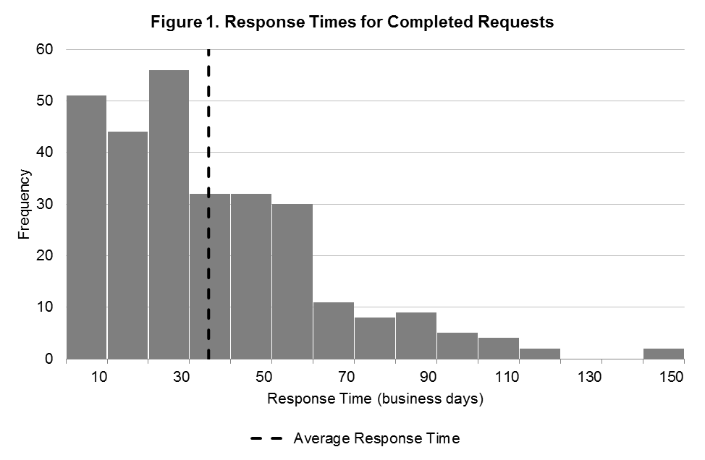
Average response time (business days) | Frequency
10 | 51
20  Average response time  = 34.6 business days | 44
30 | 56
40 | 32
50 | 32
60 | 30
70 | 11
80 | 8
90 | 9
100 | 5
110 | 4
120 | 2
130 | 0
140 | 0
150 | 2

Requests by PBO for information from Commonwealth bodies

Table 2. PBO information requests and responsiveness of Commonwealth bodies
Date | Requests Sent | Responded By Due Date | Responded After Due Date | Average Timeliness (business days) | Requests Outstanding  (and of these # overdue)
2012 | 85 | 43 (51 %) | 42 (49 %) | 3.4 late | 0 (0)
2013 Q1 | 102 | 35 (37 %) | 59 (63 %) | 4.1 late | 8 (8)
2013 Q2 | 132 | 26 (74 %) | 9 (26 %) | 1.7 early | 97 (3)
Total | 319 | 104 (49 %) | 110 (51 %) | 2.9 late | 105 (11)
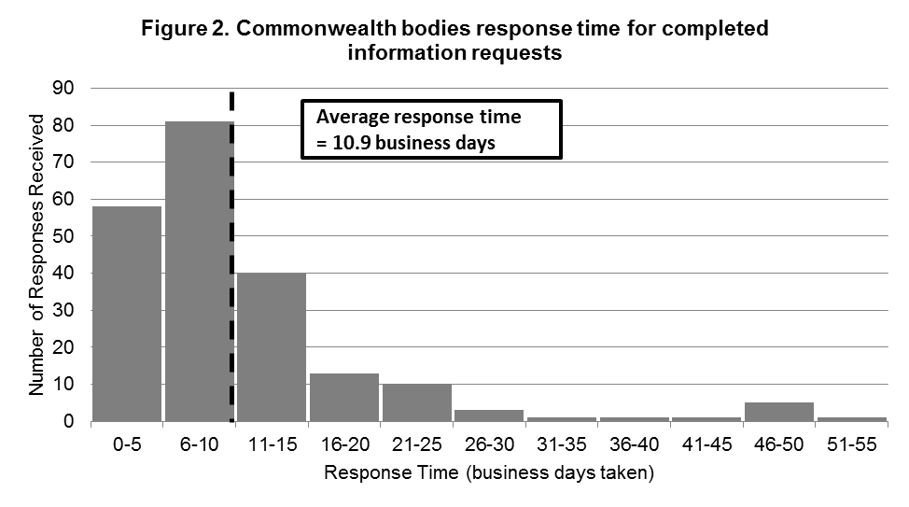
Response time (business days) | Number of responses received
0-5 | 58
6-10 | 81
11-15 | 40
16-20 | 13
21-25 | 10
26-30 | 3
31-35 | 1
36-40 | 1
41-45 | 1
46-50 | 5
51-55 | 1
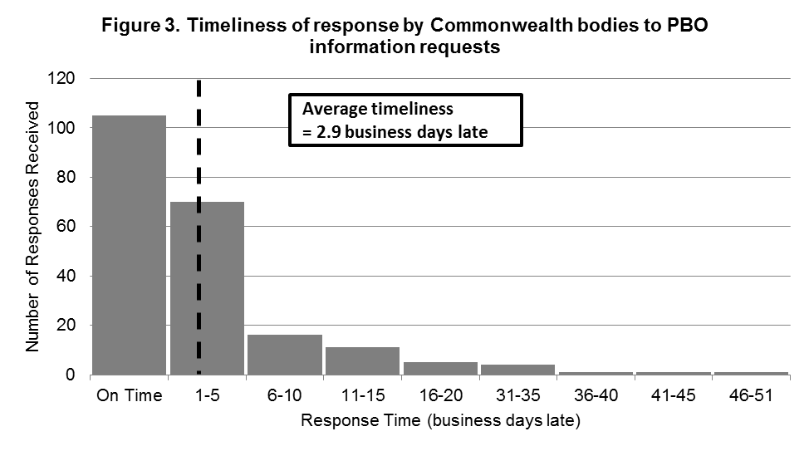
Number of responses received | Response time (business days late)
105 | On time
70 | 1-5
16 | 6-10
11 | 11-15
5 | 16-20
4 | 31-35
1 | 36-40
1 | 41-45
1 | 46-51

PBO permanent staff by function and employment level (excludes the Parliamentary Budget Officer)
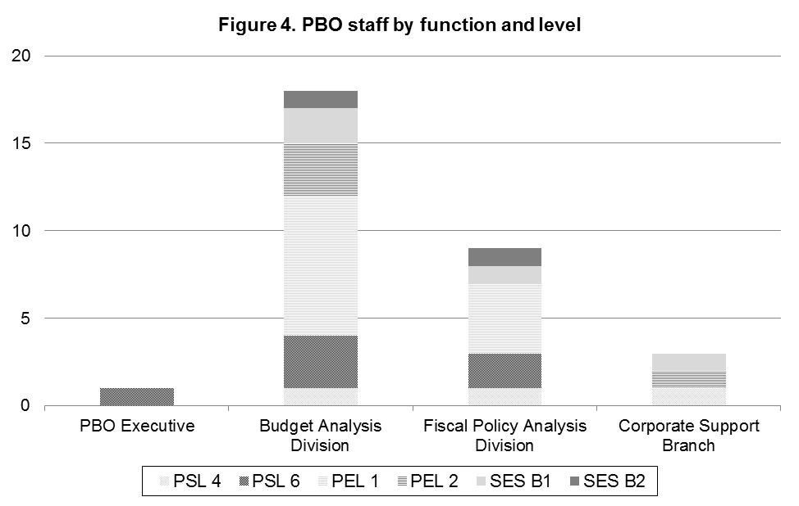

PSL4 – Parliamentary Service Level 4 | 3
PSL6 – Parliamentary Service Level 6 | 6
PEL1 – Parliamentary Executive Level 1 | 12
PEL2 – Parliamentary Executive Level 2 | 4
SES B1 – Senior Executive Service Band 1 | 4 (One acting)
SES B2 – Senior Executive Service Band 2 | 2
Total staff | 31

