REPORT TO THE SENATE FINANCE AND PUBLIC ADMINISTRATION LEGISLATION COMMITTEE ON pbo Costing Statistics AND STAFFING dATA

AS AT 31 October 2013

Requests from Parliamentarians for policy costings, other analyses and information relating to the Budget

Table 1. Requests from Parliamentarians and PBO responsiveness
 | Requests Received Outside the Caretaker Period |  |  |  |  |  | Caretaker Costing Requests | All
 | 2012 |  |  | 2013
 | Q3 | Q4 |  | Q1 | Q2 | Q3
Requests Received from Parliamentary Parties
Total Requests Received | 32 | 165 |  | 69 | 345 | 309 | 85 | 1,005
Requests Withdrawn or Lapsed at Election | - | 6 |  | 3 | 67 | 26 | - | 102
Number of Requests Completed | 32 | 159 |  | 66 | 278 | 283 | 85 | 903
Average Time to Completion (business days) | 54.6 | 43.4 |  | 24.9 | 24.2 | 8.7 | 2.2 | 21.8
Requests Received from Individual Parliamentarians
Total Requests Received | - | - |  | 6 | 5 | 1 | - | 12
Number of Requests Completed | - | - |  | 6 | 5 | 1 | - | 12
Average Time to Completion (business days) | - | - |  | 26.2 | 11.8 | 11.0 | - | 18.9
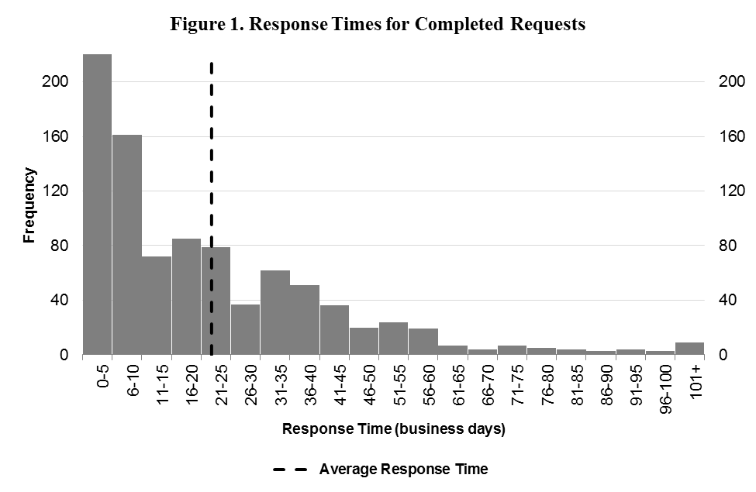
Response Time (business days) | Frequency
0-5 | 223
6-10 | 161
11-15 | 72
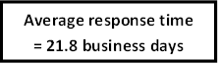  16-20 | 85
21-25 | 79
26-30 | 37
31-35 | 62
36-40 | 51
41-45 | 36
46-50 | 20
51-55 | 24
56-60 | 19
61-65 | 7
66-70 | 4
71-75 | 7
76-80 | 5
81-85 | 4
86-90 | 3
91-95 | 4
96-100 | 3

Requests by PBO for information from Commonwealth bodies

Table 2. PBO information requests and responsiveness of Commonwealth bodies
Date | Requests Sent | Responded By Due Date | Responded After Due Date | Average Lateness for Received Requests | Requests Outstanding  (overdue) | Average Days Overdue for Currently Overdue Requests
2012 | 85 | 43 (51 %) | 42 (49 %) | 3.4 business days | 0 (0) | -
2013 Q1 | 100 | 35 (36 %) | 63 (64 %) | 8.2 business days | 2 (2) | 147.5 business days
2013 Q2 | 175 | 75 (43 %) | 99 (57 %) | 4.9 business days | 1 (1) | 68.0 business days
2013 Q3 | 234 | 126 (54 %) | 106 (46 %) | 1.5 business days | 2 (2) | 53.5 business days
2013 Q4 | 4 | 1 (33 %) | 2 (67 %) | 1.7 business days | 1 (1) | 4.0 business days
Total | 598 | 280 (47 %) | 312 (53 %) | 3.9 business days | 6 (6) | 79.0 business days
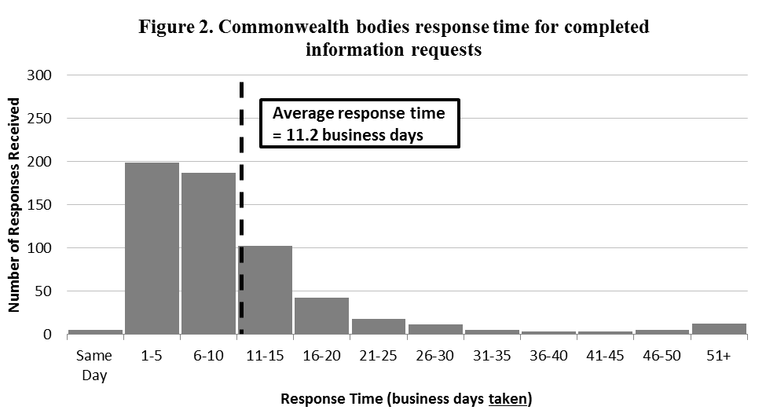
* Numbers of requests sent exclude requests that were subsequently withdrawn.
Response Time (business days taken) | Number of Responses Received
Same Day | 5
1-5 | 199
6-10 | 187
11-15 | 102
16-20 | 42
21-25 | 18
26-30 | 11
31-35 | 5
36-40 | 3
41-45 | 3
46-50 | 5
51+ | 12
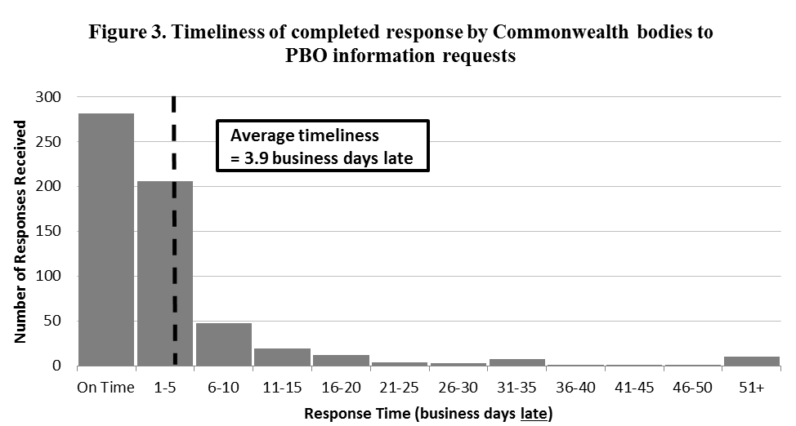
Response Time (business days late) | Number of Responses Received
On Time | 281
1-5 | 206
6-10 | 47
11-15 | 19
16-20 | 12
21-25 | 4
26-30 | 3
31-35 | 7
36-40 | 1
41-45 | 1
46-50 | 1
51+ | 10

PBO permanent staff by function and employment level

Table 3. PBO permanent staff by function and employment level
 | PBO Executive | Budget Analysis Division | Fiscal Policy and Analysis Division | Corporate Strategy Branch* | Total
Parliamentary Budget Officer (PBO) | 1 | - | - | - | 1
Senior Executive Service Band 2 (SES B2) | - | 1 | 1 | - | 2
Senior Executive Service Band 1 (SES B1) | - | 2 | 1 | 1 | 4
Parliamentary Executive Level 2 (PEL2) | - | 4 | 1 | 1 | 6
Parliamentary Executive Level 1 (PEL1) | - | 8 | 4 | 2 | 14
Parliamentary Service Level 6 (PSL6) | 1 | 2 | 2 | - | 5
Parliamentary Service Level 4 (PSL4) | - | 1 | 1 | 1 | 3
Total Staff | 2 | 18 | 10 | 5 | 35
* Includes recruitment approvals for staff commencing on 21 November 2013.
