REPORT TO THE SENATE FINANCE AND PUBLIC ADMINISTRATION LEGISLATION COMMITTEE ON pbo Activity AND STAFFING dATA

AS AT 31 JANUARY 2014

Overview
The statistics in this report highlight the very strong demand for the PBO’s services in the months leading up to the 2013 general election and during the caretaker period.
Following the release of the post-election report of election commitments in October 2013, the PBO undertook an after action review to examine the PBO’s experiences in the 2013 election processes. The review focused on identifying what the PBO did at each stage of the election and post-election report processes, what worked well and what things could be done better next time. Key recommendations of the review included that the PBO:
- replace the current spreadsheet-based registers with a purpose-built registration system to track costing and information requests;
- continue the development of PBO data and model repositories; and
- refine the reliability ratings used for PBO costings with a view to making the indicators more objective.
In November 2013, the Auditor-General advised the PBO that he had decided to conduct a performance audit of the Administration of the Parliamentary Budget Office. The objective of the audit is to assess the effectiveness of the PBO in conducting its role since being established in July 2012. The PBO is working closely with the ANAO on this audit. The Auditor-General is seeking to complete the audit by June 2014.
The Joint Committee of Public Accounts and Audit (JCPAA) has the power to request a review of the PBO to be concluded within nine months of the end of the caretaker period. To avoid duplication, the JCPAA has indicated it will not commission a separate review, but will instead rely on the ANAO performance audit report.
In November 2013, in response to an invitation from the National Commission of Audit, the PBO prepared a submission to the Commission. The PBO’s submission focussed on the establishment and activities of the PBO as well as the responsibilities of similar institutions in other countries. The submission is available on the PBO’s website.
As expected, after the work associated with the 2013 general election was completed in October 2013, demand for requests for policy costings, and budget information and analyses fell sharply, allowing the PBO to allocate significantly more resources to its self-initiated work program, which has a focus on budget sustainability and transparency.
The PBO’s 2013-14 work plan that was published in December 2013 indicated that work would be undertaken on a number of topics contained in the self-initiated work program, with a focus on publications looking at Australian Government spending trends; sensitivity of medium term projections; long run revenue trends; and detailed analysis of expenditure within one of the major functions (such as health).
- A paper covering the first part of the work on historical expenditure trends over the past decade was released in December 2013 and work is progressing on the other papers.
- Part 2 of the expenditure paper will now be released after the 2014-15 Budget, which will allow the paper to analyse forecast spending at the functional level.
The PBO is continuing to build data repositories and develop models to support its work and to be able to respond to costing requests from Parliamentarians in a timely fashion. The PBO is also continuing to engage with Commonwealth bodies to build on arrangements in place for automatic provision of information (including updates of models) following economic and fiscal updates.
As noted in the 2013-14 work plan, the PBO moved to its new, permanent accommodation in October 2013. The development of the PBO’s dedicated secure information technology network was completed in December 2013.

Requests from Parliamentarians for policy costings, other analyses and information relating to the Budget

Table 1. Requests from Parliamentarians and PBO responsiveness
 | Requests Received Outside the Caretaker Period |  |  |  |  |  |  |  |  | Caretaker Costing Requests | All
 | 2012 |  |  | 2013 |  |  |  |  | 2014
 | Q3 | Q4 |  | Q1 | Q2 | Q3 | Q4 |  | Q1
Requests Received from Parliamentary Parties
Total Requests Received | 32 | 165 |  | 69 | 345 | 309 | 2 |  | - | 85 | 1007
Requests Withdrawn or Lapsed at Election | - | 6 |  | 3 | 67 | 26 | 1 |  | - | - | 103
Number of Requests Completed | 32 | 159 |  | 66 | 278 | 283 | 1 |  | - | 85 | 904
Average Time to Completion (business days) | 54.6 | 43.4 |  | 24.9 | 24.2 | 8.7 | 15.0 |  | - | 2.2 | 21.8
Requests Received from Individual Parliamentarians
Total Requests Received | - | - |  | 6 | 5 | 1 | - |  | - | - | 12
Number of Requests Completed | - | - |  | 6 | 5 | 1 | - |  | - | - | 12
Average Time to Completion (business days) | - | - |  | 26.2 | 11.8 | 11.0 | - |  | - | - | 18.9
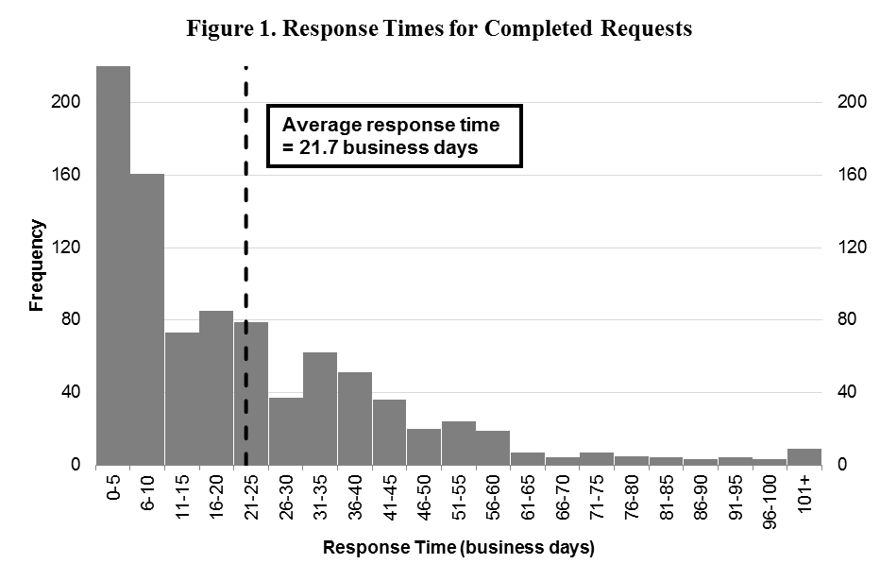
Response Time (business days) | Frequency
0-5 | 223
6-10 | 161
11-15 | 73
16-20 | 85
21-25 | 79
26-30 | 37
31-35 | 62
36-40 | 51
41-45 | 36
46-50 | 20
51-55 | 24
56-60 | 19
61-65 | 7
66-70 | 4
71-75 | 7
76-80 | 5
81-85 | 4
86-90 | 3
91-95 | 4
96-100 | 3

Requests by PBO for information from Commonwealth bodies

Table 2. PBO information requests and responsiveness of Commonwealth bodies
Date | Requests Sent* | Responded By Due Date | Responded After Due Date | Average Lateness for Received Requests ^ | Requests Outstanding  (overdue) | Average Days Overdue for Currently Overdue Requests
2012 | 85 | 43 (51%) | 42 (49%) | 3.4 business days | 0 (0) | -
2013 Q1 | 100 | 35 (35%) | 65 (65%) | 11.1 business days | 0 (0) | -
2013 Q2 | 175 | 75 (43%) | 100 (57%) | 4.9 business days | 0 (0) | -
2013 Q3 | 234 | 126 (54%) | 108 (46%) | 2.0 business days | 0 (0) | -
2013 Q4 | 16 | 11 (79%) | 3 (21%) | 0.1 business days | 2 (2) | 8.0 business days
2014 Q1 | 20 | 7 (87%) | 1 (13%) | -0.3 business days | 12 (0) | -
Total | 630 | 297 (48%) | 319 (52%) | 4.4 business days | 14 (2) | 8.0 business days
* Numbers of requests sent exclude requests that were subsequently withdrawn.
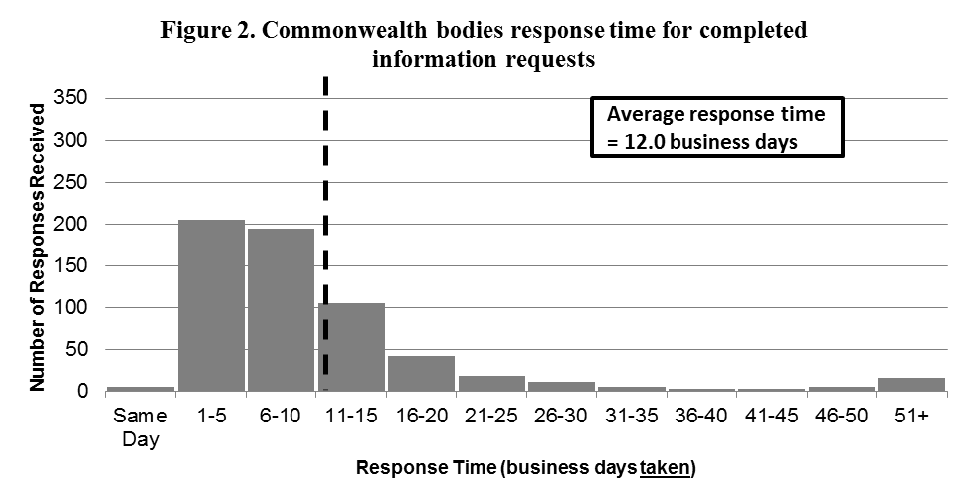
^ A negative figure indicates requests have been responded to before their due date on average.

Response Time (business days taken) | Number of Responses Received
Same Day | 5
1-5 | 205
6-10 | 195
11-15 | 105
16-20 | 42
21-25 | 19
26-30 | 12
31-35 | 6
36-40 | 3
41-45 | 3
46-50 | 5
51+ | 16
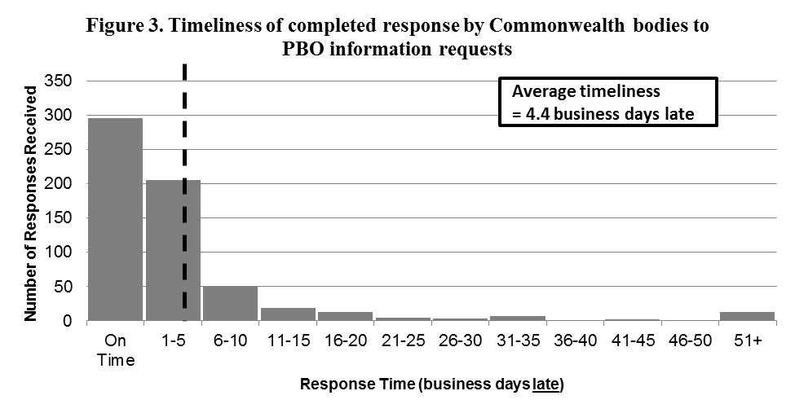
Response Time (business days late) | Number of Responses Received
On Time | 298
1-5 | 205
6-10 | 50
11-15 | 19
16-20 | 13
21-25 | 4
26-30 | 3
31-35 | 7
36-40 | 1
41-45 | 2
46-50 | 1
51+ | 13

PBO permanent staff by function and employment level

Table 3. PBO permanent staff by function and employment level
 | PBO Executive | Budget Analysis Division | Fiscal Policy and Analysis Division | Corporate Strategy Branch* | Total
Parliamentary Budget Officer (PBO) | 1 | - | - | - | 1
Senior Executive Service Band 2 (SES B2) | - | 1 | 1 | - | 2
Senior Executive Service Band 1 (SES B1) * | - | 2 | 1 | 1 | 4
Parliamentary Executive Level 2 (PEL2) | - | 4 | 1 | 1 | 6
Parliamentary Executive Level 1 (PEL1) | - | 9 | 4 | 2 | 15
Parliamentary Service Level 6 (PSL6) | 1 | 2 | 2 | - | 5
Parliamentary Service Level 5 (PSL5) | - | - | - | 1 | 1
Parliamentary Service Level 4 (PSL4) | - | 1 | - | 1 | 2
Total Staff | 2 | 19 | 9 | 6 | 36
* One ongoing SES B1 officer is on long term leave without pay and is not included in these totals.
