Report to the Senate Finance and Public Administration Legislation Committee on PBO Activity and Staffing

18 February 2015

Overview

Requests from parliamentarians and parliamentary parties
The PBO continues to face a steady demand for costings and budget analyses. During the period 1 July to 31 December 2014, the PBO completed 405 requests from parliamentarians and parliamentary parties at an average turn-around time of 16.8 business days (refer to Table 1).
The PBO has continued to request information from agencies in order to respond to requests from parliamentarians and parliamentary parties, progress our self-initiated work program and maintain and improve core data holdings. During the period 1 July to 31 December 2014, the PBO received 89 responses to information requests at an average turnaround time of 20.5 business days (refer to Table 2).

Self-initiated work program
On 26 November 2014, the PBO released a report on the Sensitivity of budget projections to changes in economic parameters. This report analysed the sensitivity of the 2014-15 Budget medium-term projections to variations in labour productivity growth, the labour force participation rate and the terms of trade. The report highlighted the importance of labour productivity growth in particular as a driver of economic growth and fiscal sustainability.
On 9 January 2015, the PBO released the 2014–15 Mid-Year Economic and Fiscal Outlook – Charts which provided a graphical summary of the 2014–15 MYEFO relative to the 2014-15 Budget, showing the impacts of policy decisions and other factors. These charts continued the PBO’s practice of adding to the transparency of the budget by presenting key budget information in a more readily accessible form.
Current work in progress includes analyses of: national fiscal trends at the Commonwealth, State and Territory levels, expected to be published in the first quarter of 2015; medium term budget projections, expected to be published around the middle of 2015; and trends in and drivers of health programs other than Medicare, the Pharmaceutical Benefits Scheme and public hospitals, expected to be published in the first half of 2015.

Capacity building
We are continuing to dedicate resources to enhancing the PBO’s capacity to more effectively fulfil its mandate to the Australian Parliament. In practice this will see an increased focus on acquiring and using detailed datasets, the in-house development and maintenance of models covering major demand driven expenditure programs and elements of the tax and transfer system, and more in-depth analyses of data and modelling results. Focusing on these areas will further improve the PBO’s responsiveness and the quality and reliability of its costings and budget analyses.

External reviews of PBO’s operations
Following the performance audit of the administration of the PBO that was undertaken by the Australian National Audit office (ANAO) last year, the JCPAA has held an inquiry into certain aspects of the PBO’s operations, specifically: the PBO’s information gathering powers; PBO reporting of Government progress against fiscal rules; PBO reporting against medium term projections; best practice for independent fiscal institutions; PBO implementation of the ANAO recommendation regarding administrative costs; and the need for any legislative change.
The JCPAA tabled its report on 28 November 2014 and made eight recommendations for consideration by the Government.

Engagement with other organisations
The PBO continues to engage with government agencies, peer organisations, and international institutions and bodies as part of its ongoing operations. These engagements support the ongoing co-operative approach to the provision of information from agencies, provide the PBO with opportunities for PBO reports to be peer reviewed prior to their release and allow for the PBO to maintain its awareness of relevant emerging issues on both the domestic and international fronts.
The First Assistant Parliamentary Budget Officer, Budget Analysis Division chairs the OECD Committee of Fiscal Affairs Working Party No. 2 on Taxation Policy and Statistics. The major focus of the working party continues to be the measurement of the impact of corporate tax base erosion and profit shifting.
The PBO continues to engage with the Tax and Transfer Policy Institute (TTPI) at the Australian National University as a member of the Government stakeholders group. This allows the PBO to provide input in relation to the Institute’s research priorities and identification of areas for cooperation between the PBO and TTPI.
The PBO also participates in the Interdepartmental Household Modelling Group which fosters technical cooperation and the coordination of training between Commonwealth departments.
The PBO has also participated in ABS consultations on future data collections and statistical products.

PBO corporate services
On 24 November 2014 the Parliamentary Budget Officer and the Clerk of the Senate signed a Memorandum of Understanding for the provision of non-ICT corporate services by the Department of the Senate to the PBO. The provision of these services commenced on 1 December 2014.

PBO staffing
The PBO is funded for approximately 40 positions and at 31 December 2014 had 38 full time equivalent staff (refer to Table 3). Recruitment is in train to fill vacant positions.

Requests from parliamentarians and parliamentary parties for costings and budget analyses
Table 1: Costing and budget analysis requests from parliamentarians and parliamentary parties to 31 December 2014
 | 2012–13  Total | 2013–14  Total | 2014–15  Q1 | 2014-15  Q2 | 2014–15  Total
Requests outstanding at start of period | - | 463 | 76 | 124 | 76
Requests received in period | 1,146 | 1,297 | 257 | 129 | 386
Requests withdrawn in period | 19 | 162 | 4 | 2 | 6
Requests completed in period | 664 | 1,522 | 205 | 200 | 405
Average time to completion (business days) | 33.9 | 13.8 | 22.6 | 11.0 | 16.8
Requests outstanding at end of period | 463 | 76 ¹ | 124 | 51 | 51
¹ The number of requests outstanding at the end of 2013-14 has increased by 5 from requests shown as outstanding in the previous report, primarily due to additional options being identified in a single request.
The table above reflects the number of ‘options’ received by the PBO, noting that a single request can contain multiple options.
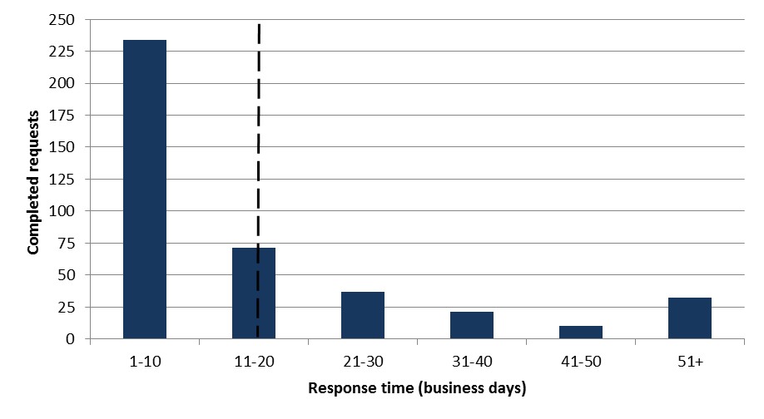
Figure 1: PBO response times for completed requests in 2014–15 to 31 December 2014
Response time (business days) | Completed requests  Average response time = 16.8 business days
1 – 10 | 234
11 – 20 | 71
21 – 30 | 37
31 – 40 | 21
41 – 50 | 10
51+ | 32

Requests by the PBO for information from agencies
Table 2: Information requests to agencies to 31 December 2014
 | 2012–13  Total | 2013–14  Total | 2014–15  Q1 | 2014–15  Q2 | 2014–15  Total
Requests outstanding at the start of the period | - | 29 | 20 | 3 | 20
Requests sent in period | 360 | 388 | 48 | 26 | 74
Requests received in period | 331 | 397 | 65 | 24 | 89
Requests received by due date | 149 | 206 | 28 | 12 | 40
Requests received after due date | 182 | 191 | 37 | 12 | 49
Average time taken to respond (business days) | 12.0 | 12.2 | 21.0 | 19.2 | 20.5
Average punctuality (business days late) | 3.0 | 5.3 | 12.3 | 7.1 | 10.9
Average lateness of late requests (business days) | 6.5 | 12.0 | 23.1 | 13.5 | 20.6
Requests outstanding at end of period | 29 | 20 | 3 | 5 | 5
Figure 2: Agencies’ response time for completed information requests in 2014–15 to 31 December 2014
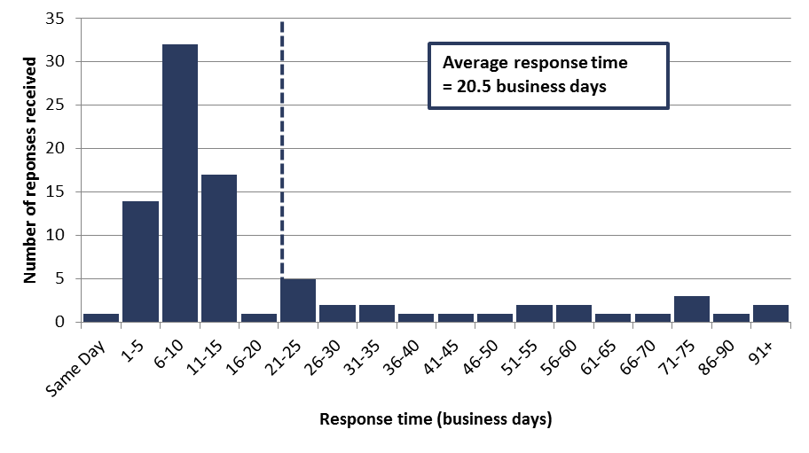
Response time (business days) | Number of responses received
Same Day | 1
1-5 | 14
6-10 | 32
11-15 | 17
16-20 | 1
21-25 | 5
26-30 | 2
31-35 | 2
36-40 | 1
41-45 | 1
46-50 | 1
51-55 | 2
56-60 | 2
61-65 | 1
66-70 | 1
71-75 | 3
86-90 | 1
91+ | 2

Figure 3: Timeliness of completed responses by agencies to information requests in 2014–15 to 31 December 2014
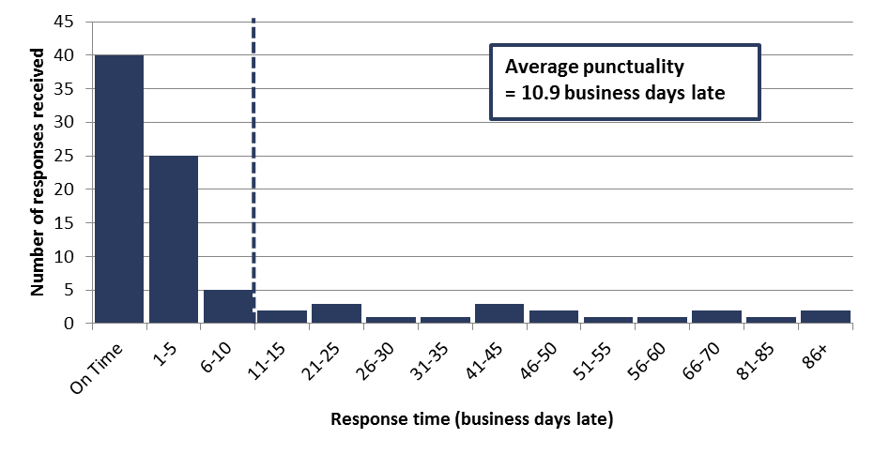
Response time (business days late) | Number of responses received
On Time | 40
1-5 | 25
6-10 | 5
11-15 | 2
21-25 | 3
26-30 | 1
31-35 | 1
41-45 | 3
46-50 | 2
51-55 | 1
56-60 | 1
66-70 | 2
81-85 | 1
86+ | 2

PBO staff by function and employment level
Table 3: PBO staff by function and employment level as at 31 December 2014
Classification | PBO Executive | Budget Analysis Division | Fiscal Policy Analysis Division | Corporate Strategy Branch | Total
Parliamentary Budget Officer | 1 | - | - | - | 1
Senior Executive Service Band 2 (SES B2) | - | 1 | 1 | - | 2
Senior Executive Service Band 1 (SES B1) ¹ | - | 2 | 1 | 1 | 4
Parliamentary Executive Level 2 (PEL 2) | - | 4 | 2 | 1 | 7
Parliamentary Executive Level 1 (PEL 1) | - | 10 | 4 | 2 | 16
Parliamentary Service Level 6 (PSL 6) | 1 | 1 | 1 | - | 3
Parliamentary Service Level 5 (PSL 5) ² | - | - | 1 | 2 | 3
Parliamentary Service Level 4 (PSL 4) | - | 1 | - | 1 | 2
Total staff | 2 | 19 | 10 | 7 | 38
¹ One ongoing SES B1 officer is on long term leave without pay and is not included in these totals.
² Includes an additional staff member as backfilling arrangements for a PSL 5 on maternity leave.
Figure 4: PBO staff by function and employment level as at 31 December 2014
