REPORT TO THE SENATE FINANCE AND PUBLIC ADMINISTRATION LEGISLATION COMMITTEE ON PBO ACTIVITY AND STAFFING

AS AT 16 MAY 2014

Overview

Requests from Parliamentarians
There has been a surge in demand for costings and analysis from parliamentarians since the last Senate estimates hearings in February 2014. Since the 2013 general election and the publication of the post-election report, the PBO has been asked to prepare 179 responses to requests for costings and analyses of the budget. Of these requests, the PBO has completed 81¹ at an average turn- around time of 16.4 business days.
In preparing responses to these requests and in order to progress the self-initiated work program and maintain and improve its core data holdings the PBO has sent out 151 requests for information to Commonwealth bodies. To date the PBO has received 121 responses to these requests with the average turnaround time for completed requests being 9.2 business days.

Self-initiated work program
Priority has been given to responding to requests from parliamentarians. However, work has also progressed on the PBO’s self-initiated program
On 15 April 2014, the PBO released a report on Trends in Australian Government receipts:1982–83 to 2012–13. This report is intended to improve understanding of the revenue side of the budget and help put into perspective the fiscal position of the Australian Government.
Other work in progress includes analyses of: Australian Government spending trends over the medium term, expected to be published by July 2014; sensitivity of medium term projections of the budget to key economic parameters, expected to be published in the first quarter of 2014–15; national fiscal trends at the Commonwealth, State and Territory levels, expected to be published in the first quarter of 2014–15; and trends in and drivers of health expenditures, expected to be published in the latter half of 2014–15.

Assessment of the PBO’s performance
A performance audit of the Administration of the Parliamentary Budget Office, currently being undertaken by the Australian National Audit Office, is expected to be completed by around mid- June 2014. The report will then be made public and will be considered by the Joint Committee of Public Accounts and Audit.

Engagement with other organisations
The PBO continues to engage with other institutions and bodies as part of its ongoing operations.
The Parliamentary Budget Officer is a member of the Organisation for Economic Cooperation and Development (OECD) working party of Parliamentary Budget Officials and Independent Fiscal Institutions, which meets annually to share experiences and discuss issues relating to the mandates and operations of independent fiscal institutions, similar to the PBO, around the world. The IMF and the World Bank are also represented in these meetings since they are supporting the establishment of independent fiscal institutions in a range of non-OECD countries. Within this forum there is considerable interest in the Australian PBO and its experience to date. The 2014 meeting was held in Jerusalem from 31 March to 1 April 2014.
The Parliamentary Budget Officer has accepted an invitation from the IMF to present a case study on the Australian PBO at a conference in Tokyo in June. The conference is titled Institutions for Fiscal Credibility – Fiscal Policy Rules and Fiscal Councils: Experience and Prospects in the Asia-
Pacific Region. The aim of the conference is to take stock of policy issues in the area of fiscal rules and independent fiscal institutions and to draw out relevant lessons for the Asia-Pacific region.
The First Assistant Parliamentary Budget Officer, Budget Analysis Division chairs the OECD Committee of Fiscal Affairs (CFA) Working Party No. 2 on Taxation Policy and Statistics (WP2). WP2 meets twice yearly to discuss issues relating to the measurement and analysis of tax policy issues, and reports to the CFA on a regular basis. A major focus of the current work of the working party is the measurement of the impact of corporate tax base erosion and profit shifting.
The PBO is also engaged with the Tax and Transfer Policy Institute at the Australian National University as a member of the Government stakeholders group. This involves the PBO in providing input in relation to the Institute’s research priorities and identification of areas for cooperation between PBO and TTPI.

PBO Staffing
The PBO is funded for 39 positions and currently has 34 full time equivalent staff (refer to Table 3). One staff member is engaged on a non-ongoing contract. Recruitment processes for two ongoing Parliamentary Executive Level (PEL) 2 positions and one ongoing PEL 1 position are expected to be concluded shortly.

Requests from Parliamentarians for policy costings, other analyses and information relating to the Budget

Table 1. Requests from Parliamentarians and PBO responsiveness – Period since 2013 General Election to 16 May 2014
 | Date Request Received |  |  |  | All
 | 2013 |  | 2014
 | Q4 |  | Q1 | Q2
Requests Received from Parliamentary Parties
Total Requests Received | 3 |  | 55 | 109 | 167
Requests Withdrawn | 1 |  | - | - | 1
Number of Requests Completed | 2 |  | 22 | 54 | 78
Average Time to Completion (business days) | 15.0 |  | 37.4 | 8.2 | 16.6
Number of Requests Outstanding | - |  | 33 | 55 | 88
Average Time Elapsed Since Receipt (business days) | - |  | 55.2 | 12.9 | 28.8
Requests Received from Individual Parliamentarians
Total Requests Received | - |  | 12 | 1 | 13
Requests Withdrawn | - |  | - | - | -
Number of Requests Completed | - |  | 2 | 1 | 3
Average Time to Completion (business days) | - |  | 18.0 | 1.0 | 12.0
Number of Requests Outstanding | - |  | 10 | - | 10
Average Time Elapsed Since Receipt (business days) | - |  | 45.0 | - | 45.0
The table above reflects the number of ‘options’ received by the PBO, noting that a single request can contain multiple options.
Previous reports itemised the number of requests received regardless of the number of options. For comparison, in February 2014, the PBO reported 916 requests completed since its inception until 31 January 2014. On an options basis, this would equate to approximately 1,835 responses to requests. 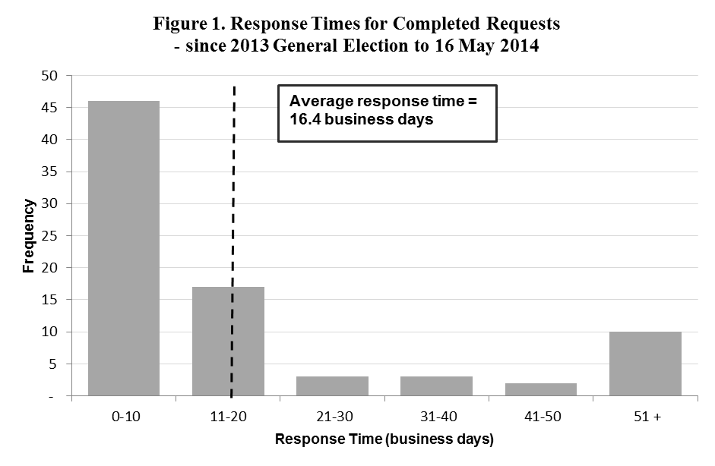

Requests by PBO for information from Commonwealth bodies

Table 2. PBO information requests and responsiveness of Commonwealth bodies – since 2013

General Election to 16 May 2014
Date | Requests Sent* | Responded By Due Date | Responded After Due Date | Average Lateness for Received Requests ^ | Requests Outstanding (overdue) | Average Days Overdue for Currently Overdue Requests
2013 Q3 | 41 | 15 (37%) | 26 (63%) | 1.8 business days | 0 (0) | -
2013 Q4 | 16 | 11 (69%) | 5 (31%) | 5.9 business days | 0 (0) | -
2014 Q1 | 43 | 27 (64%) | 15 (36%) | 1.4 business days | 1 (1) | 43.0 business days
2014 Q2 | 51 | 12 (55%) | 10 (45%) | 1.0 business days | 29 (7) | 9.6 business days
Total | 151 | 65 (54%) | 56 (46%) | 2.0 business days | 30 (8) | 13.8 business days
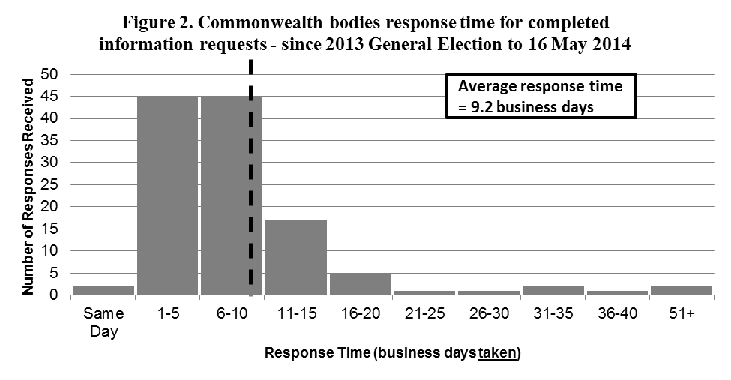
* Numbers of requests sent exclude requests that were subsequently withdrawn.
Response Time (business days taken) | Number of Responses Received
Same Day | 2
1-5 | 45
6-10 | 45
11-15 | 17
16-20 | 5
21-25 | 1
26-30 | 1
31-35 | 2
36-40 | 1
51+ | 2
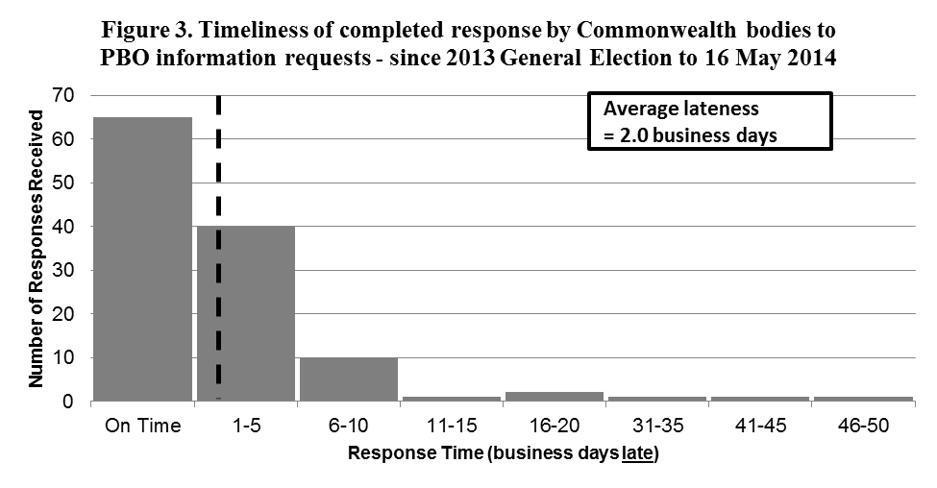
Response Time (business days late) | Number of Responses Received
On Time | 65
1-5 | 40
6-10 | 10
11-15 | 1
16-20 | 2
31-35 | 1
41-45 | 1
46-50 | 1

PBO staff by function and employment level

Table 3. PBO staff by function and employment level as at
16 May 2014
 | PBO  Executive | Budget Analysis Division | Fiscal Policy Analysis Division | Corporate Strategy Branch | Total
Parliamentary Budget Officer (PBO) | 1 | - | - | - | 1
Senior Executive Service Band 2 (SES B2) | - | 1 | 1 | - | 2
Senior Executive Service Band 1 (SES B1) | - | 2 | 1 | 1 | 4
Parliamentary Executive Level 2 (PEL2) | - | 4 | - | 1 | 5
Parliamentary Executive Level 1 (PEL1) | - | 9 | 4 | 2 | 15
Parliamentary Service Level 6 (PSL6) | 1 | 2 | 1 | - | 4
Parliamentary Service Level 5 (PSL5) | - | - | - | 1 | 1
Parliamentary Service Level 4 (PSL4) | - | 1 | - | 1 | 2
Total Staff | 2 | 19 | 7 | 6 | 34
* One ongoing SES B1 officer is on long term leave without pay and is not included in these totals.
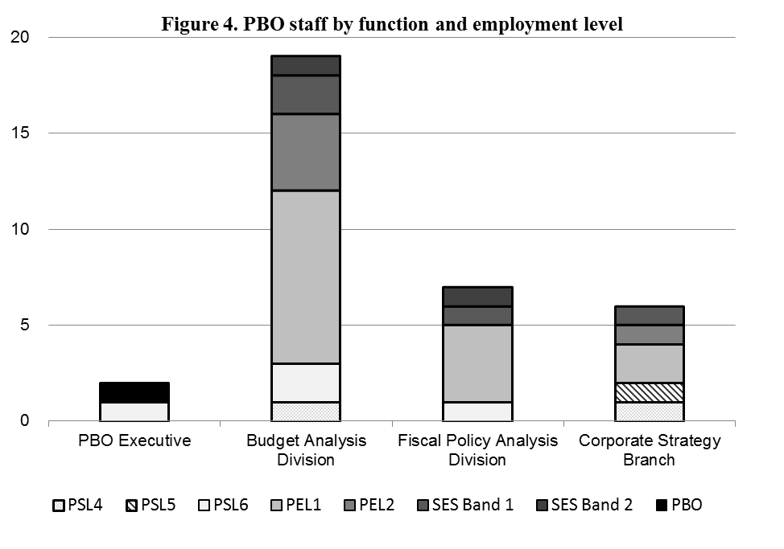

These figures relate to costing options rather than costing requests. The PBO has commenced monitoring and reporting on its workload on the basis of options rather than requests as this provides a better representation of the Office’s level of activity.

