Report to the Senate Finance and Public Administration Legislation Committee on PBO Activity and Staffing

15 October 2014

Overview

2013–14 annual report
The Parliamentary Budget Office (PBO) presented its 2013–14 annual report outside of the parliamentary sitting period on 15 October. The annual report provides an overview of the performance of the PBO during the year, with a focus on activity over the 2013 election period and other management and accountability requirements. The annual report is available on the PBO’s website.

2014–15 work plan
On 26 September 2014, following consultation with the Joint Committee of Public Accounts and Audit (JCPAA), the PBO released its 2014–15 work plan. The work plan outlines the priorities for the PBO in 2014–15, the focus of research under the PBO’s self-initiated work program, external engagement and organisational and resourcing information.

Requests from parliamentarians and parliamentary parties
The PBO continues to face a steady demand for costings and budget analyses. During the period 1 July to 30 September 2014, the PBO completed 205 requests from parliamentarians and parliamentary parties at an average turn-around time of 22.4 business days (refer to Table 1).
The PBO has continued to request information from agencies in order to respond to requests from parliamentarians and parliamentary parties, progress our self-initiated work program and maintain and improve core data holdings. During the period 1 July to 30 September 2014, the PBO received 65 responses to information requests at an average turnaround time of 21.0 business days (refer to Table 2).

Self-initiated work program
On 10 June 2014 the PBO released the 2014–15 Budget and forward estimates – charts which provided a graphical summary of the 2014–15 Budget relative to the 2013–14 Mid-year Economic and Fiscal Outlook, showing the impacts of policy decisions and other factors. The purpose of the charts was to add to the transparency of the Budget by presenting key budget information in a more readily accessible form.
On 22 August 2014 the PBO released a report on Projections of Government spending over the medium term. This report extends the historical analysis of government spending released in December 2013 and explores the outlook and drivers of Australian Government spending to help inform discussion about the sustainability of spending over the medium term.
Current work in progress includes analyses of: the sensitivity of medium-term budget projections to changes in key economic parameters, expected to be published within the next month; national fiscal trends at the Commonwealth, State and Territory levels, expected to be published by the end of December; and trends in and drivers of health programs other than Medicare, the Pharmaceutical Benefits Scheme and public hospitals, expected to be published in the first half of next year.

Capacity building
We are dedicating resources to enhancing the PBO’s capacity to more effectively fulfil its mandate to the Australian Parliament. In practice this will see an increased focus on acquiring and using detailed datasets, the in-house development and maintenance of models covering major demand driven expenditure programs and elements of the tax and transfer system, and more in-depth analyses of data and modelling results. Focusing on these areas will further improve the PBO’s responsiveness and the quality and reliability of its costings and budget analyses.

Assessment of the PBO’s current and future performance, role and operations
A performance audit of the administration of the Parliamentary Budget Office was undertaken by the Australian National Audit office (ANAO). The audit report was tabled on 5 June 2014. The ANAO concluded that since commencing operation in July 2012, the PBO has effectively undertaken its statutory role and is already well regarded as an authoritative, trusted and independent source of budgetary and fiscal policy analysis. The ANAO further commented that PBO has made a significant contribution to levelling the playing field for all parliamentarians.
The report made one recommendation that, in the interests of greater transparency, the PBO include estimates of administrative expenses in all costings, where significant. The PBO agreed with this recommendation and has since implemented it.
Following the tabling of the ANAO’s report, the JCPAA resolved to inquire into and report on the operations of the PBO with specific regard to: information gathering powers; PBO reporting of Government progress against fiscal rules; PBO reporting against medium term projections; best practice for independent fiscal institutions; PBO implementation of the ANAO recommendation regarding administrative costs; and the need for any legislative change.
The PBO prepared a comprehensive submission to the inquiry that addressed each of the above issues, and appeared at a public hearing of the Committee. The PBO’s submission is available on the PBO website.

Engagement with other organisations
The PBO continues to engage with government agencies, peer organisations, and international institutions and bodies as part of its ongoing operations. These engagements support the ongoing co-operative approach to the provision of information from agencies, provide the PBO with opportunities for PBO reports to be peer reviewed prior to their release and allow for the PBO to maintain its awareness of relevant emerging issues on both the domestic and international fronts.
On 12 June 2014, at the request of the IMF, the Parliamentary Budget Officer presented at an IMF Conference Institutions for Fiscal Credibility – Fiscal Policy Rules and Fiscal Councils: Experience and Prospects in the Asia-Pacific Region in Tokyo. The presentation reflected on the Australian experience in establishing a PBO and the history and present context of fiscal strategy in Australia.
PBO staff have also presented to visiting delegations from the Indonesian Parliament and public service, the National Assembly of Vietnam and researchers from the House of Councillors, National Diet of Japan.
The First Assistant Parliamentary Budget Officer, Budget Analysis Division chairs the OECD Committee of Fiscal Affairs (CFA) Working Party No. 2 on Taxation Policy and Statistics (WP2) which met in June 2014 in Paris. WP2 meets twice yearly to discuss issues relating to the measurement and analysis of tax policy issues, and reports to the CFA on a regular basis. A major focus of the current work of the working party is the measurement of the impact of corporate tax base erosion and profit shifting. The next meeting of the WP2 will be in Paris in November 2014.
The PBO continues to engage with the Tax and Transfer Policy Institute (TTPI) at the Australian National University as a member of the Government stakeholders group. This allows the PBO to provide input in relation to the Institute’s research priorities and identification of areas for cooperation between the PBO and TTPI.

PBO corporate services
When the PBO was established in July 2012, it entered into service provision arrangements with the Department of Parliamentary Services (DPS) for a range of corporate services and the Department of the House of Representatives (DHoR) for payroll services. At that time, DHoR also provided payroll services to DPS.
Due to tight timeframes to get the PBO’s corporate operations up and running quickly at that time, the other Parliamentary departments were not given an opportunity to express interest in providing the PBO with corporate services.
Earlier this year, the PBO decided to review these arrangements and invited proposals from each of the other Parliamentary departments for the provision of financial and other corporate services to the PBO, excluding information and communication technology services (ICT) and hardware. Proposals were received in August and September 2014.
On 17 September 2014, following an assessment of the proposals, the PBO accepted the proposal from the Department of the Senate (Senate) to provide corporate services to the PBO, comprising financial processing and reporting, payroll processing and records management.
The provision of ICT services and hardware to the PBO remains with DPS in accordance with the outcomes of the recent Roche review.
The PBO’s non-ICT corporate services are expected to be transitioned to the Senate by mid-December 2014.

PBO staffing
The PBO is funded for approximately 40 positions and currently has 39 full time equivalent staff (refer to Table 3). One staff member is engaged on a non-ongoing contract, as part of back-filling arrangements for a staff member on maternity leave.

Requests from parliamentarians and parliamentary parties for costings and budget analyses
Table 1: Costing and budget analysis requests from parliamentarians and parliamentary parties to 30 September 2014
 | 2012–13  Total | 2013–14  Total | 2014–15  Q1 | 2014–15  Total
Requests outstanding at start of period | - | 463 | 71 | 71
Requests received in period | 1,146 | 1,290 | 254 | 254
Requests withdrawn in period | 19 | 162 | 4 | 4
Requests completed in period | 664 | 1,520 | 205 | 205
Average time to completion (business days) | 33.9 | 13.8 | 22.4 | 22.4
Requests outstanding at end of period | 463 | 71 | 116 | 116
The table above reflects the number of ‘options’ received by the PBO, noting that a single request can contain multiple options.
Figure 1: PBO response times for completed requests in 2014–15 to 30 September 2014

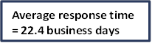
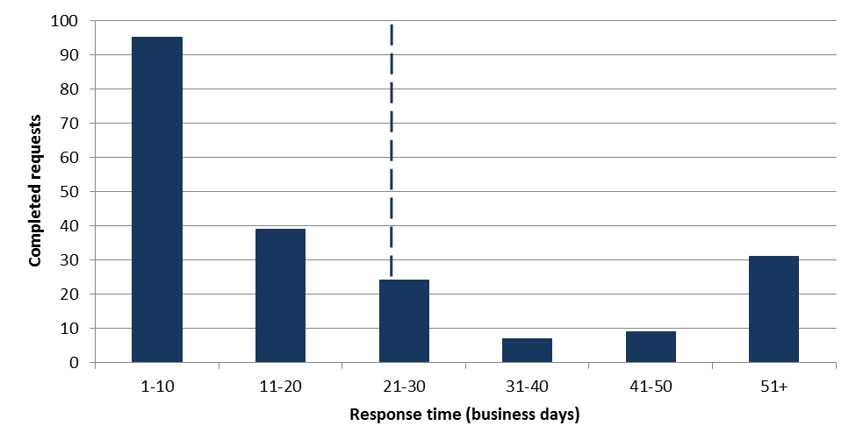

Requests by the PBO for information from agencies
Table 2: Information requests to agencies to 30 September 2014
 | 2012–13  Total | 2013–14  Total | 2014–15  Q1 | 2014–15  Total
Requests outstanding at the start of the period | - | 29 | 20 | 20
Requests sent in period | 360 | 388 | 48 | 48
Requests received in period | 331 | 397 | 65 | 65
Requests received by due date | 149 | 206 | 28 | 28
Requests received after due date | 182 | 191 | 37 | 37
Average time taken to respond (business days) | 12.0 | 12.2 | 21.0 | 21.0
Average punctuality (business days late) | 3.0 | 5.3 | 12.3 | 12.3
Average lateness of late requests (business days) | 6.5 | 12.0 | 23.1 | 23.1
Requests outstanding at end of period | 29 | 20 | 3 | 3
Figure 2: Agencies’ response time for completed information requests in 2014–15 to 30 September 2014

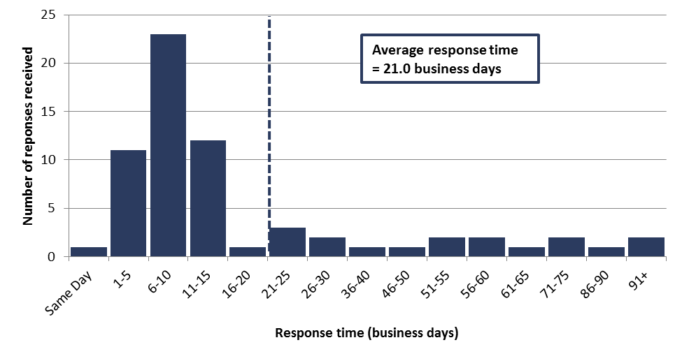

Figure 3: Timeliness of completed responses by agencies to information requests in 2014–15 to 30 September 2014
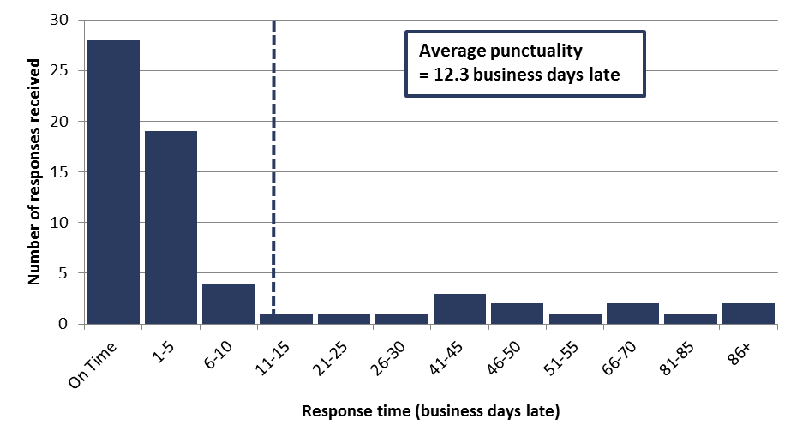

PBO staff by function and employment level
Table 3: PBO staff by function and employment level as at 30 September 2014
Classification | PBO Executive | Budget Analysis Division | Fiscal Policy Analysis Division | Corporate Strategy Branch | Total
Parliamentary Budget Officer | 1 | - | - | - | 1
Senior Executive Service Band 2 (SES B2) | - | 1 | 1 | - | 2
Senior Executive Service Band 1 (SES B1) ¹ | - | 2 | 1 | 1 | 4
Parliamentary Executive Level 2 (PEL 2) | - | 4 | 2 | 1 | 7
Parliamentary Executive Level 1 (PEL 1) | - | 10 | 5 | 2 | 17
Parliamentary Service Level 6 (PSL 6) | 1 | 1 | 1 | - | 3
Parliamentary Service Level 5 (PSL 5) ² | - | - | 1 | 2 | 3
Parliamentary Service Level 4 (PSL 4) | - | 1 | - | 1 | 2
Total staff | 2 | 19 | 11 | 7 | 39
¹ One ongoing SES B1 officer is on long term leave without pay and is not included in these totals.
² Includes an additional staff member as backfilling arrangements for a PSL 5 on maternity leave
Figure 4: PBO staff by function and employment level as at 30 September 2014
