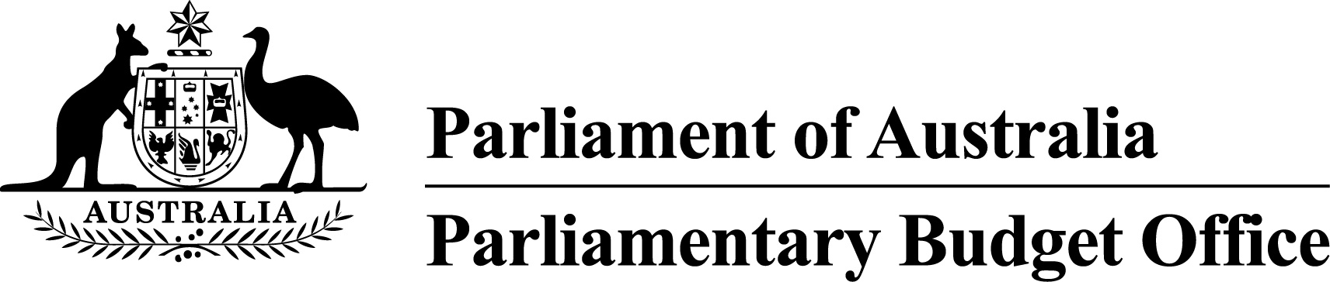

Report to the Senate Finance and
Public Administration Legislation Committee on PBO activity
21 February 2018

Overview
This activity report provides an update on PBO activities since the last report to the Committee (18 October 2017).

Independent review of the PBO
The independent review into the operations of the PBO commissioned by the Joint Committee of Public Accounts and Audit (JCPAA) under section 64T of the Parliamentary Service Act 1999 was completed in March 2017 and made 16 recommendations. The PBO continues to progress the implementation of actions to address these recommendations. The significant actions progressed since the last activity report are that we have:
- established a panel of expert advisers to ensure that the PBO’s analytical work is of the highest standard
- issued an information paper outlining the PBO’s approach to undertaking and prioritising policy costings (following consultations that closed on 15 December 2017)
- prepared a consultation paper, to be issued shortly, outlining how minor parties could be included in each Post-Election Report
- released two information papers explaining the methodological issues associated with policy costings
- issued a survey to measure stakeholder assessments of the PBO’s performance.

Requests from parliamentarians and parliamentary parties
In the first half of 2017–18, the PBO received 712 requests from parliamentarians for policy costings and analyses and responded to 692 requests at an average turnaround time of 23 business days and a median time to completion of 13 business days (refer to Table 1).
The PBO makes a number of information requests to Commonwealth agencies to support its responses to parliamentarians (and its research program). In the first half of 2017–18, the PBO received 142 responses from Commonwealth agencies to information requests at an average turnaround time of 10 business days. Requests were provided, on average, two business days ahead of the due date set (refer to Table 2). Table 3 contains details of the responsiveness of Commonwealth agencies to information requests during this period.
In the first half of 2017–18, 12 policy announcements that were made by parliamentarians or parliamentary parties included references to PBO policy costings. Five of these costings were subsequently publicly released (refer to Table 4).
The PBO has published several information papers to explain the underlying data, concepts, methodologies and processes used in preparing costings of policy proposals and budget analyses.

Research program
The PBO’s research program is set out in the 2017–18 work plan that was published on 22 September 2017.
On 19 October 2017, the PBO released Report no. 04/2017 National fiscal outlook: As at 2017–18 budgets. This report provides a national perspective on the fiscal outlook, examining outcomes across all levels of Australian government on a consistent basis.
On 7 December 2017, the PBO released Report no. 05/2017 Budget medium-term projections: economic scenario analysis. This report examines the sensitivity of medium-term budget projections to changes in economic parameters.
On 20 February 2018, the PBO released Report no. 01/2018 Disability Support Pension: Historical and projected trends. This report examines the factors underlying the recent decline in Disability Support Pension expenditure, highlighting the impacts of changes in government policy.

External engagement
Following the establishment of the panel of expert advisers, the PBO continues to seek input from the panel to assist with the development and evaluation of its work program and methodologies.
In November 2017, the PBO hosted three officials from the Kenyan Parliamentary Budget Office. The PBO presented a range of sessions to the Kenyan delegation on the operations of the PBO and facilitated discussions with other Australian Government and parliamentary departments on Australia’s budget and parliamentary processes.
The PBO has had consultations with the Victorian PBO and the Canadian PBO on various aspects of establishment and operations and continues to meet regularly with visiting international delegations to discuss the work and operation of the PBO.

PBO staffing
The PBO is allocated a budget that supports around 40 staff and receives additional funding every third year in the lead up to a general election to boost its staffing. At 31 December 2017, the PBO had 42 staff (refer to Table 5).

Requests from parliamentarians and parliamentary parties for costings and budget analyses
Table 1: Costing and budget analysis requests from parliamentarians and parliamentary parties to
31 December 2017
 | 2013–14  Total | 2014–15  Total | 2015–16  Total | 2016–17  Total | 2017–18  Q1 | 2017–18  Q2 | 2017–18  Total
Requests outstanding at start of period | 463 | 76 | 138 | 20 | 180 | 108 | 180
Requests received in period | 1,297 | 973 | 4,146 | 2,572 | 448 | 264 | 712
Requests withdrawn in period | 162 | 42 | 1,013 | 524 | 41 | 25 | 66
Requests completed in period | 1,522 | 869 | 3,251 | 1,888 | 479 | 213 | 692
Average time to completion (business days) | 14 | 20 | 19 | 20 | 22 | 25 | 23
Median time to completion (business days) | 6 | 12 | 16 | 12 | 12 | 15 | 13
Requests outstanding at end of period | 76 | 138 | 20 | 180 | 108 | 134 | 134
Note: The table identifies the number of ‘options’ received by the PBO, noting that a single request can contain multiple options.
Figure 1: PBO response times for completed requests in 2017–18 to 31 December 2017
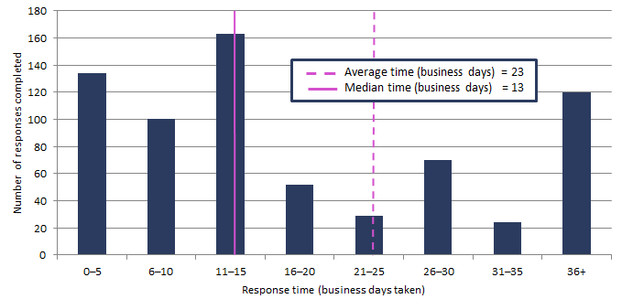

Requests by the PBO for information from agencies
Table 2: Information requests to agencies to 31 December 2017
 | 2013–14  Total | 2014–15  Total | 2015–16  Total | 2016–17  Total | 2017–18  Q1 | 2017–18  Q2 | 2017–18  Total
Requests outstanding at start of period | 28 | 16 | 3 | 1 | 16 | 13 | 16
Requests sent in period | 388 | 203 | 743 | 523 | 57 | 143 | 200
Responses received in period | 400 | 216 | 745 | 508 | 60 | 82 | 142
Responses received by due date | 209 | 147 | 695 | 499 | 57 | 81 | 138
Responses received after due date | 191 | 69 | 50 | 9 | 3 | 1 | 4
Percentage late (%) | 48 | 32 | 7 | 2 | 5 | 1 | 3
Average time taken to respond  (business days) | 13 | 13 | 7 | 8 | 16 | 6 | 10
Average punctuality  (business days late) | 5 | 3 | -1 | -2 | -1 | -3 | -2
Average lateness of late responses  (business days) | 12 | 11 | 3 | 3 | 2 | 7 | 3
Requests outstanding at end of period¹ | 16 | 3 | 1 | 16 | 13 | 74 | 74
¹ The level of outstanding requests reflects a significant number of pieces of information that, under standing arrangements, are provided to the PBO following each Economic and Fiscal Outlook Update. The Mid-year Economic and Fiscal Outlook update was released on 18 December 2017 and, consistent with the agreed timeframes for the provision of information under standing arrangements, the date for the provision of the information was following 31 December 2017.
As at 31 December 2017, no requests were overdue.

Figure 2: Agencies’ response times for completed information requests in 2017–18 to 31 December 2017
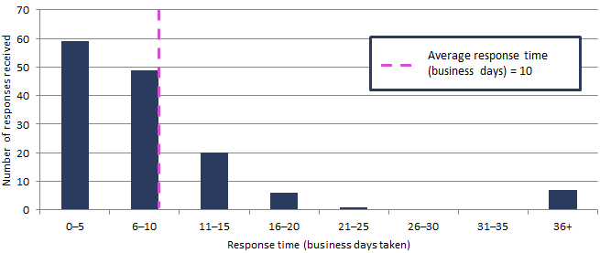

Figure 3: Timeliness of response by agencies to information requests in 2017–18 to 31 December 2017
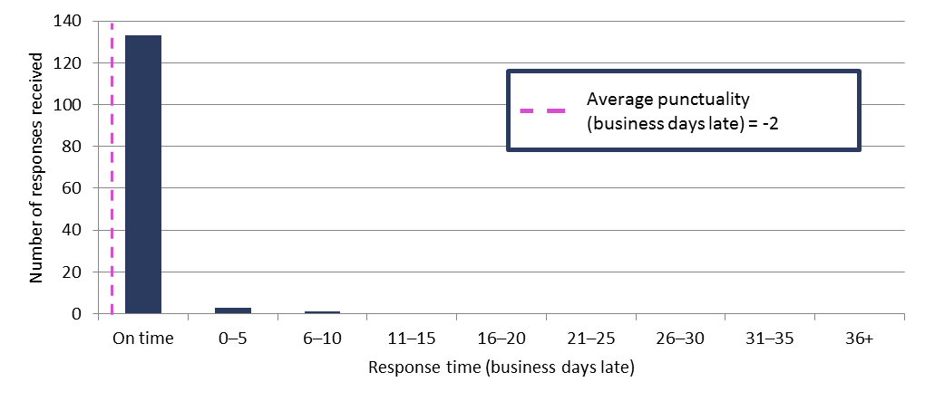
Note: ‘On time’ responses include responses provided before the due date.

Table 3: Information request responsiveness by agencies in 2017–18 to 31 December 2017
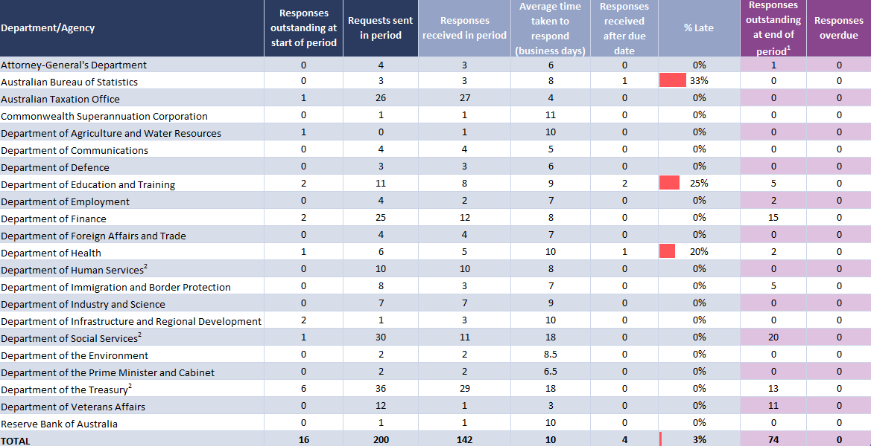
¹ The level of outstanding requests reflects a significant number of pieces of information that, under standing arrangements, are provided to the PBO following each Economic and Fiscal Outlook Update. The Mid-year Economic and Fiscal Outlook update was released on 18 December 2017 and, consistent with the agreed timeframes for the provision of information under standing arrangements, the date for the provision of the information was following 31 December 2017.
² The average timeframes for responses from these agencies are affected by the provision of updates to complex models to incorporate measures from the most recent economic and fiscal update. The provision of these updates has been agreed in standing information request arrangements and do not relate to specific requests from parliamentarians.
Table 4: Policy announcements with reference to PBO costings in 2017–18: 1 July to 31 December 2017
Description of policy announcement | Party or Parliamentarian announcing policy | Method of Announcement | Date of announcement | Costing minute released? | Date of release of costing minute
Alternative ways for funding the NDIS | Australian Greens | Media article | 02/07/2017 | No | n/a
Helping State and Territory Governments replace Stamp Duty with Land Tax | Australian Greens | Media article | 17/07/2017 | Yes | 17/07/2017  Costing posted on PBO website
Housing for young people: Freeing up investment properties | Australian Greens | Media article | 29/07/2017 | No | n/a
Introduce a standard minimum 30 per cent tax rate for discretionary trust distributions to mature beneficiaries | Australian Labor Party | Media release | 30/07/2017 | No | n/a
GST-Free Electricity | Senator David Leyonhjelm | Introduction of Bill into Parliament | 05/09/2017 | Yes | 05/09/2017 - Costing included in explanatory memorandum to Bill and posted on PBO website.
Higher threshold for Regional Student HELP repayments | Ms Cathy McGowan AO MP | Moving amendment to Higher Education Support Legislation Amendment (A More Sustainable, Responsive and Transparent Higher Education System) Bill 2017 | 13/09/2017 | Yes | 14/09/2017 - Costing posted on PBO website
Addressing fraudulent phoenix activity | Hon Dr Andrew Leigh MP | Parliamentary speech | 14/09/2017 | No | n/a
Restore Australian Federal Police presence at Hobart Airport | Australian Labor Party | Media release | 15/09/2017 | No | n/a
Funding for a National Space Agency | Senator the Hon Kim Carr | Media release | 25/09/2017 | No | n/a
Higher education and vocational education and training | Senator David Leyonhjelm | Media article | 17/10/2017 | Yes | 19/10/2017 - Costing posted on PBO website
Publish what you pay | Australian Labor Party | Media article | 31/10/2017 | No | n/a
Proposal to increase wages for Commonwealth Public Servants below the Executive Level (EL). | Australian Greens | Media article | 14/12/2017 | Yes | 14/12/2017 - Costing posted on PBO website

PBO staff by function and employment level
Table 5: PBO staff by function and employment level as at 31 December 2017
Classification | PBO Executive | Budget Analysis Division | Fiscal Policy Analysis Division | Corporate Strategy Branch | Total
Parliamentary Budget Officer (PBO) | 1 | - | - | - | 1
Senior Executive Service Band 2 (SES B2) | - | 1 | 1 | - | 2
Senior Executive Service Band 1 (SES B1) | - | 2 | 1 | 1 | 4
Parliamentary Executive Level 2 (PEL2) | - | 4 | 2 | 2 | 8
Parliamentary Executive Level 1 (PEL1) | - | 12 | 4 | 1 | 17
Parliamentary Service Level 6 (PSL6) | 1 | 4 | - | - | 5
Parliamentary Service Level 5 (PSL5) | - | 1 | 1 | 2 | 4
Parliamentary Service Level 4 (PSL4) | - | - | - | 1 | 1
Total staff | 2 | 24 | 9 | 7 | 42
Note: One SES B1, one PSL6 and one PSL4 ongoing employees are on long term leave without pay and are not included in these totals.

