Report to the Senate Finance and Public Administration Legislation Committee on PBO Activity

20 May 2015

Overview

Requests from parliamentarians and parliamentary parties

The PBO continues to face a steady demand for costings and budget analyses. During the period 1 July 2014 to 31 March 2015, the PBO completed 554 requests from parliamentarians and parliamentary parties at an average turn-around time of 21.1 business days and a median time to completion of 11.0 business days (refer to Table 1).

The PBO has continued to request information from agencies in order to respond to requests from parliamentarians and parliamentary parties, progress our self-initiated work program and maintain and improve core data holdings. During the period 1 July 2014 to 31 March 2015, the PBO received 126 responses to information requests at an average turnaround time of 17.1 business days (refer to Table 2).

Self-initiated work program

On 29 April 2015, the PBO released a report on *National fiscal trends*. This report examined historical trends and government projections of revenue, expenditure, net capital investment and the net debt position across all levels of Australian government. The report highlighted the significance of the Commonwealth’s fiscal position to the national position and identified a number of uncertainties around the improvement in the budget position projected by the Commonwealth and the states.

The PBO plans shortly to release its *2015–16-Budget and forward estimates – charts* which will provide a graphical summary of the 2015–16 Budget relative to the 2014–15 Mid-Year Economic and Fiscal Outlook, showing the impacts of policy decisions and other factors. These charts will continue the PBO’s practice of adding to the transparency of the budget by presenting key budget information in a more readily accessible form.

Current work in progress includes analyses of medium term budget projections, expected to be published by July 2015; the distributional effects of the GST in Australia, expected to be published in the first quarter of 2015-16; and spending trends and drivers of the Medicare Benefits Schedule, also expected to be published in the first quarter of 2015–16.

Capacity building and information management

Considerable effort is being directed to acquiring detailed datasets and developing models covering major demand driven expenditure programs and elements of the tax and transfer system. These tools will further improve the PBO’s responsiveness and the quality and reliability of its costings and budget analyses.

The PBO has a strong culture of digital information management through the use of an electronic data and records management system. The PBO’s establishment of a strong digital culture was recognised in May by the National Archives of Australia when the PBO received a Commendation Award in the Archives’ inaugural Digital Excellence Awards.

The PBO is currently evaluating tenders for a new work flow management system. Subject to a suitable system being selected it could be operational by the end of the year. The acquisition will be funded from the PBO’s current budget.

External engagement

The PBO continues to engage on a regular basis with government agencies, peer organisations, and international institutions and bodies. These engagements support the ongoing co-operative approach to the provision of information from agencies, provide the PBO with opportunities for PBO reports to be peer reviewed prior to their release and allow the PBO to maintain its awareness of relevant emerging issues on both the domestic and international fronts.

On 20 May 2015, the PBO initiated its inaugural Stakeholder Survey. The survey will give parliamentarians and other stakeholders the opportunity to provide feedback on PBO products and services, which will help to shape the PBO’s future service delivery. The survey is being conducted online by ORIMA Research.

The Parliamentary Budget Officer attended the seventh annual meeting of the OECD Network of Parliamentary Budget Officials and Independent Fiscal Institutions, hosted by the Austrian Parliament, in Vienna from 16 – 17 April 2015.

The First Assistant Parliamentary Budget Officer, Budget Analysis Division chairs the OECD Committee of Fiscal Affairs Working Party No. 2 on Taxation Policy and Statistics. The major focus of the working party continues to be the measurement of the impact of corporate tax base erosion and profit shifting.

The PBO continues to engage with the Tax and Transfer Policy Institute (TTPI) at the Australian National University as a member of the government stakeholders group. This allows the PBO to provide input in relation to the TTPI’s research priorities and identification of areas for cooperation between the PBO and TTPI.

The PBO also participates in the Interdepartmental Household Modelling Group which fosters technical cooperation and the coordination of training between Commonwealth departments.

The PBO has also participated in discussions with the Australian Bureau of Statistics on future data collections and statistical products.

PBO staffing

The PBO is funded for approximately 40 positions and at 31 March 2015 had 37 staff (refer to Table 4). Recruitment is in train to fill vacant positions.

Requests from parliamentarians and parliamentary parties for costings and budget analyses

Table 1: Costing and budget analysis requests from parliamentarians and parliamentary parties to 31 March 2015

|  | **2012–13**  **Total** | **2013–14**  **Total** | 2014–15  Q1 | 2014–15  Q2 | 2014–15  Q3 | **2014–15**  **Total** |
| --- | --- | --- | --- | --- | --- | --- |
| Requests outstanding at start of period | **-** | **463** | 76 | 124 | 51 | **76** |
| Requests received in period | **1,146** | **1,297** | 257 | 129 | 214 | **600** |
| Requests withdrawn in period | **19** | **162** | 4 | 2 | 1 | **7** |
| Requests completed in period | **664** | **1,522** | 205 | 200 | 149 | **554** |
| Average time to completion (business days) | **33.9** | **13.8** | 22.4 | 10.9 | 29.3 | **21.1** |
| Median time to completion (business days) | **n/a** | **6.0** | 13.0 | 8.0 | 20.0 | **11.0** |
| Requests outstanding at end of period | **463** | **76** | 124 | 51 | 115 | **115** |

The table above reflects the number of ‘options’ received by the PBO, noting that a single request can contain multiple options.

Figure 1: PBO response times for completed requests in 2014–15 to 31 March 2015

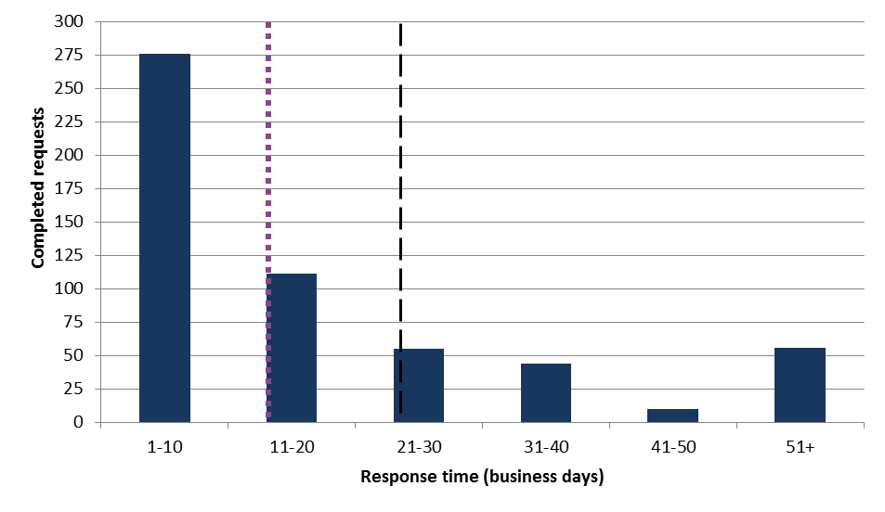

**Average response time = 21.1 business days**

**Median response time = 11.0 business days**

Requests by the PBO for information from agencies

Table 2: Information requests to agencies to 31 March 2015

|  | **2012–13**  **Total** | **2013–14**  **Total 1** | 2014–15  Q1 **1** | 2014–15  Q2 **1** | 2014–15  Q3 | **2014–15**  **Total** |
| --- | --- | --- | --- | --- | --- | --- |
| Requests outstanding at the start of the period | **-** | **29** | 16 | 4 | 6 | **16** |
| Requests sent in period | **360** | **388** | 50 | 26 | 40 | **116** |
| Requests received in period | **331** | **401** | 62 | 24 | 40 | **126** |
| *Requests received by due date* | ***149*** | ***209*** | *35* | *15* | *26* | ***76*** |
| *Requests received after due date* | ***182*** | ***192*** | *27* | *9* | *14* | ***50*** |
| Average time taken to respond (business days) | **12.0** | **12.6** | 17.0 | 17.3 | 17.1 | **17.1** |
| Average punctuality (business days late) | **2.9** | **5.3** | 6.9 | 4.7 | 1.9 | **4.9** |
| Average lateness of late requests (business days) | **6.5** | **11.9** | 17.9 | 14.1 | 6.7 | **14.1** |
| Requests outstanding at end of period | **29** | **16** | 4 | 6 | 6 | **6** |

1 Data has been updated following confirmation of information from agencies.

As at 31 March 2015, no requests were overdue.

Figure 2: Agencies’ response time for completed information requests in 2014–15 to 31 March 2015

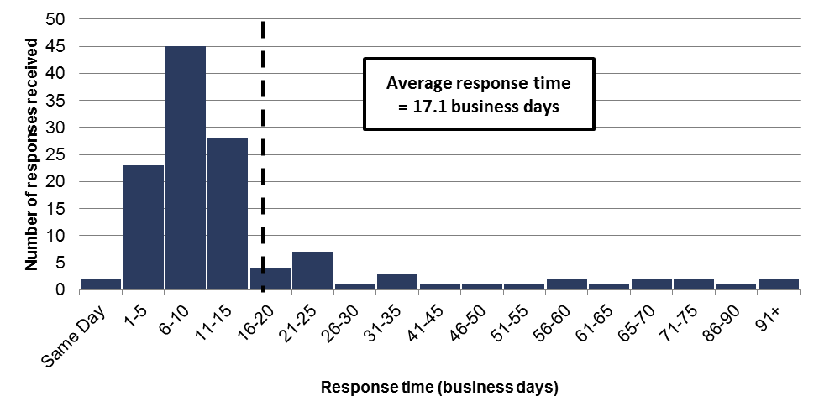

Figure 3: Timeliness of completed responses by agencies to information requests in 2014–15 to 31 March 2015

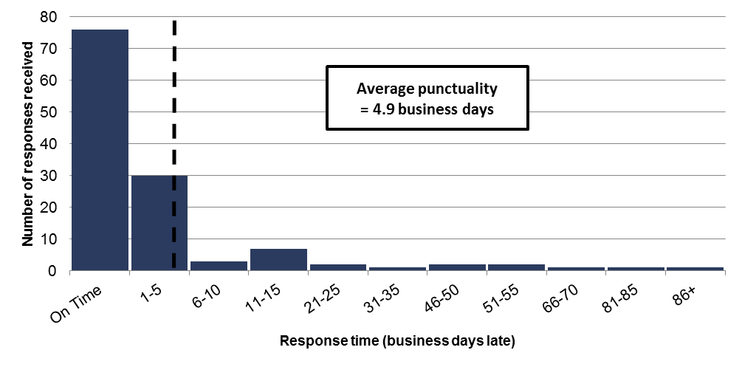

Table 3: Information request responsiveness by agencies in 2014–15 to 31 March 2015



1 Includes 16 outstanding requests as at 30 June 2014 carried over to 2014–15.

PBO staff by function and employment level

Table 4: PBO staff by function and employment level as at 31 March 2015

|  |  |  |  |  |  |
| --- | --- | --- | --- | --- | --- |
| Classification | PBO Executive | Budget Analysis Division | Fiscal Policy Analysis Division | Corporate Strategy Branch | Total |
| Parliamentary Budget Officer (PBO) | 1 | - | - | - | **1** |
| Senior Executive Service Band 2 (SES B2) | - | 1 | 1 | - | **2** |
| Senior Executive Service Band 1 (SES B1) 1 | - | 3 | 1 | 1 | **5** |
| Parliamentary Executive Level 2 (PEL2) | - | 3 | 2 | 1 | **6** |
| Parliamentary Executive Level 1 (PEL1) | - | 9 | 4 | 2 | **15** |
| Parliamentary Service Level 6 (PSL6) | 1 | 2 | 1 | - | **4** |
| Parliamentary Service Level 5 (PSL5) 2 | - | - | 1 | 2 | **3** |
| Parliamentary Service Level 4 (PSL4) | - | - | - | 1 | **1** |
| Total Staff | **2** | **18** | **10** | **7** | **37** |

1 One ongoing SES B1 officer is on long term leave without pay and is not included in these totals.  
2 Includes an additional staff member as backfilling arrangements for a PSL 5 on maternity leave.

Figure 4: PBO staff by function and employment level as at 31 March 2015

