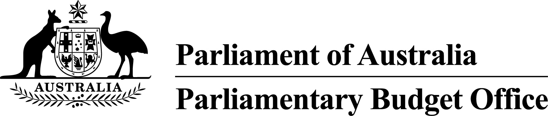

Report to the Senate Finance and
Public Administration Legislation Committee on PBO activity
18 October 2017

Overview
The Parliamentary Budget Office (PBO) 2016–17 Annual Report was tabled on 17 October 2017.
The demand from parliamentarians and parliamentary parties for policy costings and budget analyses declined in 2016–17 following the peak in demand arising from the 2016 general election. Despite this year on year decline, the trend in demand for PBO costings and budget analyses has continued to increase. During 2016–17, the PBO completed more than double the number of responses it prepared in 2014–15, the previous non-election year. The average time to completion of responses in 2016–17 was maintained at a similar level to that achieved in 2015–16.
The remainder of this activity report provides an update on PBO activities since the commencement of 2017–18.

Independent review of the PBO
The independent review into the operations of the PBO commissioned by the Joint Committee of Public Accounts and Audit (JCPAA) under section 64T of the Parliamentary Service Act 1999 was completed in March 2017 and made 16 recommendations. The recommendations and our responses are outlined at Attachment A.

Requests from parliamentarians and parliamentary parties
In the first quarter of 2017–18, the PBO received 448 requests from parliamentarians for costings and analysis responded to 479 requests at an average turnaround time of 22 business days and a median time to completion of 12 business days (refer to Table 1). The number of requests outstanding declined in the quarter, from 180 at the start to 108 at the end.
In the same period, the PBO received 60 responses from Commonwealth agencies to information requests at an average turnaround time of 16 business days with requests being submitted, on average, one business day ahead of the deadline set (refer to Table 2). Table 3 contains details of the responsiveness of Commonwealth agencies to information requests during this period.
In the first quarter of 2017–18, nine policy announcements that were made by parliamentarians or parliamentary parties included references to PBO costings. Three of these costings were subsequently publicly released (refer to Table 4).

Research program
Details of our research program for 2017–18 are set out in our work plan that was published on 22 September 2017.
On 5 July 2017, the PBO released Report No. 02/2017 2017–18 Budget: medium-term projections. This annual report provides detailed analysis and projections of receipts and payments over the forward estimates and the medium-term period to explain the drivers of the Budget aggregates.
On 13 September 2017, the PBO released Technical Note No. 01/2017 Factors influencing the reliability of policy proposal costings. This note explains the factors that impact on the uncertainty in policy costings and the PBO’s approach to explaining uncertainty in its costing response documents.
On 11 October 2017, the PBO released Report No. 03/2017 Changes in average personal income tax rates: distributional impacts. The report analyses the projected increase in average tax rates for individuals in different parts of the taxable income distribution.
The next annual report on the national fiscal outlook over the forward estimates period is expected to be published on 19 October 2017. This report provides a national perspective on the fiscal outlook, examining outcomes across all levels of Australian government on a consistent basis.
The remaining reports foreshadowed in the work plan are expected to be published progressively over the course of the financial year.

PBO staffing
The PBO is allocated a budget that supports around 40 staff and receives additional funding every third year in the lead up to a general election to boost its staffing. At 30 September 2017, the PBO had 41 staff (refer to Table 5), including one secondee under the 2017 Parliament of Australia graduate program.

Requests from parliamentarians and parliamentary parties for costings and budget analyses
Table 1: Costing and budget analysis requests from parliamentarians and parliamentary parties to
30 September 2017
 | 2013–14  Total | 2014–15  Total | 2015–16  Total | 2016–17  Total | 2017–18  Q1
Requests outstanding at start of period | 463 | 76 | 138 | 20 | 180
Requests received in period | 1,297 | 973 | 4,146 | 2,572 | 448
Requests withdrawn in period | 162 | 42 | 1,013 | 524 | 41
Requests completed in period | 1,522 | 869 | 3,251 | 1,888 | 479
Average time to completion (business days) | 14 | 20 | 19 | 20 | 22
Median time to completion (business days) | 6 | 12 | 16 | 12 | 12
Requests outstanding at end of period | 76 | 138 | 20 | 180 | 108
Note: The table identifies the number of ‘options’ received by the PBO, noting that a single request can contain multiple options.
Figure 1: PBO response times for completed requests in 2017–18 to 30 September 2017
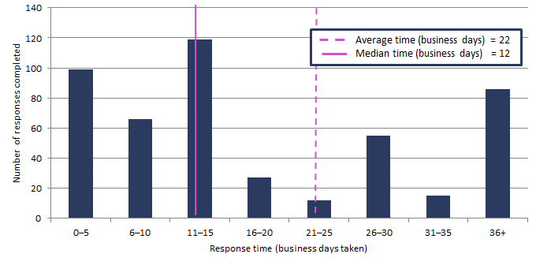

Requests by the PBO for information from agencies
Table 2: Information requests to agencies to 30 September 2017
 | 2013–14  Total | 2014–15  Total | 2015–16  Total | 2016–17  Total | 2017–18  Q1
Requests outstanding at start of period | 28 | 16 | 3 | 1 | 16
Requests sent in period | 388 | 203 | 743 | 523 | 57
Requests received in period | 400 | 216 | 745 | 508 | 60
Requests received by due date | 209 | 147 | 695 | 499 | 57
Requests received after due date | 191 | 69 | 50 | 9 | 3
Percentage late (%) | 48 | 32 | 7 | 2 | 5
Average time taken to respond  (business days) | 13 | 13 | 7 | 8 | 16
Average punctuality  (business days late) | 5 | 3 | -1 | -2 | -1
Average lateness of late requests  (business days) | 12 | 11 | 3 | 3 | 2
Requests outstanding at end of period | 16 | 3 | 1 | 16 | 13
As at 30 September 2017, no requests were overdue.
Figure 2: Agencies’ response times for completed information requests in 2017–18 to 30 September 2017
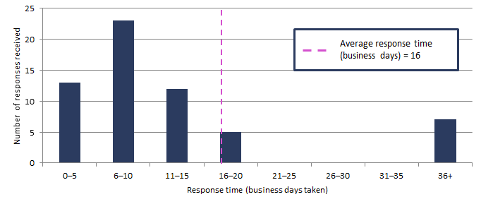
Figure 3: Timeliness of response by agencies to information requests in 2017–18 to 30 September 2017
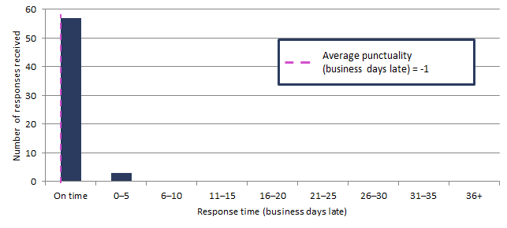Note: ‘On time’ responses include responses provided before the due date.

Table 3: Information request responsiveness by agencies in 2017–18 to 30 September 2017
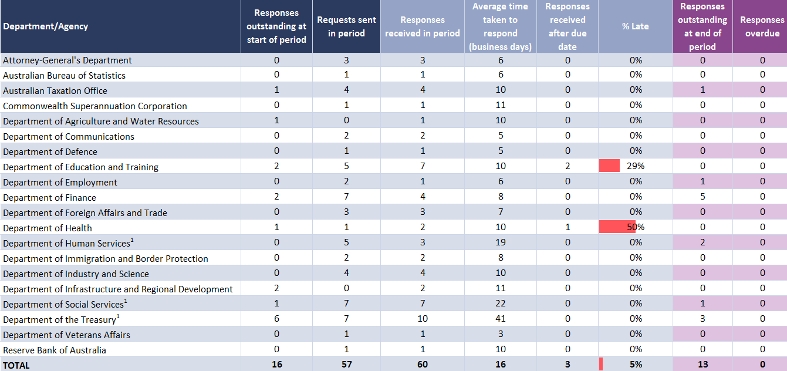
¹ The average timeframes for responses from these agencies are affected by the provision of updates to complex models to incorporate measures from the most recent economic and fiscal update. The provision of these updates has been agreed in standing information request arrangements and do not relate to specific requests from parliamentarians.

Table 4: Policy announcements with reference to PBO costings in 2017–18: 1 July to 30 September 2017
Description of policy announcement | Party or Parliamentarian announcing policy | Method of Announcement | Date of announcement | Costing minute released? | Date of release of costing minute
Alternative ways for funding the NDIS | Australian Greens | Media article | 02/07/2017 | No | n/a
Helping State and Territory Governments replace Stamp Duty with Land Tax | Australian Greens | Media article | 17/07/2017 | Yes | 17/07/2017  Costing minute released on Sydney Morning Herald hosted site at: http://www.smh.com.au/cqstatic/gv3wim/AustralianGreensPolicyCostingStampDuty.pdf
Housing for young people: Freeing up investment properties | Australian Greens | Media article | 29/07/2017 | No | n/a
Introduce a standard minimum 30 per cent tax rate for discretionary trust distributions to mature beneficiaries | Australian Labor Party | Media release | 30/07/2017 | No | n/a
GST-Free Electricity | Senator David Leyonhjelm | Introduction of Bill into Parliament | 05/09/2017 | Yes | 05/09/2017  Costing included in explanatory memorandum to Bill and posted on PBO website.
Higher threshold for Regional Student HELP repayments | Ms Cathy McGowan AO MP | Moving amendment to Higher Education Support Legislation Amendment (A More Sustainable, Responsive and Transparent Higher Education System) Bill 2017 | 13/09/2017 | Yes | 14/09/2017  Costing posted on PBO website.
Addressing fraudulent phoenix activity | Hon Dr Andrew Leigh MP | Parliamentary speech | 14/09/2017 | No | n/a
Restore Australian Federal Police presence at Hobart Airport | Australian Labor Party | Media release | 15/09/2017 | No | n/a
Funding for a National Space Agency | Senator the Hon Kim Carr | Media release | 25/09/2017 | No | n/a

PBO staff by function and employment level
Table 5: PBO staff by function and employment level as at 30 September 2017
Classification | PBO Executive | Budget Analysis Division | Fiscal Policy Analysis Division | Corporate Strategy Branch | Total
Parliamentary Budget Officer (PBO) | 1 | - | - | - | 1
Senior Executive Service Band 2 (SES B2) | - | 1 | 1 | - | 2
Senior Executive Service Band 1 (SES B1) | - | 2 | 1 | 1 | 4
Parliamentary Executive Level 2 (PEL2) | - | 4 | 2 | 2 | 8
Parliamentary Executive Level 1 (PEL1) | - | 10 | 4 | 1 | 15
Parliamentary Service Level 6 (PSL6) | 1 | 4 |  | - | 5
Parliamentary Service Level 5 (PSL5) | - | 1 | 1 | 2 | 4
Parliamentary Service Level 4 (PSL4) | - | - | - | 1 | 1
Secondees | - | 1 | - | - | 1
Total staff | 2 | 23 | 9 | 7 | 41
Note: One SES B1, one PSL6 and one PSL4 ongoing employees are on long term leave without pay and are not included in these totals.
In addition, one PEL1 employee is on secondment to the Australian Taxation Office and is not included in the above totals.

Attachment A

Parliamentary Budget Office Review 2016–17
Recommendations from the report of the independent review panel
Section 64T of the Parliamentary Service Act 1999 enables the JCPAA to seek an independent review of the PBO after a general election. On 14 November 2016 the Committee announced a review to focus on how the PBO could continue to strengthen its abilities. In particular, the review examined, reported and made recommendations on the scope for the PBO to build on the foundations it has established and continue to strengthen its ability to achieve its aims of:
- providing a more level playing field for all parliamentarians in their access to publicly funded policy costings and budget analyses
- improving the accuracy of costings of election commitments
- enhancing the transparency and public understanding of budget information and fiscal policy settings.
The review was completed in March 2017 and made 16 recommendations. The recommendations and our responses are outlined below.

No. | Description | Response
1 | The PBO should replace the reliability rating in its costing response documents with a statement on the factors that can affect the uncertainty of that type of policy costing. The PBO’s costing response documents should expand existing qualitative comments on reliability to highlight particularly uncertain elements of the specific policy when that is appropriate. | Agreed. The PBO issued Guidance: 01/2017 – Replacement of reliability ratings in costing responses on 31 March 2017. The PBO issued Technical note no. 02/2017 – Factors influencing the reliability of policy proposal costings on 13 September 2017, which explains the factors that impact on the uncertainty in policy costings and the PBO’s approach to explaining uncertainty in its costing response documents.
2 | The PBO should further develop and publish principles and processes to help set priorities in relation to requests from parliamentarians for costings and budget analysis, having regard to:  - the relevance of the request to matters expected to be before the Parliament  - the level of representation of the requesting political party in Parliament  - the level of priority given to the request by the parliamentarian’s political party and/or the parliamentarian, and  - the level of resources required to complete the request. | Agreed. The PBO will outline its principles and processes for setting priorities in a guidance note.
3 | The PBO should take action within its resource constraints to improve the quality and timeliness of its responses to parliamentarians’ requests for policy costings in peak periods, including:  - entering into secondment arrangements, including reciprocal arrangements, with Government Departments and Agencies, and  - exploring other mechanisms, such as using technology to streamline the costing process, and increasing collaboration with Government Departments and Agencies on model development. | Agreed. The PBO is developing and implementing a strategy to expand our current secondment program. The PBO is also actively exploring how technological improvements can improve processes.
4 | The PBO should establish a small, independent, expert advisory panel that it could consult on cross-cutting issues associated with policy costings and fiscal analysis. This advisory panel would not be provided with information on confidential costings of parliamentarians and would have no direct role in their preparation and provision. | Agreed. The PBO will establish a panel of expert advisors that it can consult on policy costing and fiscal policy issues.
5 | The PBO should ensure that the JCPAA is provided with sufficient data to allow it to regularly monitor the provision of information to the PBO through the Memorandum of Understanding. | Agreed. The PBO will continue to provide its activity report to the JCPAA at the same time it is provided to the Senate Finance and Public Administration Legislation Committee in advance of each Senate estimates hearing.
6 | The PBO should continue to work collaboratively with Government Departments and Agencies on information requests and model development, consistent with maintaining the confidentiality of parliamentarians’ policy proposals. The PBO should ensure that it includes sufficient context to enable the provision of the most appropriate information in response. | Agreed. The PBO is continuing to maintain effective working relationships with agencies to facilitate the timely provision of information under the MOU.
7 | The PBO should periodically conduct an ex-post analysis of a limited selection of its policy costing estimates, to help identify areas for improvement in future costings, and report the results to the JCPAA. | Agreed. The PBO will develop an evaluation methodology to conduct ex-post analyses of policy costings estimates.
8 | To improve the relevance of its self-initiated work, the PBO should:  - develop deeper and broader consultation with the JCPAA and other parliamentary committees  - align more closely its self-initiated work with, and help build the capacity of, PBO costing work, and  - consider a possible evolution of its self-initiated work program by:  - expanding its existing focus on medium-term fiscal sustainability issues  - building its capacity to analyse underlying drivers of the budget over the longer term, including, but not limited to, demographic analysis, and  - ensuring it has the capacity to further develop its longer-term analytic ability to allow consideration to be given to transferring responsibility for the next Intergenerational Report (scheduled for 2020) to the PBO. | Agreed. In developing the 2017–18 work plan, the PBO has broadened its consultation to include relevant parliamentary committees. The PBO will engage more deeply with committees through briefings on our research work.
9 | The PBO should more fully explain the methodology underlying the policy costing process, including in a non-technical fashion. | Agreed. The PBO will publish information to more fully explain the methodology underlying the policy costing process.
10 | The PBO should publish regular data on the number of policy announcements made with reference to PBO costings, and whether or not, and when, the underlying PBO costing response document was released by the party or parliamentarian concerned. | Agreed. The PBO issued Guidance: 02/2017 – PBO publication of responses that have been publicly released by parliamentarians to give effect to this recommendation. The PBO will publish the number of references in its activity report and annual report and, to enhance transparency, will publish those costings that have been publicly released on the PBO website.
11 | The Post-election Report of election commitments should include the financial impact over the medium term (in addition to the forward estimates period) of:  - the top ten policy proposals by dollar value  - any proposal with an impact of over $1 billion in a year  - proposals with a materially different impact beyond the forward estimates, and  - the overall election platform for each political party. | Agreed. This recommendation will be implemented in the next post-election report.
12 | The timing of the publication of the Post-election Report of election commitments should be delayed to the later of the first sitting day of Parliament following a general election or 30 days after the return of the writs from a general election. | Agreed, noting that legislative amendments would be required to give effect to this recommendation.
13 | The PBO should provide parliamentary political parties with fewer than five Members or Senators the option to have the financial impact of their election commitments included in the PBO’s Post-election Report of election commitments. | Agreed. The PBO will explore options to give effect to this recommendation.
14 | The PBO should consider the value of continuing to publish the chart pack following each fiscal update. | Agreed. The PBO will seek feedback on the value of the chart pack through the stakeholder survey (refer recommendation 16).
15 | The PBO should ensure that the JCPAA is regularly provided with sufficient information on the PBO’s workload, resource requirements and efficiency, to enable the JCPAA to monitor their impact on the level and timeliness of the PBO’s outputs. | Agreed. The PBO will provide this information to the JCPAA when the PBO engages with the JCPAA throughout the year.
16 | The PBO should conduct a survey once in each term of Parliament to get feedback on its performance from its stakeholders. | Agreed. The PBO will conduct a stakeholder survey once in each term of Parliament.

