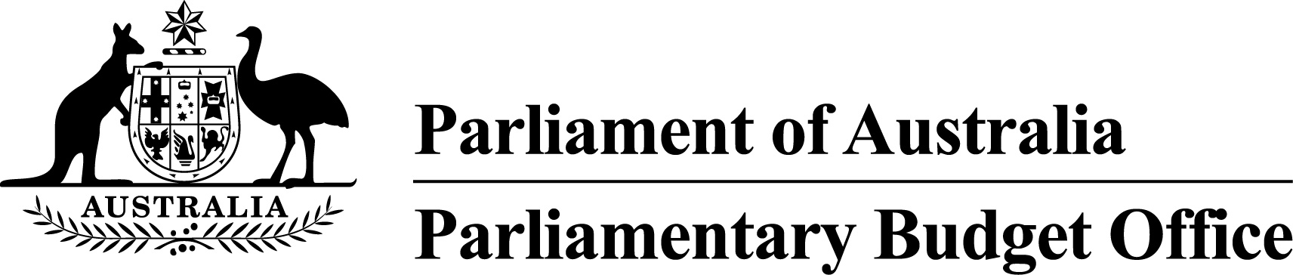

Report to the Senate Finance and   
Public Administration Legislation Committee on PBO activity

17 May 2018

Overview

This activity report provides an update on PBO activities since the last report to the Committee (21 February 2018).

Independent review of the PBO

The independent review into the operations of the PBO commissioned by the Joint Committee of Public Accounts and Audit (JCPAA) was completed in March 2017 and made 16 recommendations. The PBO has implemented actions to address these recommendations and on 30 April 2018 we provided a comprehensive summary to the JCPAA on how we implemented these actions. The significant actions progressed since the last activity report are that we have:

* scheduled our first annual gathering of the panel of expert advisors for 5 June 2018
* established an ongoing process for the formal evaluation of a selection of completed and published costings
* published guidance to Senators and Members on how we will give effect to allowing minor parties to opt in to the PBO’s post-election report of election commitments
* concluded, and analysed results from, the recent stakeholder survey.

Feedback from stakeholders

The PBO conducted a stakeholder survey during February and March 2018. The survey responses indicated that the PBO’s performance across a range of metrics had improved since the previous survey in 2015. Overall, there continues to be very high levels of satisfaction with the work and the role of the PBO. A summary of the survey results is at Attachment A.

In addition to this survey, we are looking at ways to gather more regular feedback through a range of channels to enhance reporting on the PBO’s performance as part of the annual performance statement in our annual report.

Requests from parliamentarians and parliamentary parties

In the nine months to 31 March 2018, the PBO received 1,329 requests from parliamentarians for policy costings and analyses and responded to 1,089 requests at an average turnaround time of 20 business days and a median time to completion of 13 business days (refer to Table 1).

The PBO makes a number of information requests to Commonwealth agencies to support its responses to parliamentarians (and its research program). In the nine months to 31 March 2018, the PBO received 265 responses from Commonwealth agencies to information requests at an average turnaround time of 10 business days. Requests were provided, on average, one business day ahead of the due date (refer to Table 2). Table 3 contains details of the responsiveness of Commonwealth agencies to information requests during this period.

In the nine months to 31 March 2018, 18 policy announcements that were made by parliamentarians or parliamentary parties included references to PBO policy costings. Five of these costings were subsequently publicly released (refer to Table 4).

Research program

The PBO’s research program is set out in the 2017–18 work plan that was published on 22 September 2017.

On 9 May 2018, the PBO released a graphical snapshot of the key information in the 2018‑19 Budget. The snapshot presents key budget information in an accessible form with the aim of improving public understanding of budget issues. By the end of May, we will release our 2018‑19 Budget chart pack which will explain the main changes to the budget in more detail. Further, we plan to release our 2018–19 Budget medium-term projections report in July 2018.

Reports on the trends affecting the sustainability of the tax base and the impact of Australia’s ageing population on the budget are in train and are expected to be published in the next quarter.

External engagement

Following the establishment of the panel of expert advisors, the PBO continues to seek input from the panel to assist with the development and evaluation of its work program and methodologies.

The PBO has had consultations with the Victorian PBO on various aspects of establishment and operations and continues to meet regularly with visiting international delegations to discuss the work and operation of the PBO.

The PBO continues to work with agencies to arrange access to electronic data warehouses, where possible. This ongoing access reduces the time it takes to respond to parliamentarian requests and reduces the ongoing burden on agencies in responding to individual requests for information.

PBO staffing

The PBO is allocated a budget that supports around 40 staff and receives additional funding every third year in the lead up to a general election to boost its staffing. At 31 March 2018, the PBO had 43 staff (including one person on secondment from another Commonwealth agency).

The PBO has established secondment arrangements with some agencies. These arrangements will build capability in the PBO and agencies, and expand the pool of potential candidates that the PBO can draw upon during election periods when surge capacity may be required. Three secondments have been established in 2017–18.

The PBO is also continuing to participate in the Parliament of Australia graduate program. Seven graduates are joining the PBO from a range of agencies during 2018, for periods of three to six months.

Requests from parliamentarians and parliamentary parties for costings and budget analyses

Table 1: Costing and budget analysis requests from parliamentarians and parliamentary parties to   
31 March 2018

|  | **2014–15**  **Total** | **2015–16**  **Total** | **2016–17**  **Total** | **2017–18**  **Q1** | **2017–18**  **Q2** | **2017–18**  **Q3** | **2017–18**  **Total** |
| --- | --- | --- | --- | --- | --- | --- | --- |
| Requests outstanding at start of period | 76 | 138 | 20 | 180 | 108 | 134 | 180 |
| Requests received in period | 973 | 4,146 | 2,572 | 448 | 264 | 617 | 1,329 |
| Requests withdrawn in period | 42 | 1,013 | 524 | 41 | 25 | 39 | 105 |
| Requests completed in period | 869 | 3,251 | 1,888 | 479 | 213 | 397 | 1,089 |
| Average time to completion (business days) | 20 | 19 | 20 | 22 | 25 | 15 | 20 |
| Median time to completion (business days) | 12 | 16 | 12 | 12 | 15 | 13 | 13 |
| Requests outstanding at end of period | 138 | 20 | 180 | 108 | 134 | 315 | 315 |

Note: The table identifies the number of ‘options’ received by the PBO, noting that a single request can contain multiple options.

Figure 1: PBO response times for completed requests in 2017–18 to 31 March 2018

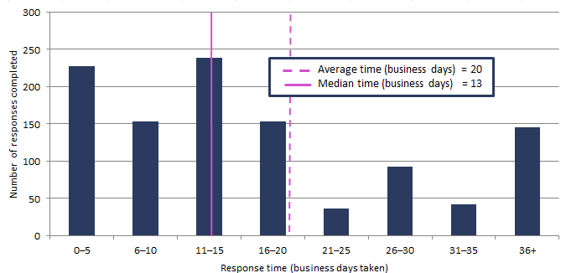

Requests by the PBO for information from agencies

Table 2: Information requests to agencies to 31 March 2018

|  |  |  |  |  |  |  |  |
| --- | --- | --- | --- | --- | --- | --- | --- |
|  | **2014–15**  **Total** | **2015–16**  **Total** | **2016–17**  **Total** | **2017–18**  **Q1** | **2017–18**  **Q2** | **2017-18**  **Q3** | **2017–18**  **Total** |
|  |  |  |  |  |  |  |  |
| Requests outstanding at start of period | 16 | 3 | 1 | 16 | 13 | 74 | 16 |
| Requests sent in period | 203 | 743 | 523 | 57 | 143 | 56 | 256 |
| Responses received in period | 216 | 745 | 508 | 60 | 82 | 123 | 265 |
| Responses received by due date | 147 | 695 | 499 | 57 | 81 | 123 | 261 |
| Responses received after due date | 69 | 50 | 9 | 3 | 1 | 0 | 4 |
| Percentage late (%) | 32 | 7 | 2 | 5 | 1 | 0 | 2 |
| Average time taken to respond (business days) | 13 | 7 | 8 | 16 | 6 | 9 | 10 |
| Average punctuality (business days late) | 3 | -1 | -2 | -1 | -3 | -1 | -1 |
| Average lateness of late responses (business days) | 11 | 3 | 3 | 2 | 7 | 0 | 3 |
| Requests outstanding at end of period | 3 | 1 | 16 | 13 | 74 | 7 | 7 |

As at 31 March 2018, no responses to requests were overdue.

Figure 2: Agencies’ response times for completed information requests in 2017–18 to 31 March 2018

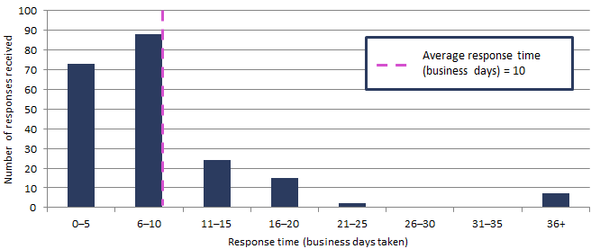

Figure 3: Timeliness of response by agencies to information requests in 2017–18 to 31 March 2018

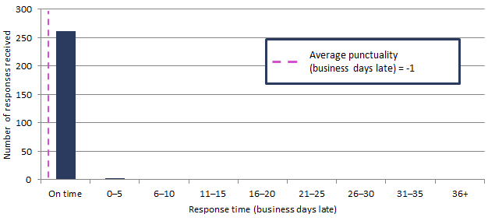

Note: ‘On time’ responses include responses provided before the due date.

Table 3: Information request responsiveness by agencies in 2017–18 to 31 March 2018



1 The average timeframes for responses from these agencies are affected by the provision of updates to complex models to incorporate measures from the Mid-Year Economic and Fiscal Outlook update. The provision of these updates has been agreed in standing information request arrangements and do not relate to specific requests from parliamentarians.

Table 4: Policy announcements with reference to PBO costings in 2017–18 to 31 March 2018

| **Description of policy announcement** | **Party or Parliamentarian announcing policy** | **Method of Announcement** | **Date of announcement** | **Costing minute released?** | **Date of release of costing minute** |
| --- | --- | --- | --- | --- | --- |
|  |  |  |  |  |  |
| Alternative ways for funding the NDIS | Australian Greens | Media article | 02/07/2017 | No | n/a |
| Helping State and Territory Governments replace Stamp Duty with Land Tax | Australian Greens | Media article | 17/07/2017 | Yes | 17/07/2017 - Costing posted on PBO website |
| Housing for young people: Freeing up investment properties | Australian Greens | Media article | 29/07/2017 | No | n/a |
| Introduce a standard minimum 30 per cent tax rate for discretionary trust distributions to mature beneficiaries | Australian Labor Party | Media release | 30/07/2017 | No | n/a |
| GST-Free Electricity | Senator David Leyonhjelm | Introduction of Bill into Parliament | 05/09/2017 | Yes | 05/09/2017 - Costing included in explanatory memorandum to Bill and posted on PBO website. |
| Higher threshold for Regional Student HELP repayments | Ms Cathy McGowan AO MP | Moving amendment to Higher Education Support Legislation Amendment (A More Sustainable, Responsive and Transparent Higher Education System) Bill 2017 | 13/09/2017 | Yes | 14/09/2017 - Costing posted on PBO website |
| Addressing fraudulent phoenix activity | Hon Dr Andrew Leigh MP | Parliamentary speech | 14/09/2017 | No | n/a |
| Restore Australian Federal Police presence at Hobart Airport | Australian Labor Party | Media release | 15/09/2017 | No | n/a |
| Funding for a National Space Agency | Senator the Hon Kim Carr | Media release | 25/09/2017 | No | n/a |
| Higher education and vocational education and training | Senator David Leyonhjelm | Media article | 17/10/2017 | Yes | 19/10/2017 - Costing posted on PBO website |
| Publish what you pay | Australian Labor Party | Media article | 31/10/2017 | No | n/a |
| Proposal to increase wages for Commonwealth Public Servants below the Executive Level (EL). | Australian Greens | Media article | 14/12/2017 | Yes | 14/12/2017 - Costing posted on PBO website |
| Impact on Northern Territory schools of difference between Government and Australian Labor Party policy | Australian Labor Party | Media article | 25/01/2018 | No | n/a |
| National (Federal) Integrity Commission | Australian Labor Party | Media article | 31/01/2018 | No | n/a |
| Redress Scheme for Stolen Generation | Australian Labor Party | Media article | 31/01/2018 | No | n/a |
| Investment allowance | Australian Labor Party | Media release | 13/03/2018 | No | n/a |
| A Fairer Tax System: Dividend Imputation Reform | Australian Labor Party | Media release | 13/03/2018 | No | n/a |
| Pensioner Guarantee – protecting pensioners from changes to excess dividend imputation credits | Australian Labor Party | Media release | 27/03/2018 | No | n/a |



2018 Stakeholder Survey

Summary report

**Issued: May 2018**

Introduction

In February 2018, the Parliamentary Budget Office (PBO) conducted its latest stakeholder survey. The survey invited feedback from Parliamentarians and other stakeholders, including economic policy analysts, representatives of peak bodies and media. The survey was based on the PBO’s 2015 stakeholder survey to enable comparisons to be made over time.

The survey received 34 responses (2015: 63) between 12 February and 5 March 2018. Responses were received from the offices of 4% of parliamentarians (2015: 20%). 20% of the other stakeholders invited to participate in the survey also provided a response (2015: 33%).

Survey responses indicated that the PBO’s performance across a range of metrics has improved since the previous survey in 2015. We have implemented a range of initiatives to improve transparency around internal processes and procedures; increase external engagement and consultation; enhance evaluation and feedback mechanisms; and increase the focus of the research and publication program on medium-term fiscal sustainability issues. Many of these initiatives have been implemented over the past 12 months following the 2016–17 independent review of the PBO.

There are some further opportunities to improve the accessibility of information on, and structure of, the PBO website. A project is currently underway to improve the structure, content and accessibility of the PBO’s website.

While the sentiments and ratings expressed in the survey responses suggest satisfaction with the PBO has improved, we acknowledge that a relatively small number of responses were received. We are investigating a range of mechanisms to gather feedback through other channels.

Overall impressions of the PBO

Overall, there continues to be very high levels of satisfaction with the work and role of the PBO. 98% of respondents indicated they were either satisfied or very satisfied (2015: 86%).

The vast majority of respondents on average (98%) held the view that: the PBO is **independent and non-partisan**; they have **confidence in the integrity** of the PBO; the PBO helps **improve transparency** of the budget and fiscal policy settings; and that the PBO provides a **level playing field** for all parliamentarians (2015: 90%). There was a strong increase in the view that the PBO’s work is of **high quality** (2018: 96%; 2015: 74%) and the PBO is **transparent in its processes** (2018: 92%; 2015: 76%).

Figure 1 illustrates the level of overall satisfaction with the PBO, including the specific metrics that constitute the overall impressions and customer service metrics.

Respondents were invited to provide comments on their experiences with the PBO, including suggestions for improvement. Where these are specific to publications or policy costings, they are mentioned later in this report. Other overall comments included:

|  |
| --- |
| *‘Role and remit should be expanded‘* |
| *‘The PBO has made a highly valuable contribution to the public debate through empowering oppositions and minor parties to engage in more serious policy work‘* |
| *‘An important organisation that has added to the quality of budget analysis‘* |

**Figure 1: Overall satisfaction with the PBO**

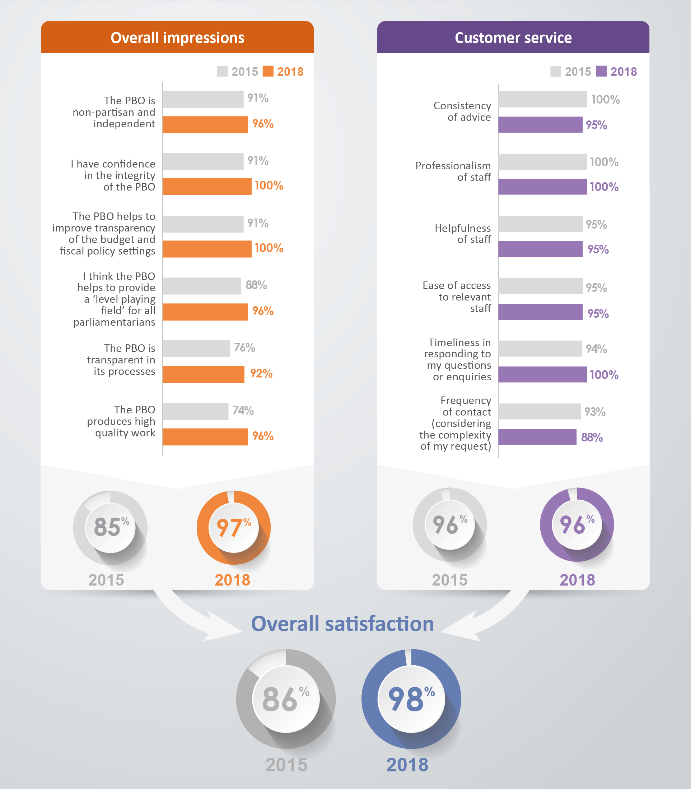

Published research

Around seven in ten respondents indicated that they had read at least one PBO publication in the last 12 months. The most commonly read publications were research reports (67%; 2015: 59%) and information and consultation papers (63%; 2015: not available). The chart packs, the 2013 Post‑election report and the work plan and annual report had a lower level of readership   
(41-48%; 2015: 28-60%).

A majority of respondents (84%; 2015: 76%) considered that the publications were a valuable resource in decision-making. Respondents were also asked to rate the publications they had read across five quality attributes. All respondents agreed that the PBO reports helped them to gain a better understanding of budget issues (100%; 2015: 97%), the report findings were supported by the analysis (100%; 2015: 91%) and information was clearly sourced and referenced (100%; 2015: 91%). The vast majority of respondents also agreed that the assumptions used by the PBO were clear (96%; 2015: 88%); and the reports were easy to understand (96%; 2015: 88%).

Two additional attributes were also measured in the survey relating to the accessibility of the PBO’s publications, with a vast majority of respondents finding the reports to be easy to download from the website (91%; 2015: 94%) and easy to find (72%; 2015: 88%). Further analysis on the PBO website is outlined below.

Figure 2 illustrates the level of usage (ie whether read) of PBO publications with the level of usefulness (if read).

Respondents provided additional comments in relation to the publications provided by the PBO:

|  |
| --- |
| *‘Excellent’* |
| *‘PBO’s research output is incredibly important and I appreciate the focus on the medium-term outlook’* |
| *‘I find them very useful in my work’* |

The majority of respondents indicated that they were made aware of new PBO publications through the PBO email list (60%; 2015: 71%). Other ways through which respondents became aware of new publications were by checking the PBO website (37%; 2015: 29%), through word of mouth (26%; 2015: 26%) or through the media (30%; 2015: 23%). Only 7% (2015: 3%) of respondents recalled being made aware of new publications via the PBO’s twitter account.

**Figure 2: Usage and usefulness of PBO publications**

Policy costings and budget analyses

The PBO provides a direct service to parliamentarians (and their staff) in producing confidential costings of policy proposals and budget analyses outside the caretaker period.

Parliamentarians and staff were invited to respond to questions about their direct dealings with the PBO in submitting a request. Of those that completed this section:

A majority (63%; 2015: 70%) had **direct contact** with the PBO around four times or more in the last 12 months

78% (2015: 75%) had an **initial discussion** with the PBO prior to submitting a request, and

89% (2015: 83%) submitted a **formal request** in the past 12 months.

Respondents were given the opportunity to rate their experiences with the PBO across each of the three stages of contact with the PBO: **initial discussion**; **formal request**; and **formal response**. Their ratings across a range of service attributes within each stage show a solid to very high level of overall satisfaction across each of the three stages. As illustrated in Figure 3, 100% (2015: 89%) of respondents were satisfied with the initial discussion, 100% (2015: 89%) were satisfied with the customer service during the formal request although 88% (2015: 75%) were satisfied with the request template itself, and 88% (2015: 75%) were satisfied with the formal response.

**Figure 3: Experiences in dealing with the PBO**

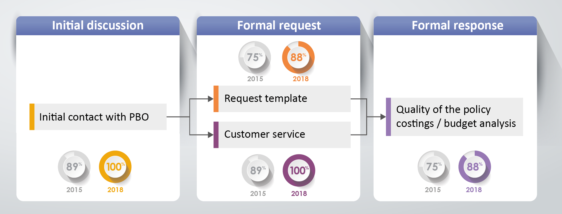

Alongside these strong positive ratings, the findings also identified a number of opportunities for improvement in certain aspects of the PBO’s service delivery arrangements. Positive sentiments tended to be more subdued for measures that related to responsiveness and timeliness of interactions with clients and accessibility of the request template and the response. Specifically, these related to the following within each interaction stage:

**Initial discussion**: ensuring that all questions are answered (71% satisfied; 2015: 67%) and clearly informing stakeholders of how long it would take to finalise their request(s) (71%; 2015: 63%);

**Formal request**: the request template is easy to complete (75%; 2015: 100%), information requested was reasonable (88%; 2015: 100%) and the PBO kept me advised of the progress of my request (75%; 2015: 78%), and

**Formal response**: the response was easy to understand (75%; 2015: 86%).

One respondent provided the following comment:

|  |
| --- |
| *‘Sometimes completed costings that we receive are very complicated and confusing. It would help if they could be simplified as much as possible’* |

A significant area of improvement from the previous survey was in relation to responses on the appropriate priority the PBO gave to requests issued by the parliamentarian or their party (100%; 2015: 59%).

PBO Website

The PBO’s website is an important mechanism to communicate information in a clear and accessible manner.

Particular areas for improvement are the structure of the website (satisfied 68%; 2015: 68%) and the ease of finding information respondents were looking for (satisfied 73%; 2015: 75%).

Respondents provided the following comments:

|  |
| --- |
| *‘I find the sorting of publications into reports/responses/submissions etc unclear’* |
| *‘Might be useful to be able to go to it directly, rather than via the APH website’* |