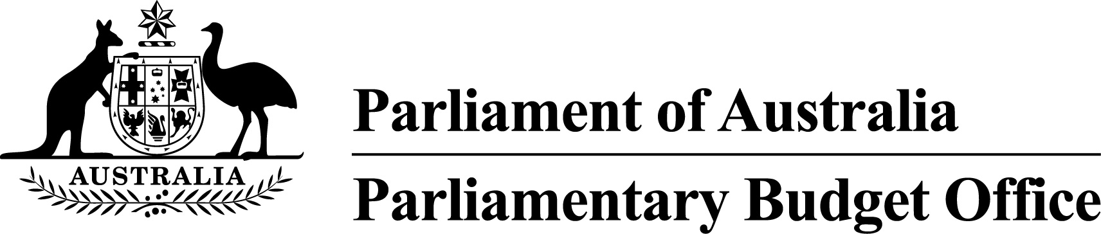

Report to the Senate Finance and
Public Administration Legislation Committee on PBO activity
17 May 2017

Overview
This activity report provides an update on PBO activities since the last report to the Committee (22 February 2017).

Independent review of the PBO
The independent review into the operations of the PBO commissioned by the Joint Committee of Public Accounts and Audit (JCPAA) under Section 64T of the Parliamentary Service Act 1999 was tabled in Parliament on 29 March 2017.
The report of the independent review panel described the PBO as ‘a successful institutional development in Australian governance’, which has ‘filled a significant gap in Australia’s public policy landscape’. The report made a number of recommendations to help improve the PBO’s operations in the future. The PBO will consult with the JCPAA on its response to these recommendations in the context of the development of its work plan for 2017–18.

Requests from parliamentarians and parliamentary parties
In the nine months to 31 March 2017, the PBO responded to 1,348 requests from parliamentarians at an average turnaround time of 19.3 business days and a median time to completion of nine business days (refer to Table 1). Early in this period there were a large number of requests related to costings prepared for the post-election report of election commitments. Demand for costings quickly resumed with the resumption of Parliament following the election with a further surge in requests following the Mid-year Economic and Fiscal Outlook (MYEFO) in December.
In the same period, the PBO received 288 responses from Commonwealth agencies to information requests at an average turnaround time of 7.7 business days and with an average punctuality of 2.2 business days early (refer to Table 2). Table 3 contains details of the responsiveness of Commonwealth agencies to information requests during this period.

Self-initiated research program
With the release of the 2017–18 Budget, a report on the 2017–18 Budget medium-term projections and the 2017–18 Budget chart pack will be published in the current quarter.

International engagement
In April 2017, the Parliamentary Budget Officer participated in the 9th Annual Meeting of the OECD Network of Parliamentary Budget Officials and Independent Fiscal Institutions hosted by the Scottish Parliament in Edinburgh. He gave a presentation on the recent independent review into the PBO’s operations.
In May 2017, the First Assistant Parliamentary Budget Officer, Fiscal Policy Analysis Division presented at the 2017 Seoul International Forum on Elections hosted by National Election Commission of the Republic of Korea. He gave a presentation on the preparation of policy costings by the PBO and the post-election report of election commitments.

PBO staffing
The PBO has a staffing establishment of approximately 40 positions and receives additional funding every third year in the lead up to a general election to boost its staffing. At 31 March 2017, the PBO had 46 staff (refer to Table 4), reflecting the higher staffing level associated with the general election and the continuing demand for policy costing services. In addition, the PBO currently has two secondees under the 2017 Parliament of Australia graduate program.

Requests from parliamentarians and parliamentary parties for costings and budget analyses
Table 1: Costing and budget analysis requests from parliamentarians and parliamentary parties to
31 March 2017
 | 2012–13  Total | 2013–14  Total | 2014–15  Total | 2015–16  Total | 2016–17  Q1 | 2016–17  Q2 | 2016–17  Q3 | 2016–17  Total
Requests outstanding at start of period | – | 463 | 76 | 138 | 20 | 203 | 350 | 20
Requests received in period | 1,146 | 1,297 | 973 | 4,146 | 787 | 755 | 523 | 2,065
Requests withdrawn in period | 19 | 162 | 42 | 1,013 | 28 | 307 | 133 | 468
Requests completed in period | 664 | 1,522 | 869 | 3,251 | 576 | 301 | 471 | 1,348
Average time to completion (business days) | 33.9 | 13.8 | 19.7 | 18.6 | 5.8 | 20.7 | 33.8 | 19.3
Median time to completion (business days) | n/a | 6 | 12 | 16 | 6 | 13 | 21 | 9
Requests outstanding at end of period | 463 | 76 | 138 | 20 | 203 | 350 | 269 | 269
Note: The table identifies the number of ‘options’ received by the PBO, noting that a single request can contain multiple options.
Figure 1: PBO response times for completed requests in 2016–17 to 31 March 2017
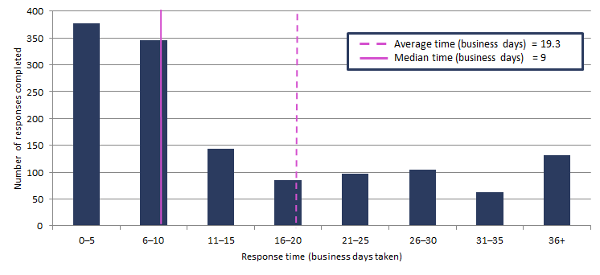

Requests by the PBO for information from agencies
Table 2: Information requests to agencies to 31 March 2017
 | 2012–13  Total | 2013–14  Total | 2014–15  Total | 2015–16  Total | 2016–17  Q1 | 2016–17  Q2 | 2016–17  Q2 | 2016–17  Total
Requests outstanding at start of period | – | 28 | 16 | 3 | 1 | 7 | 76 | 1
Requests sent in period | 360 | 388 | 203 | 743 | 36 | 184 | 82 | 302
Requests received in period | 332 | 400 | 216 | 745 | 30 | 115 | 143 | 288
Requests received by due date | 149 | 209 | 147 | 695 | 29 | 113 | 139 | 281
Requests received after due date | 183 | 191 | 69 | 50 | 1 | 2 | 4 | 7
Percentage late | 55.1 | 47.8 | 31.9 | 6.7 | 3.3 | 1.8 | 2.8 | 2.4
Average time taken to respond (business days) | 13.1 | 12.6 | 13.5 | 6.5 | 13.7 | 5.1 | 8.4 | 7.7
Average punctuality (business days late) | 3.0 | 5.3 | 2.9 | -1.3 | -2.5 | -4.6 | -0.6 | -2.2
Average lateness of late requests (business days) | 6.5 | 11.9 | 11.2 | 3.5 | 1.0 | 1.0 | 4.5 | 3.0
Requests outstanding at end of period | 28 | 16 | 3 | 1 | 7 | 76 | 15 | 15
As at 31 March 2017, no requests were overdue.
Figure 2: Agencies’ response times for completed information requests in 2016–17 to 31 March 2017
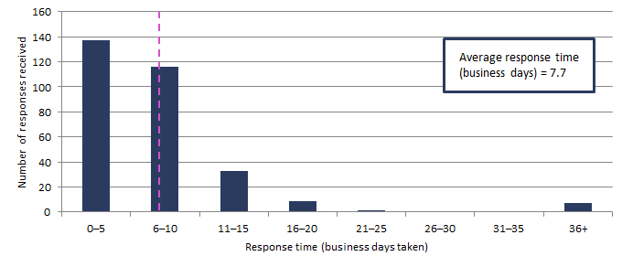
Figure 3: Timeliness of response by agencies to information requests in 2016–17 to 31 March 2017
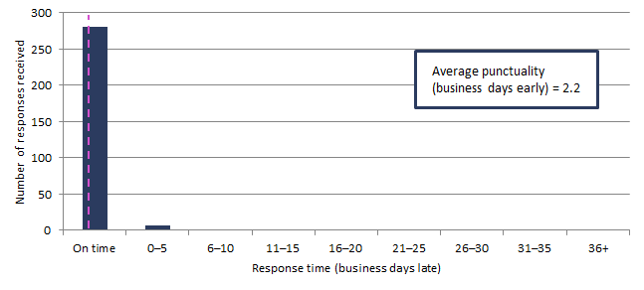Note: ‘On time’ responses include responses provided before the due date.

Table 3: Information request responsiveness by agencies in 2016–17 to 31 March 2017
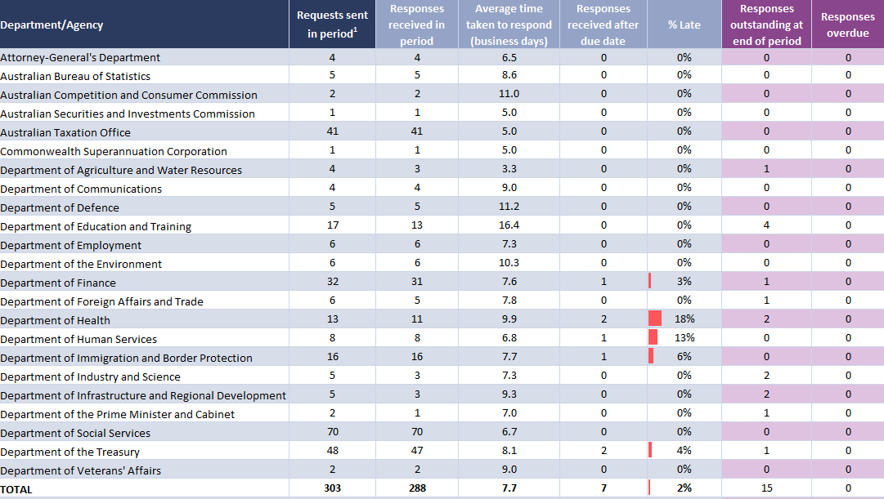
¹ Includes one outstanding request as at 30 June 2016 carried over to 2016–17.

PBO staff by function and employment level
Table 4: PBO staff by function and employment level as at 31 March 2017
Classification | PBO Executive | Budget Analysis Division | Fiscal Policy Analysis Division | Corporate Strategy Branch | Total
Parliamentary Budget Officer (PBO) | 1 | - | - | - | 1
Senior Executive Service Band 2 (SES B2) | - | 1 | 1 | - | 2
Senior Executive Service Band 1 (SES B1) ¹ | - | 2 | 1 | 1 | 4
Parliamentary Executive Level 2 (PEL2) | - | 4 | 2 | 2 | 8
Parliamentary Executive Level 1 (PEL1) ¹ | - | 13 | 4 | 1 | 18
Parliamentary Service Level 6 (PSL6) | 1 | 7 | - | - | 8
Parliamentary Service Level 5 (PSL5) ¹ | - | 1 | 1 | 2 | 4
Parliamentary Service Level 4 (PSL4) ¹ | - | - | - | 1 | 1
Total staff | 2 | 28 | 9 | 7 | 46
¹ One SES B1, one PSL5 and one PSL4 ongoing employees are on long term leave and are not included in these totals.
In addition, one PEL1 employee is on secondment to the Australian Taxation Office and is not included in the above totals.
Figure 4: PBO staff by function and employment level as at 31 March 2017

