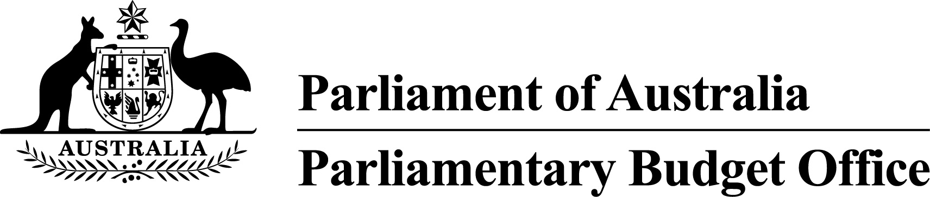

Report to the Senate Finance and
Public Administration Legislation Committee on PBO activity
12 October 2016

Overview
The Parliamentary Budget Office (PBO) 2015–16 Annual Report will be tabled on 12 October 2016.
In 2015–16, the demand from parliamentarians and parliamentary parties for policy costings and budget analyses increased significantly in the lead up to the 2016 general election. During 2015–16 the PBO responded to 3,251 requests, more than double the number of responses it prepared in 2013–14, the previous election year, and almost four times the number completed in 2014–15 (refer to Table 1).
The remainder of this activity report provides an update on PBO activities since the commencement of 2016–17.

Requests from parliamentarians and parliamentary parties
In the first quarter of 2016–17, the PBO responded to 576 requests from parliamentarians at an average turnaround time of 5.8 business days and a median time to completion of 6 business days (refer to Table 1). The bulk of these requests related to costings prepared for the post-election report of election commitments. The turnaround time in quarter 1, 2016-17 reflects that many of these requests had previously been completed by the PBO on a confidential basis.
In the same period, the PBO received 30 responses from Commonwealth agencies to information requests at an average turnaround time of 13.7 business days and with an average punctuality of 2.5 business days early (refer to Table 2). Table 3 contains details of the responsiveness of Commonwealth agencies to information requests during the first quarter of 2016–17.

Post-election report of election commitments
The Parliamentary Budget Officer is required, within 30 days after the end of the caretaker period for a general election, to prepare a post-election report of the budget impacts of the election commitments of each parliamentary party with five or more members in the Parliament immediately before the commencement of the caretaker period.
For each designated parliamentary party, the post-election report includes costings of all the election commitments of that party that the Parliamentary Budget Officer, in his best professional judgement, reasonably believes would have a material impact on the Commonwealth budget estimates for the current financial year and the following three financial years, along with the total combined impact of those commitments on the budget.
This report for the 2016 election was published on 5 August 2016.

Self-initiated research program
Details of the PBO’s published research program for 2016–17 are set out in our 2016–17 work plan that was published on 9 August 2016.
A report on the national fiscal outlook over the forward estimates period is expected to be published in November 2016.
The remaining reports flagged in the work plan are expected to be published progressively over the course of the financial year.

Capacity building and information management
The PBO continues to acquire detailed datasets and develop models covering major demand driven expenditure programs and elements of the tax and transfer system to further improve the PBO’s responsiveness and the quality and reliability of our costings and budget analyses.
The PBO implemented a new workflow management system on 4 May 2016 that has already yielded significant efficiency improvements in our work practices.

External engagement
The PBO continues to engage on a regular basis with government agencies, peer organisations and international institutions and bodies.
At the request of the Parliamentary Budget Office of the Republic of South Africa, the Parliamentary Budget Officer participated in the 2016 African Parliamentary Budget Office Conference in August 2016, held in Cape Town, South Africa.

PBO staffing
The PBO has a staffing establishment of approximately 40 positions and receives additional funding every third year in the lead up to a general election to boost its staffing. At 30 September 2016, the PBO had 45 staff (refer to Table 4), which reflects the increase in staff associated with the lead up to the general election. In addition, the PBO currently has two secondees under the 2016 Parliament of Australia graduate program.

Requests from parliamentarians and parliamentary parties for costings and budget analyses
Table 1: Costing and budget analysis requests from parliamentarians and parliamentary parties to
30 September 2016
 | 2012–13  Total | 2013–14  Total | 2014–15  Total | 2015–16  Total | 2016–17  Q1
Requests outstanding at start of period | – | 463 | 76 | 138 | 20
Requests received in period | 1,146 | 1,297 | 973 | 4,146 | 787
Requests withdrawn in period | 19 | 162 | 42 | 1,013 | 28
Requests completed in period | 664 | 1,522 | 869 | 3,251 | 576
Average time to completion (business days) | 33.9 | 13.8 | 19.7 | 18.6 | 5.8
Median time to completion (business days) | n/a | 6 | 12 | 16 | 6
Requests outstanding at end of period | 463 | 76 | 138 | 20 | 203
Note: The table identifies the number of ‘options’ received by the PBO, noting that a single request can contain multiple options.
Figure 1: PBO response times for completed requests in 2016–17 to 30 September 2016
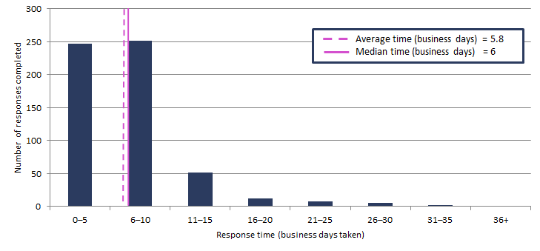

Requests by the PBO for information from agencies
Table 2: Information requests to agencies to 30 September 2016
 | 2012–13  Total | 2013–14  Total | 2014–15  Total | 2015–16  Total | 2016–17  Q1
Requests outstanding at start of period | – | 28 | 16 | 3 | 1
Requests sent in period | 360 | 388 | 203 | 743 | 36
Requests received in period | 332 | 400 | 216 | 745 | 30
Requests received by due date | 149 | 209 | 147 | 695 | 29
Requests received after due date | 183 | 191 | 69 | 50 | 1
Percentage late | 55.1 | 47.8 | 31.9 | 6.7 | 3.3
Average time taken to respond (business days) | 13.1 | 12.6 | 13.5 | 6.5 | 13.7
Average punctuality (business days late) | 3.0 | 5.3 | 2.9 | -1.3 | -2.5
Average lateness of late requests (business days) | 6.5 | 11.9 | 11.2 | 3.5 | 1.0
Requests outstanding at end of period | 28 | 16 | 3 | 1 | 7
As at 30 September 2016, no requests were overdue.
Figure 2: Agencies’ response times for completed information requests in 2016–17 to 30 September 2016
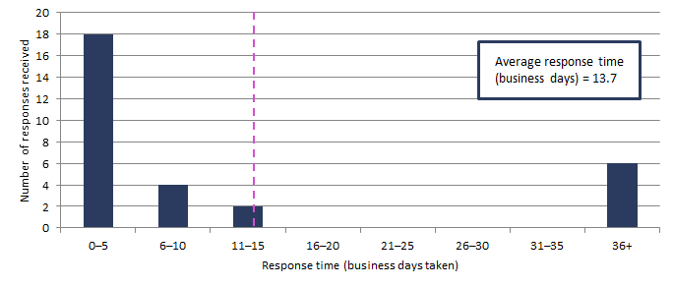
Figure 3: Timeliness of response by agencies to information requests in 2016–17 to 30 September 2016
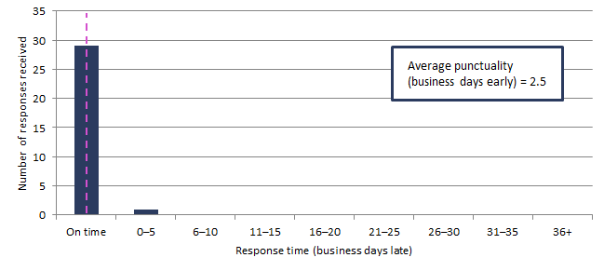
‘On time’ responses include responses provided before the due date.

Table 3: Information request responsiveness by agencies in 2016–17 to 30 September 2016
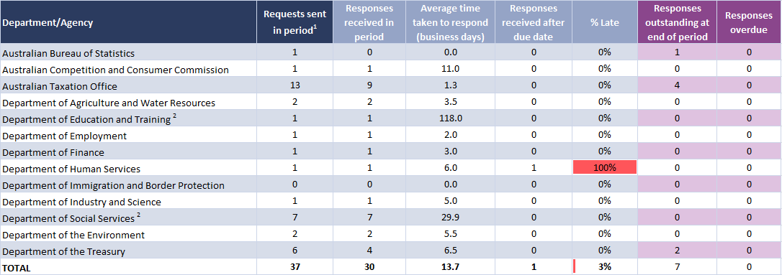
¹ Includes one outstanding request as at 30 June 2016 carried over to 2016–17.
² The timeframes for these agencies are affected by the provision of highly detailed microdata sets that require the agency providing the data to undertake data extraction, checking and cleansing work prior to provision of the requested information.

PBO staff by function and employment level
Table 4: PBO staff by function and employment level as at 30 September 2016
Classification | PBO Executive | Budget Analysis Division | Fiscal Policy Analysis Division | Corporate Strategy Branch | Total
Parliamentary Budget Officer (PBO) | 1 | – | – | – | 1
Senior Executive Service Band 2 (SES B2) | – | 1 | 1 | – | 2
Senior Executive Service Band 1 (SES B1) ¹ | – | 2 | 1 | 1 | 4
Parliamentary Executive Level 2 (PEL2) | – | 4 | 2 | 2 | 8
Parliamentary Executive Level 1 (PEL1) ¹ | – | 13 | 4 | 1 | 18
Parliamentary Service Level 6 (PSL6) | 1 | 7 | 1 | – | 9
Parliamentary Service Level 5 (PSL5) | – | – | – | 2 | 2
Parliamentary Service Level 4 (PSL4) | – | – | – | 1 | 1
Total staff ² | 2 | 27 | 9 | 7 | 45
¹ One ongoing SES B1 and two ongoing PEL1 employees are on long term leave without pay and are not included in these totals.
In addition, one PEL1employee is on secondment to the Australian Taxation Office and is not included in the above totals.
Figure 4: PBO staff by function and employment level as at 30 September 2016

