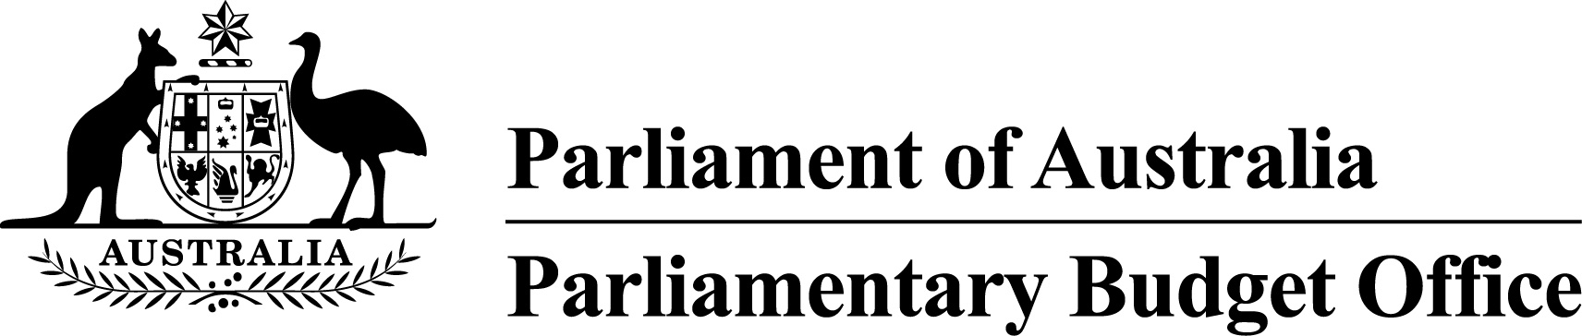

Report to the Senate Finance and   
Public Administration Legislation Committee on PBO activity

3 February 2016

Overview

The Parliamentary Budget Office (PBO) 2014–15 Annual Report was tabled on 14 October 2015. This activity report provides an update on PBO activities since July 2015.

Requests from parliamentarians and parliamentary parties

In the first half of 2015–16, the PBO responded to 802 requests from parliamentarians  
(2014–15 full year: 869 responses) at an average turnaround time of 16.6 business days and a median time to completion of 16.0 business days (refer to Table 1).

In the same period, the PBO received 216 responses from Commonwealth agencies to information requests at an average turnaround time of 6.8 business days and with an average punctuality of 1.0 business days early (refer to Table 2). Table 3 contains details of the responsiveness of Commonwealth agencies to information requests during the first half of 2015–16.

Submissions to parliamentary committees

During the reporting period, the PBO prepared two submissions in response to requests from parliamentary committees: on 17 September 2015, a submission to the House of Representatives Standing Committee on Tax and Revenue inquiry into the Tax Expenditures Statement; and on 21 January 2016, a submission to the House of Representatives Standing Committee on Economics inquiry into tax deductibility. The requests to make a submission and the PBO’s responses are published on the PBO website.

In addition, in December 2015, the Senate Select Committee on Health requested the PBO to make a submission in relation to Commonwealth funding of public hospitals. This submission will be completed in early February 2016.

Self-initiated research program

On 25 November 2015, the PBO released Report no. 04/2015 *Medicare Benefits Schedule – Spending trends and projections*. The report examined the main factors contributing to the growth in Medicare Benefits Schedule (MBS) spending over the past two decades and provided projections of MBS spending over the next decade based on current policy settings.

On 9 December 2015, the PBO released Report no. 05/2015 *Goods and Services Tax: Distributional analysis and indicative reform scenarios.* The report sought to inform public discussion on the potential for reform of Australia’s Goods and Services Tax by providing an independent analysis of the revenue and distributional impacts of five indicative reform scenarios.

On 13 January 2016, the PBO released the *2015–16 Mid-Year Economic and Fiscal Outlook – Charts* which provided a graphical summary of the 2015–16 MYEFO relative to the 2015–16 Budget. These charts continue the PBO practice of adding to the transparency of the budget by presenting the key changes to the budget outlook in a graphical form with minimal explanatory text.

On 3 February 2016, the PBO released an update of the *Unlegislated measures carried forward in the budget estimates*. The analysis provided an update of the projected impact of unlegislated measures on the current budget estimates and over the medium term.

On 3 February 2016, the PBO also released Report no. 01/2016 *National fiscal outlook: As at the 2015–16 mid-year fiscal updates*, which highlighted the changes in the fiscal balance and net debt since the release of the 2015–16 Commonwealth and state budgets.

Current work in progress includes analyses of: the costs and risks for the budget of the Higher Education Loan Programme, expected to be published in the first quarter of 2016; and medium-term budget projections and the sensitivity of projections to changes in economic parameters, expected to be released in the second quarter of 2016.

Capacity building and information management

We continue to acquire detailed datasets and develop models covering major demand driven expenditure programs and elements of the tax and transfer system to further improve the PBO’s responsiveness and the quality and reliability of our costings and budget analyses.

We are aiming to implement a new workflow management system around April 2016. Following a tender process, the PBO entered into a contract with Optus Networks Pty Limited in October 2015 for the supply of the system. The total cost payable to Optus for development, implementation and three years of maintenance and support is $0.455 million, including GST.

External engagement

The PBO continues to engage on a regular basis with government agencies, peer organisations, and international institutions and bodies.

The First Assistant Parliamentary Budget Officer, Budget Analysis Division, attended his final meeting as chair of the OECD Committee on Fiscal Affairs Working Party 2 on Tax Policy and Statistics held from 17 to 19 November 2015, and the associated Joint Meeting of Tax and Environment Experts on 20 November 2015.

PBO staffing

The PBO has a staffing establishment of approximately 40 positions and receives additional funding every third year in the lead up to a general election to boost its staffing. At 31 December 2015, the PBO had 43 staff (refer to Table 4) with further commencements to occur in February to support the anticipated increase in workload in 2016.

Requests from parliamentarians and parliamentary parties for costings and budget analyses

Table 1: Costing and budget analysis requests from parliamentarians and parliamentary parties to 31 December 2015

|  | **2012–13**  **Total** | **2013–14**  **Total** | **2014–15**  **Total** | 2015–16  Q1 | 2015–16  Q2 | **2015–16**  **Total** |
| --- | --- | --- | --- | --- | --- | --- |
| Requests outstanding at start of period | **–** | **463** | **76** | 138 | 165 | **138** |
| Requests received in period | **1,146** | **1,297** | **973** | 418 | 424 | **842** |
| Requests withdrawn in period | **19** | **162** | **42** | 25 | 28 | **53** |
| Requests completed in period | **664** | **1,522** | **869** | 366 | 436 | **802** |
| Average time to completion (business days) | **33.9** | **13.8** | **19.7** | 16.3 | 16.9 | **16.6** |
| Median time to completion (business days) | **n/a** | **6.0** | **12.0** | 14.0 | 16.0 | **16.0** |
| Requests outstanding at end of period | **463** | **76** | **138** | 165 | 125 | **125** |

Figure 1: PBO response times for completed requests in 2015–16 to 31 December 2015

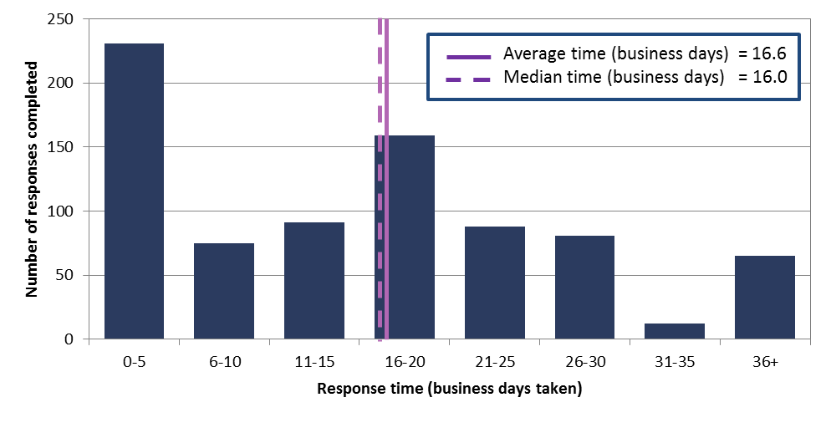

Requests by the PBO for information from agencies

Table 2: Information requests to agencies to 31 December 2015

|  |  |  |  |  |  |  |
| --- | --- | --- | --- | --- | --- | --- |
|  | **2012–13**  **Total** | **2013–14**  **Total** | **2014–15**  **Total** | 2015**–**16  Q11 | 2015–16  Q2 | **2015–16**  **Total** |
| Requests outstanding at start of period | **–** | **28** | **16** | 3 | 8 | **3** |
| Requests sent in period | **360** | **388** | **203** | 71 | 200 | **271** |
| Requests received in period | **332** | **400** | **216** | 66 | 150 | **216** |
| *Requests received by due date* | ***149*** | ***209*** | ***147*** | 59 | 142 | **201** |
| *Requests received after due date* | ***183*** | ***191*** | ***69*** | 7 | 8 | **15** |
| Percentage late | **55.1** | **47.8** | **31.9** | 10.6 | 5.3 | **6.9** |
| Average time taken to respond (business days) | **13.1** | **12.6** | **13.5** | 6.6 | 6.9 | **6.8** |
| Average punctuality (business days late) | **3.0** | **5.3** | **2.9** | -0.8 | -1.1 | **-1.0** |
| Average lateness of late requests (business days) | **6.5** | **11.9** | **11.2** | 2.4 | 8.5 | **5.7** |
| Requests outstanding at end of period | **28** | **16** | **3** | 8 | 58 | **58** |

1 Data has been updated following a review of the PBO’s records in consultation with agencies.

As at 31 December 2015, no requests were overdue.

Figure 2: Agencies’ response times for completed information requests in 2015–16 to 31 December 2015



Figure 3: Timeliness of response by agencies to information requests in 2015–16 to 31 December 2015

‘On time’ responses include responses provided before the due date.

Table 3: Information request responsiveness by agencies in 2015–16 to 31 December 2015



1 Includes three outstanding requests as at 30 June 2015 carried over to 2015–16.

PBO staff by function and employment level

Table 4: PBO staff by function and employment level as at 31 December 2015

|  |  |  |  |  |  |
| --- | --- | --- | --- | --- | --- |
| Classification | PBO Executive | Budget Analysis Division | Fiscal Policy Analysis Division | Corporate Strategy Branch | Total |
| Parliamentary Budget Officer (PBO) | 1 | – | – | – | **1** |
| Senior Executive Service Band 2 (SES B2) | – | 1 | 1 | – | **2** |
| Senior Executive Service Band 1 (SES B1) 1 | – | 2 | 1 | 1 | **4** |
| Parliamentary Executive Level 2 (PEL2) | – | 4 | 3 | 2 | **9** |
| Parliamentary Executive Level 1 (PEL1) 2 | – | 12 | 4 | 2 | **18** |
| Parliamentary Service Level 6 (PSL6) | 1 | 3 | 1 | – | **5** |
| Parliamentary Service Level 5 (PSL5) | – | 1 | – | 1 | **2** |
| Parliamentary Service Level 4 (PSL4) | – | 1 | – | 1 | **2** |
| Total staff | **2** | **24** | **10** | **7** | **43** |

1 One ongoing SES B1 officer is on long term leave without pay and is not included in these totals.  
2 One ongoing PEL1 officer is on long term leave without pay and is not included in these totals.

Figure 4: PBO staff by function and employment level as at 31 December 2015