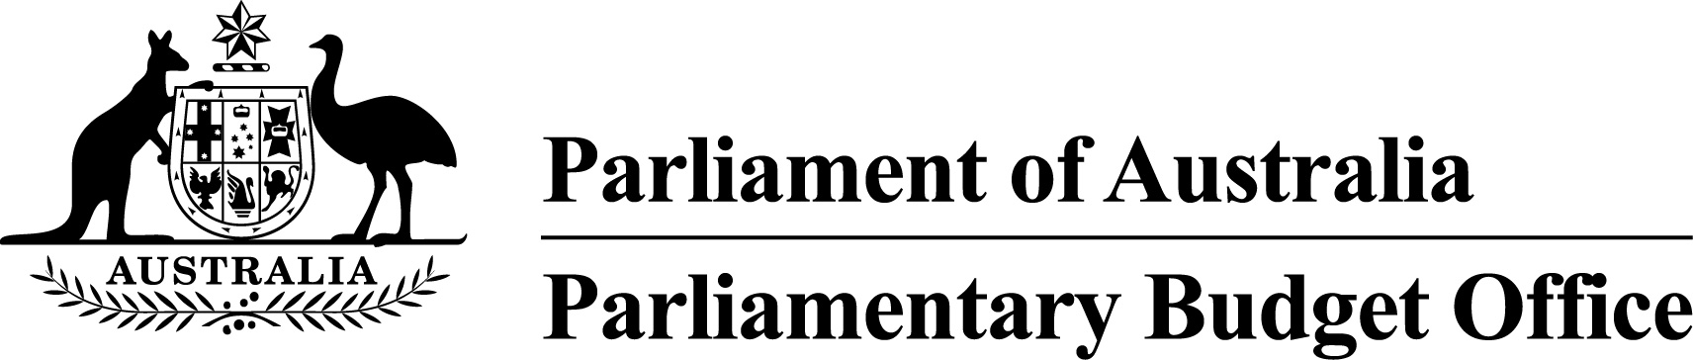

Report to the Senate Finance and   
Public Administration Legislation Committee on PBO activity

4 May 2016

Overview

This activity report provides an update on PBO activities since the last report to the Committee (3 February 2016).

Guidance to parliamentarians

On 21 April 2016, the PBO issued guidance 01/2016 to Senators and Members relating to policy costings in the 2016 election caretaker period. This guidance covers who can request costings during the caretaker period, what policies can be costed, how policies should be submitted for costing, consultation arrangements, timelines for preparing costings, costing methodology, how costings will be released and the treatment of requests submitted before the commencement of the caretaker period.

Requests from parliamentarians and parliamentary parties

For the 2015–16 year to 31 March 2016, the PBO responded to 1,534 requests from parliamentarians (2014–15 full year: 869 responses) at an average turnaround time of 20.3 business days and a median time to completion of 17.0 business days (refer to Table 1). This has been a record high level of activity for the PBO with a higher level of output in the first nine months of 2015–16 than in any of the previous three years of the PBO’s operations, including the lead up to the last election in 2013–14.

In the same period, the PBO received 371 responses from Commonwealth agencies to information requests at an average turnaround time of 8.3 business days and with an average punctuality of 0.6 business days early (refer to Table 2). Table 3 contains details of the responsiveness of Commonwealth agencies to information requests during 2015–16 to 31 March 2016.

Submissions to parliamentary committees

In December 2015, the Senate Select Committee on Health requested the PBO to make a submission in relation to Commonwealth funding of public hospitals. This submission was lodged on 3 February 2016.

Self-initiated research program

On 24 February 2016, the PBO released analysis of the *Impact of policy decisions and parameter variations on Australian Government revenue and spending estimates.* The analysis highlighted that external factors such as economic variables have been the main drivers of changes in revenue estimates whereas changes in spending estimates have been largely driven by policy decisions.

On 6 April 2016, the PBO released Report No. 02/2016 *Higher Education Loan Programme (HELP) – Impact on the Budget*. The report analysed the costs of HELP and projected the impact of the programme on the underlying cash balance to 2025–26.

The PBO released supplementary analysis of HELP on 20 April 2016 which provided the projected budget impacts of major policy decisions affecting HELP and of the related policy decision to reduce the level of subsidies provided to higher education institutions under the Commonwealth Grant Scheme.

Current work in progress includes medium-term budget projections and the sensitivity of projections to changes in economic parameters.

Capacity building and information management

The PBO continues to acquire detailed datasets and develop models covering major demand driven expenditure programs and elements of the tax and transfer system to further improve the PBO’s responsiveness and the quality and reliability of our costings and budget analyses.

The PBO is on schedule to implement a new workflow management system in the first week of May 2016 that will yield significant efficiency improvements in our work practices.

External engagement

The PBO continues to engage on a regular basis with government agencies, peer organisations, and international institutions and bodies.

The Parliamentary Budget Officer participated in the 8th Annual Meeting of OECD Parliamentary Budget Officials and Independent Fiscal Institutions on 11 – 12 April in Paris.

PBO staffing

The PBO has a staffing establishment of approximately 40 positions and receives additional funding every third year in the lead up to a general election to boost its staffing.

In the second half of 2015–16, the PBO recruited above its ongoing establishment to help ensure that it was adequately staffed in the lead up to the 2016 general election. At 31 March 2016, the PBO had 43 staff (refer to Table 4), with a further three staff on secondment from other Commonwealth agencies under the PBO’s secondment program and the 2016 Parliament of Australia graduate program.

By the end of 2015–16, the staffing level is expected to reach 51, including three secondees. During 2016–17, it is anticipated that the average staffing level will be approximately 45, returning to around 40 in 2017–18 with natural attrition.

On 10 March 2016, Phil Bowen was reappointed to the office of Parliamentary Budget Officer from 23 July 2016, for a term of one year.

.

Requests from parliamentarians and parliamentary parties for costings and budget analyses

Table 1: Costing and budget analysis requests from parliamentarians and parliamentary parties to 31 March 2016

|  | **2012–13**  **Total** | **2013–14**  **Total** | **2014–15**  **Total** | 2015–16  Q1 | 2015–16  Q2 | 2015–16  Q3 | **2015–16**  **Total** |
| --- | --- | --- | --- | --- | --- | --- | --- |
| Requests outstanding at start of period | **–** | **463** | **76** | 138 | 165 | 125 | **138** |
| Requests received in period | **1,146** | **1,297** | **973** | 418 | 424 | 1023 | **1,865** |
| Requests withdrawn in period | **19** | **162** | **42** | 25 | 28 | 34 | **87** |
| Requests completed in period | **664** | **1,522** | **869** | 366 | 436 | 732 | **1534** |
| Average time to completion (business days) | **33.9** | **13.8** | **19.7** | 16.3 | 16.9 | 24.4 | 20.3 |
| Median time to completion (business days) | **n/a** | **6.0** | **12.0** | 14.0 | 16.0 | 21.0 | **17.0** |
| Requests outstanding at end of period | **463** | **76** | **138** | 165 | 125 | 382 | **382** |

Figure 1: PBO response times for completed requests in 2015–16 to 31 March 2016

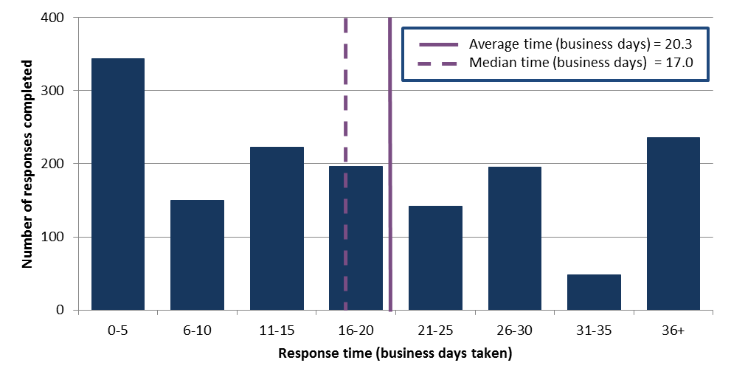

Requests by the PBO for information from agencies

Table 2: Information requests to agencies to 31 March 2016

|  |  |  |  |  |  |  |  |
| --- | --- | --- | --- | --- | --- | --- | --- |
|  | **2012–13**  **Total** | **2013–14**  **Total** | **2014–15**  **Total** | 2015**–**16  Q11 | 2015–16  Q2 | 2015–16  Q3 | **2015–16**  **Total** |
| Requests outstanding at start of period | **–** | **28** | **16** | 3 | 8 | 58 | **3** |
| Requests sent in period | **360** | **388** | **203** | 71 | 200 | 110 | **381** |
| Requests received in period | **332** | **400** | **216** | 66 | 150 | 155 | **371** |
| *Requests received by due date* | ***149*** | ***209*** | ***147*** | 59 | 142 | 139 | **340** |
| *Requests received after due date* | ***183*** | ***191*** | ***69*** | 7 | 8 | 16 | **31** |
| Percentage late | **55.1** | **47.8** | **31.9** | 10.6 | 5.3 | 10.3 | **8.4** |
| Average time taken to respond (business days) | **13.1** | **12.6** | **13.5** | 6.6 | 6.9 | 10.4 | **8.3** |
| Average punctuality (business days late) | **3.0** | **5.3** | **2.9** | -0.8 | -1.1 | -0.1 | **-0.6** |
| Average lateness of late requests (business days) | **6.5** | **11.9** | **11.2** | 2.4 | 8.5 | 3.6 | **4.6** |
| Requests outstanding at end of period | **28** | **16** | **3** | 8 | 58 | 13 | **13** |

1 Data has been updated following a review of the PBO’s records in consultation with agencies.

As at 31 March 2016, no requests were overdue.

Figure 2: Agencies’ response times for completed information requests in 2015–16 to 31 March 2016



Figure 3: Timeliness of response by agencies to information requests in 2015–16 to 31 March 2016

‘On time’ responses include responses provided before the due date.

Table 3: Information request responsiveness by agencies in 2015–16 to 31 March 2016



1 Includes three outstanding requests as at 30 June 2015 carried over to 2015–16.

PBO staff by function and employment level

Table 4: PBO staff by function and employment level as at 31 March 2016

|  |  |  |  |  |  |
| --- | --- | --- | --- | --- | --- |
| Classification | PBO Executive | Budget Analysis Division | Fiscal Policy Analysis Division | Corporate Strategy Branch | Total |
| Parliamentary Budget Officer (PBO) | 1 | – | – | – | **1** |
| Senior Executive Service Band 2 (SES B2) | – | 1 | 1 | – | **2** |
| Senior Executive Service Band 1 (SES B1) 1 | – | 2 | 1 | 1 | **4** |
| Parliamentary Executive Level 2 (PEL2) | – | 4 | 2 | 2 | **9** |
| Parliamentary Executive Level 1 (PEL1) 1 | – | 12 | 4 | 1 | **18** |
| Parliamentary Service Level 6 (PSL6) | 1 | 5 | 1 | – | **5** |
| Parliamentary Service Level 5 (PSL5) | – | 1 | – | 2 | **2** |
| Parliamentary Service Level 4 (PSL4) | – | – | – | 1 | **2** |
| Total staff 2 | **2** | **25** | **9** | **7** | **43** |

1 One ongoing SES B1 and one ongoing PEL1 officers are on long term leave without pay and are not included in these totals.  
2 In addition to the above, as at 31 March, the PBO had one Australian Public Service Level 6 employee on secondment from the Australian Taxation Office and two graduates on secondment from other Commonwealth agencies under the 2016 Parliament of Australia graduate program.

Figure 4: PBO staff by function and employment level as at 31 March 2016

