**16 March 2021**

Parliamentary Budget Office activity report

# Overview

This activity report provides an update on Parliamentary Budget Office (PBO) activities since the last activity report of 15 October 2020.

## Requests from parliamentarians and parliamentary parties

Demand for costings and budget analysis accelerated in the three months to 31 December 2020. During this time, the PBO received 388 requests for policy costings and requests for budget analysis; a marked increase compared with the 231 requests received in the first quarter of 2020-21. In the second quarter of 2020-21, the PBO responded to 188 requests, at an average turnaround time of 25 business days and a median time to completion of 20 business days (refer to Table 1). We are working on reducing the average and median time to completion.

During the three months to 31 December 2020, we received 186 responses from Commonwealth agencies to our information requests, at an average turnaround time of eight business days (refer to Table 2). Only two responses were received late. Table 3 contains details of the responsiveness of Commonwealth agencies to information requests during this period.

In the period since the last activity report, one policy costing and one budget analysis have been publicly released. These are available on the PBO website (refer to Table 4).

## Evaluations

In adopting Recommendation 7 of the Joint Committee of Public Accounts and Audit (JCPAA)’s *2016‑17 Independent review of the PBO*, the PBO now periodically conducts evaluations of a limited selection of its policy costing estimates, to help identify areas for improvement in future costings.

So far we have completed a total of 13 evaluations (five in the last six months) which cover a broad range of topics including: education, goods and services tax, child care, humanitarian migration, personal income tax, corporate tax, tax deductions and health. These evaluations are focused on the models, methods and assumptions that we expect to be drawn upon heavily in the lead up to the next election. The 13 completed evaluations have resulted in 33 recommendations, of which 23 have been implemented.

An update on evaluations will become a regular feature in the PBO’s activity report.

## Research program

Our research program has delivered the PBO’s planned regular products which had been delayed because of the deferral of the 2020-21 Budget.

* The *2020-21 Medium-term fiscal projections* was published on 10 December 2020.
* The *2020-21 Mid-Year Economic and Fiscal Outlook Snapshot* was published on 18 December 2020.
* The *2020-21 Budget Chart Pack* was published on 12 February 2021.
* The *National Fiscal Outlook* was published on 4 March 2021, based on Commonwealth and State governments’ 2020-21 mid-year updates, including a report, an ‘At a Glance’ summary page, and a technical appendix.

Two editions of *Government Finances* were published, for the September quarter (11 November 2020) and for the December quarter (11 February 2021).

The PBO Data Portal is being used to publish data related to our publications in a single place. Data is also available on the data.gov.au website.

Research is underway on fiscal sustainability and the government’s balance sheet, which will build on our medium-term projections methodology and analysis.

The PBO’s research program is set out in the 2020-21 Corporate Plan. We retain flexibility within our research program to add additional research topics to our work program over the course of the year, including in response to emerging issues.

## Online resources

On 16 October 2020 we released our online Public Debt Interest (PDI) Calculator. The PDI Calculator estimates the costs of servicing debt associated with hypothetical changes in the amount of Commonwealth Government borrowing compared to a baseline level of Commonwealth Government borrowing. The PDI Calculator is an exciting advancement for the PBO in presenting information in an interactive way, allowing interested parties to estimate the likely borrowing costs associated with a specific policy.

## External engagement

The PBO continues to seek input from our expert panel and external stakeholders to assist with the development and evaluation of its work program and methodologies, improve the quality of our analysis, and to review pieces of work before publication.

## Staffing

As at 17 February 2021, the PBO had 42 staff (headcount) and an average staffing level (ASL) of 40. This is below our projected 2020–21 ASL of 44. COVID-19 exacerbated the recruitment delay to fill vacant positions in the 2020 calendar year. Significant recruitment activity is underway to increase our ASL to projected levels by the end of this financial year.

We are continuing to participate in the Parliament of Australia graduate program. Eleven graduates from the 2021 program and two graduates from the 2020 (deferred due to COVID-19) are joining the PBO for periods of three to six months over the course of the year.

# Requests from parliamentarians and parliamentary parties for costings and budget analyses

Table 1: Completion of costing and budget analysis requests

|  | 2016–17  Total | 2017–18  Total | 2018–19  Total | 2019–20 Total | 2020–21  Q1 | 2020–21  Q2 | 2020–21  Total |
| --- | --- | --- | --- | --- | --- | --- | --- |
| Requests completed in period | 1,888 | 1,560 | 2,970* | 279 | 115 | 188 | 303 |
| Average time to completion (business days) | 20 | 20 | 18 | 27 | 20 | 25 | 23 |
| Median time to completion (business days) | 12 | 15 | 12 | 25 | 19 | 20 | 20 |

* Includes 429 costings and budget analyses prepared for the purpose of the election commitment report.

Note: The table identifies the number of ‘options’ received by the PBO, noting that a single request can contain multiple options.

Figure 1: PBO response times for completed requests in 2020–21 to 31 December 2020

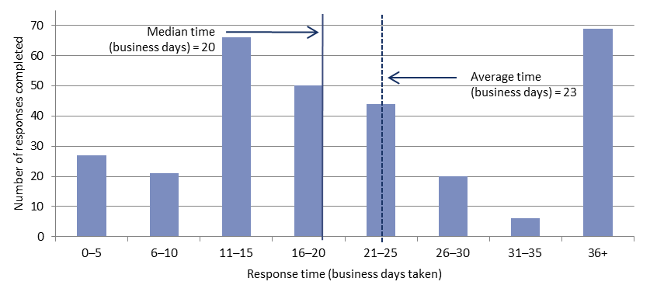

# Requests by the PBO for information from agencies

Table 2: Responses to PBO information requests

|  |  |  |  |  |  |  |  |
| --- | --- | --- | --- | --- | --- | --- | --- |
|  | 2016–17  Total | 2017–18  Total | 2018–19  Total | 2019–20  Total | 2020–21  Q1 | 2020–21  Q2 | 2020–21  Total |
| Responses received in period | 508 | 429 | 549 | 175 | 119 | 186 | 305 |
| Percentage received on time (%) | 98 | 99 | 98 | 99 | 99 | 99 | 99 |
| Average response time (business days) | 8 | 9 | 7 | 12 | 10 | 8 | 9 |

As at 31 December 2020, there was two overdue responses to requests for information.

Table 3: Information request responsiveness by agencies in 2020–21 to 31 December 2020



Table 4: Announcements by parliamentarians that referenced PBO costings or budget analysis —   
in the period since the activity report of 15 October 2020

| Description of policy  announcement | Party or Parliamentarian announcing policy | Method of Announcement | Date of announcement | Date of release  of costing minute |
| --- | --- | --- | --- | --- |
| Loss of public revenue and a distributional analysis of the tax cuts packages | Australian Greens | Media article | 14/11/2020 | 17/11/2020 - Costing posted on PBO website |
| Australian Federal Integrity Commission and Commonwealth Parliamentary Standards Commissioner | Dr Helen Haines MP | Speech | 16/10/2020 | 16/10/2020 - Costing posted on PBO website |