**16 October 2019**

Parliamentary Budget Office activity report

# Overview

The Parliamentary Budget Office (PBO) 2018–19 annual report was tabled on 14 October 2019 and contains details of PBO activity during 2018–19.

The PBO published its 2019–20 corporate plan on 20 September 2019, following consultation with the Joint Committee of Public Accounts and Audit.

This activity report provides an update on PBO activities since the activity report of 5 April 2019.

## Election commitment report

On 19 June 2019, the PBO published the 2019 Post-election report of election commitments, detailing and aggregating the budget impacts of the election commitments made by the major political parties. The report includes the commitments of the Coalition, the Australian Labor Party and the Australian Greens. The impacts provided in the report were estimated using the budget baselines from the 2019 Pre-election Economic and Fiscal Outlook, as this was the most recent budget update before the election.

For the first time, we invited parliamentary parties with fewer than five members and independent parliamentarians to be included in the election commitment report. No minor parties or independent parliamentarians opted to be included on this occasion.

Publication of the election commitment report is the culmination of a significant amount of policy costing work undertaken in the months ahead of the election, and particularly in the lead-up to  
non-government parties announcing election commitments.

We significantly improved our communication to the public around this report. The most significant of these improvements was our website, where we built a set of pages to support the election period and provided additional detail about our role and requirements before and after the election. We also implemented a new search tool, where each election commitment costing is separately listed, and can be searched and accessed. This is much more accessible than the consolidated document of commitments we have provided in the past and is part of our ongoing drive to enhance transparency.

## Requests from parliamentarians and parliamentary parties

The general election on 18 May 2019 had a major influence on our policy costing and budget analysis work during 2018–19. We experienced a surge in demand for costings as parties finalised their election platforms and requested updated costings following the release of budget updates. For the full 2018–19 year we responded to 2,970 requests, almost twice the number we delivered in the previous year (refer to Table 1).

Since the election, the demand for policy costings has eased considerably. In the first three months of 2019–20 to 30 September 2019, the PBO received 91 requests from parliamentarians for policy costings and analysis and responded to 49 requests at an average turnaround time of 19 business days and a median time to completion of 23 business days. Response times increased in this first quarter due to the complexity of some requests.

The PBO makes information requests to Commonwealth agencies to support its responses to parliamentarians (and its research program). During 2018–19, the PBO received 549 responses from Commonwealth agencies (refer to Table 2). The strong support we are provided is reflected by the fact that 98 per cent of responses to requests for information were returned within the timeframe we requested. In the three months to 30 September 2019, the PBO received 24 responses from Commonwealth agencies to information requests at an average turnaround time of nine business days. Requests were provided, on average, three business days ahead of the due date. Table 3 contains details of the responsiveness of Commonwealth agencies to information requests in the period 1 July to 30 September 2019.

Since the activity report of 5 April 2019, four policy announcements that were made by parliamentarians or parliamentary parties included references to PBO policy costings. Three of these costings were subsequently released (refer to Table 4).

## Research program

The PBO’s research program is set out in the 2019–20 corporate plan.

* On 26 September 2019 the PBO released its regular *Medium-term fiscal projections* publication*.* The report provides detailed analysis and projections of receipts and payments over the next decade to highlight the factors that explain the underlying cash balance and net debt projections.
* Work is underway on the PBO’s regular *National Fiscal Outlook* publication, which we expect to release before the end of 2019.
* Good progress has been made on other reports, including one examining the budget impact of alternative financing mechanisms such as concessional loans and equity injections, and another on how observed trends in recipients could affect expenditure projections for the Newstart allowance. We intend to publish both of these papers prior to the 2020–21 Budget.

## External engagement

The PBO continues to seek high-level advice across all aspects of our work from our panel of expert advisors. Our second annual meeting was held on 26 July 2019 and we engage with members out of session as required, throughout the year.

The findings of the 2019 election commitment report have been presented to a number of Commonwealth agencies, and we expanded consultation on our 2019–20 research program to a wider number and range of organisations including government agencies, public policy research organisations and commercial banks.

At the request of the New Zealand government, the Parliamentary Budget Officer visited New Zealand to meet with members of parliament and government officials to share our experience of establishing a parliamentary budget office, and on our costings and budget analysis activities.

## Staffing

The PBO employed several strategies to allow us to meet the heightened level of demand for costings and election related work encountered during the 2018–19 year.

* We re-balanced our internal resourcing to focus more on our costing and budget analysis work, with an associated reduction in our research activity.
* We engaged in secondment agreements with other Commonwealth agencies and parliamentary departments to temporarily increase our resourcing and access highly-skilled staff with relevant experience in costings, election monitoring and report drafting.
* We expanded our participation in the Parliament of Australia graduate program by increasing the number of graduate placements we provided and increasing the length of these placements.

During the election period, the staffing level in the PBO peaked at a headcount of 56, which included eight secondees and five graduates from other parliamentary departments and Commonwealth agencies. During 2018, seven graduates joined the PBO for periods up to six months.

As at 30 September 2019 the PBO had 42 staff.

# Requests from parliamentarians and parliamentary parties for costings and budget analysis

Table 1: Completion of costing and budget analysis requests

|  | 2015–16  Total | 2016–17  Total | 2017–18  Total | 2018–19  Total | 2019–20  Q1 |
| --- | --- | --- | --- | --- | --- |
| Requests completed in period | 3,251 | 1,888 | 1,560 | 2,970* | 49 |
| Average time to completion (business days) | 19 | 20 | 20 | 18 | 19 |
| Median time to completion (business days) | 16 | 12 | 15 | 12 | 23 |

* includes 429 costings and budget analyses prepared for the purpose of the election commitment report

**Note**: The table identifies the number of ‘options’ contained in requests completed by the PBO, noting that a single request can contain multiple options.

Figure 1: PBO response times for completed requests in 2018–19

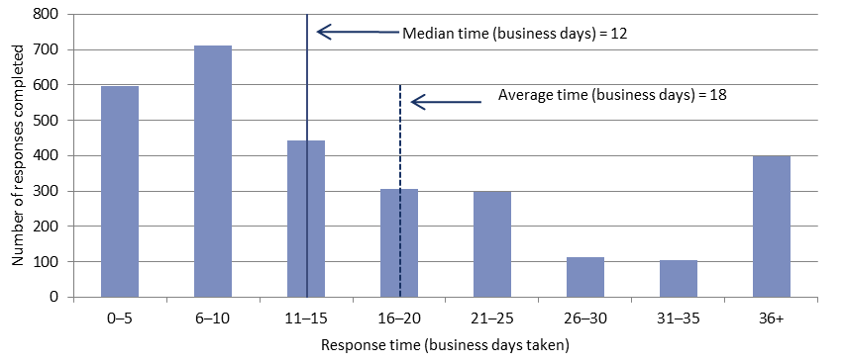

Figure 2: PBO response times for completed requests in the first quarter, 2019–20

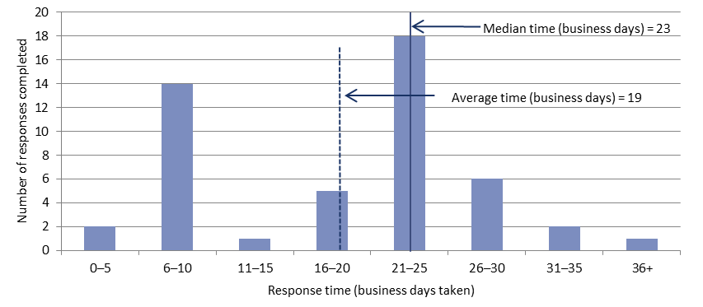

# Requests for information from agencies

Table 2: Information requests to agencies

|  |  |  |  |  |  |
| --- | --- | --- | --- | --- | --- |
|  | 2015–16  Total | 2016–17  Total | 2017–18  Total | 2018–19  Total | 2019–20  Q1 |
| Responses received in period | 745 | 508 | 429 | 549 | 24 |
| Percentage received on time (%) | 93 | 98 | 99 | 98 | 100 |
| Average response time (business days) | 7 | 8 | 9 | 7 | 9 |

As at 30 September 2019, there were no overdue responses to a request for information.

Table 3: Information request responsiveness by agencies – 1 July to 30 September 2019



Table 4: Policy announcements with reference to PBO costings —   
in the period since the activity report of 5 April 2019   
(excluding costings of publicly announced election policies included in the election commitment report)

|  |  |  |  |  |
| --- | --- | --- | --- | --- |
| Description of policy  announcement | Party or parliamentarian announcing policy | Method of announcement | Date of announcement | Date of release  of costing minute |
|  |  |  |  |  |
| Business investment tax concessions | Not stated | Media article | 14/05/2019 | Costing minute not released |
| Tax cuts package | Australian Greens | Media article | 28/06/2019 | 28/06/2019 – Costing posted on PBO website |
| Personal income tax plan | Australian Labor Party | Media article | 05/07/2019 | 28/06/2019 – Costing posted on PBO website |
| Common group insurance | Australian Greens | Media article | 25/07/2019 | 17/09/2019 – Costing posted on PBO website |

Note: The table excludes any costings that were part of the 2019 election commitment report.