**15 October 2020**

Parliamentary Budget Office activity report

# Overview

The Parliamentary Budget Office (PBO) 2019–20 annual report was tabled on 13 October 2020 and contains details of PBO activity during 2019–20.

The PBO published its 2020–21 corporate plan on 16 September 2020, following consultation with the Joint Committee of Public Accounts and Audit.

This activity report provides an update on PBO activities since the last activity report of 21 May 2020.

## Requests from parliamentarians and parliamentary parties

In the three months to 30 September 2020, the PBO received 231 requests for policy costings and analysis and responded to 115 requests, at an average turnaround time of 20 business days and a median time to completion of 19 business days (refer to Table 1). Efforts were made to meet any critical dates where these were advised. There has been a strong uptick in demand for costings and budget analysis over this period relative to 2019–20, during which there was a total of 279 requests.

On 10 August 2020 we released *Guidance on requests for budget analysis against COVID-19 medium term fiscal scenarios.* This guidance note advised parliamentarians that they could seek budget analysis using a medium-term scenario that took account of the impact of COVID-19 on their policy proposals. This was particularly relevant for parliamentarians in the period leading up to the 2020–21 Budget, due to the high degree of uncertainty associated with costings as a result of the outdated budget baseline.

In the three months to 30 September 2020, we received 119 responses from Commonwealth agencies to our information requests, at an average turnaround time of 10 business days (refer to Table 2). Only one response was received late. Table 3 contains details of the responsiveness of Commonwealth agencies to information requests during this period.

In the period since the last activity report, there have been three policy costings and one budget analysis that have been publicly released. These are available on the PBO website (refer to Table 4).

## Research program

Since the emergence of the COVID‑19 health and economic crisis, our research program has prioritised work designed to inform the Parliament and the public about the fiscal impacts of the pandemic.

The PBO’s 2020–21 research program was set out in the 2020–21 corporate plan. It includes both shorter pieces and explainers to support parliamentary considerations in the near term, and larger research reports relevant to the medium-term fiscal implications of the economic response to COVID-19.

The PBO has released eight research publications and three research tools since our last activity report in May.

* On 5 June 2020 we released the research paper *Medium-term fiscal projection scenarios: impact of COVID‑19 pandemic and response*. To provide timely information on the rapidly evolving fiscal situation and support an understanding of the magnitude of the impact of COVID-19 on key fiscal aggregates, the PBO developed and published medium-term fiscal scenarios based on the Reserve Bank of Australia's May economic forecasts. An updated version using the RBA’s August forecasts was published on 21 August.
* On 9 June and 8 July 2020, we released the *Government finances* snapshots for April and May. These were the second and third in a series of short monthly publications designed to track the effect of COVID‑19 and the associated policy response on the Commonwealth’s fiscal position, using information from the government’s monthly financial statements*.* As is typical, monthly financial information for June was included in the Final Budget Outcome published in September and we plan to continue with these snapshots after July and August data are available.
* In addition to research publications we have been producing research tools for our website. In June we released two tools: the first version of our Online budget glossary, which explains 63 key terms related to the Commonwealth Government budget in a non‑technical way, and an online data portal to consolidate the data published with each PBO report. In August we published an online search function for the behavioural assumptions used in PBO costings. An online public debt interest calculator will be released shortly.
* On 4 September 2020 we released the research report *Structural trends in GST*. This report examines the trends in GST relative to the size of the economy over the last twenty years, including the impact of demographic change, and possible trajectories for future GST collections.
* On 30 September 2020 we released the research report *JobSeeker Payment: understanding economic and policy trends affecting Commonwealth expenditure.* This report examines historical trends in JobSeeker payment expenditure and recipient demographics, the drivers of these trends, and the implications for expenditure on the JobSeeker payment over the medium term.
* Graphical A3 summaries of the July 2020 Economic and Fiscal Update and the 2020–21 Budget were published on 24 July and 7 October, respectively.

Our research publications continue to be positively received, with strong media coverage.

Given the heightened interest in fiscal sustainability, we plan to release a research paper later this year outlining what fiscal sustainability is and providing a framework for assessing the sustainability of the fiscal position. Other items from the 2020–21 corporate plan that are due for release in the coming months include the 2020–21 Budget chart pack, medium‑term projections report and national fiscal outlook report and snapshot.

## External engagement

With the health situation improving, we will seek opportunities to speak about our work at in‑person events and we are continuing to use other channels for disseminating our research, such as collaborating with other organisations on fact sheets and blog posts.

We continue to engage with external stakeholders to improve the quality of our analysis and research and present the findings of our work to interested audiences. In particular, we continue to seek high-level advice across all aspects of our work from our panel of expert advisors. The third annual meeting of the panel of expert advisors was held on 20 July, and engagement with members continues regularly out-of-session throughout the year.

We have also entered into a number of staff secondment arrangements with government agencies throughout this non-election year to boost the capabilities of staff and enhance relationships with these agencies.

## Staffing

As at 30 September 2020 the PBO had 39 staff (headcount) and average staffing level (ASL) of 37. This is well below our 2019–20 estimated ASL of 44. COVID-19 significantly exacerbated the recruitment delay to fill vacant positions, resulting in this reduced staffing profile. Significant recruitment activity has recently been completed. We are in the process of on-boarding new staff and anticipate our ASL will increase to budgeted levels by the end of the year.

We are continuing to participate in the Parliament of Australia graduate program, however the timing of graduates joining us in 2020 has been impacted by Australian Public Service agencies retaining their graduates to support the delivery of their essential services, and restrictions on graduates being able to travel interstate.

Six graduates have joined the PBO in 2020 to-date, with one returning to their home agency early to support the delivery of essential services. We anticipate the remaining four graduates will be joining the PBO for periods of three to six months in early 2021 dependent upon any travel restrictions.

# Requests from parliamentarians and parliamentary parties for costings and budget analysis

Table 1: Completion of costing and budget analysis requests

|  | 2016–17  Total | 2017–18  Total | 2018–19  Total | 2019–20  Total | 2020–21  Q1 |
| --- | --- | --- | --- | --- | --- |
| Requests completed in period | 1,888 | 1,560 | 2,970* | 279 | 115 |
| Average time to completion (business days) | 20 | 20 | 18 | 27 | 20 |
| Median time to completion (business days) | 12 | 15 | 12 | 25 | 19 |

* Includes 429 costings and budget analyses prepared for the purpose of the election commitment report.

**Note**: The table identifies the number of ‘options’ contained in requests completed by the PBO, noting that a single request can contain multiple options.

Figure 1: PBO response times for completed requests in 2020–21 to 30 September 2020

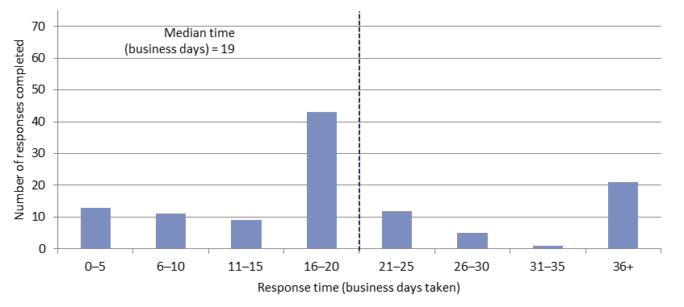

Average time   
(business days) = 20

# Responses from agencies to PBO requests for information

Table 2: Responses to PBO information requests

|  |  |  |  |  |  |
| --- | --- | --- | --- | --- | --- |
|  | 2016–17  Total | 2017–18  Total | 2018–19  Total | 2019–20  Total | 2020–21  Total |
| Responses received in period | 508 | 429 | 549 | 175 | 119 |
| Percentage received on time (%) | 98 | 99 | 98 | 99 | 99 |
| Average response time (business days) | 8 | 9 | 7 | 12 | 10 |

As at 30 September 2020, there was one overdue response to a request for information.

Table 3: Information request responsiveness by agencies – 2020–21 to 30 September 2020



**Note:** The Department/Agency column lists all entities that have provided responses to information requests. These can include previous departments or agencies that have been the subject of a Machinery of Government change.

Table 4: Announcements by parliamentarians that referenced PBO costings or budget analysis —   
in the period since the activity report of 21 May 2020

|  |  |  |  |  |
| --- | --- | --- | --- | --- |
| **Description of announcement** | Party or parliamentarian announcing | Method of announcement | Date of announcement | Date of release of PBO advice |
| Impact of accelerating Stage 2 personal income tax cuts | Australian Greens | Media article | 9/09/2020 | 18/09/2020 – Costing posted on PBO website |
| Servicing public debt | Australian Greens | Media article | 9/09/2020 | 18/09/2020 – Costing posted on PBO website |
| Establish the Australian Local Power Agency | Dr Helen Haines MP | Media article | 23/09/2020 | 23/09/2020 – Costing posted on PBO website |
| Coalition parties’ election commitments (Indi) 2019 | Dr Helen Haines MP | Media article | 2/10/2020 | 2/10/2020 – Budget analysis released with media article  9/10/2020 – Budget analysis posted on PBO website |