**5 April 2019**

Parliamentary Budget Office activity report

# Overview

This activity report provides an update on PBO activities since the last report dated 13 February 2019.

## Requests from parliamentarians and parliamentary parties

In the nine months to 31 March 2019, the PBO received 1,663 requests from parliamentarians for policy costings and analyses and responded to 1,547 requests at an average turnaround time of 26 business days and a median time to completion of 19 business days (refer to Table 1). The longer completion times than in previous periods reflected the volume of requests submitted to the PBO since the Budget in May 2018.

The PBO makes information requests to Commonwealth agencies to support its responses to parliamentarians (and its research program). In the nine months to 31 March 2019, the PBO received 305 responses from Commonwealth agencies to information requests at an average turnaround time of nine business days. Requests were provided, on average, three business days ahead of the due date (refer to Table 2). Table 3 contains details of the responsiveness of Commonwealth agencies to information requests during this period.

In the period since the last activity report, six policy announcements that were made by parliamentarians or parliamentary parties included references to PBO policy costings. None of these costings were subsequently publicly released (refer to Table 4).

## Research program

The PBO’s research program is set out in the 2018–19 corporate plan. Two research papers on fiscal policy matters have been released since February:

* On 14 March 2019, the PBO released a report *Net debt and investment funds – Trends and balance sheet implications*, which examines the impact of growth in government investment funds on net debt.
* On 1 April 2019, the PBO released a report titled *Australia's ageing population - Understanding the fiscal impacts over the next decade,* which builds on the 2015 Intergenerational Report by providing a detailed analysis of the impacts of an ageing population on revenue and spending over the next decade.

On 3 April 2019, the PBO released a graphical snapshot of the key information in the 2019–20 Budget. The snapshot presents key budget information in an accessible form with the aim of improving public understanding of budget issues.

In addition to these, the PBO released a publication on 21 March 2019 titled *Unlegislated measures carried forward in the budget estimates— March 2019*, which provides updated estimates of the medium-term impact on the Commonwealth budget of measures with significant financial implications that have been announced but are yet to be implemented.

In terms of future research, good progress has been made on reports examining alternative financing mechanisms and expenditure on the Newstart allowance. The PBO intends to publish these in 2019.

In advance of the next election, the PBO will also release a guidance note on how it will engage with parliamentary parties to produce its post-election report of election commitments.

## External engagement

The PBO continues to seek input from its panel of expert advisors to assist with elements of its work program.

The PBO continues to work with Commonwealth agencies to arrange access to electronic data warehouses, where possible. This ongoing access reduces the time it takes to respond to parliamentarian requests and reduces the ongoing burden on agencies in responding to individual requests for information.

## Staffing

As at 31 March 2019, the PBO had 48 staff, including six people on secondment from other Commonwealth agencies. This is an increase in staffing levels compared with previous periods. The PBO has undertaken recruitment and secondment activities to ensure it has sufficient staff to manage the increased demand for its costing services during the forthcoming election period. The PBO receives additional funding every third year in the lead up to a general election to boost its staffing.

The PBO is continuing to participate in the Parliament of Australia graduate program. Five graduates have joined the PBO during 2019.

## Resourcing

In the 2019–20 Budget, the PBO has been provided with additional resourcing of $5.3 million over four years and ongoing funding of $2.0 million a year from 2023–24. This resourcing enables the PBO to maintain the level of modelling and analysis services it provides and includes additional funding for staffing, consultancies and data purchases. Receiving this funding in 2019–20 enables the PBO to retain its special appropriation balance, to be able to respond flexibly to changes in demand throughout the election cycle.

# Requests from parliamentarians and parliamentary parties for costings and budget analyses

Table 1: Costing and budget analysis requests from parliamentarians and parliamentary parties to   
31 March 2019

|  | 2014–15  Total | 2015–16  Total | 2016–17  Total | 2017–18  Total | 2018–19  Q1 | 2018–19  Q2 | 2018–19  Q3 | 2018–19  Total |
| --- | --- | --- | --- | --- | --- | --- | --- | --- |
| Requests outstanding at start of period | 76 | 138 | 20 | 180 | 586 | 336 | 149 | 586 |
| Requests received in period | 973 | 4,146 | 2,572 | 2,218 | 438 | 296 | 929 | 1,663 |
| Requests withdrawn in period | 42 | 1,013 | 524 | 252 | 51 | 146 | 123 | 320 |
| Requests completed in period | 869 | 3,251 | 1,888 | 1,560 | 637 | 337 | 573 | 1,547 |
| Average time to completion (business days) | 20 | 19 | 20 | 20 | 29 | 24 | 23 | 26 |
| Median time to completion (business days) | 12 | 16 | 12 | 15 | 25 | 13 | 19 | 19 |
| Requests outstanding at end of period | 138 | 20 | 180 | 586 | 336 | 149 | 382 | 382 |

Note: The table identifies the number of ‘options’ received by the PBO, noting that a single request can contain multiple options.

Figure 1: PBO response times for completed requests in 2018–19 to 31 March 2019

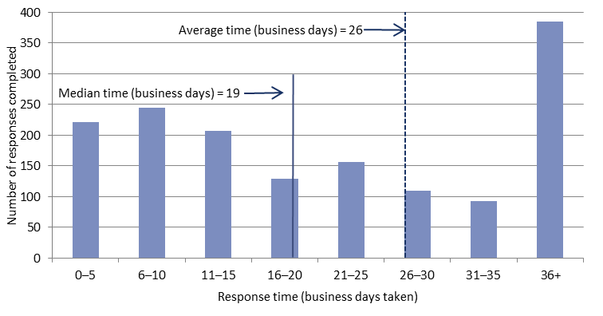

# Requests by the PBO for information from agencies

Table 2: Information requests to agencies to 31 March 2019

|  |  |  |  |  |  |  |  |  |
| --- | --- | --- | --- | --- | --- | --- | --- | --- |
|  | 2014–15  Total | 2015–16  Total | 2016–17  Total | 2017–18  Total | 2018–19  Q1 | 2018–19  Q2 | 2018–19  Q3 | 2018–19  Total |
|  |  |  |  |  |  |  |  |  |
| Responses outstanding at start of period | 16 | 3 | 1 | 16 | 11 | 9 | 83 | 11 |
| Requests sent in period | 203 | 743 | 523 | 424 | 82 | 159 | 66 | 307 |
| Responses received in period | 216 | 745 | 508 | 429 | 84 | 85 | 136 | 305 |
| Responses received by due date | 147 | 695 | 499 | 425 | 80 | 83 | 135 | 298 |
| Responses received after due date | 69 | 50 | 9 | 4 | 4 | 2 | 1 | 7 |
| Percentage late (%) | 32 | 7 | 2 | 1 | 5 | 2 | 1 | 2 |
| Average time taken to respond (business days) | 13 | 7 | 8 | 9 | 7 | 5 | 12 | 9 |
| Average punctuality (business days late) | 3 | -1 | -2 | -1 | -1 | -4 | -1 | -3 |
| Average lateness of late responses (business days) | 11 | 3 | 3 | 3 | 3 | 3 | 2 | 2 |
| Responses outstanding at end of period | 3 | 1 | 16 | 11 | 9 | 83 | 13 | 13 |

As at 31 March 2019, there were no overdue responses to a request for information.

Table 3: Information request responsiveness by agencies in 2018–19 to 31 March 2019



Table 4: Policy announcements with reference to PBO costings — in the period since the last Activity report (to 1 April 2019)

|  |  |  |  |  |
| --- | --- | --- | --- | --- |
| Description of policy  announcement | Party or parliamentarian announcing policy | Method of announcement | Date of announcement | Date of release  of costing minute |
|  |  |  |  |  |
| A Home for All | Australian Greens | Media release | 21/02/2019 | Costing minute not released |
| Pension for politicians | Australian Greens | Media article | 4/03/2019 | Costing minute not released |
| Household Solar Storage Scheme | Australian Greens | Media article | 19/03/2019 | Costing minute not released |
| Clean Energy Small Business Fund | Australian Greens | Media article | 21/03/2019 | Costing minute not released |
| Renew Australia 2030 - Powering past coal for a future for all of us | Australian Greens | Media release | 28/03/2019 | Costing minute not released |
| Build To Rent and Affordable Housing and Negative Gearing | Australian Labor Party | Media release | 1/04/2019 | Costing minute not released |