**26 February 2020**

Parliamentary Budget Office activity report

# Overview

This activity report provides an update on PBO activities since the last activity report of 16 October 2019.

## Requests from parliamentarians and parliamentary parties

In the first half of 2019–20, the PBO received 175 requests from parliamentarians for policy costings and analysis and responded to 144 requests, at an average turnaround time of 25 business days and a median time to completion of 18 business days (refer to Table 1). The longer completion times than in previous periods in part reflect the complexity and novelty of costings received. Where delays occurred, PBO staff contacted requestors to negotiate alternate deadlines, and efforts were made to meet any critical dates where these were advised.

The PBO makes information requests to Commonwealth agencies to support its responses to parliamentarians and its research program. In the first half of 2019–20, the PBO received 55 responses from Commonwealth agencies to information requests at an average turnaround time of seven business days. Responses to all requests were provided on time, on average, five business days ahead of the due date (refer to Table 2). Table 3 contains details of the responsiveness of Commonwealth agencies to information requests during this period.

Alongside costings work, over the first half of 2019-20, internal work was carried out to enhance our modelling capability, including model redevelopment, evaluations of select previous costings, and model updates to reflect new data.

In the period since the last activity report, there were no policy announcements made by parliamentarians or parliamentary parties that included references to PBO policy costings.

## Research program

The PBO’s research program is set out in the 2019–20 corporate plan.

* On 27 November 2019 the PBO released its regular *National Fiscal Outlook* publication and accompanying A3 snapshot. These documents provide a national perspective on the fiscal outlook, and a complete picture of the size of general government by examining outcomes and estimates, on a consistent basis, across all levels of Australian government.
* On 17 December 2019 the PBO released the *2019–20 Mid‑Year Economic and Fiscal Outlook Snapshot*, which provides a graphical summary of key information contained in the   
  2019–20 Mid-Year Economic and Fiscal Outlook.
* On 15 January 2020 the PBO released the information paper *Behavioural assumptions and PBO costings*, which outlines the principles that guide our approach to determining behavioural assumptions that are incorporated into the models we use to cost policy proposals. It also provides details of how these have been applied in a consolidated list of behavioural assumptions used in published PBO costings in 2019.

Good progress has been made on other reports, including one examining the budget impact of alternative financing mechanisms such as concessional loans and equity injections, and another on how observed trends in recipients could affect the PBO’s medium-term projections for the Newstart allowance. Prior to the 2020–21 Budget, we intend to publish the paper on alternative financing mechanisms, and an online glossary of budget terms which is aimed at a non-technical audience.

## External engagement

During the first half of 2019–20, the PBO presented to a range of government agencies and external audiences on its work, including on the 2019 election commitment report and other recently published PBO research reports.

The PBO continues to engage with external stakeholders to improve the quality of our analysis and research and present the findings of our work to interested audiences. In particular we continue to seek high-level advice across all aspects of our work from our panel of expert advisors. Our second annual meeting of our panel of expert advisors was held on 26 July 2019 and we engage with members out-of-session as required throughout the year.

The PBO has also entered into a number of secondment arrangements with government agencies over this non-election year to boost the capabilities of our staff and enhance relationships within government.

## Staffing

As at 31 December 2019 the PBO had 44 staff. The PBO is continuing to participate in the Parliament of Australia graduate program. Ten graduates are joining the PBO for periods of three to six months over the course of 2020.

# Requests from parliamentarians and parliamentary parties for costings and budget analysis

Table 1: Completion of costing and budget analysis requests

|  | 2015–16  Total | 2016–17  Total | 2017–18  Total | 2018–19  Total | 2019–20  Q1 | 2019–20  Q2 | 2019–20  Total |
| --- | --- | --- | --- | --- | --- | --- | --- |
| Requests completed in period | 3,251 | 1,888 | 1,560 | 2,970* | 49 | 95 | 144 |
| Average time to completion (business days) | 19 | 20 | 20 | 18 | 19 | 29 | 25 |
| Median time to completion (business days) | 16 | 12 | 15 | 12 | 23 | 16 | 18 |

* Includes 429 costings and budget analyses prepared for the purpose of the election commitment report.

**Note**: The table identifies the number of ‘options’ contained in requests completed by the PBO, noting that a single request can contain multiple options.

Figure 1: PBO response times for completed requests in 2019–20 to 31 December 2019

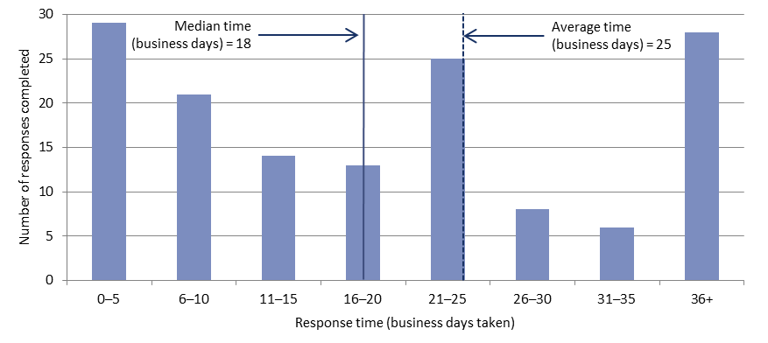

# Responses from agencies to PBO requests for information

Table 2: Responses to PBO information requests

|  |  |  |  |  |  |  |  |
| --- | --- | --- | --- | --- | --- | --- | --- |
|  | 2015–16  Total | 2016–17  Total | 2017–18  Total | 2018–19  Total | 2019–20  Q1 | 2019–20  Q2 | 2019–20  Total |
| Responses received in period | 745 | 508 | 429 | 549 | 24 | 31 | 55 |
| Percentage received on time (%) | 93 | 98 | 99 | 98 | 100 | 100 | 100 |
| Average response time (business days) | 7 | 8 | 9 | 7 | 9 | 5 | 7 |

As at 31 December 2019, there were no overdue responses to a request for information.

Table 3: Information request responsiveness by agencies – 1 July to 31 December 2019

