**21 May 2020**

Parliamentary Budget Office activity report

# Overview

This activity report provides an update on Parliamentary Budget Office (PBO) activities since the last activity report of 26 February 2020.

## Requests from parliamentarians and parliamentary parties

In the nine months to 31 March 2020, the PBO received 272 requests for policy costings and analysis and responded to 174 requests, at an average turnaround time of 27 business days and a median time to completion of 21 business days (refer to Table 1). The longer completion times than in previous periods in part reflect the complexity and novelty of costings received. Where delays occurred, PBO staff contacted requestors to negotiate alternate deadlines, and efforts were made to meet any critical dates where these were advised.

We have continued to receive new costing requests and to finalise outstanding requests over the COVID-19 pandemic period. There is currently a high degree of uncertainty associated with costing estimates given the significant economic and fiscal impact of the pandemic. In the absence of revised budget estimates, the baseline for costings is the 2019–20 Mid-Year Economic and Fiscal Outlook (the most recent update), as required under legislation. For some costings, this could result in a significant variation to the fiscal impact if later re-costed against an updated baseline. This risk is currently being highlighted, where relevant, in the costings advice provided to parliamentarians.

We make information requests to Commonwealth agencies to support our responses to parliamentarians and our research program. In the nine months to 31 March 2020, we received 163 responses from Commonwealth agencies to our information requests, at an average turnaround time of 11 business days. Responses to all requests were provided on time (refer to Table 2). Table 3 contains details of the responsiveness of Commonwealth agencies to information requests during this period.

In the period since the last activity report, there was one policy announcement that included reference to a confidential PBO policy costing that was subsequently released (refer to Table 4). There was a separate announcement by a parliamentarian that contained estimates of the fiscal implications of previous policy decisions and included reference to a confidential PBO budget analysis, also subsequently released (refer to Table 4).

On 30 April 2020, the Senate Community Affairs References Committee released a report on their inquiry into the *Adequacy of Newstart and related payments and alternative mechanisms to determine the level of income support payments in Australia*. This report featured costings that the Committee requested from the PBO, which were publicly released by the Committee and the PBO at the time the report was released.

## Research program

The PBO’s research program was set out in the 2019–20 corporate plan. Each year, we retain flexibility within our research program to add additional research topics to our work program over the course of the year, including in response to emerging issues. Given the unprecedented nature of the current fiscal challenges, much of our analytical work has been re-focussed for the remainder of 2019‑20 and into 2020‑21. Our research program is now prioritising work designed to inform the Parliament and the public about the fiscal impacts of COVID-19.

This revised work program includes both shorter pieces and explainers to support parliamentary considerations over the coming months, and larger research reports relevant to the medium-term fiscal implications of the economic response to COVID-19. In addition to a new publication on the monthly financial statements, we are investigating medium‑term scenario analysis and undertaking analysis on the JobSeeker payment, net financial worth and fiscal sustainability.

Other items from the 2019–20 corporate plan that are due for release in the coming months include a report on goods and services tax revenue, an online glossary of budget terms, and a data portal.

The PBO has released three publications since our last activity report.

* On 19 March 2020 we released the research report *Alternative financing of government policies - Understanding the fiscal costs and risks of loans, equity injections and guarantees*. This report examines trends in the use of alternative financing arrangements, explains how these arrangements relate to the Commonwealth budget, and identifies possible enhancements to budget reporting to support public understanding.
* On 24 April 2020, we released the regular report *Unlegislated measures carried forward in the budget estimates—April 2020*. This report highlights the financial impact of budget measures where the necessary enabling legislation has not passed Parliament after more than a year or where the announced start date has passed.
* On 8 May 2020, we released the snapshot *Government finances—March 2020*. This was the first in a series of short monthly publications designed to track the effect of COVID‑19 and the associated policy response on the Commonwealth’s fiscal position, using information from the government’s monthly financial statements*.*

## External engagement

The COVID-19 pandemic has understandably meant the cancellation or postponement of events where the PBO would present its work. We are exploring virtual opportunities to do so, along with other channels such as collaborating with other organisations on fact sheets and blog posts.

We continue to engage with external stakeholders to improve the quality of our analysis and research and present the findings of our work to interested audiences. In particular, we continue to seek high-level advice across all aspects of our work from our panel of expert advisors. The third annual meeting of the panel of expert advisors is scheduled for late July, and engagement with members continues out-of-session as required throughout the year.

We have also entered into a number of staff secondment arrangements with government agencies over this non-election year to boost the capabilities of staff and enhance relationships with these agencies.

## Staffing

As at 31 March 2020 the PBO had 43 staff. We are continuing to participate in the Parliament of Australia graduate program, however the timing of graduates joining us in 2020 has been impacted by Australian Public Service agencies retaining their graduates to support the delivery of their essential services. Three graduates have joined the PBO in 2020 to-date, with one returning to their home agency early to support the delivery of essential services. We anticipate up to a further seven graduates will be joining the PBO for periods of three to six months over the remainder of 2020.

# Requests from parliamentarians and parliamentary parties for costings and budget analysis

Table 1: Completion of costing and budget analysis requests

|  | 2016–17  Total | 2017–18  Total | 2018–19  Total | 2019–20  Q1 | 2019–20  Q2 | 2019–20  Q3 | 2019–20  Total |
| --- | --- | --- | --- | --- | --- | --- | --- |
| Requests completed in period | 1,888 | 1,560 | 2,970* | 49 | 95 | 30 | 174 |
| Average time to completion (business days) | 20 | 20 | 18 | 19 | 29 | 35 | 27 |
| Median time to completion (business days) | 12 | 15 | 12 | 23 | 16 | 34 | 21 |

* Includes 429 costings and budget analyses prepared for the purpose of the election commitment report.

**Note**: The table identifies the number of ‘options’ contained in requests completed by the PBO, noting that a single request can contain multiple options.

Figure 1: PBO response times for completed requests in 2019–20 to 31 March 2020

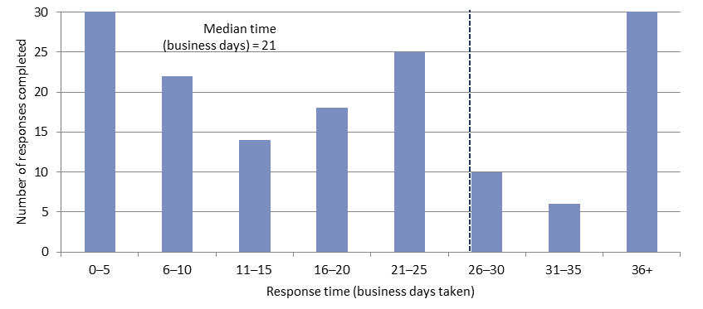

Average time   
(business days) = 27

# Responses from agencies to PBO requests for information

Table 2: Responses to PBO information requests

|  |  |  |  |  |  |  |  |
| --- | --- | --- | --- | --- | --- | --- | --- |
|  | 2016–17  Total | 2017–18  Total | 2018–19  Total | 2019–20  Q1 | 2019–20  Q2 | 2019–20  Q3 | 2019–20  Total |
| Responses received in period | 508 | 429 | 549 | 24 | 31 | 108 | 163 |
| Percentage received on time (%) | 98 | 99 | 98 | 100 | 100 | 100 | 100 |
| Average response time (business days) | 8 | 9 | 7 | 9 | 6 | 13 | 11 |

As at 31 March 2020, there were no overdue responses to a request for information.

Table 3: Information request responsiveness by agencies – 2019–20 to 31 March 2020



**Note:** The Department/Agency column lists all entities that have provided responses to information requests, including previous departments/agencies that have been the subject of a Machinery of Government change.

Table 4: Announcements by parliamentarians that referenced PBO costings or budget analysis —   
in the period since the activity report of 26 February 2020   
(excluding costings of publicly announced election policies included in the election commitment report)

|  |  |  |  |  |
| --- | --- | --- | --- | --- |
| **Description of announcement** | Party or parliamentarian announcing | Method of announcement | Date of announcement | Date of release of PBO advice |
| Exempting historic vehicle imports from luxury car tax | Mr Julian Hill MP | Media article | 10/03/2020 | 20/05/2019 – Costing posted on PBO website |
| Total budget expenditure savings from parenting payment single that have occurred to date | Australian Greens | Media article | 27/02/2020 | 28/02/2020 – Budget analysis posted on PBO website |