**6 February 2023**



Parliamentary Budget Office Activity Report

Contents

At a glance 1

Our Activities in detail 3

Policy costings and budget analysis 3

Self-initiated work 8

External engagement 9

People and systems 10

Concluding summary 11

# At a glance

This report provides an update on Parliamentary Budget Office (PBO) activities since the last activity report (24 October 2022) up to 23 January 2023. Key highlights include:

* Average time for completion of parliamentary requests in the December quarter met our performance benchmark of 15 days. Requests remained at elevated levels, compared to previous post-election periods.
* In our self-initiated work program, we published on topics including the October 2022-23 Budget, personal income tax, Jobseeker payment and, our flagship report *Beyond the budget*. We also released for consultation *Build your own budget*, a tool that allows users to adjust policies and economic parameters to gauge the effect on the government’s fiscal position.
* We began our *Budget Insights* seminars providing information and support for parliamentarians and their staff, and celebrated the tenth anniversary of the PBO’s establishment with the well‑attended inaugural PBO Conference in early November.
* Progress was also made with two key ICT projects – a new website and parliamentarian portal.

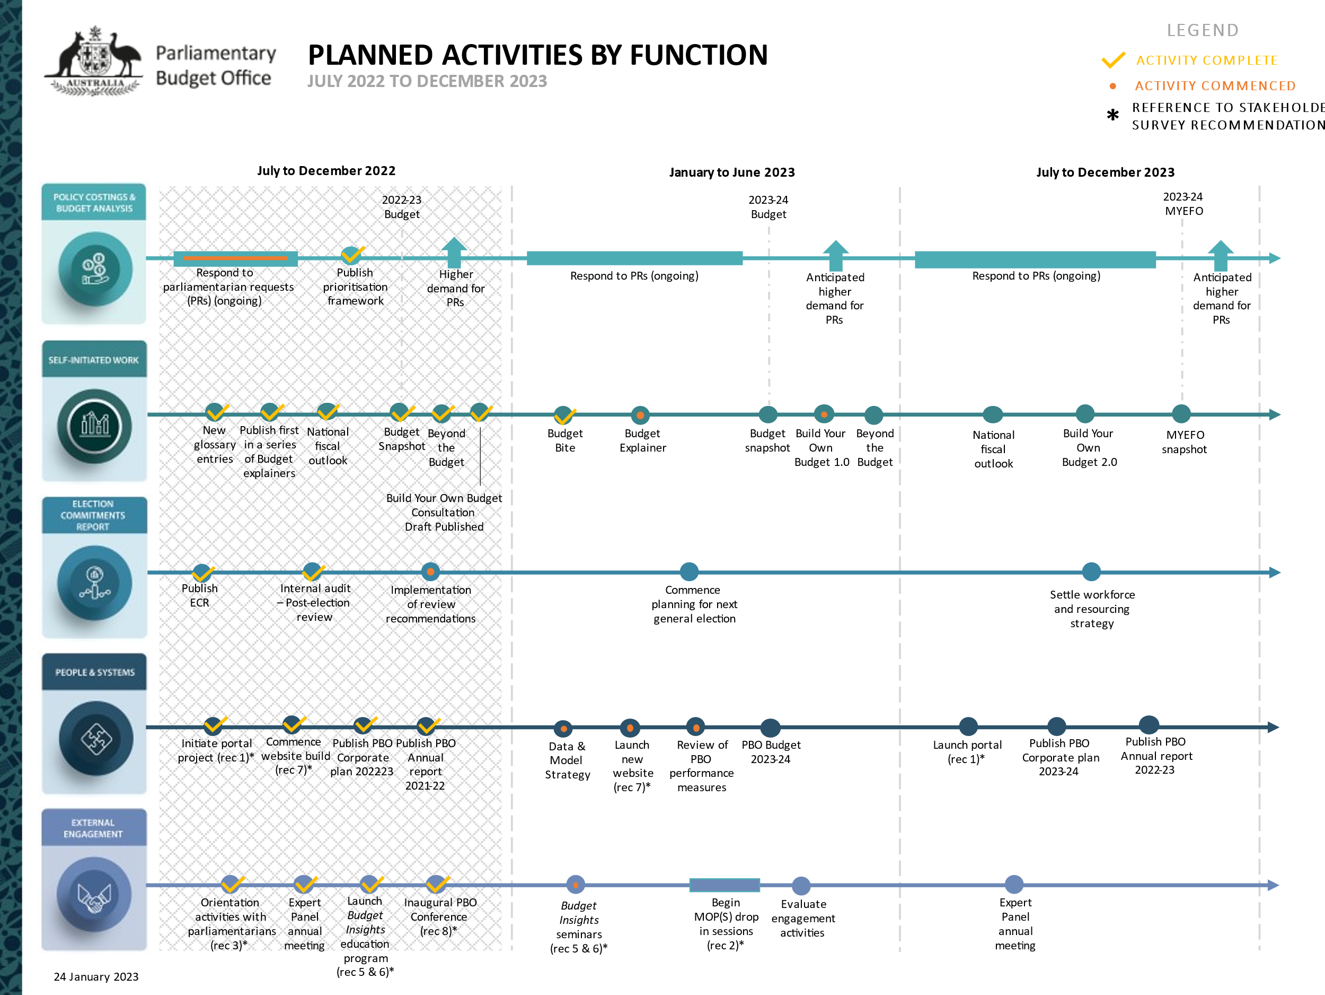

# Our Activities in detail

The purpose of the activity report is to provide an update on our key activities since our activity report, published on 24 October 2022, up to 23 January 2023. This supports transparency on how we are meeting the activities outlined in our [corporate plan](https://www.aph.gov.au/About_Parliament/Parliamentary_departments/Parliamentary_Budget_Office/About_the_PBO/Corporate_information/Corporate_plans). For information on our achievements before 24 October 2022, please see our [annual report](https://www.aph.gov.au/About_Parliament/Parliamentary_departments/Parliamentary_Budget_Office/About_the_PBO/Corporate_information/Annual_reports) and previous [activity reports](https://www.aph.gov.au/About_Parliament/Parliamentary_departments/Parliamentary_Budget_Office/About_the_PBO/Corporate_information/Activity_reports).

In the December quarter we moved beyond preparing for the 47th Parliament to delivering services to our client base on a more regular basis. We took concrete steps to broaden the way we interact with our stakeholders, by introducing seminars, producing some short publications and enhancing data and self-service access, though the release of additional historical fiscal data and a consultation version of *Build your own budget*.

We are getting close to releasing our new web site, and continuing development of a parliamentarian portal, which will deliver better access to our services through self-serve capability and real-time status reporting.

## Policy costings and budget analysis

### Requests from parliamentarians and parliamentary parties

In the 3 months to 31 December 2022, we received a total of 184 request options from parliamentarians and parliamentary parties and completed 180. This is fewer than the same quarter in the previous year where we received 603 request options and completed 613. However, it is more than we would usually expect at this point in the parliamentary cycle, as shown in Figure 1 below, which presents the historical context for the number of request options completed. Further statistics on request options, including the total stock and the time taken to complete them is included in Table 1.

Figure 1: Number of completed request options from parliamentarians

#### 

Table 1: Costing and budget analysis request performance

|  |  |  |  |  |  |  |  |
| --- | --- | --- | --- | --- | --- | --- | --- |
|  | **18–19** | **19–20** | **20–21** | **21-22** | **22-23** | | |
| **Total** | **Total** | **Total** | **Total** | **Q1** | **Q2** | **YTD** |
| **Request options outstanding at start of period** | **586** | **20** | **40** | **343** | **35** | **51** | **35** |
| **Request options received in period** | **3,014(a)** | **332** | **1,253** | **3,241(b)(c)** | **124(d)** | **184** | **308** |
| **Request options completed in period** | **2,970(a)** | **279** | **813** | **2,550(b)(c)** | **105** | **180** | **285** |
| **Request options withdrawn in period** | **610** | **33** | **137** | **999(c)** | **3** | **2** | **5** |
| **Request options outstanding at end of period** | **20** | **40** | **343** | **35** | **51(d)** | **53** | **53** |
| **Average time to completion (business days)** | **18** | **27** | **31** | **29** | **20** | **14** | **16** |
| **Median time to completion  (business days)** | **12** | **25** | **25** | **18** | **19** | **15** | **15** |

Note: The table identifies the number of ‘options’ received by the PBO, noting that a single request can contain multiple options. The number of options for a request is assessed as part of confirming the exact specification of the request. Between 1 January 2023 and 23 January 2023, we received an additional 31 request options and completed 27.

1. This includes 429 costings prepared for the 2019 Election commitments report.
2. This includes 316 costings prepared for the 2022 Election commitments report. 314 costings were for commitments by parties and 2 additional costings were for interactions between policies.
3. Most of these requests were automatically withdrawn due to the expiration of the 46th Parliament in accordance with the PBO’s legislative mandate which does not allow requests to carry over between parliaments.
4. In preparing this report we re-examined metadata for the first quarter of 2022-23 and recalculated the number of options to ensure consistency with the metadata used for the second quarter of 2022-23. This has led to an upwards revision of 2 request options received and 2 outstanding compared to the calculation used in the 24 October 2022 activity report.

We have been able to reduce our completion time this quarter to below the 15‑business day target, reflecting our continued focus on business process improvements and fit-for-purpose approaches (Figure 2).

The time taken to complete request options reflects a variety of factors including the volume of requests we have on hand, their priority and complexity, as well as the experience level and availability of staff.

Figure 2: Median time taken to respond to requests by quarter



### Requests by the PBO for Information from agencies

We continue to have highly collaborative and cooperative relationships with other Commonwealth agencies. These agencies provide us with key information and models and help us to understand policies to support the provision of robust costings and analyses. Table 2 below provides high level performance data for Commonwealth agencies responding to PBO information requests. Table 3 provides information for individual agencies from 1 October 2022 to 31 December 2022.

Table 2: Responses to PBO information requests

|  |  |  |  |  |  |  |  |  |
| --- | --- | --- | --- | --- | --- | --- | --- | --- |
|  | **17–18** | **18–19** | **19–20** | **20–21** | **21–22** | **22–23** | | |
| **Total** | **Total** | **Total** | **Total** | **Total** | **Q1** | **Q2** | **YTD** |
| **Responses received in period** | 429 | 549 | 175 | 523 | 538 | 21 | 163 | 184 |
| **Percentage received on time (%)** | 99 | 98 | 99 | 99 | 99 | 100 | 99 | 99 |
| **Average response time (business days)** | 9 | 7 | 12 | 11 | 6 | 12 | 10 | 10 |

Note: An additional 4 responses were received between 1 January 2023 and 23 January 2023.

Table 3: Information request responsiveness by agencies 1 October 2022 to 31 December 2022

|  |  |  |  |  |
| --- | --- | --- | --- | --- |
| **Department/Agency** | **Responses received in period** | **Average of time taken to respond (business days)** | **Responses received after due date** | **Per cent late** |
| Attorney-General's Department | 4 | 10 | 0 | 0% |
| Australian Taxation Office | 16 | 9 | 1 | 6% |
| Department of Climate Change, Energy, the Environment and Water | 2 | 9 | 0 | 0% |
| Department of Defence | 1 | 7 | 0 | 0% |
| Department of Education | 7 | 6 | 0 | 0% |
| Department of Employment and Workplace Relations | 7 | 7 | 0 | 0% |
| Department of Finance | 21 | 8 | 1 | 5% |
| Department of Health | 1 | 6 | 0 | 0% |
| Department of Health and Aged Care | 7 | 6 | 0 | 0% |
| Department of Home Affairs | 4 | 11 | 0 | 0% |
| Department of Industry, Science, Energy and Resources | 3 | 9 | 0 | 0% |
| Department of Infrastructure, Transport, Regional Development and Communications and the Arts | 3 | 9 | 0 | 0% |
| Department of Social Services | 41 | 15 | 0 | 0% |
| Department of the Treasury | 29 | 8 | 0 | 0% |
| Department of Veterans Affairs | 11 | 10 | 0 | 0% |
| National Indigenous Australians Agency | 2 | 8 | 0 | 0% |
| Services Australia | 4 | 4 | 0 | 0% |
| **Total** | **163** | **10** | **2** | **1%** |

Note: Between 1 January 2023 and 23 January 2023, we received an additional response from each of the following agencies: the Department of Employment and Workplace Relations, the Department of Finance, the National Disability Insurance Agency, and Services Australia. None of these responses were received after the due date.

### Publicly referenced costings

Table 4 shows our costings or budget analyses that have been publicly referenced for the first time in the period from 1 October 2022 to 23 January 2023. The items listed include references to costings whether or not the associated document has been publicly released. The table shows a continuation of the practice of our clients referencing PBO work without releasing the associated costing minute. Figure 3 provides a breakdown of this practice over the past 4 quarters.

Table 4: Costings or budget analysis publicly referenced for the first time between 1 October 2022 and 23 January 2023

| **Description of policy announcement** | **Party or Parliamentarian announcing policy** | **Method of Announcement** | **Date of announcement** | **Date of release of costing minute on the PBO website** |
| --- | --- | --- | --- | --- |
|  |
| Interest rate rises and the impact of landlords tax deductions | Australian Greens | Online media article | 3 November 2022 | Costing minute not released |  |
| Using windfall profits to cap everyone’s energy bills | Australian Greens | Online media article | 4 November 2022 | Costing minute not released |  |
| Suburb Zero pilot in the ACT | Senator David Pocock | Online media article | 15 December 2022 | Costing minute not released |  |

Note: While the PBO endeavours to capture all policy announcements that reference PBO costings, there may be announcements missing from the table above, for example, because the announcement was not reflected in any media monitored by the PBO.

Figure 3: Publicly referenced responses that have not been publicly released

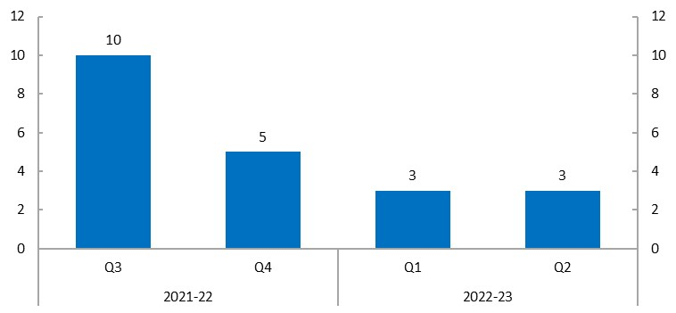

If a response to a request is publicly released, it is subsequently published on the PBO website.

In addition to the publicly referenced costings shown in Table 4, we publicly released the following costing response on our website:

* ***Increase in the Assistance for Isolated Children Allowance*** (released on 16 January 2023). This request was submitted on a non-confidential basis meaning that once completed it was publicly released.

### Correcting the record

We routinely monitor references to the PBO in media articles to ensure we, and the information or advice we prepared, are referenced correctly. Our policy for correcting the record is available on our [website](https://www.aph.gov.au/About_Parliament/Parliamentary_Departments/Parliamentary_Budget_Office/Guidance_for_Senators_and_Members).

We have started a log of instances where we seek to correct the record since 1 January 2023. We will report this information at an aggregate level in future activity reports providing transparency while maintaining confidentiality. So far in 2023 we have recorded zero instances of needing to correct the record.

### Model evaluations

We have begun the development of a data and model strategy to inform how we manage and take advantage of our data, alongside a process to evaluate our key costing models. This work complements and is supported by the development of user-led interactive tools, such as *Build your own budget*. Additionally, when recosting policy proposals we consider methodology and check for newly available or updated data.

## Self-initiated work

We retain flexibility within our self-initiated work program and regularly re-evaluate our priorities, given our available resources, throughout the year. We undertake projects under the following themes:

* fiscal sustainability
* medium- and long-term fiscal risks, with a focus on climate change
* improving understanding of the budget
* distributional analysis, with a focus on gender.

The following self-initiated publications have been released since the last activity report:

* *2022‑23 October Budget snapshot,* published on 25 October 2022, provides a visual summary of key information from the 2022-23 October Budget
* *Budget Bite: Trends in personal income tax*, published on 18 November 2022, presents trends in personal income tax in a historical context, building on previously published work on bracket creep
* *Beyond the budget 2022-23: Fiscal outlook and scenarios*, published on 8 December 2022, provides independent medium-term projections of key budget outcomes such as debt and the budget balance
* *Build your own budget* *– consultation release*, published on 15 December 2022, an interactive tool that allows users to adjust various policy and economic parameters to test their impact on the Commonwealth fiscal position
* *Budget Bite: Jobseeker Payment: COVID-19, age & gender*, published on 12 January 2023, updates the PBO’s 2020 Jobseeker Payment report, with analysis on the short-term impacts of COVID-19 and long-term trends in recipient demographics.

Over a year, we aim to deliver at least 4 major publications and 4 occasional ones. We are on track to meet this in 2022-23.

We regularly review our self-initiated work agenda, taking into account the views of our panel of expert advisors and other stakeholders. Accordingly, the work program changes over the course of a year to publish insights on topical issues related to our research themes, where we feel the PBO can add value.

## External engagement

A key priority for the PBO is to enhance our interactions with parliamentarians, their staff, and committees. We are committed to continual improvement in our service delivery and to making our work accessible to our audience.

We have initiated a program of *Budget Insights* seminars providing information and support for parliamentarians and their staff on fiscal issues. Since 1 October 2022, we have had 2 *Budget Insights* seminars on the topics of the Budget papers and process (17 October 2022), and tax design (16 November 2022). These will continue in 2023.

### PBO Conference – Building fiscal insights for the decade ahead

The inaugural PBO conference, titled *Building fiscal insights for the decade ahead,* was held on Thursday 3 November 2022 to celebrate the tenth anniversary of the PBO’s establishment.

The conference brought together world-leading experts to present on a range of topics relevant to the fiscal challenges for Australia and the region, and to discuss the place of the PBO in meeting these challenges.

Approximately 100 people attended the conference in person at Australian Parliament House or online via Zoom.[1] Attendees joined from across the globe – online attendance was recorded from Australia, New Zealand, the United States, France, Canada and Kenya.

Feedback from attendees showed the presentations were interesting and relevant, with the panel discussion being the most popular session. Videos of presentations can be accessed on the [PBO website](https://www.aph.gov.au/About_Parliament/Parliamentary_departments/Parliamentary_Budget_Office/PBO_conference).

### Digital engagement statistics

Interest in our products can be seen through the statistics on webpage views and media citations. These figures, together with relevant dates, are shown in Figure 4 below.

Figure 4: Overview of webpage views and media citations



The largest peaks in the period coincided with the release of the *2022-23 October Budget snapshot* on 25 October and the first public references to the costings *Interest rate rises and the impact of landlord's tax deductions* on 3 November 2022 and *Using windfall profits to cap everyone’s energy bills* on 4 November.

## People and systems

To support us in effectively delivering services, we continue to invest in our people and systems in three key areas:

* OnePBO – a refresh of our organisational approach to enhance operational flexibility and support timely fit for purpose outputs that add value and reflect the needs of our clients.
* investment in our people, to enhance team efficiency and effectiveness and support staff to expand their skills, experience, and capabilities.
* modernisation of our tools and systems including website upgrades and digital tools that are more user focused.

### Staffing

At 19 January 2023, we had 43 full-time equivalent (FTE) staff and a headcount of 46. In 2022–23, we estimate an average staffing level (ASL) of 44.

We are continuing to participate in the Parliament of Australia graduate program. Seven graduates from the 2023 program will be joining the PBO for periods of 4 to 6 months over the course of this calendar year.

### Parliamentary Workplace Support Service (PWSS)

The Operating Protocol between the PBO and the Parliamentary Service Commissioner (PSC) for provision of the Parliamentary Workplace Support Service (PWSS) was finalised and executed in November 2022, following a period of consultation. The Operating Protocol outlines the scope and functions of the PWSS and the obligations of the parties, including a series of scenarios which provide examples of how the PBO and PWSS will work together to support staff.

### Information and communication technology (ICT) capability

The PBO operates in a modern, collaborative, and integrated cloud-based ICT environment. We have 2 large ICT projects underway to enhance our services: website project and parliamentarian portal project.

*Website project*

We have initiated a project to redevelop our website, enabling better access for our staff to manage the site and to improve how it supports users. This will be achieved through a refresh of the information architecture, improved search functionality and enhancing the interactivity of tools and charts available on the site.

We anticipate delivering the new website by the end of Quarter 3 2022-23, subject to the scope and availability of resources.

*Parliamentarian portal*

In response to the stakeholder survey feedback, work has commenced with the Department of Parliamentary Services (DPS) on a self-service portal that allows authorised users to submit, manage, and download costings and budget analysis requests. This will be supported by real-time management of status and prioritisation of requests.

Scope has been finalised and development work is expected to commence shortly. Initial functionality is expected to be operational by the end of 2023. This is a joint project between DPS and the PBO.

### Review into Parliamentary culture

We continue to work closely with the other parliamentary departments to effectively coordinate responding to the Jenkins review and associated matters, including the Foster review and any recommendations from Comcare.

### Election commitment report evaluation

Our internal auditors have reviewed the PBO’s management of peak demand during the 2022 federal election. Many positive observations were made including that the PBO had a high level of readiness and preparedness strategies established in advance of the election. They also noted that the PBO developed strategies to manage resourcing during the caretaker period and immediately thereafter by seconding staff from line agencies and other parliamentary departments to work on costings and fulfil commitment tracker roles. Opportunities to enhance agency and stakeholder collaboration on costing methodologies and processes, streamlining communication channels, as well as improvements to information presentation, training and managing staff were identified and will be implemented.

An internal report on the status of planning for the next ECR, and timing of key decision points will be delivered by mid-2023, to ensure that we are well prepared in advance of the next scheduled federal election (expected to be in the period from August 2024 to September 2025).

## Concluding summary

Over the period covered by this report, we have responded to stakeholder feedback and improved the timeliness of our products, meeting the 15-business day average response time target and publishing *Beyond the budget* much closer to the release of the Budget than for most previous editions. We held the first PBO Conference to celebrate our 10-year anniversary, which helped lift awareness of our products and services and published the videos on our website. We have held *Budget Insights* seminars in support of enhancing knowledge and relationships with parliamentarians and their staff.

We are also investing in new ICT solutions to improve the user experience of our website to make information easier to find and streamline service delivery of costing and budget analysis services.

We have a significant publication schedule over the rest of the year, including our suite of flagship publications related to the 2023-24 Budget and fiscal sustainability, as well as *Budget Explainers* and *Budget Bites*.

We remain committed to continuous improvement and will look for further ways to enhance delivery of meaningful and timely information to our clients.

1. Exact figures cannot be determined as online participant numbers fluctuated through the day and Zoom does not supply an attendance record report.