**17 May 2021**

Parliamentary Budget Office activity report

# Overview

This activity report provides an update on Parliamentary Budget Office (PBO) activities since the last activity report of 16 March 2021.

## Requests from parliamentarians and parliamentary parties

In the three months to 31 March 2021, we have received 166 requests for policy costings and requests for budget analysis. This compares with the 423 requests received in the second quarter of 2020–21 and 256 in the first quarter. This quarter, we responded to 293 requests, at an average turnaround time of 42 business days and a median time to completion of 46 business days (see Table 1). While we are working on reducing the average and median time to completion, recorded completion times have increased, reflecting the completion of older requests.

During the three months to 31 March 2021, we received 65 responses from Commonwealth agencies to our information requests, at an average turnaround time of eight business days (see Table 2). No responses were received late. Table 3 contains details of the responsiveness of Commonwealth agencies to information requests during this period.

In the period since the last activity report, four policy costing and one budget analysis have been publicly released. These are available on our website (see Table 4).

## Evaluations

In adopting Recommendation 7 of the Joint Committee of Public Accounts and Audit (JCPAA)’s *2016–17 Independent review of the PBO*, we periodically conduct evaluations of a limited selection of policy costing estimates, to help identify areas for improvement in future costings.

So far we have completed a total of 13 evaluations which cover a broad range of topics including: education, goods and services tax, child care, humanitarian migration, personal income tax, corporate tax, tax deductions and health. These evaluations are focused on the models, methods and assumptions that we expect to be drawn upon heavily in the lead up to the next election. The 13 completed evaluations have resulted in 33 recommendations, of which 23 have been implemented.

The outstanding recommendations are work-in-progress with a focus on implementing those recommendations related to models, methods and assumptions that we expect to draw upon in the lead up to the next general election.

## Research program

Since 16 March, the PBO has published the following reports.

* *Fiscal Sustainability* was published on 28 April.
* *Government Finances* was published on 6 May.
* *Understanding the Budget* was published on 7 May.
* *Budget Snapshot* was published on 11 May.

We also issued a series of posts on Twitter and Linkedin highlighting different aspects of the Budget.

Preparation is underway on our annual *Budget Chart Pack* and *Medium-term projections*, plus products to assist in understanding Budget-related topics, including bracket creep and the contingency reserve.

The PBO’s research program is set out in the 2020–21 Corporate Plan. We retain flexibility within our research program to add additional research topics to our work program over the course of the year, including in response to emerging issues.

We are preparing our research program for 2021–22, which will incorporate feedback from consultation with the JCPAA and our expert panel. The research program will be published in the 2021–22 Corporate Plan.

## External engagement

The PBO continues to seek input from our expert panel and external stakeholders to assist with the development and evaluation of our work program and methodologies, improve the quality of our analysis, and to review selected pieces of work before publication.

The three-year terms of the original expert panel expired in December 2020. We are currently re-appointing existing members to our expert panel and will appoint some additional members to increase the diversity of experience of panel members.

## Staffing

As at 31 March 2021, the PBO had 42.13 full-time equivalent (FTE) staff (headcount: 44). In 2020–21, the PBO is estimating an average staffing level (ASL) of 44.

We are continuing to participate in the Parliament of Australia graduate program. 11 graduates from the 2021 program and two graduates from the 2020 program (deferred due to COVID-19) are joining the PBO for periods of three to six months over the course of the year.

# Requests from parliamentarians and parliamentary parties for costings and budget analyses

Table 1: Completion of costing and budget analysis requests

|  | 2016–17  Total | 2017–18  Total | 2018–19  Total | 2019–20 Total | 2020–21  Q1 | 2020–21  Q2 | 2020–21  Q3 | 2020–21  Total |
| --- | --- | --- | --- | --- | --- | --- | --- | --- |
| Requests completed in period | 1,888 | 1,560 | 2,970* | 279 | 115 | 188 | 293 | **596** |
| Average time to completion (business days) | 20 | 20 | 18 | 27 | 20 | 25 | 42 | **32** |
| Median time to completion (business days) | 12 | 15 | 12 | 25 | 19 | 20 | 46 | **26** |

* Includes 429 costings and budget analyses prepared for the purpose of the election commitment report.

Note: The table identifies the number of ‘options’ received by the PBO, noting that a single request can contain multiple options.

Figure 1: PBO response times for completed requests in 2020–21 to 31 March 2021

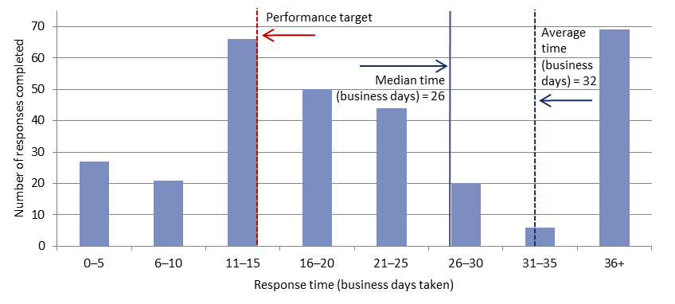

# Requests by the PBO for information from agencies

Table 2: Responses to PBO information requests

|  |  |  |  |  |  |  |  |  |
| --- | --- | --- | --- | --- | --- | --- | --- | --- |
|  | 2016–17  Total | 2017–18  Total | 2018–19  Total | 2019–20  Total | 2020–21  Q1 | 2020–21  Q2 | 2020–21  Q3 | 2020–21  Total |
| Responses received in period | 508 | 429 | 549 | 175 | 119 | 186 | 65 | **370** |
| Percentage received on time (%) | 98 | 99 | 98 | 99 | 99 | 99 | 100 | **99** |
| Average response time (business days) | 8 | 9 | 7 | 12 | 10 | 8 | 8 | **8** |

As at 31 March 2021, there was two overdue responses to requests for information.

Table 3: Information request responsiveness by agencies in 2020–21 to 31 March 2021



Table 4: Announcements by parliamentarians that referenced PBO costings or budget analysis —   
in the period since the activity report of 16 March 2021

| Description of policy  announcement | Party or Parliamentarian announcing policy | Method of Announcement | Date of announcement | Date of release  of costing minute |
| --- | --- | --- | --- | --- |
| A mining super profits tax | Mr Adam Bandt MP | Media release | 26 March 2021 | Released on the PBO website 30 March 2021 |
| Lost revenue from the original mining tax | Mr Adam Bandt MP | Media release | 26 March 2021 | Released on the PBO website 30 March 2021 |
| Billionaire’s tax | Mr Adam Bandt MP | Media release | 28 March 2021 | Released on the PBO website 1 April 2021 |
| Interest withholding tax for financial institutions | Senator Andrew Bragg | Media article | 21 April 2021 | Released on the PBO website 13 April 2021 at Senator Bragg’s request |
| Profitable corporations to return JobKeeper payments | Mr Adam Bandt MP | Media release | 3 May 2021 | Released on the PBO website 4 May 2021 |