7 February 2022

Parliamentary Budget Office Activity Report

Overview
This activity report provides an update on Parliamentary Budget Office (PBO) activities since the last activity report of 18 October 2021.

Requests from parliamentarians and parliamentary parties
In the three months to 31 December 2021, we received 603 requests for policy costings and requests for budget analysis. During the quarter, we responded to 613 requests, at an average turnaround time of 34 business days and a median time to completion of 34 business days (see Table 1).
As noted in our last activity report we are aiming to reduce the average and median time taken for requests as we are concerned that the existing average timeframes may not sufficiently support the needs of our requestors. This was not achieved in the December 2021 quarter. While the average and median time taken to complete requests was well above our performance target of 15 business days (largely consistent with the September 2021 quarter), the 613 responses we completed was almost double what was achieved in the September quarter and 75 per cent of what was delivered in the entire 2020-21 financial year.
Despite doubling the number of completed requests, the slight increase in the proportion of responses completed in 15 days or less was more than offset by the proportion of responses which had taken more than 45 days.
The longer than desired completion times continue to reflect the relative complexity of many of the requests we received, particularly requests involving complex policy matters and requests that require the construction of new models, acquisition of new data or requests that contain numerous options or policy components. Longer completion times also reflect the statistical effect of finalising requests that have taken a long time to complete, which has the effect of increasing completion times despite the increased costings output.
Our focus on those requests flagged by our clients as being critical, coupled with changes to internal processes, appears to be delivering some improvements with the indicative activity and performance statistics for the month of January 2022 showing more than 60 option responses delivered at an average time of 18 business days, a significant improvement on recent performance. A small number of outstanding requests on hand have been with us for some time, which suggests that our 2021-22 figures will continue to be impacted by our completion of older responses.
During the three months to 31 December 2021, we received 108 responses from Commonwealth agencies to our information requests, with an average turnaround time of 6 business days (see Table 2). This was a significant reduction in turnaround time from last quarter, reflecting very prompt responses by several agencies to standing requests after MYEFO and to more of our requests being categorised as urgent due to election priorities. Despite the increase in urgent requests, only one response was received late, reflecting the strong relationships that we have with agencies.
Table 3 contains details of the responsiveness of Commonwealth agencies to information requests during this period.
During the first 7 months of 2021–22, 14 policy announcements that were made by parliamentarians or parliamentary parties included references to PBO policy costings and 6 of these costings were subsequently publicly released. In the period since the last activity report, 6 policy announcements referenced PBO costings, with 2 costings publicly released (refer to Table 4).

Evaluations
We have not undertaken any further evaluations of our models so far in the 2021–22 year. This reflects a deliberate choice to focus on preparing for the election, including building the capability of new staff and optimising our new ICT environment. We undertook evaluations of several of our key models in 2020-21, and implementation of the relevant recommendations is underway.

Self-initiated work program
The PBO public information program is focussed on analysis that improves and informs assessments of the medium-term trends and pressures facing Australia’s fiscal position. We also seek to improve the understanding that parliamentarians and the public have of complex budget and financial mechanisms.
The PBO’s 2021-22 self-initiated work program was set out in the 2021-22 Corporate Plan and features a focus on shorter reports aimed at enhancing understanding of budget concepts and transparency, with fewer major reports.
The PBO has released seven self-initiated publications since the last activity report of 18 October 2021:
- Government finances: June quarter 2021, published on 21 October. This is the latest in a regular series, first published for March 2020, designed to track the impact of the COVID-19 pandemic and the associated policy response on the Commonwealth’s fiscal position.
- Transcript of Fiscal Sustainability, Parliamentary Library seminar series address, by Stein Helgeby, Parliamentary Budget Officer (webinar presented on 15 September), published on 22 November.
- The Fiscal sustainability dashboard, published on 22 November, is an interactive dashboard designed for educational purposes, providing a range of possible projections for the debt-to-GDP ratio depending on different scenarios for interest rates, economic growth and the budget balance. The dashboard is complementary to the Beyond the Budget and Fiscal sustainability reports, published earlier in 2021, and the Parliamentary Library seminar series address.
- National fiscal outlook: As at 2021-22 Budgets, published on 2 December. This is the eighth edition of our annual update of government finances combining Commonwealth, State and local government data. The report was accompanied by a comprehensive set of charts, published as National fiscal outlook: At a glance, also published on 2 December.
- The contingency reserve, published on 9 December, is the second in our series of shorter web-based explainer pieces on key fiscal issues and concepts. It supports other shorter pieces to assist understanding, such as our Online budget glossary and Guide to the budget.
- 2021-22 Mid-Year Economic and Fiscal Outlook Snapshot, published on 16 December, the latest edition of charts summarising the most recent government budget update.
We continue to present and discuss the results of our work, and to increase the public’s understanding of budget and fiscal matters. On 12 November 2021, the Parliamentary Budget Officer presented a Senate occasional lecture on the history of and role of the PBO.
We also continued to maintain our Online budget glossary. As flagged in our 2021-22 Corporate Plan, a database of historical fiscal data is being prepared, with the first tranche expected to be published in the coming weeks.
Over the next few months, most of our public information resources will be redirected towards costing work in the lead-up to the general election and towards the preparation of the election commitments report which is required shortly after the election.

General election preparation
Preparations for the 2022 Election Commitments Report are well underway, including planning for the temporary expansion of our workforce required to complete the report by the statutory deadline.
Section 64MA of the Parliamentary Service Act 1999 requires the Parliamentary Budget Officer to release a report outlining the financial impacts of all the election commitments that have a material impact on the budget for all parliamentary parties with five or more members (referred to as ‘designated’ parties or major parties). The report must be released within 30 days of the end of the caretaker period for a general election or seven days prior to the first sitting day of the new parliament, whichever is later.

External engagement

PBO Expert Panel
The PBO continues to seek input from our expert panel and external stakeholders throughout the year to assist with the development and evaluation of its work program and methodologies, improve the quality of our analysis, and to review pieces of work before publication.

Staffing
At 31 December 2021, the PBO had 46.09 full-time equivalent (FTE) staff (headcount: 47). In 2021-22, the PBO is estimating an average staffing level (ASL) of 48.
We are continuing to participate in the Parliament of Australia graduate program. Seven graduates from the 2022 program are joining the PBO for periods of four to six months over the course of the 2022 calendar year.

APS Census results
Throughout May and June 2021, the PBO participated in the APSC Employee Census for the first time. The PBO had high levels of engagement, with a 98% response rate. Survey results were circulated to all staff on 13 August 2021 and are available at APS Employee Census - Parliamentary Budget Office (pbo.gov.au).
A staff-led survey working group is working through the results from the census and the proposed actions. Areas for improvement are likely to include enhancements to communication and change management within the PBO.

Response to COVID-19
The PBO continues to follow advice from ACT Health and the Presiding Officers relating to working arrangements in the context of COVID-19. The PBO’s flexible approach seeks to ensure operational requirements and services to Parliamentarians can be met, whilst balancing the benefits of colocation and face-to-face working with the need to minimise staff attendance at Australian Parliament House, for example during sitting periods. PBO staff can attend APH in person at any time for operational reasons.
The PBO continues to actively consider staff availability, resourcing, health and wellbeing, and strategic priorities in the context of COVID-19. As part of our election preparedness, the PBO is considering business continuity in the context of both the direct and indirect impacts of COVID-19 on our key personnel. Given the small size of the PBO, managing key person risk is a focus for the Executive.

Review into Parliamentary culture
The PBO provided input, alongside the other Parliamentary Departments, into the Australian Human Rights Commission’s Independent Review into Commonwealth Parliamentary Workplaces.
Following the publication of the Jenkins review in November 2021 the PBO is carefully considering the inquiry’s findings. The PBO is currently working with the Australian Human Rights Commission to arrange an all staff briefing on the report.
The PBO will be working closely with the other Parliamentary Departments to effectively coordinate responding to the Jenkins review and associated matters, including the Foster review and any recommendations from Comcare.
The PBO, along with the other Parliamentary Departments, has joined several cross-government working groups, coordinated by the Department of Prime Minister and Cabinet. To date, these include working groups focused on Work Health and Safety issues, Access and Inclusion, and Parliamentary Induction.

Requests from parliamentarians and parliamentary parties for costings and budget analyses
Table 1: Completion of costing and budget analysis requests
 | 2018–19  Total | 2019–20 Total | 2020–21  Total | 2021–22  Q1^{(a)} | 2021-22  Q2 | 2021–22  Total | Trend
Requests received in period | 3,019 | 332 | 1,253 | 456 | 603 | 1,059 | -
Requests completed in period | 2,970* | 279 | 813 | 298 | 613 | 922 | -
Average time to completion (business days) | 18 | 27 | 31 | 34 | 34 | 34 | ↑
Median time to completion (business days) | 12 | 25 | 25 | 36 | 34 | 34 | ↑
*Includes 429 costings and budget analyses prepared for the purposes of the Election Commitments Report.
Note: The table identifies the number of ‘options’ received by the PBO, noting that a single request can contain multiple options.
(a) Since the publication of the October 2021 Activity report, the data for 2021-22 Q1 has changed. Specifically:
- the number of options submitted has changed because the number of options was varied after the close of the quarter for reporting purposes.
- the increase in the number of options completed reflects the identification of a handful of completed options not specifically identified in preparing the previous activity report, partially offset by a revision in the number of options where the PBO has reissued a previously completed response. Where the PBO reissues a completed response, we amend the completion date to reflect the timing of the final version of the response.
As a result, the number of requests submitted has increased from 397 to 456, the number of options completed has increased from 296 to 298 and the average time to completion increased from 33 to 34 business days.

Figure 1: Number of received and completed costing requests in each of the last four quarters
(median time (business days) to completion for quarter shown above relevant column)
Last two quarters 2020-21
Figure 2: PBO response times for requests completed in 2021–22 quarter two

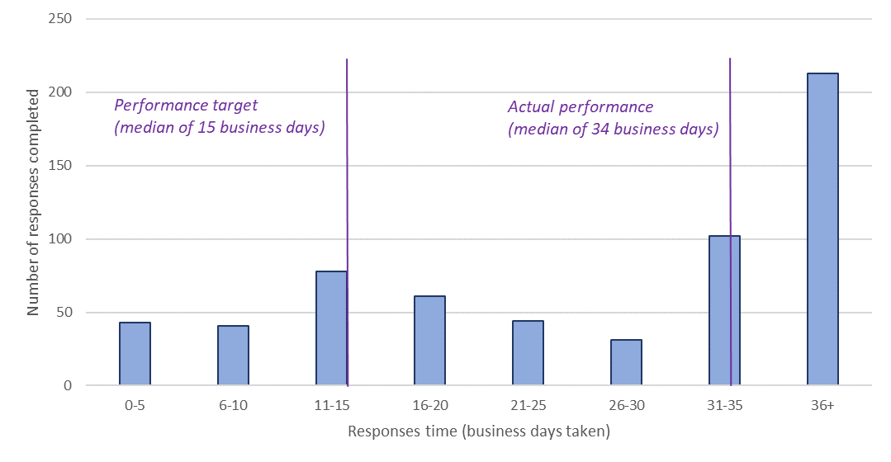

Figure 3: Median response time for policy costing and budget analysis requests by quarter

Requests by the PBO for information from agencies
Table 2: Responses to PBO information requests
 | 2017–18  Total | 2018–19  Total | 2019–20  Total | 2020–21  Total | 2021–22  Q1 | 2021–22  Q2 | 2021–22  Total
Responses received in period | 429 | 549 | 175 | 523 | 32 | 108 | 140
Percentage received on time (%) | 99 | 98 | 99 | 99% | 100% | 99% | 99%
Average response time (business days) | 9 | 7 | 12 | 11 | 10 | 6 | 7
As of 31 December 2021, only one response to requests for information was late.

Table 3: Information request responsiveness by agencies in 2021–22 quarter two
Department/Agency | Responses received in period | Average of Time taken to respond (business days) | Responses received after due date | Per cent late
Attorney-General's Department | 4 | 10 | 0 | 0%
Australian Competition and Consumer Commission | 1 | 13 | 1 | 100%
Australian Taxation Office | 13 | 3 | 0 | 0%
Department of Agriculture, Water and the Environment | 6 | 7 | 0 | 0%
Department of Defence | 1 | 8 | 0 | 0%
Department of Education, Skills and Employment | 15 | 7 | 0 | 0%
Department of Finance | 8 | 5 | 0 | 0%
Department of Health | 15 | 7 | 0 | 0%
Department of Home Affairs | 3 | 9 | 0 | 0%
Department of Industry, Science, Energy and Resources | 4 | 9 | 0 | 0%
Department of Infrastructure, Transport, Regional Development and Communications | 4 | 11 | 0 | 0%
Department of Social Services | 5 | 6 | 0 | 0%
Department of the Prime Minister and Cabinet | 1 | 6 | 0 | 0%
Department of the Treasury | 22 | 5 | 0 | 0%
Department of Veterans Affairs | 1 | 17 | 0 | 0%
National Indigenous Australians Agency | 1 | 9 | 0 | 0%
Services Australia | 4 | 4 | 0 | 0%
 | 108 | 6 | 1 | 1%

Publicly referenced costings
Table 4 shows the PBO costings or budget analyses that have been publicly referenced by parliamentarians. The table captures a costing or analysis that is referenced in the public domain for the first time. This includes references to costings that have been publicly released (and subsequently published on the PBO website), and those that have not been publicly released by the requesting parliamentarian, where there is a first public reference to the PBO. Subsequent public references of PBO costings or budget analyses are excluded from the table below.
Table 4 differs from what was reported in the last activity report (October 2021), which for the current financial year (that is, 2021-22) only included those costings that were publicly released by the parliamentarian. From 2021-22 onwards, the PBO will revert to reporting costings that are referenced publicly but have not been publicly released by the requesting parliamentarian.
From May 2020 to October 2021, the PBO did not publish information on costings referenced for the first time but not publicly released by parliamentarians. This reflected concerns about data accuracy and completeness, particularly whether the PBO’s internal media monitoring was capturing references in all relevant media.

Table 4: Costings or budget analysis publicly referenced for the first time
in 2021-22 (to 1 February 2022)
Description of policy  announcement | Party or Parliamentarian announcing policy | Method of Announcement | Date of announcement | Date of release  of costing minute on the PBO website
Ending Corporate Tax Avoidance | Mr Adam Bandt MP | Online media article | 12 November 2021 | 17 November 2021
Make Functional Assessments a Medicare Benefits Schedule Item | Joint Standing Committee on the National Disability Insurance Scheme | Committee report | 19 October 2021 | 20 October 2021
One Million Homes | Mr Adam Bandt MP | Online media article | 17 October 2021 | 18 October 2021
Mining Super Profits Tax | Mr Adam Bandt MP | Media release | 6 September 2021 | 6 September 2021
Corporate Super Profits Tax | Mr Adam Bandt MP | Media release | 6 September 2021 | 6 September 2021
Distributional analysis of the stage 3 tax cuts | Mr Adam Bandt MP | Media release | 28 July 2021 | 29 July 2021
Truth and Justice Commission | Mr Adam Bandt MP | Online media article | 23 January 2022 | Costing minute not released
Air Filters for Schools | Mr Adam Bandt MP | Online media article | 23 January 2022 | Costing minute not released
Funding for Tenants’ Advocacy Services | Senator Mehreen Faruqi | Media release | 24 November 2021 | Costing minute not released
Horse Racing Transition Plan and Horse Betting Levy | Senator Mehreen Faruqi | Media release | 2 November 2021 | Costing minute not released
Free and Unlimited Mental Health in Medicare | Senator Jordon Steele-John | Media release | 20 September 2021 | Costing minute not released
Dentistry Vouchers for Older Australians | Rebekha Sharkie MP | Media release | 16 August 2021 | Costing minute not released
JobKeeper | Dr Andrew Leigh MP | Online media article | 23 July 2021 | Costing minute not released
Aged Care Funding | Ms Clare O’Neil MP | Online media article | 12 July 2021 | Costing minute not released
Note: All costings published on the PBO’s website are captured in the table above. While the PBO endeavours to capture all policy announcements that reference PBO costings, there may be announcements missing from the table above, for example, because the announcement was not reflected in any media monitored by the PBO.

In comparison to the previous financial year

