29 October 2018

Australia’s fiscal position – opening remarks to the 2018 ACOSS National Conference Plenary Session: “Funding our future – where will it come from?”

Jenny Wilkinson, Parliamentary Budget Officer

CHECK AGAINST DELIVERY

Thank you for inviting me to provide some opening remarks to this plenary session.
Government policies and programs deliver outcomes that should be designed to improve the welfare of Australians. Policy debates, including in forums and conferences such as this one, are about how best to do this, recognising that there are differences of view about policy priorities and about how to achieve these priorities; and there are challenging trade-offs between alternative options.
One of the roles of the Parliamentary Budget Office, which is an independent agency, is to analyse fiscal sustainability issues, to provide transparency around how the budget is evolving, and to elevate thinking about budgetary issues. The PBO does not provide advice on policy issues.
So the purpose of my talk today is to provide some context for the panel discussion about policy priorities and trade-offs.
I will organise my brief comments around three questions:
- First – how is Australia currently positioned from a budgetary perspective?
- Second – what are some of the fiscal risks that the PBO has identified?
- Third – what are some of the emerging sources of pressure that Governments will need to grapple with over the next several decades?
Any conversation about policy in Australia inevitably leads to a discussion about the nation’s finances. There is generally broad agreement across the Australian community that fiscal sustainability should be a priority for government. But what does this really mean?
Essentially, it boils down to three things.
Firstly, government needs to be raising sufficient revenue to fund the spending they have committed to. When governments think about doing this, they usually think in terms of a timeframe that spans the economic cycle, rather than at every specific point in time. This recognises that there are times when it is appropriate to run budget deficits and other times, surpluses.
Second, government needs to ensure that funds are available to provide additional support to the economy in the event of an (inevitable) economic downturn.
And third, government needs to be managing slow-building sources of pressure (on either the spending or revenue side) as they are emerging and before they become critical.

How is Australia currently positioned?
Like many countries, Australia’s debt increased significantly during and following the global financial crisis (GFC). This was caused by the cyclical downturn in revenue and increase in expenditure that occurred as a consequence of the GFC. The significant stimulus packages that were introduced by the Government to offset some of the negative impacts of the GFC, and the reductions in personal income taxes that were implemented in 2008–09, also contributed.

Figure 1: Net and gross debt
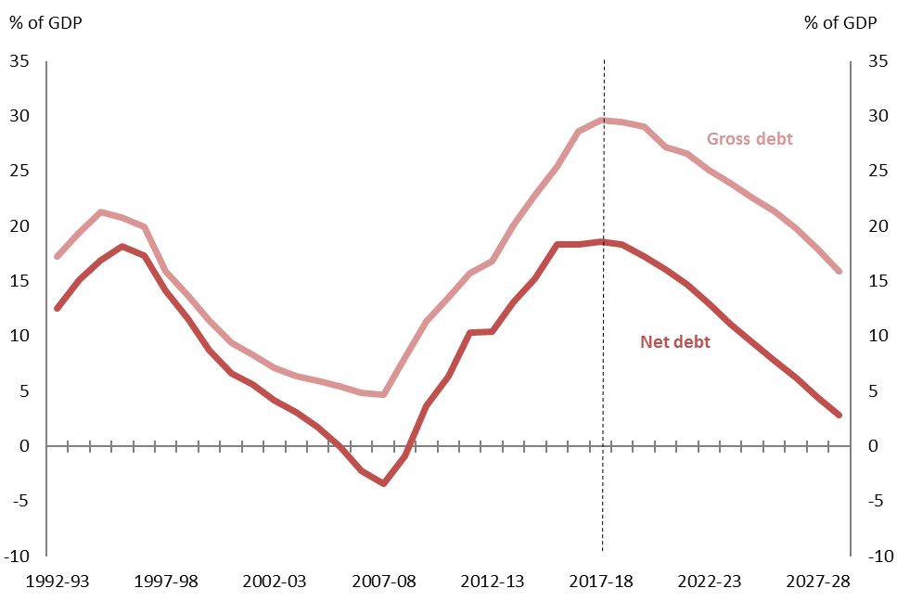
Note: Vertical dotted line indicates the break between historical data and estimates. Figures are for the Commonwealth Government.
Source: PBO Report 03/2018: 2018–19 Budget: medium-term projections.
While we had the advantage, compared with most other countries, that we started with very low levels of government debt, this period illustrated that economic shocks can have a significant impact on a country’s fiscal position.
Over the period since the GFC and the very significant boom and bust in commodity prices that Australia faced, successive Governments have taken a range of decisions to repair our budget position. The budget deficit has been wound back and the latest result is that in 2017-18, the Commonwealth ran a deficit of just $10 billion or 0.6 per cent of GDP.
Over the next 10 years, the PBO’s projections are that the budget will move into surplus and remain there. And, as previously illustrated, that net debt will fall back to below 5 per cent of GDP. These projections are based on an assumption that the economy evolves as projected by the Government and are based on the policy settings that applied at the most recent budget.

Figure 2: Underlying cash balance
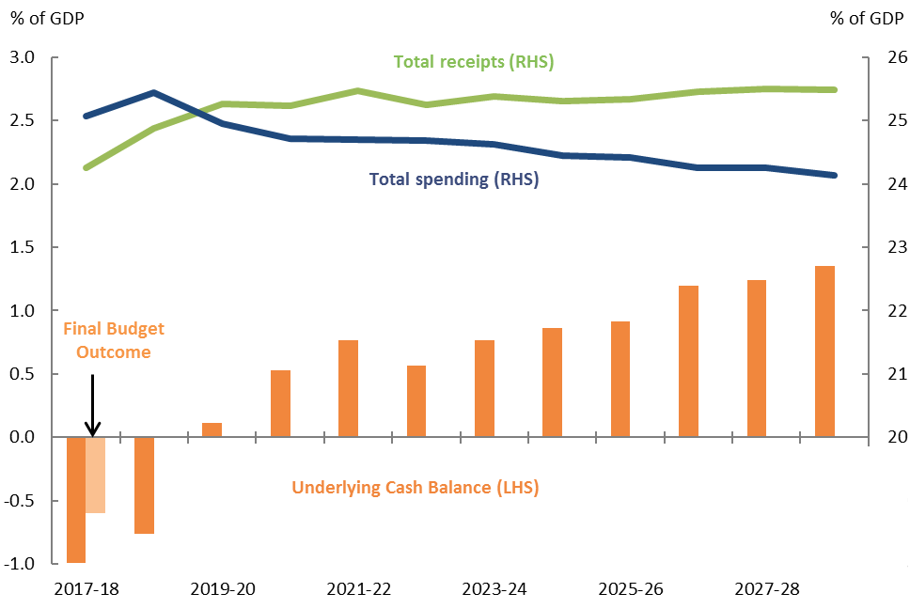
Notes:
- Net Future Fund earnings are included in the underlying cash balance from 2020–21 consistent with the 2018–19 Budget treatment.
- The Final Budget Outcome revealed a deficit of 0.6 per cent of GDP in 2017–18. Payments in 2017-18 were 0.5 per cent of GDP lower than estimated at the 2018-19 Budget. This downward revision is not reflected in the projections.
Source: PBO Report 03/2018: 2018–19 Budget: medium-term projections.
We have highlighted in our published research that this return to surplus is being driven by a combination of a pick-up in revenues (or tax receipts), primarily personal income tax, and ongoing spending restraint.

Figure 3: Receipts and payments following the global financial crisis
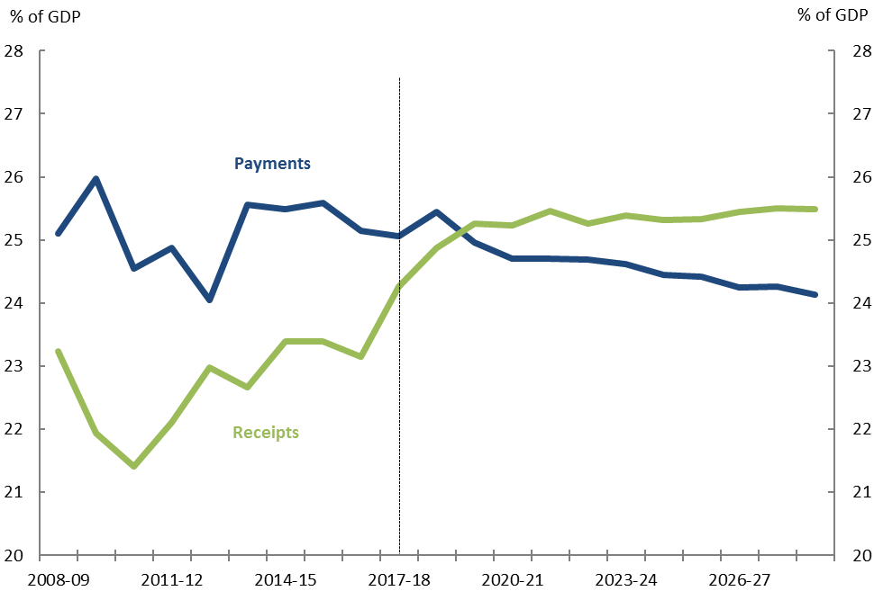
Note: Vertical dotted line indicates the break between historical data and estimates.
Source: PBO report 03/2018: 2018–19 Budget: medium-term projections.
The reductions in spending as a share of the economy in part reflect the series of difficult policy decisions that have been taken by successive Governments to constrain spending across a number of major programs.

What are the fiscal risks in the medium term?
The PBO has identified a number of risks to the medium-term outlook for the Budget.
There is the risk that economic growth will not be able to be sustained over these 10 years at the rate projected by the Government and, in particular, a risk that wages growth will take longer to return to historical levels. This is always a risk with longer-term projections and either of these outcomes would lead to lower budget surpluses and higher net debt than projected.
There is also a risk that a number of specific taxes, particularly consumption taxes, may raise less revenue than is currently predicted because of structural changes taking place in the economy. The switch to more fuel efficient vehicles, for example, is likely to decrease the amount of fuel excise collected in the future.
Finally, these projections assume that there are no new spending initiatives beyond those contained in the budget. Given the policy announcements that have been made since budget and given the public discussion around pressures across a number of areas, there is clearly a risk that government spending will increase above the levels contained in our projections.

Long-term fiscal pressures
Let me now turn briefly to the longer-term pressures the Australian Government will face, just like many Governments around the world.
The last Intergenerational Report (IGR) was released by the Government in 2015. This provided a
long-term, 40-year outlook for fiscal policy. While a significant number of policy settings have changed since 2015, the report is still useful as it identified the key fiscal pressures that are going to build over the next forty years.
The IGR and others identified three broad sources of fiscal pressure:
- first, pressure from the ageing of the population
- second, pressure arising from increasing expectations of citizens, particularly for expenditure on health care, and
- third, pressure arising to address challenges stemming from technological and structural changes.

Ageing of the population
Australia’s population has aged significantly since the 1970s and is projected to continue doing so. Lower mortality rates (and hence increasing life expectancy) coupled with falling fertility rates will see an increasing proportion of people aged over 65 in the population.
This means the proportion of Australians in the labour force will shrink, reducing the potential for growth in the economy and reducing growth in future tax revenues.

Figure 4: Ratio of working age people to those aged 65 years and over
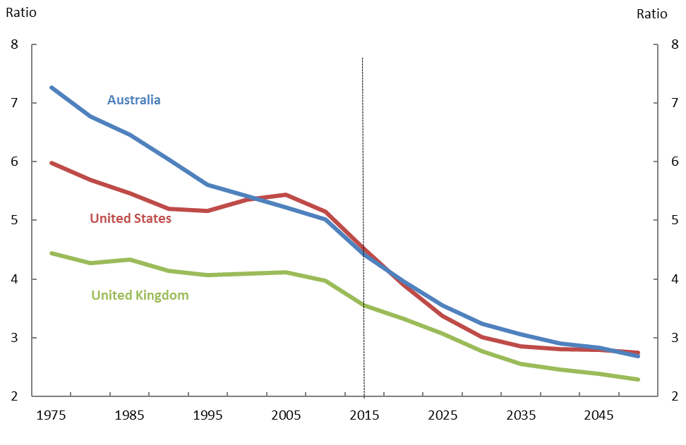
Note: Vertical dotted line indicates the break between historical data and estimates.
Source: United Nations, 2017 Revision of World Population Prospects.
To illustrate, in 1975, there were over 7 people of working age for every person aged 65 and over, in 2015 there were around 4½, and by mid-century there are projected to be under 3 working age people for every older person.
Australia is unique in the size of our post-war baby boom. Over the past several decades, Australia received an economic and budget benefit from having such a large baby boomer generation joining the workforce. This is now being unwound. The impact of ageing on Age Pension payments is already evident and is likely to peak during the 2020s. As the baby boomers move into their 70s and 80s, there will be subsequent waves of pressures on the health and aged care systems.

Increasing consumer expectations - health care
The second significant source of pressure over the next few decades in Australia is likely to be on health care spending.

Figure 5: Historical heath spending by source
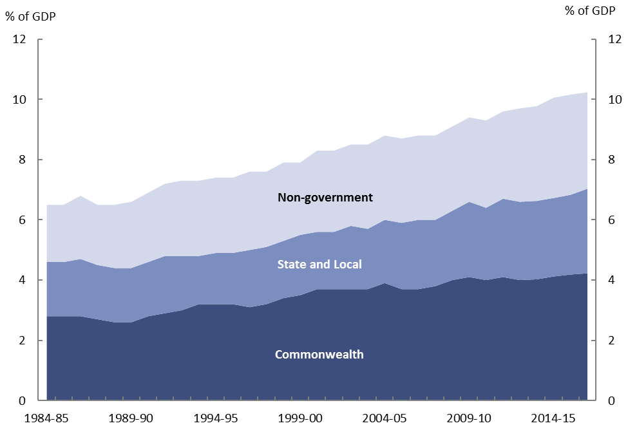
Note: ‘Non-government’ includes out of pocket expenses not covered by the Medicare Benefits Scheme or the Pharmaceutical Benefits Scheme and payments by private health insurance funds.
Source: Australian Institute of Health and Welfare.
Over the past few decades, higher incomes have been associated with significant increases in the share of spending on health care services. Since the mid 1980s, total spending on health has increased by over 3½ percentage points of GDP, and the Commonwealth contribution has increased by around 1½ percentage points of GDP. The trend increase in total health spending is likely to continue.
As the IGR and the Productivity Commission have noted, the key drivers of the health care costs over the next 40 years are non-demographic—in fact only around 10 per cent of the projected increase in real expenditure per person is due to population ageing. The main contributors to future health spending growth include changes in disease rates – particularly increases in chronic diseases – technological change and individual preferences.
Improvements in technology have improved treatment options for a range of conditions, expanding the health care market and/or displacing existing services with more costly alternatives. This is already evident in spending programs such as Medicare, where a combination of consumer demand and new technology has led to new diagnostic imaging items being made eligible for government rebates. This, in turn, has led to a significant increase in spending on these services.
The pressure for governments has been, and will continue to be, to decide which of these health services are worthy of government funding and to what degree.

Technological change
It is evident that we are living in a time of significant technological innovation that will continue to change the ways in which we live and work. There is a lot of debate in this area around the impact of technology on productivity, on what it means for the future of work and on the distribution of income. These are each substantial issues upon which there are a wide range of views.
They key point I would like to make is that, from a budgetary perspective, these changes should prompt a re-examination of our assumptions about our taxation and spending arrangements. They should prompt us to think about the most efficient way to collect taxes, and where the greatest benefit for public spending might be.

Conclusion
In conclusion, Australia has done a very good job of managing fiscal policy in the past. We have always been at the forefront of providing transparency around budget projections, and we have a history of taking tough policy decisions—including reforms of both payments and taxation systems—to ensure fiscal policy is sustainable. It is considerably better to implement such reforms in a measured and considered way, ahead of a crisis emerging.
The challenge for Australia is to manage the next set of fiscal pressures that are emerging in a similarly responsible way.

Thanks to Linda Ward, Anupam Sharma, Samuel Pelly and Cid Mateo for their assistance with this speech.
PBO Report 03/2018, 2018-19 Budget: medium-term projections. By legislation, the PBO is required to use the Government’s macroeconomic forecasts to underpin its projections.
PBO Report 02/2018, Trends affecting the sustainability of Commonwealth taxes.
2015 Intergenerational Report: Australia in 2055, p. 62.
PBO Report 05/2017, 2017-18 Budget medium-term projections: economic scenario analysis examined the budgetary impact of both temporary and permanent economic shocks. It also illustrated that the future evolution of interest rates is crucial to long-term budgetary analysis.

