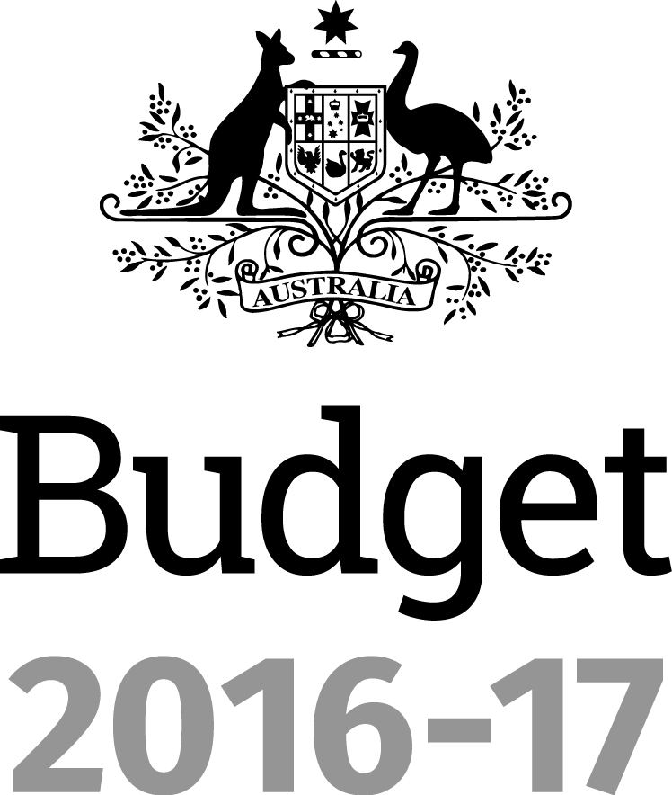
Portfolio Budget Statements 2016–17
Budget Related Paper No. 1. 17D
Parliamentary Budget Office

Budget Initiatives and Explanations of
Appropriations Specified by Outcomes and Programs by Entity

© Commonwealth of Australia 2016
ISBN 978-0-9944547-4-4
This publication is available for your use under a Creative Commons BY Attribution 3.0 Australia licence, with the exception of the Commonwealth Coat of Arms, the Parliamentary Budget Office (PBO) logo, photographs, images, signatures and where otherwise stated. The full licence terms are available from http://creativecommons.org/licenses/by/3.0/au/legalcode.
Use of PBO material under a Creative Commons BY Attribution 3.0 Australia licence requires you to attribute the work (but not in any way that suggests that the PBO endorses you or your use of the work).
The PBO material used 'as supplied'
Provided you have not modified or transformed PBO material in any way including, for example, by changing the PBO text; calculating percentage changes; graphing or charting data; or deriving new statistics from published PBO statistics – then the PBO prefers the following attribution:
Source: Parliament of Australia, Parliamentary Budget Office
Derivative material
If you have modified or transformed PBO material, or derived new material from those of the PBO in any way, then the PBO prefers the following attribution:
Based on Parliament of Australia, Parliamentary Budget Office data
Use of the Coat of Arms
The terms under which the Coat of Arms can be used are set out on the It’s an Honour website (see www.itsanhonour.gov.au)
Other uses
Enquiries regarding this licence and any other use of this document are welcome at:
Karen Williams, Assistant Parliamentary Budget Officer, (02) 6277 9520.
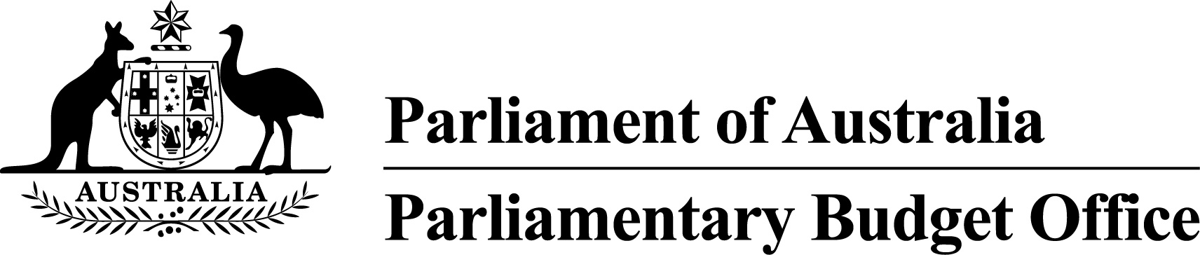Phil Bowen PSM FCPA
Parliamentary Budget Officer
Senator the Hon Stephen Parry
President of the Senate
Parliament House
CANBERRA ACT 2600
The Hon Tony Smith MP
Speaker of the House of Representatives
Parliament House
CANBERRA ACT 2600
Dear Mr President and Mr Speaker
I hereby submit Portfolio Budget Statements in support of the 2016–17 Budget for the Parliamentary Budget Office.
I present these statements to provide accountability to the Parliament and through it, the public.
Yours sincerely
Phil Bowen
27 April 2016

Abbreviations and conventions
The following notation may be used:
NEC/nec not elsewhere classified
- nil
.. not zero, but rounded to zero
na not applicable (unless otherwise specified)
nfp not for publication
$m $ million
$b $ billion
Figures in tables and in the text may be rounded. Figures in text are generally rounded to one decimal place, whereas figures in tables are generally rounded to the nearest thousand. Discrepancies in tables between totals and sums of components are due to rounding.

Enquiries
Should you have any enquiries regarding this publication please contact Jenny Jacobs, Chief Financial Officer, Parliamentary Budget Office on (02) 6277 9522.
A copy of this document can be located on the Australian Government Budget website at: www.budget.gov.au.

User guide
to the
Portfolio Budget Statements

User guide
The purpose of the 2016–17 Portfolio Budget Statements (PB Statements) is to inform Senators and Members of Parliament of the proposed allocation of resources to the Parliamentary Budget Office (PBO) outcome. The PBO receives resources from the annual parliamentary departments appropriations acts and a special appropriation.
A key role of the PB Statements is to facilitate the understanding of proposed annual appropriations in Appropriation (Parliamentary Departments) Bill (No. 1) 2016–17. In this sense the PB Statements are Budget related papers and are declared by the appropriation acts to be ‘relevant documents’ to the interpretation of the acts according to section 15AB of the Acts Interpretation Act 1901.
The PB Statements provide information, explanation and justification to enable Parliament to understand the purpose of each outcome proposed in the Bill.
Contents
Department overview 1
Parliamentary Budget Office overview 3
Parliamentary Budget Office 5

Department overview

Parliamentary Budget Office overview

Departmental responsibilities
The Parliamentary Budget Office (PBO) is one of four parliamentary departments supporting the Australian Parliament.
The purpose of the PBO is to inform the Parliament by providing independent and non-partisan analysis of the budget cycle, fiscal policy and the financial implications of proposals.
The Parliamentary Budget Officer, under the Presiding Officers, is responsible for leading and managing the PBO.
As set out in the Parliamentary Service Act 1999, the Parliamentary Budget Officer has the following functions:
- outside the caretaker period for a general election, to prepare policy costings on request by Senators and Members, with the requests and the PBO’s responses to be kept confidential if so directed by the requestor
- during the caretaker period for a general election, to prepare costings of publicly announced policies on request by authorised members of parliamentary parties or independent parliamentarians, with the requests and the PBO’s responses to be made public
- to prepare responses (other than policy costings) to requests relating to the budget from Senators and Members, with the requests and the PBO’s responses to be kept confidential if so directed by the requestor
- to prepare submissions to inquiries of parliamentary committees, on request by such committees, with the requests and the PBO’s responses to be made public
- after a general election, to report on the budget impacts of the election commitments of designated parliamentary parties
- to conduct, on his or her own initiative, research on the budget and fiscal policy settings, with the results of this work to be made public.

Parliamentary Budget Office
Entity resources and planned performance

Parliamentary Budget Office
Section 1: Entity overview and resources 7
1.1 Strategic direction statement 7
1.2 Entity resource statement 8
Section 2: Outcome and planned performance 9
2.1 Budgeted expenses and performance 9
Section 3: Budgeted financial statements 11
3.1 Budgeted financial statements 11

Parliamentary Budget Office

Section 1: Entity overview and resources

1.1 Strategic direction statement
The Parliamentary Budget Office (PBO), as an independent and non-partisan institution, engages with the Parliament to help improve the integrity of the policy development process, better inform public policy debates and strengthen budget and fiscal policy transparency.
To support the 2016–17 Portfolio Budget Statements (PB Statements) and in accordance with section 64Q of the Parliamentary Service Act 1999, the Parliamentary Budget Officer, in consultation with the Joint Committee of Public Accounts and Audit, will prepare a work plan for the PBO setting out:
- the priorities of the PBO for the 2016–17 financial year
- protocols for the allocation of the resources of the PBO during the financial year.
The PBO’s 2016–17 work plan will be released before 1 July 2016.
Ahead of the release of the 2016–17 work plan, section 2 of the 2016–17 PB Statements provides detail on the PBO’s outcome and planned performance.

1.2 Entity resource statement
Table 1.1 shows the total resources from all sources. The table summarises how resources will be applied by the PBO.
Table 1.1: PBO resource statement—Budget estimates for 2016–17
as at Budget May 2016
Prepared on a resourcing (i.e. appropriations available) basis.
Please note: All figures shown above are GST exclusive—these may not match figures in the cash flow statement.
- Appropriation (Parliamentary Departments) Bill (No.1) 2016–17.
- Parliamentary Service Act 1999.

Section 2: Outcome and planned performance
The Parliamentary Budget Office (PBO) outcome is described below, specifying the performance indicators and targets used to assess and monitor the performance of the PBO. This performance information is detailed in the PBO’s 2016–17 work plan.
The outcome described below provides detailed information on expenses broken down by funding source.

2.1 Budgeted expenses and performance
Outcome:
To inform the Parliament by providing independent and non-partisan analysis of the budget cycle, fiscal policy and the financial implications of proposals

Budgeted expenses
This table shows how much the PBO intends to spend (on an accrual basis) on achieving its outcome, broken down by funding sources.
Table 2.1.1: Budgeted expenses for its Outcome
- Departmental Appropriation comprises ‘Ordinary annual services (Appropriation (Parliamentary Departments) Bill (No.1))’.
- Expenses not requiring appropriation in the Budget year are made up of depreciation expenses, amortisation expenses, and resources received free of charge.
Note: Departmental appropriation splits and totals are indicative estimates and may change in the course of the budget year as government priorities change.

Table 2.1.2: Performance criteria for its outcome
Table 2.1.2 below details the performance criteria for the PBO’s program.
Outcome:
To inform the Parliament by providing independent and non-partisan analysis of the budget cycle, fiscal policy and the financial implications of proposals
Program 1—Parliamentary Budget Office (PBO)
To help level the playing field for all parliamentarians by providing access to costing and budget analysis services, and to enhance the transparency of election commitments and the budget and fiscal policy settings more generally.
Delivery | The PBO, as an independent and non-partisan institution, engages with the Parliament to help improve the integrity of the policy development process, better inform public policy debates and strengthen budget and fiscal policy transparency.
Performance information
Year | Performance criteria | Targets
2015–16 | The PBO’s performance will be judged by the relevance, quality and timeliness of its outputs as assessed by feedback from key parliamentary and external stakeholders.  The independence, transparency and integrity of the PBO’s processes will be another important indicator of performance. | These indicators will be measured by the extent of the demand for the PBO’s services and citations of the PBO’s outputs in the media.
2016–17 | As above | As above
2017–18 and beyond | As above | As above
Purpose | The purpose of the PBO is to inform the Parliament by providing independent and non-partisan analysis of the budget cycle, fiscal policy and the financial implications of proposals.

Section 3: Budgeted financial statements
Section 3 presents explanatory tables and budgeted financial statements which provide a comprehensive snapshot of entity finances for the 2016–17 budget year.

3.1 Budgeted financial statements

3.1.1 Explanatory notes and analysis of budgeted financial statements
The financial statements contain estimates prepared in accordance with the requirements of the Australian Government’s financial budgeting and reporting framework, including Australian Accounting Standards, as well as specific guidelines issued by the Department of Finance.
The financial statements have been prepared on an accrual and fair value basis and are in accordance with the historical cost convention, with the exception of employee entitlements.

Budgeted financial statements
Under the Australian Government’s accrual budgeting framework, transactions that entities control (entity transactions) are separately budgeted for and reported from transactions entities do not have control over (administered transactions).
Entity assets, liabilities, revenue and expenses are those which are controlled by the entity. Entity expenses include employee and supplier expenses and other administrative costs, which are incurred by the entity in providing its goods and services to the Australian Parliament.

Budgeted comprehensive income statement
Under the net cash appropriation framework the Parliamentary Budget Office (PBO) receives an appropriation to meet budgeted expenses (except depreciation). This appropriation is recognised as revenue.
The PBO received a special appropriation at the time of its establishment. The special appropriation is recognised as revenue in the year the funds are spent. The associated expense is recognised in the comprehensive income statement except where the PBO has purchased assets, which are recognised in the balance sheet.
The PBO is budgeting for a break-even operating result for 2016–17 and the forward years, after non-appropriation expenses such as depreciation are removed.
The PBO has sufficient cash reserves to fund provisions and payables, and asset replacement, as they fall due across the forward estimates period.

3.1.2 Budgeted financial statements tables
Table 3.1: Comprehensive income statement (showing net cost of services)
for the period ended 30 June

Note: Impact of net cash appropriation arrangements
Prepared on Australian Accounting Standards basis.

Table 3.2: Budgeted departmental balance sheet (as at 30 June)
* ‘Equity’ is the residual interest in assets after deduction of liabilities.
Prepared on Australian Accounting Standards basis.

Table 3.3: Departmental statement of changes in equity—
summary of movement (Budget year 2016–17)
Prepared on Australian Accounting Standards basis.

Table 3.4: Budgeted departmental statement of cash flows
(for the period ended 30 June)
Prepared on Australian Accounting Standards basis.
Table 3.5: Departmental capital budget statement (for the period ended 30 June)
Prepared on Australian Accounting Standards basis.

Table 3.6: Statement of asset movements (Budget year 2016–17)
Prepared on Australian Accounting Standards basis.

