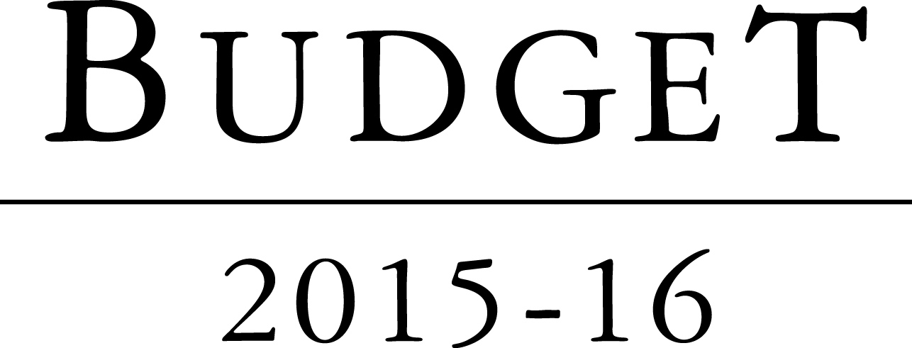

**Portfolio Budget Statements 2015–16**

**Budget Related Paper No. 1.17D**

parliamentary budget office

Budget Initiatives and Explanations of

Appropriations Specified by Outcomes

and Programmes by Entity

© Commonwealth of Australia 2015

ISBN 978-0-9925131-0-8

This publication is available for your use under a [Creative Commons BY Attribution 3.0 Australia](http://creativecommons.org/licenses/by/3.0/au/deed.en) licence, with the exception of the Commonwealth Coat of Arms, the Parliamentary Budget Office (PBO) logo, photographs, images, signatures and where otherwise stated. The full licence terms are available from <http://creativecommons.org/licenses/by/3.0/au/legalcode>.



Use of PBO material under a [Creative Commons BY Attribution 3.0 Australia](http://creativecommons.org/licenses/by/3.0/au/deed.en) licence requires you to attribute the work (but not in any way that suggests that the PBO endorses you or your use of the work).

*The PBO material used 'as supplied'*

Provided you have not modified or transformed PBO material in any way including, for example, by changing the PBO text; calculating percentage changes; graphing or charting data; or deriving new statistics from published PBO statistics – then the PBO prefers the following attribution:

*Source: Parliament of Australia, Parliamentary Budget Office*

**Derivative material**

If you have modified or transformed PBO material, or derived new material from that of the PBO in any way, then the PBO prefers the following attribution:

*Based on Parliament of Australia, Parliamentary Budget Office data*

**Use of the Coat of Arms**

The terms under which the Coat of Arms can be used are set out on the It’s an Honour website (see [www.itsanhonour.gov.au](http://www.itsanhonour.gov.au)).

**Other uses**

Enquiries regarding this licence and any other use of this document are welcome at:

Karen Williams, Assistant Parliamentary Budget Officer, (02) 6277 9520

Phil Bowen PSM FCPA  
Parliamentary Budget Officer

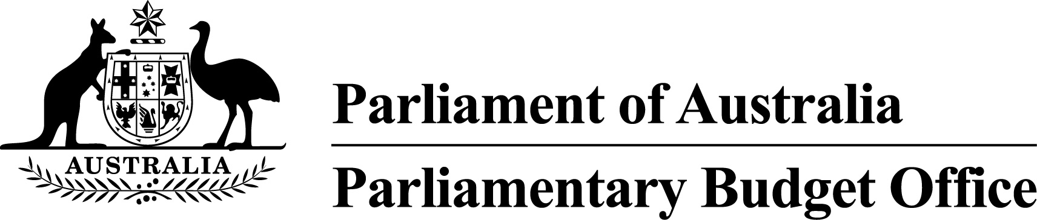

The Hon Bronwyn Bishop MP

Speaker of the House of Representatives

Parliament House

CANBERRA ACT 2600

Senator the Hon Stephen Parry

President of the Senate

Parliament House

CANBERRA ACT 2600

Dear Madam Speaker and Mr President

I hereby submit Portfolio Budget Statements in support of the 2015–16 Budget for the Parliamentary Budget Office (PBO).

These statements have been developed, and are submitted to the Parliament, as a statement on the outcomes for the PBO.

I present these statements to provide accountability to the Parliament and, through it, the public.

Yours sincerely

Phil Bowen

1 May 2015

#### Abbreviations and conventions

The following notation may be used:

NEC/nec not elsewhere classified

- nil

.. not zero, but rounded to zero

na not applicable (unless otherwise specified)

nfp not for publication

$m $ million

$b $ billion

Figures in tables and in the text may be rounded. Figures in text are generally rounded to one decimal place, whereas figures in tables are generally rounded to the nearest thousand. Discrepancies in tables between totals and sums of components are due to rounding.

#### Enquiries

Should you have any enquiries regarding this publication please contact Jenny Jacobs, Chief Financial Officer, Parliamentary Budget Office on (02) 6277 9522.

A copy of this document can be located on the Australian Government Budget website at: www.budget.gov.au.

User guide

to the

Portfolio Budget Statements

# User guide

The purpose of the 2015–16 Portfolio Budget Statements (PB Statements) is to inform Senators and Members of Parliament of the proposed allocation of resources to the Parliamentary Budget Office (PBO) outcome. The PBO receives resources from the annual parliamentary departments appropriations acts and a special appropriation.

A key role of the PB Statements is to facilitate the understanding of proposed annual appropriations in Appropriation (Parliamentary Departments) Bill (No. 1) 2015–16. In this sense the PB Statements are Budget related papers and are declared by the appropriation acts to be ‘relevant documents’ to the interpretation of the acts according to section 15AB of the *Acts Interpretation Act 1901*.

The PB Statements provide information, explanation and justification to enable Parliament to understand the purpose of each outcome proposed in the Bill.

Contents

Department overview 1

Entity resources and planned performance 5

Parliamentary Budget Office 7

Department overview

# Parliamentary Budget Office overview

## Department responsibilities

The Parliamentary Budget Office (PBO) is one of four parliamentary departments supporting the Australian Parliament.

The purpose of the PBO is to inform the Parliament by providing independent and non-partisan analysis of the budget cycle, fiscal policy and the financial implications of proposals.

The Parliamentary Budget Officer, under the Presiding Officers, is responsible for leading and managing the PBO.

As set out in the *Parliamentary Service Act 1999*, the Parliamentary Budget Officer has the following functions:

* outside the caretaker period for a general election, to prepare policy costings on request by Senators and Members, with the requests and the PBO’s responses to be kept confidential if so directed by the requestor
* during the caretaker period for a general election, to prepare costings of publicly announced policies on request by authorised members of parliamentary parties or independent members
* to prepare responses (other than policy costings) to requests relating to the budget from Senators and Members, with the requests and the PBO’s responses to be kept confidential if so directed by the requestor
* to prepare submissions to inquiries of parliamentary committees, on request by such committees, with the requests and the PBO’s responses to be made publicly available
* after a general election, to report on the costs of the election commitments of designated parliamentary parties
* to conduct, on his or her own initiative, research on the budget and fiscal policy settings, with the results of this work to be made publicly available.

### Department resources

Table 1 shows the total new resources provided to the PBO in the 2015–16 budget year.

Table 1: Department resources 2015–16



Parliamentary Budget Office

Entity resources and planned performance

Parliamentary Budget Office

Section 1: Entity overview and resources 9

1.1 Strategic direction statement 9

1.2 Entity resource statement 10

1.3 Budget measures 11

Section 2: Outcomes and planned performance 12

2.1 Outcomes and performance information 12

Section 3: Explanatory tables and budgeted financial statements 15

3.1 Explanatory tables 15

3.2 Budgeted financial statements 16

# Parliamentary Budget Office

## Section 1: Entity overview and resources

### 1.1 Strategic direction statement

The Parliamentary Budget Office (PBO), as an independent and non-partisan institution, engages with the Parliament to help improve the integrity of the policy development process, better inform public policy debates and strengthen budget and fiscal policy transparency.

To support the 2015–16 Portfolio Budget Statements and in accordance with section 64Q of the *Parliamentary Service Act 1999*, the Parliamentary Budget Officer, in consultation with the Joint Committee of Public Accounts and Audit, will prepare a work plan for the PBO setting out:

* the priorities of the PBO for the 2015–16 financial year
* protocols for the allocation of the resources of the PBO during the financial year.

The PBO’s 2015–16 work plan will be released before 1 October 2015.

Ahead of the release of the 2015–16 work plan, section 2 of the   
2015–16 Portfolio Budget Statements provides detail on the PBO’s outcome and planned performance.

There is one measure for the 2015–16 Budget affecting the PBO detailed at section 1.3 - Budget measures.

### 1.2 Entity resource statement

Table 1.1 shows the total resources from all sources. The table summarises how resources will be applied by outcome and classification.

Table 1.1: PBO resource statement — Budget estimates for 2015–16 as at   
Budget May 2015



1. Appropriation (Parliamentary Departments) Bill (No.1) 2015–16.

Reader note: All figures are GST exclusive.

### 1.3 Budget measures

Budget measures in Part 1 relating to the PBO are detailed in Budget Paper No. 2 and are summarised below.

Table 1.2: Entity 2015–16 Budget measures

Part 1: Measures announced since the 2014–15 Mid-Year Economic and Fiscal Outlook (MYEFO)



Prepared on a Government Finance Statistics (fiscal) basis.

## Section 2: Outcomes and planned performance

### 2.1 Outcomes and performance information

The Parliamentary Budget Office (PBO) outcome is described below, specifying the performance indicators and targets used to assess and monitor the performance of the PBO. This performance information will be further detailed in the PBO’s the   
2015–16 work plan.

|  |
| --- |
| Outcome:  To inform the Parliament by providing independent and non-partisan analysis of the budget cycle, fiscal policy and the financial implications of proposals |

##### Outcome expense statement

Table 2.1 provides an overview of the total expenses for its outcome.

Table 2.1: Budgeted expenses for its Outcome



1. Departmental Appropriation combines ‘Ordinary annual services   
   (Appropriation (Parliamentary Departments) Bill (No. 1))’ and ‘Revenue from independent sources   
   (s 74 of the *Public Governance, Performance and Accountability Act 2013*)’.
2. Expenses not requiring appropriation in the Budget year are made up of depreciation expenses, amortisation expenses, and resources received free of charge.

Note: Departmental appropriation splits and totals are indicative estimates and may change in the course of the Budget year as government priorities change.

#### Contributions to its Outcome

|  |
| --- |
| Programme: Parliamentary Budget Office |

|  |
| --- |
| Programme objective  To help level the playing field for all parliamentarians by providing access to costing and budget analysis services, and enhance the transparency of election commitments and the budget and fiscal policy settings more generally. |

|  |
| --- |
| Programme expenses  The estimates for 2015–16 reflect additional funding to allow the PBO to augment its analytical capability and permanent workforce in the lead-up to a general election. In addition, the estimates reflect the PBO’s use of its special appropriation in 2015–16 and across the forward estimates. |

**Table 2.2: Programme expenses**



1. Expenses not requiring appropriation in the Budget year are made up of depreciation expenses, amortisation expenses and resources received free of charge.

|  |
| --- |
| Programme deliverables   * Undertake policy costings and budget analyses, in response to requests from Senators and Members. * Prepare submissions to inquiries of parliamentary committees, on request by such committees. * Undertake a self-initiated program of published research to promote a better understanding of the budget and fiscal policy settings. * After a general election, report on the election commitments of designated parliamentary parties. |

|  |
| --- |
| Programme key performance indicators   * The relevance, quality and timeliness of outputs, based on feedback from stakeholders. * The independence, transparency and integrity of processes. |

## Section 3: Explanatory tables and budgeted financial statements

Section 3 presents explanatory tables and budgeted financial statements which provide a comprehensive snapshot of entity finances for the 2015–16 budget year. It explains how budget plans are incorporated into the financial statements and provides further details of the reconciliation between appropriations and programme expenses, movements in administered funds, special accounts and government Indigenous expenditure.

### 3.1 Explanatory tables

#### 3.1.1 Movement of administered funds between years

The Parliamentary Budget Office (PBO) does not have administered funding.

#### 3.1.2 Special accounts

The PBO does not have any special accounts.

#### 3.1.3 Australian Government Indigenous expenditure

The PBO does not have any Australian Government Indigenous expenditure.

### 3.2 Budgeted financial statements

#### 3.2.1 Differences in entity resourcing and financial statements

There are no material differences between the entity resourcing table and the financial statements.

#### 3.2.2 Analysis of budgeted financial statements

The PBO is budgeting for a surplus of $0.4 million for 2015–16 as a result of recognising the use of funds from the PBO’s special appropriation as revenue to complete projects which will be capitalised rather than expensed.

From 2016–17 onwards the PBO is budgeting for a break-even operating result, after non-appropriation expenses such as depreciation are removed.

The PBO has sufficient cash reserves to fund provisions and payables, and asset replacement, as they fall due across the forward estimates period.

#### 3.2.3 Budgeted financial statements tables

Table 3.2.1: Comprehensive income statement (showing net cost of services) for the period ended 30 June



Prepared on Australian Accounting Standards basis.

Table 3.2.2: Budgeted departmental balance sheet (as at 30 June)



* ‘Equity’ is the residual interest in assets after deduction of liabilities.

Prepared on Australian Accounting Standards basis.

Table 3.2.3: Departmental statement of changes in equity —   
summary of movement (Budget year 2015–16)



Prepared on Australian Accounting Standards basis.

Table 3.2.4: Budgeted departmental statement of cash flows   
(for the period ended 30 June)



Prepared on Australian Accounting Standards basis.

Table 3.2.5: Departmental capital budget statement   
(for the period ended 30 June)



Prepared on Australian Accounting Standards basis.

Table 3.2.6: Statement of asset movements (Budget year 2015–16)



Prepared on Australian Accounting Standards basis.

#### 3.2.4 Notes to the financial statements

The financial statements contain estimates prepared in accordance with the requirements of the Australian Government’s financial budgeting and reporting framework, including Australian Accounting Standards, as well as specific guidelines issued by the Department of Finance.

The financial statements have been prepared on an accrual and fair value basis and are in accordance with the historical cost convention, with the exception of employee entitlements.

##### Budgeted financial statements

Under the Australian Government’s accrual budgeting framework, transactions that entities control (entity transactions) are separately budgeted for and reported from transactions entities do not have control over (administered transactions).

Entity assets, liabilities, revenue and expenses are those which are controlled by the entity. Entity expenses include employee and supplier expenses and other administrative costs, which are incurred by the entity in providing its goods and services to the Australian Parliament.

The PBO does not have any administered transactions.

##### Budgeted comprehensive income statement

Under the net cash appropriation framework the PBO receives an appropriation to meet budgeted expenses (except depreciation). This appropriation is recognised as revenue.

The PBO received a special appropriation at the time of its establishment. The special appropriation is recognised as revenue in the year the funds are spent. The associated expense is recognised in the comprehensive income statement except where the PBO has purchased assets, which are recognised in the balance sheet.