Parliamentary Budget Office
work plan 2017–18

© Commonwealth of Australia 2017
ISSN 2201-232X (Print)
ISSN 2202-6398 (Online)
This work is licensed under the Creative Commons Attribution-NonCommercial-NoDerivs 3.0 Australia Licence.
The details of this licence are available on the Creative Commons website: http://creativecommons.org/licenses/by-nc-nd/3.0/au/
Use of the Coat of Arms
The terms under which the Coat of Arms can be used are detailed on the following website: www.itsanhonour.gov.au/coat-arms
Produced by: Parliamentary Budget Office
Designed by: Studio Tweed
Printed by: Prinstant
Cover photograph by:
Assistant Parliamentary Budget Officer
Corporate Strategy Branch
Parliamentary Budget Office
Parliament House
PO Box 6010
CANBERRA ACT 2600
Phone: (02) 6277 9500
Email: pbo@pbo.gov.au

Contents
Foreword v
Background 1
Priorities 2
Policy costings and budget analyses 2
Published research 3
Regular publications 3
Other research reports 4
Information papers 4
Post-election report of election commitments 5
Engagement with parliamentary committees 5
Capability building 5
External engagement 6
Accountability and performance 7
Organisation and resourcing 7
Structure 7
Allocation of resources 8
Governance and risk management 9
Budget 9
Staffing 10
Corporate services 10
Appendix A 11

Foreword
This work plan has been prepared following consultation with the Joint Committee of Public Accounts and Audit (JCPAA) in accordance with section 64Q of the Parliamentary Service Act 1999. It also serves as the corporate plan for the Parliamentary Budget Office (PBO) for the period 2017–18 to 2020–21 as required by section 35(1)(b) of the Public Governance, Performance and Accountability Act 2013.
Section 64T of the Parliamentary Service Act enables the JCPAA to seek an independent review of the PBO after a general election. On 14 November 2016 the JCPAA announced a review to focus on how the PBO could build on its foundations and strengthen its abilities. The review was completed in March 2017.
The review found that the PBO has been a successful institutional development in Australian governance that has filled a significant gap in Australia's public policy landscape. The review confirmed the PBO is regarded by stakeholders as an independent and non-partisan organisation that produces rigorous analysis relevant to the public policy debate. It noted that demand for the PBO’s costing and budget analysis services has continued to grow at a significant rate.
Sixteen recommendations were made in relation to how we could further improve our operations and effectiveness. The PBO agrees with all recommendations. Our responses and proposed actions are reflected in this work plan.
In developing this work plan we have more broadly consulted with parliamentary committees to ensure our research topics are of interest to the Parliament and we have offered to provide briefings to committees on the outcomes of our research. We will also continue to respond to requests for assistance from parliamentary committees on issues that fall within our mandate.
Our planned work over the coming year will position the PBO well to meet the expected increase in demand for our services in the lead up to the next general election.
Jenny Wilkinson
Parliamentary Budget Officer
22 September 2017

Background
- The Parliamentary Budget Officer is an independent statutory officer of the Australian Parliament and head of the PBO.
- The PBO’s purpose is to inform the Parliament by providing independent and non-partisan analysis of the budget cycle, fiscal policy and the financial implications of policy proposals.
- We aim to help level the playing field for all parliamentarians by providing access to costing and budget analysis services, and to enhance the transparency and public understanding of budget information, fiscal policy settings, and the financial implications of election commitments.
- The Parliamentary Service Act gives the Parliamentary Budget Officer the following functions:
  - outside the caretaker period for a general election, to prepare policy costings on request by Senators and Members, with the requests and the PBO’s responses to be kept confidential if so directed by the requestor
  - during the caretaker period for a general election, to prepare costings of publicly announced policies on request by authorised members of parliamentary parties or independent parliamentarians, with the requests and the PBO’s responses to be made public
  - to prepare responses to other requests for budget analysis from Senators and Members, with the requests and the PBO’s responses to be kept confidential if so directed by the requestor
  - to prepare submissions to inquiries of parliamentary committees, on request by such committees, with the requests and the PBO’s responses to be made public
  - after a general election, to report on the budget impacts of the election commitments of designated parliamentary parties
  - to conduct research on, and analysis of, the budget and fiscal policy settings, with the results of this work to be made public.
- The Parliamentary Budget Officer is required to prepare a work plan for the PBO for each financial year, before 1 October each year. The work plan is to be prepared in consultation with the JCPAA and is to be made public.

Priorities
- Our priorities in 2017–18 are to:
  - prepare high quality policy costings and budget analyses at the request of parliamentarians in a timely manner
  - publish research that promotes a better public understanding of the budget and fiscal policy settings, with a particular focus on the sustainability of the budget over the medium term
  - engage effectively with parliamentary committees
  - develop and maintain our costing and projection models and databases
  - ensure we are appropriately prepared for the expected increase in demand for policy costing services in the lead up to the next general election.
- In addition to these priorities, over 2017–18 we will be implementing our responses to the PBO review to further improve our operations and effectiveness. Our responses to the review recommendations are included throughout this work plan, and summarised at Appendix A.
- Beyond 2017–18, we will continue to focus on meeting the demand for our services from parliamentarians and parliamentary committees, while maintaining our program of published research.

Policy costings and budget analyses
- In 2016–17, demand for policy costings and budget analyses quickly increased with the resumption of Parliament following the general election in July 2016, with a further surge in requests following the Mid-Year Economic and Fiscal Outlook in December 2016.
- In 2017–18, we will continue to liaise with parliamentarians to help ensure that their requests are given appropriate priority, recognising that our responsiveness is affected by a range of factors including policy complexity, availability of data and models, and total workload. We will consult on the principles and processes we use to set priorities across parliamentarian requests and will publicly release a guidance note that outlines these principles.
- We will also endeavour to improve the public understanding of the costing work we undertake by publishing papers that explain, in accessible language, the methodology underlying the policy costing process, the treatment of economy-wide impacts in costings and the factors that influence the reliability of costings.
- To increase transparency, we will regularly publish data on the number of policy announcements made with reference to our costings, and whether or not, and when, the underlying costing response document was released by the party or parliamentarian concerned. All costing response documents that are released by a party or parliamentarian will henceforth be available on the PBO website to improve transparency in relation to these costings.
- The Memorandum of Understanding between the Parliamentary Budget Officer and the Heads of Commonwealth Bodies in relation to the Provision of Information and Documents (the MOU) continues to provide a reasonable basis for the PBO to gain access to the information it needs to perform our functions.
- We will continue to maintain effective working relationships with Commonwealth agencies to facilitate the timely provision of information, including continuing with the standing information provision arrangements that we already have with several agencies. Where appropriate, we will establish new arrangements for data and model sharing with agencies.

Published research
- Our research program will continue to focus on fiscal sustainability over the medium term. It will also seek to improve budget transparency and promote a better public understanding of the budget and fiscal policy settings.
- The development of our research program has taken into account the recommendations of the review: that the work program is aligned with, and helps build the capacity of, our costing work; and that it builds our capacity to analyse the underlying drivers of the budget over the longer term.
- The program will comprise three strands of work in 2017–18 and beyond: regular publications; other research reports; and information papers.

Regular publications
- We plan to release the following regular publications each year:
  - a report on the medium-term (budget year plus 10 years) projections of receipts and payments following the Budget
  - a report on the national fiscal outlook over the forward estimates period, following the release of all Commonwealth, state and territory budgets
  - a chart pack, providing a graphical summary and highlighting the impacts of policy decisions and parameter changes, following the Budget.

Other research reports
- Our other research work is selected on the basis of its contribution to improving understanding of the underlying drivers of the budget over the medium term. This includes research into the relationships between economic parameters and major components of the Budget, as well as research into other underlying drivers of budget outcomes such as demographics and structural factors.
- Topics are chosen on the basis of their significance to the budget position and the need for detailed analysis to more accurately project the growth of major areas of revenue and expenditure.
- We plan to undertake and publish research in 2017–18 on the following issues, depending on the availability of resources:
  - analysis of the sensitivity of the medium-term budget estimates to changes in economic parameters such as the rate of productivity growth and interest rates
  - analysis of historic spending on significant programs such as the Disability Support Pension and the Pharmaceutical Benefits Scheme, with the objective of improving short and medium-term projection methodologies
  - analysis outlining the impact of ageing on the budget over the medium term
  - distributional analysis of personal income tax revenue trends over the medium term
  - analysis of trends affecting the sustainability of the tax base, including those due to the changing composition of the Australian workforce.

Information papers
- From time to time, the PBO publishes information papers in the form of technical notes and guidance notes. Technical notes are information papers that explain the concepts and methodologies that the PBO uses in preparing policy costings and budget analyses. Guidance notes provide Senators and Members with information on processes and procedures relating to policy costings and budget analyses, and the preparation of the post-election report.
- As noted above, we plan to publish a number of technical notes in 2017–18 on:
  - the methodology underlying the policy costing process
  - when it is appropriate for a policy costing to take into account economy-wide impacts (second round effects), and how this differs from the inclusion of direct behavioural responses in policy costings
  - factors influencing the reliability of policy proposal costings.

Post-election report of election commitments
- The Parliamentary Budget Officer is required, within 30 days after the end of the caretaker period for a general election, to prepare a post-election report of the budget impacts of the election commitments of each parliamentary party with five or more members in the Parliament immediately before the commencement of the caretaker period.
- In the next post-election report, we plan to extend the reporting of the financial impact of commitments from the forward estimates period to the medium term. That is, ten year projections of the financial impact of each election commitment will be provided.
- We are also exploring how the PBO could provide parliamentary political parties with fewer than five Senators or Members the option to have the financial impact of their election commitments included in the post-election report.

Engagement with parliamentary committees
- The JCPAA has an important oversight role in relation to the PBO. We will continue to engage with the JCPAA on a regular basis on our work plan, resourcing and efficiency, ensuring the Committee is provided with data to monitor the provision of information to the PBO through the MOU, and the level and timeliness of our outputs.
- We will continue to regularly appear before the Senate Finance and Public Administration Legislation Committee and will continue our practice of providing this Committee, as well as the JCPAA, with an up-to-date report on our activities prior to each hearing.
- In the development of the published research component of this work plan, we broadened our consultation to include parliamentary committees to further refine our research to topics of interest to the Parliament, as well as offering briefings to committees on our research work. Additionally, we will respond to requests for assistance from parliamentary committees on issues that fall within the PBO’s mandate.

Capability building
- We will continue to build our capabilities with a view to enhancing our ability to respond to parliamentarians’ requests for costings and budget analyses, and meeting our objective of improving public understanding of the Budget. Areas for continuing development include the acquisition and use of detailed datasets, in-house development of models covering major demand-driven expenditure programs and elements of the tax and transfer systems, and more in-depth analyses of data and modelling results.
- We will also continue to invest in technical training for staff focusing on developing our modelling, data analysis and programming skills. This will ensure that we are equipped to undertake analysis of complex policy issues, have the ability to take advantage of large datasets, and are able to use and build models based on those datasets.
- The increasing complexity of models and utilisation of large datasets is providing the PBO with an ability to deliver more robust modelling and distributional information in responses to requests from parliamentarians. At the same time, this stretches our information technology capacity and we are exploring ways to enhance our information technology effectiveness. This will be important in ensuring that we maintain our responsiveness to parliamentarians and the quality of our outputs.
- In May 2016, we implemented a workflow management system (WMS), replacing a number of spreadsheet-based registers, to keep track of requests received from parliamentarians and requests for information sent from the PBO to Commonwealth agencies. In early 2017, we undertook a review of the WMS and business processes to identify further efficiencies which could be achieved. Enhancements are currently being explored with the system vendor, with efficiencies expected to be implemented in 2017–18.
- We will continue to invest in developing and maintaining a strong understanding of policy issues. This is important in order to understand the context of policy costing requests and their relationship to other policy areas with which they interact.
- In 2017–18 we will be developing an evaluation methodology to conduct ex-post analyses of policy costing estimates to help identify areas for improvement of future costings.

External engagement
- We continue to engage with other institutions and bodies as part of our ongoing operations. We regularly liaise with Commonwealth agencies to maintain our strong relationships with them as we rely heavily on the information provided to us through information requests under the MOU. Where appropriate, we share the model development and analysis we conduct with agencies to contribute to improvements in capability across the public service.
- Over the next year, we will be establishing a panel of expert advisors that we will be able to consult on cross-cutting issues associated with policy costings and fiscal analysis. This will broaden our networks, contribute to the development of closer linkages with relevant experts in universities and the private sector, and will enhance our capability and the quality of our analysis.
- In the preparation of reports under our research program, we will continue to engage with external reviewers to seek comments and suggestions on pre-publication draft reports. External reviewers vary according to the subject matter of the report and include other independent fiscal institutions, university academics, private sector economists, and researchers from independent think tanks.
- The Parliamentary Budget Officer is a member of the Organisation for Economic Co-operation and Development (OECD) Network of Parliamentary Budget Officials and Independent Fiscal Institutions. The OECD Network meets annually to share experiences and discuss issues relating to the mandates and operations of independent fiscal institutions around the world.

Accountability and performance
- As outlined in our Portfolio Budget Statements, the PBO’s performance will continue to be judged by the relevance, quality and timeliness of its outputs as assessed through feedback from key parliamentary and external stakeholders. The independence, transparency and integrity of the PBO’s processes will be another important indicator of performance.
- Performance against these indicators will be measured by the extent of the demand for the PBO’s services and citations of the PBO’s outputs in the media.
- We are developing a stakeholder feedback strategy to identify a range of mechanisms to receive qualitative feedback on our outputs and services on a more regular, ongoing basis.
- In addition, we are committed to surveying stakeholders once in each term of Parliament, with the next survey expected to occur in 2017–18. The survey will also provide us with an opportunity to review the value of the chart pack we publish following the Budget update.
- An assessment of the PBO’s performance for 2017–18 will be outlined in our annual performance statement in the annual report for that year.

Organisation and resourcing

Structure
- The PBO’s organisational structure comprises:
  - Budget Analysis Division, responsible for preparation of budget analyses and policy costings
  - Fiscal Policy Analysis Division, responsible for leading the PBO’s research program and coordinating the post-election report of election commitments
  - Corporate Strategy Branch, responsible for developing and implementing the PBO’s corporate strategies and policies, managing the delivery of the PBO’s corporate services, and meeting the PBO’s compliance obligations.
- The PBO’s organisational structure and senior staffing is as follows:
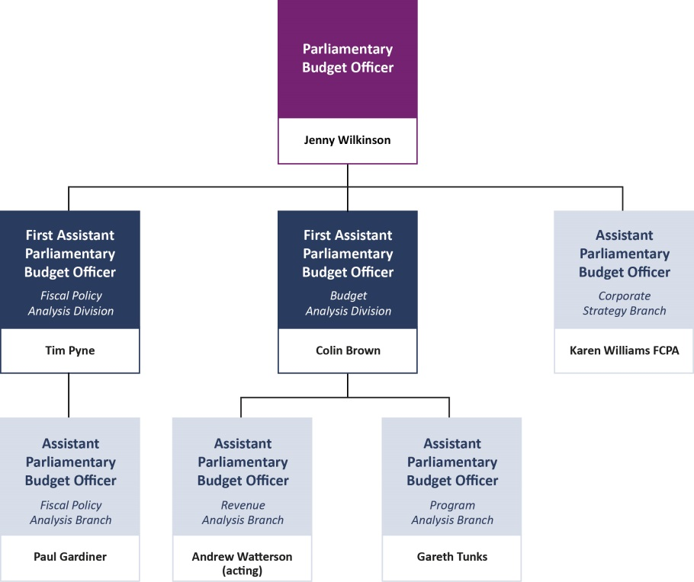

Allocation of resources
- Approximately two thirds of the PBO’s resources are allocated to the preparation of costings and budget analyses. This is the most resource intensive element of our functions. Resources for this function are augmented in the lead up to a general election, to meet the increased demand for these services.
- Our published research program and related activities account for approximately one quarter of the PBO’s resources. During and immediately after a caretaker period, these resources will be redirected to the preparation of the post-election report.
- Staff are deployed on a flexible basis as operational needs dictate. Accordingly, the allocation of resources to the above activities varies from time to time to meet changing workload demands.
- A small core of staff is dedicated to managing our corporate service delivery and compliance functions.
- In 2017–18, we intend to continue to participate in the Parliament of Australia Graduate Program to expose Australian Public Service graduates to our work, and to supplement our core workforce.
- A further opportunity to supplement our workforce is through secondment arrangements. During the year, we will be developing and implementing a strategy to expand our current secondment program with the aim of creating a pool of secondees we could draw on to supplement our workforce in the lead up to the general election.

Governance and risk management
- The Parliamentary Budget Officer is supported in the governance of the PBO by the following bodies:
  - the PBO Executive, comprising the Parliamentary Budget Officer and Senior Executive Service officers, that advises the Parliamentary Budget Officer on PBO-wide issues
  - the Audit Committee, comprising two independent members (including the Chair) and the Assistant Parliamentary Budget Officer, Corporate Strategy Branch, that provides the Parliamentary Budget Officer with independent assurance and advice in relation to the PBO’s governance, risk, control and compliance framework, and its external accountability responsibilities.
- The PBO’s risk management framework and policy outlines how we manage risk through our policies, processes and structures. The management of risk forms an important part of the PBO’s governance arrangements and informs the allocation of resources. Risk planning continues to be embedded at key levels in the PBO. A strategic risk assessment is undertaken annually, followed by operational risk assessments in divisional and branch work planning. Specialist risk assessments for security and fraud are undertaken every two years. Project risk assessments are also undertaken as part of planning for major projects. The PBO’s risk management policy is in accordance with the Commonwealth Risk Management Policy.

Budget
- The PBO’s departmental appropriation for 2017–18 is $6.753 million. In addition, we anticipate drawing $0.788 million from the special appropriation under section 64D of the Parliamentary Service Act. The balance of the special appropriation at 1 July 2017 was $3.772 million.
- The PBO’s departmental appropriation is supplemented every third year with $0.500 million to augment our workforce in the lead up to a general election. The next supplementation of this funding will occur in 2018–19.
- Employee expenses of $6.560 million represent our major expense item.
- By the end of the forward estimates period, the PBO’s special appropriation is expected to be fully drawn down and consideration of our resourcing beyond that time will be required prior to the 2020–21 Budget.

Staffing
- The PBO’s departmental appropriation allows for the ongoing employment of approximately 40 full-time staff.
- In the second half of 2015–16, we recruited above our ongoing establishment to help ensure that we were adequately staffed in the lead up to the 2016 general election. During 2016–17, the average staff level was approximately 45. In 2017–18, the average staff level is anticipated to return to around 40 through natural attrition.
- All PBO staff are subject to the Parliamentary Service Values, Employment Principles and Code of Conduct. Individual staff performance and career development is managed consistent with the PBO’s Performance Management Framework.

Corporate services
- To minimise the staff and resources dedicated to corporate services, the PBO has shared services arrangements with other parliamentary departments for the delivery of the PBO’s back-office services.
- The Department of the Senate provides the PBO’s financial transactions and payroll services. The PBO’s information and communication technology services are provided by the Department of Parliamentary Services.
- We continue to work collaboratively with the other parliamentary departments on common and joint activities in relation to corporate matters, both informally and more formally through a range of interdepartmental committees.

Appendix A

Parliamentary Budget Office Review 2016–17
Recommendations from the report of the independent review panel
Section 64T of the Parliamentary Service Act enables the JCPAA to seek an independent review of the PBO after a general election. On 14 November 2016 the Committee announced a review to focus on how the PBO could continue to strengthen its abilities. In particular, the review examined, reported and made recommendations on the scope for the PBO to build on the foundations it has established and continue to strengthen its ability to achieve its aims of:
  - providing a more level playing field for all parliamentarians in their access to publicly funded policy costings and budget analyses
  - improving the accuracy of costings of election commitments
  - enhancing the transparency and public understanding of budget information and fiscal policy settings.
The review was completed in March 2017 and made 16 recommendations. The recommendations and our responses are outlined below.
No. | Description | Response | Refer paragraph
1 | The PBO should replace the reliability rating in its costing response documents with a statement on the factors that can affect the uncertainty of that type of policy costing. The PBO’s costing response documents should expand existing qualitative comments on reliability to highlight particularly uncertain elements of the specific policy when that is appropriate. | Agreed. The PBO issued Guidance: 01/2017 – Replacement of reliability ratings in costing responses on 31 March 2017. The PBO issued Technical note no. 02/2017 – Factors influencing the reliability of policy proposal costings on 13 September 2017, which explains the factors that impact on the uncertainty in policy costings and the PBO’s approach to explaining uncertainty in its costing response documents. | 11, 23
2 | The PBO should further develop and publish principles and processes to help set priorities in relation to requests from parliamentarians for costings and budget analysis, having regard to:  - the relevance of the request to matters expected to be before the Parliament  - the level of representation of the requesting political party in Parliament  - the level of priority given to the request by the parliamentarian’s political party and/or the parliamentarian, and  - the level of resources required to complete the request. | Agreed. The PBO will outline its principles and processes for setting priorities in a guidance note. | 10
3 | The PBO should take action within its resource constraints to improve the quality and timeliness of its responses to parliamentarians’ requests for policy costings in peak periods, including:  - entering into secondment arrangements, including reciprocal arrangements, with Government Departments and Agencies, and  - exploring other mechanisms, such as using technology to streamline the costing process, and increasing collaboration with Government Departments and Agencies on model development. | Agreed. The PBO is developing and implementing a strategy to expand our current secondment program. The PBO is also actively exploring how technological improvements can improve processes. | 32, 33, 52
4 | The PBO should establish a small, independent, expert advisory panel that it could consult on cross-cutting issues associated with policy costings and fiscal analysis. This advisory panel would not be provided with information on confidential costings of parliamentarians and would have no direct role in their preparation and provision. | Agreed. The PBO will establish a panel of expert advisors that it can consult on policy costing and fiscal policy issues. | 37
5 | The PBO should ensure that the JCPAA is provided with sufficient data to allow it to regularly monitor the provision of information to the PBO through the Memorandum of Understanding. | Agreed. The PBO will continue to provide its activity report to the JCPAA at the same time it is provided to the Senate Finance and Public Administration Legislation Committee in advance of each Senate estimates hearing. | 27
6 | The PBO should continue to work collaboratively with Government Departments and Agencies on information requests and model development, consistent with maintaining the confidentiality of parliamentarians’ policy proposals. The PBO should ensure that it includes sufficient context to enable the provision of the most appropriate information in response. | Agreed. The PBO is continuing to maintain effective working relationships with agencies to facilitate the timely provision of information under the MOU. | 14
7 | The PBO should periodically conduct an ex-post analysis of a limited selection of its policy costing estimates, to help identify areas for improvement in future costings, and report the results to the JCPAA. | Agreed. The PBO will develop an evaluation methodology to conduct ex-post analyses of policy costings estimates. | 35
8 | To improve the relevance of its self-initiated work, the PBO should:  - develop deeper and broader consultation with the JCPAA and other parliamentary committees  - align more closely its self-initiated work with, and help build the capacity of, PBO costing work, and  - consider a possible evolution of its self-initiated work program by:  - expanding its existing focus on medium-term fiscal sustainability issues  - building its capacity to analyse underlying drivers of the budget over the longer term, including, but not limited to, demographic analysis, and  - ensuring it has the capacity to further develop its longer-term analytic ability to allow consideration to be given to transferring responsibility for the next Intergenerational Report (scheduled for 2020) to the PBO. | Agreed. In developing this work plan, the PBO has broadened its consultation to include relevant parliamentary committees. The PBO will engage more deeply with committees through briefings on our research work. | 29
9 | The PBO should more fully explain the methodology underlying the policy costing process, including in a non-technical fashion. | Agreed. The PBO will publish information to more fully explain the methodology underlying the policy costing process. | 11
10 | The PBO should publish regular data on the number of policy announcements made with reference to PBO costings, and whether or not, and when, the underlying PBO costing response document was released by the party or parliamentarian concerned. | Agreed. The PBO issued Guidance: 02/2017 – PBO publication of responses that have been publicly released by parliamentarians to give effect to this recommendation. The PBO will publish the number of references in its activity report and annual report and, to enhance transparency, will publish those costings that have been publicly released on the PBO website. | 12
11 | The Post-election Report of election commitments should include the financial impact over the medium term (in addition to the forward estimates period) of:  - the top ten policy proposals by dollar value  - any proposal with an impact of over $1 billion in a year  - proposals with a materially different impact beyond the forward estimates, and  - the overall election platform for each political party. | Agreed. This recommendation will be implemented in the next post-election report. | 25
12 | The timing of the publication of the Post-election Report of election commitments should be delayed to the later of the first sitting day of Parliament following a general election or 30 days after the return of the writs from a general election. | Agreed, noting that legislative amendments would be required to give effect to this recommendation. | n/a
13 | The PBO should provide parliamentary political parties with fewer than five Members or Senators the option to have the financial impact of their election commitments included in the PBO’s Post-election Report of election commitments. | Agreed. The PBO will explore options to give effect to this recommendation. | 26
14 | The PBO should consider the value of continuing to publish the chart pack following each fiscal update. | Agreed. The PBO will seek feedback on the value of the chart pack through the stakeholder survey (refer recommendation 16). | 43
15 | The PBO should ensure that the JCPAA is regularly provided with sufficient information on the PBO’s workload, resource requirements and efficiency, to enable the JCPAA to monitor their impact on the level and timeliness of the PBO’s outputs. | Agreed. The PBO will provide this information to the JCPAA when the PBO engages with the JCPAA throughout the year. | 27
16 | The PBO should conduct a survey once in each term of Parliament to get feedback on its performance from its stakeholders. | Agreed. The PBO will conduct a stakeholder survey once in each term of Parliament. | 43

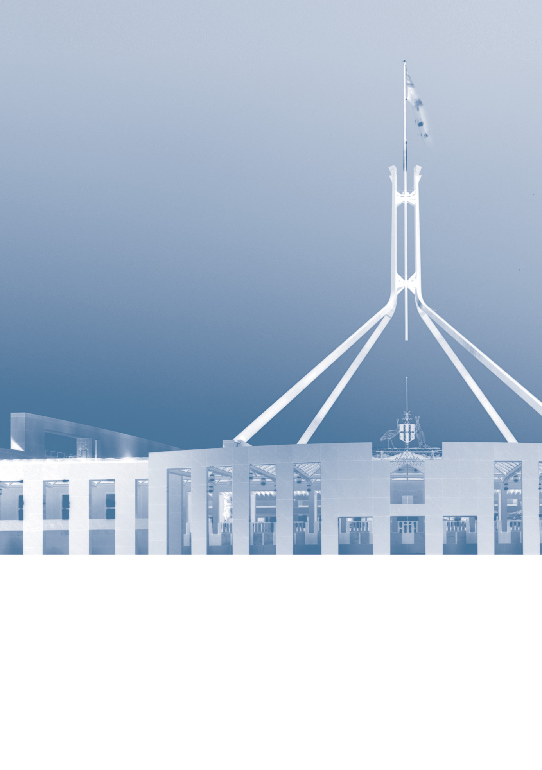
www.pbo.gov.au

