pARLIAMENTARY bUDGET oFFICE

**CORPORATE PLAN**

**2021–22**

|  |
| --- |
| © Commonwealth of Australia 2021  **ISSN 2209-766X** (online)  Copyright notice  This work is licensed under the Creative Commons Attribution-NonCommercial-NoDerivs 3.0 Australia License <http://creativecommons.org/licenses/by-nc-nd/3.0/au/>    Attribution  This publication should be attributed as follows:  Parliamentary Budget Office Corporate plan 2021–22.  Use of the Coat of Arms  The terms under which the Coat of Arms can be used are detailed on the following website: <https://www.pmc.gov.au/government/commonwealth-coat-arms>  Feedback  If you found this report useful, or have suggestions for improvement, please provide feedback to [feedback@pbo.gov.au](mailto:feedback@pbo.gov.au). |

Contents

Foreword iii

Our purpose 1

Our core functions 1

Our operating context 3

Our management of risk 5

Our key activities 7

Our capabilities 10

Our performance 13

Foreword



The Parliamentary Budget Office (PBO) assists the parliament by providing independent, high quality and non-partisan analysis of budgetary issues and the fiscal cost of policy proposals.

The Parliamentary Budget Office (PBO) Corporate plan 2021–22 sets out our approach and priorities for the next four years (2021–22 to 2024–25) and the measures by which we will be held to account. The Corporate plan is the PBO’s primary planning document. Our strategic planning process allows us to flexibly respond throughout the year to changes in the needs of parliament.

As a general election comes nearer, we expect there to be an increase in demand for our policy costing and budget analysis services. To support this demand, we will reposition and supplement our workforce to support parliamentarians and to prepare the election commitment report required by our legislation. More broadly, we will continue to work with parliamentarians and parliamentary parties, Commonwealth agencies and other key stakeholders to enhance our operations and to make our work more accessible to them.

This plan outlines our key activities and the capability investments we will make to achieve our purpose. The plan also provides detail about our approach to risk management, which is critical to successfully providing independent and non-partisan analysis and advice.

In developing this plan, we have consulted with parliamentary committees and a wide range of stakeholders, to ensure our work priorities reflect the interests of parliament and the broader community.

As the accountable authority of the PBO, I present the PBO Corporate plan 2021–22, as required under paragraph 35(1)(b) of the *Public Governance, Performance and Accountability Act 2013*. This plan has been prepared in accordance with section 16E of the *Public Governance, Performance and Accountability Rule 2014*. This plan also serves as the PBO’s work plan for 2021–22, as required by section 64Q of the *Parliamentary Service Act 1999*.

**Stein Helgeby**

Parliamentary Budget Officer

30 August 2021

Our purpose

The purpose of the Parliamentary Budget Office (PBO) is outlined in section 64B of the Parliamentary Service Act and is supported by our outcome and program as articulated in our Portfolio Budget Statements.

|  |  |
| --- | --- |
| Purpose  As articulated in the Portfolio Budget Statements and in legislation | * Provide confidential policy costing and budget analysis services to all parliamentarians to enable the fiscal impacts to be considered during policy development. * Conduct and publish research to improve public understanding of budget and fiscal policy issues. * Publish a report on the budget impacts of the election commitments of parliamentary parties after each general election to enhance transparency around election commitments. |
| **Outcome**  As articulated in the Portfolio Budget Statements | Inform parliament by providing independent and non-partisan analysis of the budget cycle, fiscal policy, and the financial implications of proposals. |
| **Program**  As articulated in the Portfolio Budget Statements | The PBO provides all parliamentarians access to confidential costing and budget analysis services to improve the quality of the public policy debate.  The PBO publishes research to improve public understanding of fiscal policy and budget policy issues and enhances transparency around the financial implications of election commitments. |

Our core functions

The PBO is an independent and non-partisan institution of the Australian parliament. We inform the parliament and the public by providing analysis of the budget and financial matters, particularly in relation to the financial implications of proposals. We do this through our three core functions:

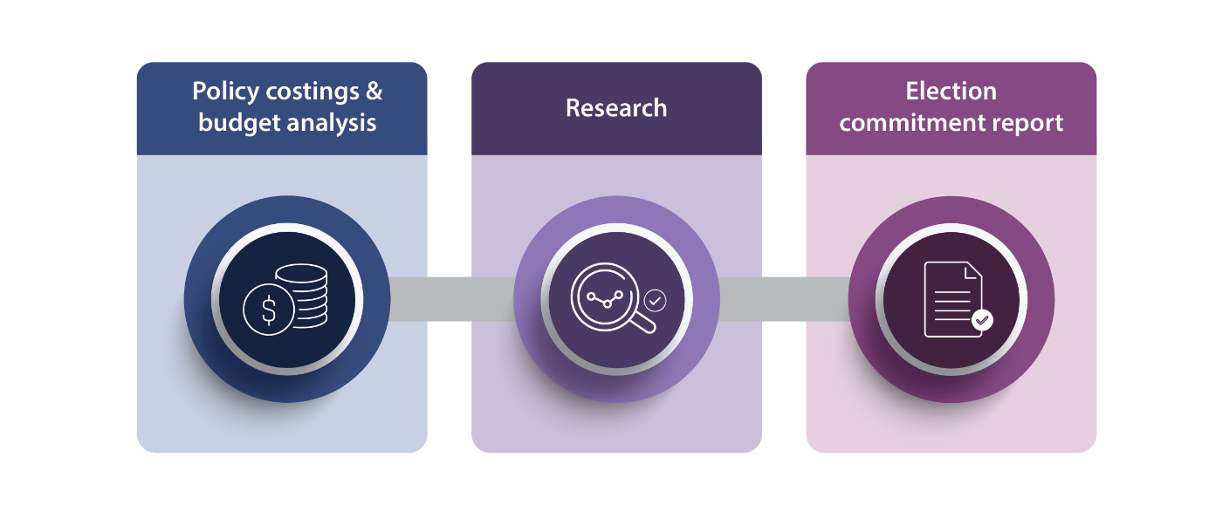

Policy costings and budget analysis

We provide all parliamentarians with access to advice on the financial implications of their policy proposals, based on the specifications they provide. Outside of the caretaker period for an election, parliamentarians may submit requests for policy costings on a confidential basis, in which case we are required to keep both the request and our response in confidence.

We provide parliamentarians with access to information relating to the budget, which they can request on a confidential basis regardless of when the request is made.

We also provide support as requested to parliamentary committees on issues that fall within our mandate.

Research

We publish research which focusses on the fiscal sustainability of the Australian Government budget, particularly over the medium term. We also seek, through our publications, to improve budget transparency and promote a better public understanding of budget and fiscal policy settings and mechanisms.

Election commitment report

After every general election we publish a report that presents the budget impacts of the election commitments of each of the major parliamentary parties, including on a policy by policy basis as well as the aggregate impact of each party’s policy platform on the fiscal position. Minor parties may choose to opt in to have their election commitments included in this report. The publication of this report serves an important role in encouraging parliamentary parties to announce fully costed election commitments and to publish their election platforms prior to polling day.

Refining our core functions

The PBO is refining how we describe our core functions by integrating outcomes and capabilities. This will support more flexible ways of working, an increased focus on digital, ensuring that we are delivering services in a way that meets the needs of our stakeholders, and makes it easier for PBO staff to identify how their work contributes to achieving organisational outcomes. It is expected that this work will continue to develop throughout 2021-22.

The below diagram outlines the PBO’s core functions as they relate to the delivery of our services:

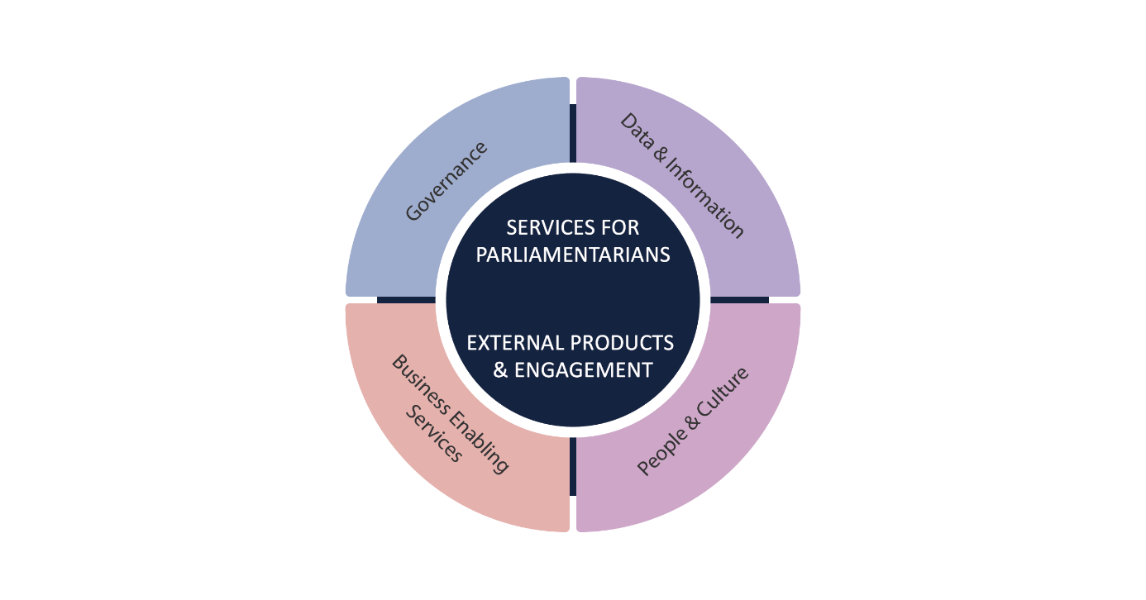

Our operating context

We operate within the broad public governance and accountability arrangements which apply across the public sector and work closely with the other parliamentary departments.

The PBO’s environment is affected by several factors over which we have varying levels of influence. We have greater influence over our accountability to the parliament and the public, our relationships with key stakeholders, the quality of our work, the capability of our staff and systems, and our management of risks. We have partial influence over the demand for our services and the provision of information from Commonwealth agencies. While we have less influence over how our information is used, we clarify and correct references to PBO work where inaccurately reported.

External environment

The PBO holds a unique position in supporting the Australian parliament. For our parliament to work effectively, it is important that our parliamentarians, whether in government or not, are   
well informed about the policy choices they make. Similarly, a well-informed public is important in a well-functioning democracy.

To support these democratic processes, we provide the parliament and the general public with information and analysis about budget and financial issues. This information supports policy thinking by enabling fiscal impacts to be carefully considered.

While our purpose remains constant from one election cycle to the next the demand for our policy costing services peaks at different times through the election cycle. The most significant increase in the demand for our services occurs in the lead-up to a general election and the period immediately following the election when we prepare our election commitment report.

Internal operating environment

The PBO’s internal operating environment is underpinned by five elements:

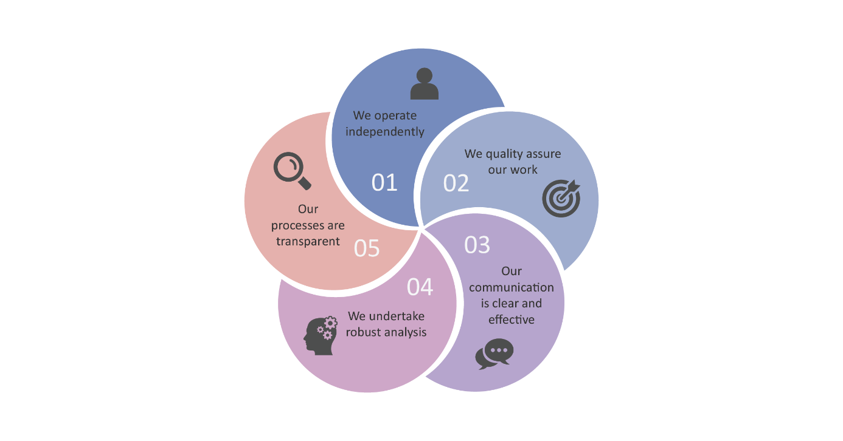

We operate independently

* The independence of the PBO is enshrined in the Parliamentary Service Act. The Parliamentary Budget Officer reports to the Presiding Officers of the Parliament on the operation and administration of the PBO. However, the Parliamentary Service Act provides that the Parliamentary Budget Officer is not subject to a direction by a Presiding Officer in relation to the performance of their functions.
* At our own initiative, we conduct research in areas that we consider will enhance transparency and improve the public’s understanding of the budget and fiscal policy settings.

We quality assure our work

* Our focus on quality assurance has been embedded across our internal policies and procedures.
* Outcomes from our quality assurance activities are used to refine our internal processes, identify current and future training needs, and prioritise model and capability development.
* Our quality assurance processes for costings and budget analysis are backed up by a program of evaluations, which examine our past work to identify improvements in data, methodologies, and assumptions that we can apply to future work.
* We internally and externally review our research material, including review by our expert panel.

Our communication is clear and effective

* Our information is presented clearly and coherently, in a manner that is designed to be accessible to a broad audience.
* Independent experts are asked to review our draft research papers to verify if our messages are conveyed effectively and accurately. These reviewers may be members of our panel of expert advisors, selected for their economic, fiscal, and public finance expertise, or other specialists.
* We engage with our stakeholders to refine the way we communicate our work.

We undertake robust analysis

* Our costing advice is designed to be comparable to the costing estimates contained in the government’s budget papers. We prepare our costing advice based on the same costing conventions, standards and definitions used by the government, using the most recent official budget estimates as a baseline and the most recent budget economic parameters and forecasts in our models.
* Using our best professional judgement, we independently determine the most appropriate modelling methodology, data, and assumptions to use to estimate the fiscal cost of policy proposals.
* In the preparation of our research reports, we engage with independent experts to seek feedback on the quality of our analysis and the clarity of its presentation.

Our processes are transparent

* We publish information papers setting out details of how we work to provide a greater understanding of key factors which influence our work.
* We publish guidance notes in the lead-up to an election period to provide transparency around our approach to the preparation of the election commitment report.
* Our costing advice to parliamentarians sets out the financial impacts of their proposals and provides details of the key assumptions made in the analysis, the methodology and data sources used, and any issues that may affect the reliability of the estimates provided. Our budget analysis advice similarly provides comprehensive details on the methodology, data, and information we have used.
* Where our advice is provided publicly, or we are advised by a parliamentarian that a request they have made is no longer to be treated as confidential, we publish our response to the parliamentarian on our website.
* In our research papers, we provide detailed information on the methodologies that we have used, and publish the data underlying our analysis on our website.

Our management of risk

Risk management is a fundamental responsibility of all PBO employees. At its core, risk management is about understanding what is within and outside the PBO’s control and sphere of influence and undertaking coordinated activities to influence the operating environment, enabling the PBO to achieve its objectives.

The PBO’s risk management framework consists of a collection of policies, processes, and plans that are embedded into business-as-usual practices at all levels. The framework captures how the PBO manages risk through a considered and systematic process that takes into account its legislative obligations pursuant to the *Public Governance, Performance and Accountability Act 2013* and the Commonwealth Risk Management Policy.

Individual risk management plans are developed to operationalise the PBO’s risk policy and strategy at various levels, including strategic risks; divisional/branch operational risks; specialist risks—including security and fraud; and project risks.

The key areas of strategic risk for the PBO and a summary of mitigation strategies are outlined in the table below:

|  |  |  |
| --- | --- | --- |
| **Strategic risk** | | **Mitigating strategies** |
| 1 | **Impartiality and independence**  The PBO is seen to be an instrument of a particular political party or is not perceived to be an independent, credible organisation. | Our outputs contain factual reporting and objective analysis, undertaken with documented assumptions.  We are transparent in our workflow management and prioritisation processes.  We actively engage with external stakeholders, including parliamentarians, Commonwealth agencies and our expert panel. |
| 2 | **Relevance and influence**  The PBO is not seen to be relevant or influential. | We undertake regular consultation with external stakeholders, including the JCPAA, our expert panel, parliamentary committees, and external peers.  We actively seek and respond to feedback. |
| 3 | **Relationships with service providers.**  The PBO fails to maintain productive and collaborative relationships with agencies which provide services, information, data and models to the PBO. | Our liaison, data provision and service arrangements are tailored with Commonwealth agencies and are underpinned by active and regular engagement. |
| 4 | **Confidence in deliverables**  PBO deliverables are convincingly and publicly challenged. | We regularly monitor media and public references to PBO outputs to ensure accurate reporting.  Our research publications are externally reviewed prior to release. |
| 5 | **Sensitive information**  Sensitive information held by or provided to the PBO is inadvertently released because of accidental or intentional disclosure, or cyber-attack. | We assess our maturity and annually review against the Protective Security Policy Framework.  We regularly and systematically engage with our outsourced ICT provider at both an operational and strategic level. |
| 6 | **PBO workforce**  The PBO is perceived to not provide a safe working environment. | We provide wellbeing support to our staff, access to independent and confidential counselling, and training.  We undertake comprehensive reviews of our human resources policies and procedures, underpinned by external and independent legal advice. |

Our key activities

Our key activities[1] in 2021–22 and beyond are:

|  |  |  |
| --- | --- | --- |
| Outcome 1: Inform the Parliament by providing independent and non-partisan analysis of the budget cycle, fiscal policy and the financial implications of proposals | | |
| Policy costings and budget analysis | Research | Election commitment report |
| Prepare high quality policy costings and budget analyses at the request of parliamentarians in a timely manner.  Develop and maintain our costing and projection models and databases. | Publish research material that promotes a better public understanding of the budget and fiscal policy settings, with a particular focus on sustainability of the budget over the medium and long term.  Develop analysis and tools to complement our research papers. | Prepare and publish a report analysing the budget impact of the election commitments of parliamentary parties after the next general election. |
| Effectively engage with external stakeholders | | |
| Modernise our website | | |
| Continue building and maturing our organisational capabilities | | |



Policy costings and budget analysis

The provision of policy costing and budget analysis advice to parliamentarians continues to be our highest priority. We expect particularly strong demand for this advice during 2021–22 in the lead‑up to the next general election.

In 2021–22 we will:

* liaise regularly with parliamentarians and parliamentary committees to ensure that their requests are given appropriate priority in an election year
* build on our analysis services by providing parliamentarians with tracking information on the costings and analysis they have requested from the PBO
* liaise regularly with Commonwealth agencies to facilitate the timely provision of information that underpins our advice, including continuing to expand our use of the standing information requests and remote access arrangements that we already have with several agencies
* provide transparency, through our regular reporting, on the demand for our services, timeliness of our responses, evaluation of our models and use of advice in policy announcements
* continue to develop our data and model holdings in anticipation of future demands, as well as evaluating the performance of our existing models to improve our analytic capabilities, including liaising with Commonwealth agencies on these models, where appropriate
* respond to any costing requests made during the caretaker period for a general election as set out in our legislation and contribute to the preparation of an election commitment report.



Research

The PBO research program is focussed on analysis that improves and informs assessments of the medium-term trends and pressures facing Australia’s fiscal position. It also seeks to improve the understanding parliamentarians and the public have of complex budget and financial mechanisms.

The research program is aligned with, and helps build the capacity of, our costing work by improving estimates of the baselines against which our medium-term costings are compared. It is also informed by themes that arise in the course of our costings and budget analysis work.

During the year ahead, some of our research resources will be redirected towards costing work in the lead-up to the general election and towards the preparation of the election commitment report immediately following the election. This will reduce our capacity to publish research compared to non-election years. Consequently, we will focus on publishing shorter reports which aim to improve understanding and transparency, rather than major research reports.

**Regular publications**

The PBO publishes the following regular publications each year:

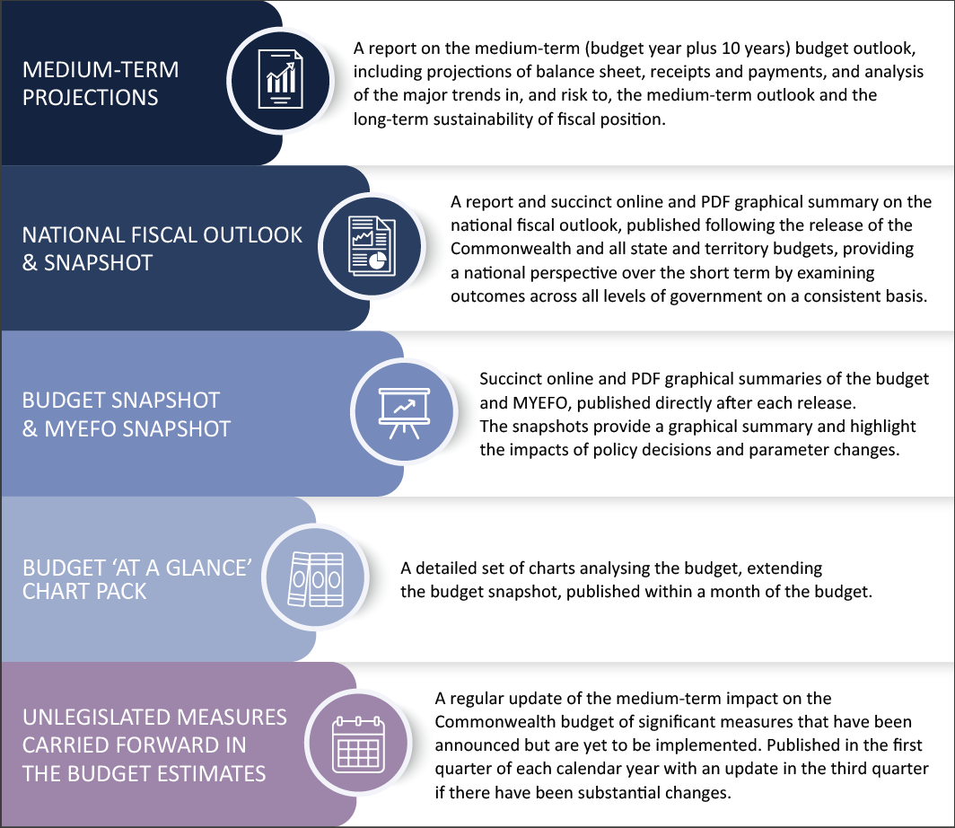

Other research reports and information papers

In addition to the PBO’s regular publications, we undertake other research projects of varying size and complexity, with a view to improving parliamentary and public understanding of specific budgetary and financial issues. We prioritise our research projects using criteria including the strength of the relationship with the PBO’s mandate and the contribution the PBO could make by publishing on the topic.

We plan to undertake the following research and related activity in 2021–22, subject to the timing of the general election:

* continue our analysis of the effect of COVID-19 and the associated policy response on the Commonwealth’s fiscal position
* publish explainers on key aspects of the budget and fiscal position, such as the government’s balance sheet, bracket creep and the contingency reserve, as well as expand the online budget glossary and compile key historical fiscal data
* build on our guide to understanding the budget papers
* develop online interactive tools to facilitate understanding of budget and fiscal policy issues

The PBO retains flexibility within its research program to add additional research topics to its work program over the course of the year, including in response to emerging issues or the interests of parliamentary committees.

The PBO publishes short papers to explain the concepts and methodologies that we use in preparing policy costings and budget analyses. We also publish guidance notes to provide parliamentarians with information on processes and procedures relating to policy costings and budget analyses, and, in relevant years, the preparation of the election commitment report.

We have commenced updates of our election-related guidance notes to ensure parliamentarians are well informed about how they may need to engage with us in the lead-up to, and following, the general election.



Election commitment report

The Parliamentary Budget Officer is required to prepare a report on the budget impacts of the election commitments of each parliamentary party that had five or more members in the Parliament immediately before the commencement of the caretaker period. Minor parties and independent parliamentarians may choose to opt in to have the budget impacts of their election commitments included in an addendum to the report.

The PBO anticipates publishing an election commitment report in 2021–22 or early 2022–23. The election commitment report must be published before the later of 30 days after the end of the caretaker period or seven days before the first sitting day of parliament. Internal planning in preparation for the election is well underway and guidance materials for Parliamentary parties on the approach to the report are being progressively published on our website.

Our capabilities

Building organisational capability, through continual improvement and learning and development, is a key priority for the PBO. Our current strengths and future needs are detailed below, linked to our four core capabilities. Our approach to our capabilities is informed by a desire to ensure more flexible ways of working, an increased focus on digital, and ensuring we are delivering services in a way that meets the needs of our stakeholders.

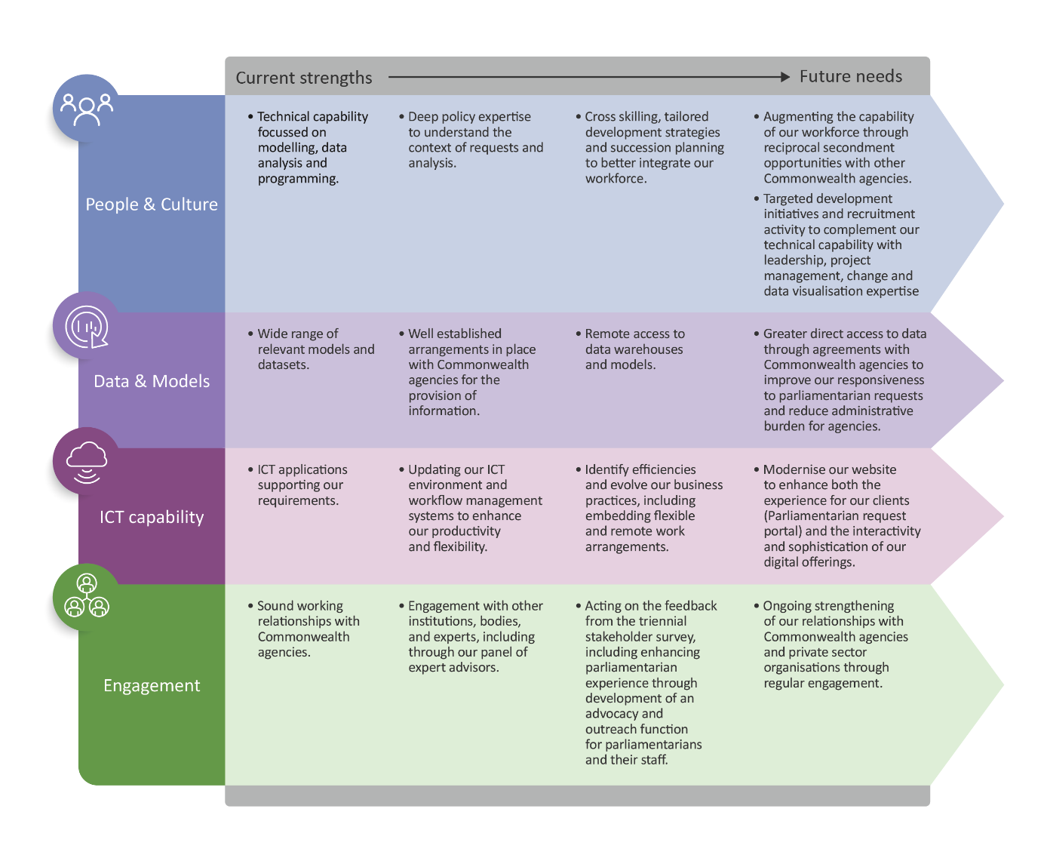

Workforce allocation and capability[2]

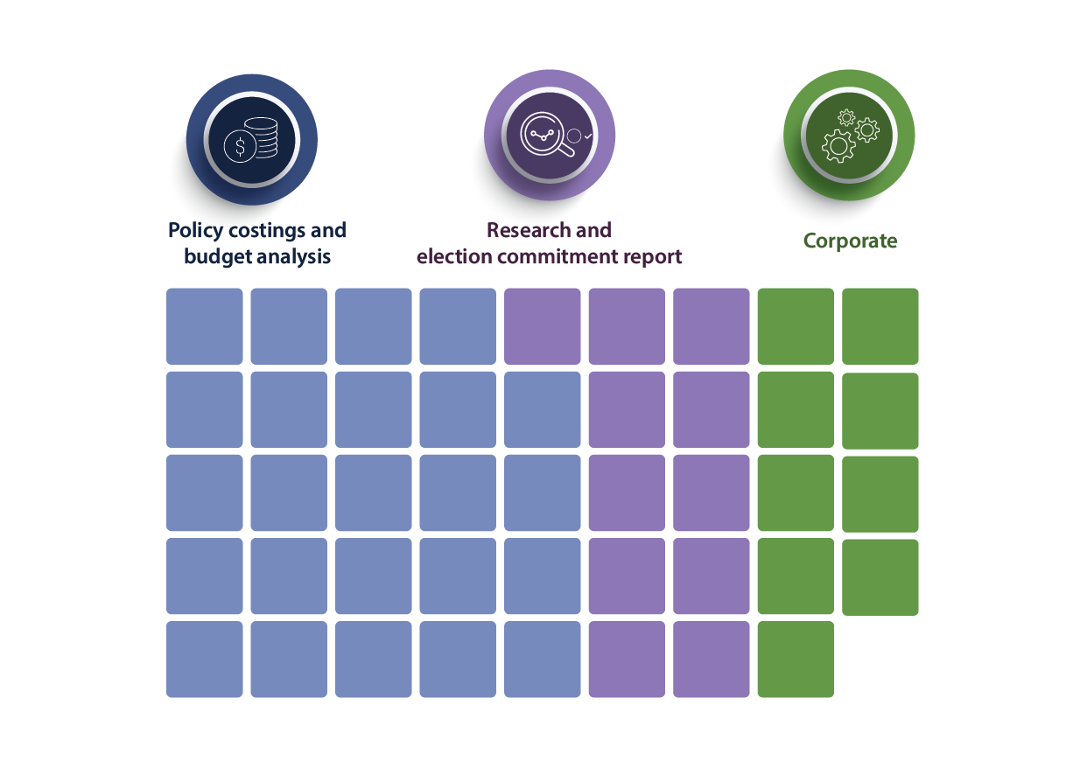

With a small, dedicated workforce of around 45 people, we adopt an efficient and flexible operating model to enable us to meet the demand for our services and maximise the impact of our research. In an election year, we receive additional funding to surge our workforce to support the preparation and publication of the election commitment report.

Around two-thirds of our employees are allocated to the preparation of costings and budget analysis as this is the most resource-intensive element of our functions. Our published research program and related activities account for approximately one quarter of our employees. A small team of employees is dedicated to managing our corporate service delivery and compliance functions, including our outsourced payroll, financial transactions, and ICT services.

During and immediately after a general election period, all PBO employees along with a number of secondees assist with costings and the preparation of the election commitment report.

The PBO workforce includes ongoing employees, secondees from other Commonwealth agencies and external organisations and graduates under the Parliament of Australia Graduate Program.

In the coming year, our focus will be on cross skilling in the lead up to the next general election, identifying and developing top talent, tailored development strategies, recruitment, and succession planning – to better integrate workforce and organisational capability. The PBO will also continue to support staff to further embed flexible and remote working practices and to enhance key enablers such as resilience and increased productivity through better use of collaboration tools and technology.

Data and models

The PBO develops and maintains a wide range of models and datasets. Access to the data held by various Commonwealth agencies is critical for us to estimate the budget impact of policy proposals and analyse key budget issues through our research program.

We have well established arrangements in place with agencies to facilitate the provision of information. This includes agreements with several agencies to provide specified data and models understanding information requests after each budget update. These standing information requests give agencies notice of what information the PBO will seek after a budget update and allows them to plan for its provision to the PBO. In addition, we have agreements with several agencies for remote access to data and model warehouses. Remote access enables us greater flexibility to access the information required for us to efficiently respond to costing requests and reduces the administrative burden on agencies.

As we commence preparation for the next general election, we will continue to work with Commonwealth agencies for greater direct access where we can, to improve our responsiveness.

Information and communication technology (ICT) capability

In early July 2021, the PBO’s underlying ICT environment was significantly upgraded to a modern, collaborative, and integrated Microsoft cloud-based environment. In 2021-22, the organisation will focus on becoming familiar with the new environment and develop an understanding of how it can support strategic direction and operational efficiencies. A robust change management process will ensure that we focus resources on implementing enhancements to the ICT environment that are based on agreed priorities. The new environment will support a range of the PBO’s strategic objectives including organisational cohesion, stakeholder engagement and business continuity.

In 2021–22 and beyond, as part of the PBO’s increased focus on digital, we will consider how best to modernise our website to enhance both the experience for our clients (through features such as a Parliamentarian request portal) and the interactivity and sophistication of our digital offerings.

External engagement and cooperation

The PBO engages with a wide range of organisations and people, including our panel of expert advisors, as part of our ongoing operations. These engagements contribute to us achieving our purpose through enhancing our capability, improving the quality of our analysis and improving the relevance of our research.

Each term of parliament the PBO conducts a stakeholder survey. The PBO anticipates that acting on the feedback of the survey from the 46th Parliament will be a key activity in 2021–22. This may include including enhancing the experience that parliamentarians have of our services through more active outreach to parliamentarians and their staff.

The Joint Committee of Public Accounts and Audit (JCPAA) has an important oversight role in relation to the PBO. We engage with the JCPAA on a regular basis on our work plan, resourcing and performance.

We regularly liaise with Commonwealth agencies to maintain our strong relationships and, where appropriate, we share with agencies the model development and analysis we conduct, to contribute to strengthening capability across the public service.

Our research program benefits from engagement with external stakeholders at all stages of the research process, including consultation on priority areas for research, peer review of our research by experts and post-publication presentations to disseminate our analysis.

Our performance

The outcome objective against which our overall performance is assessed is:

Inform the parliament by providing independent and non-partisan analysis of the budget cycle, fiscal policy and the financial implications of policy proposals.

Our performance is judged by:

* the relevance, quality and timeliness of our outputs, and
* the independence, transparency and integrity of our processes.

Our performance criteria provide a measurement of the delivery of our outputs and are supported by targets of efficiency, effectiveness and feedback. The effectiveness targets seek to provide information on how outputs contribute to improving public understanding of budget and fiscal policy issues.

Performance framework

|  |  |  |  |
| --- | --- | --- | --- |
| Our outcome | Inform the Parliament by providing independent and non-partisan analysis of the budget cycle, fiscal policy and the financial implications of proposals. | | |
| **Our purpose** | * Providing policy costing and budget analysis services to all parliamentarians to enable fiscal impacts to be considered during policy development. * Conducting and publishing research to improve public understanding of budget and fiscal policy issues. * Publishing a report on the budget impacts of the election commitments of parliamentary parties after each election to enhance transparency around election commitments. | | |
| **Our core functions** | Policy costings and budget analysis | Research | Election commitment report |

The table below sets out our performance criteria and targets and provides information on what we expect to achieve in the next four years. Our framework includes both qualitative and quantitative measures of our performance in terms of our outputs, the quality and/or efficiency in the delivery of our outputs and their impact.

Our performance targets, particularly those in relation to the level of demand for costing services, are linked to the election cycle. We will review our performance criteria and targets annually to ensure they remain relevant and appropriate.

|  | Measure | Rationale | Methodology | Target | | | |
| --- | --- | --- | --- | --- | --- | --- | --- |
| 21–22 | 22–23 | 23–24 | 24–25 |
| **Output** | | | | | | | |
|  | Number of policy costing and budget analysis requests completed. | Stable demand and timely provision of costing services, particularly from repeat clients, suggests that the PBO’s outputs are relevant, of high quality and timely. | The system used for workflow management records the relevant data that will be used to assess the performance target. This includes the number of requests/options, date received, date completed and/or date withdrawn. | Equal to or greater than historical levels in the election cycle | Equal to or greater than historical levels in the election cycle | Equal to or greater than historical levels in the election cycle | Equal to or greater than historical levels in the election cycle |
|  | Number of PBO research publications. | Demand for our research products suggests that our research is relevant, of high quality and timely. | The number of research publications on the PBO website. | Seven regular | Seven regular | Seven regular | Seven regular |
| Two non-regular | Four non-regular | Four non-regular | Four non-regular |
|  | Percentage of regular reports triggered by a specific event (e.g. budget release) published on time. | The reports are published while the triggering event remains relevant. | Publication dates are specified on the PBO website. | 100% | 100% | 100% | 100% |
|  | Publication of the election commitment report within the legislated timeframe | The PBO measures the timeliness of the election commitment report to provide evidence of compliance with its legislative obligations. | The formal approval to publish by the Parliamentary Budget Officer and publication date of the election commitment report on the PBO website. | Less than 30 days after the end of the caretaker period or seven days before the first sitting day of parliament [3] | NA | NA | Less than 30 days after the end of the caretaker period or seven days before the first sitting day of parliament |
| **Efficiency** | | | | | | | |
|  | Median time to complete policy costing and budget analysis requests. | Results are interpreted to provide evidence of the PBO’s performance in terms of efficiency of outputs as assessed by time to completion against our targets. | The system used for workflow management records the relevant data that will be used to assess the performance target. This includes the number of requests/options, date received, date completed and/or date withdrawn.[4] | Fewer than 15 business days (non-caretaker period) | Fewer than 15 business days (non-caretaker period) | Fewer than 15 business days (non-caretaker period) | Fewer than 15 business days (non-caretaker period) |
| Fewer than five business days (caretaker period) | NA | NA | NA |
| **Effectiveness** | | | | | | | |
|  | Percentage of publicly released costings referenced in the public debate. | The reference of PBO outputs in public debate suggests that PBO’s outputs are relevant. The independence, transparency and integrity of the PBO’s processes may be inferred from mentions. | Assessment[5] of the number and nature (positive/negative or neutral) of mentions from:   * daily media monitoring * speeches/media releases/interviews * other sources, as appropriate. | 100% | 100% | 100% | 100% |
|  | Demand and impact of PBO research material. | The number and nature of mentions may indicate demand and impact of our research material over time.  Results are interpreted as evidence of PBO’s contribution to the public debate. | Assessment of the number and nature (positive/negative or neutral) of:   * report downloads * website analytics * daily media monitoring * social media analytics * Hansard mentions * other sources, as appropriate. | Demand and impact of research is equal to or greater than historical trends | Demand and impact of research is equal to or greater than historical trends | Demand and impact of research is equal to or greater than historical trends | Demand and impact of research is equal to or greater than historical trends |
|  | Demand and impact of the election commitment report. | The number and nature of mentions may indicate demand and impact of our election commitment report over time.  Results are interpreted as evidence of PBO’s contribution to the public debate. | Assessment of the number and nature (positive/negative or neutral) of:   * report downloads * website analytics * daily media monitoring * social media analytics * other sources, as appropriate.   Mentions may also be assessed in the year following the election, as the impact of the report may be ongoing. | Demand and impact of research is equal to or greater than the previous report[6] | NA | NA | Demand and impact of research is equal to or greater than the previous report |
|  | | | | | | | |
|  | Satisfaction and/or perception of stakeholders. | Feedback from stakeholders may indicate satisfaction, perception and/or may inform all other measures of performance.  Feedback may indicate our outputs are relevant, high quality and timely, and/or our work is undertaken with independence, transparency, and integrity. | Assessment of the nature (positive/negative or neutral) of mentions and/or feedback from:   * daily media monitoring * meetings/private briefings/speeches * PBO stakeholder survey * written feedback provided to [feedback@pbo.gov.au](mailto:feedback@pbo.gov.au) * other sources, as appropriate. | 90% of mentions are positive or neutral | 90% of mentions are positive or neutral | 90% of mentions are positive or neutral | 90% of mentions are positive or neutral |



www.pbo.gov.au

1. *Key activities* serve as the *priorities* for the PBO’s work plan, as required by sub-section 64Q(3)(a) of the Parliamentary Service Act.
2. *Workforce capability* serves as the *allocation of resources* for the PBO’s work plan, as required by sub-section 64Q(3)(b) of the Parliamentary Service Act.
3. If an election was to occur late in the financial year, the PBO may publish the election commitment report in the next financial year.
4. This is calculated using the number of business days from when the request is received to when the requested is provided, excluding any time where the PBO is waiting for additional information from the requestor to complete the response.
5. References are considered neutral if they relate to the PBO’s function or outputs without accompanying descriptive language.
6. Depending on the timing of the election, the PBO may publish the election commitment report in early 2022-23.