PARLIAMENTARY BUDGET OFFICE

**CORPORATE PLAN**

**2020–21**

|  |
| --- |
| © Commonwealth of Australia 2020  **ISSN 2209-766X** (Online)  Copyright notice  This work is licensed under the Creative Commons Attribution-NonCommercial-NoDerivs 3.0 Australia License <http://creativecommons.org/licenses/by-nc-nd/3.0/au/>    Attribution  This publication should be attributed as follows:  Parliamentary Budget Office Corporate Plan 2020–21.  Use of the Coat of Arms  The terms under which the Coat of Arms can be used are detailed on the following website: <https://www.pmc.gov.au/government/commonwealth-coat-arms>  Feedback  If you found this publication useful, or have suggestions for improvement, please provide feedback to [feedback@pbo.gov.au](mailto:feedback@pbo.gov.au). |

**Contents**

Foreword 1

Our purpose 2

Our core functions 2

Our key activities 4

Our operating context 7

Our capability 10

Risk oversight and management 13

Our performance 14

Foreword



The Parliamentary Budget Office (PBO) assists the Parliament by providing independent, high quality and non-partisan analysis of budgetary issues and the fiscal cost of policy proposals.

The Parliamentary Budget Office (PBO) Corporate Plan 2020–21 sets out our approach and priorities for the next four years (2020–21 to 2023–24) and the measures by which we will be held to account. The corporate plan is the PBO’s primary planning document. Our strategic planning process allows us to flexibly respond throughout the year to changes in the needs of parliament.

Over the year ahead, we will continue to focus our published analytical work on topics designed to promote public understanding of the deteriorating fiscal situation due to the COVID-19 pandemic and the implications for the budget over the medium term. This program of work retains flexibility to ensure that the research remains relevant and timely.

In light of the rapidly evolving budget situation, the PBO has developed its capacity to provide parliamentarians with budget analysis using a medium-term scenario that takes account of the impact of COVID-19 on their policy proposals. This is particularly relevant for parliamentarians in the period leading up to the 2020-21 Budget, as there is currently a high degree of uncertainty associated with costings due to the current budget baseline. Following a year of relatively low demand for costings, a sharp increase in demand is anticipated, particularly in the lead-up to and during the general election period.

This plan outlines our key activities and the capability investments we will make to achieve our purpose. In addition, the plan provides detail about our approach to risk management, which is critical to successfully providing independent and non-partisan analysis and advice.

In developing this plan we have consulted with parliamentary committees and a wide range of stakeholders, including our panel of expert advisors, to ensure our work priorities reflect the interests of Parliament and the broader community.

As the acting accountable authority of the PBO, I present the PBO Corporate Plan 2020–21, as required under paragraph 35(1)(b) of the *Public Governance, Performance and Accountability Act 2013*. This plan has been prepared in accordance with section 16E of the *Public Governance, Performance and Accountability Rule 2014*. This plan also serves as the PBO’s work plan for 2020–21, as required by section 64Q of the *Parliamentary Service Act 1999*.

**Linda Ward**

Acting Parliamentary Budget Officer

16 September 2020

Our purpose

The purpose of the PBO is outlined in section 64B of the Parliamentary Service Actand is supported by our outcome and program as articulated in our Portfolio Budget Statements:

|  |  |
| --- | --- |
| **Purpose**  As articulated in the Corporate plan and in legislation | * + providing policy costing and budget analysis services to all parliamentarians to enable fiscal impacts to be considered during policy development   + conducting and publishing research to improve public understanding of budget and fiscal policy issues   + publishing a report on the budget impacts of the election commitments of parliamentary parties after every general election to enhance transparency around election commitments. |
| **Outcome**  As articulated in the Portfolio Budget Statements | Inform the Parliament by providing independent and non-partisan analysis of the budget cycle, fiscal policy and the financial implications of proposals. |
| **Program**  As articulated in the Portfolio Budget Statements | The PBO provides all parliamentarians access to confidential costing and budget analysis services to improve the quality of the public policy debate. The PBO publishes research to improve public understanding of fiscal and budget policy issues and enhances transparency around the financial implications of election commitments. |

Our core functions

The PBO is an independent and non-partisan institution of the Australian Parliament. We inform the Parliament and the public by providing analysis of the budget cycle, fiscal policy and the financial implications of proposals. We do this through our three core functions:

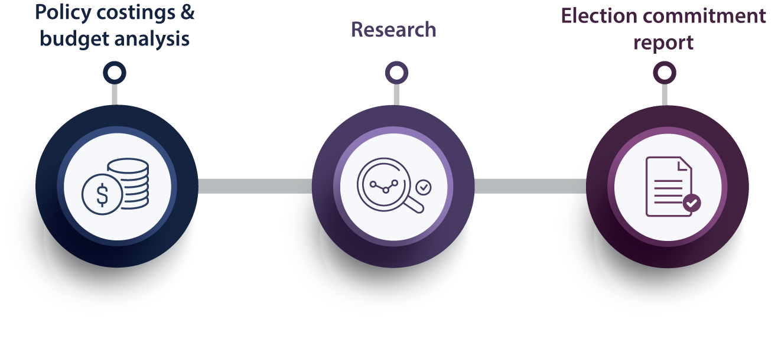

Policy costings and budget analysis

We provide all parliamentarians with access to advice on the financial implications of their policy proposals, based on the specifications they provide. Outside of the caretaker period for an election, parliamentarians may submit requests for policy costings on a confidential basis, in which case both the request and our response are kept in confidence.

We provide parliamentarians with access to information relating to the budget, which we may provide on a confidential basis regardless of when the request is made.

We also respond to requests for assistance from parliamentary committees on issues that fall within our mandate.

Research

We publish research which focusses on the fiscal sustainability of the Australian Government budget, particularly over the medium term. We also seek, through our publications, to improve budget transparency and promote a better public understanding of the budget and fiscal policy settings.

Election commitment report

After every general election we publish a report that presents the budget impacts of each of the election commitments of the major parliamentary parties, including their aggregate impact on the fiscal position. Minor parties may choose to opt in to have their election commitments included in this report. The publication of this report serves an important role in encouraging parliamentary parties to announce fully costed election commitments and publish their fiscal position prior to polling day.

Our key activities

Our key activities[1] in 2020–21 and beyond are:

|  |  |  |  |  |  |
| --- | --- | --- | --- | --- | --- |
| Outcome 1: Inform the Parliament by providing independent and non-partisan analysis of the budget cycle, fiscal policy and the financial implications of proposals | | | | | |
|  | **Policy costings and budget analysis** |  | **Research** |  | **Election commitment report** |
| * prepare high quality policy costings and budget analyses at the request of parliamentarians in a timely manner * develop and maintain our costing and projection models and databases | | * publish research papers, that promote a better public understanding of the budget and fiscal policy settings, with a particular focus on sustainability of the budget over the medium term * develop analysis and tools to complement our research papers | | * prepare and publish a report analysing the budget impact of the election commitments of parliamentary parties after the next general election | |
| Effectively engage with external stakeholders | | | | | |
| Continue building and maturing our core capabilities | | | | | |

Policy costings and budget analysis

The provision of policy costing and budget analysis advice to parliamentarians continues to be our highest priority.

In 2020–21 we will:

* continue to respond to requests from parliamentarians for costings and budget analysis, including scenario analysis that takes into account the impact of COVID-19
* liaise regularly with parliamentarians and parliamentary committees to ensure that their requests are given appropriate priority
* build on our analysis services by providing parliamentarians with summary information on the costings and analysis they have requested from the PBO, to enable them to understand the combined impacts on the budget of policies they have requested
* liaise regularly with Commonwealth agencies to facilitate the timely provision of information that underpins our advice, including continuing to expand the standing information provision and remote access arrangements that we already have with several agencies
* provide transparency, through our regular reporting, on the demand for our services, timeliness of our responses and use of advice in policy announcements
* continue to develop new costing models and evaluate the performance of existing models in light of new requests, including liaising with Commonwealth agencies on these models, where appropriate.

Research

The PBO research program is focussed on analysis that improves and informs assessments of the medium-term trends and pressures facing Australia’s fiscal position. It also seeks to improve budget transparency and promote a better public understanding of the budget and fiscal policy settings.

The research program is aligned with, and helps build the capacity of, our costing work by improving estimates of the baselines against which medium-term costings are compared. It is also informed by questions that arise in the course of our costings and budget analysis work.

This year, the research program is shaped taking into account the deteriorating fiscal situation. It is designed to provide parliamentarians and the general public with timely information on the current fiscal situation as it evolves, and an understanding of the implications for the budget over the next decade.

Regular publications

The PBO publishes the following regular publications each year:

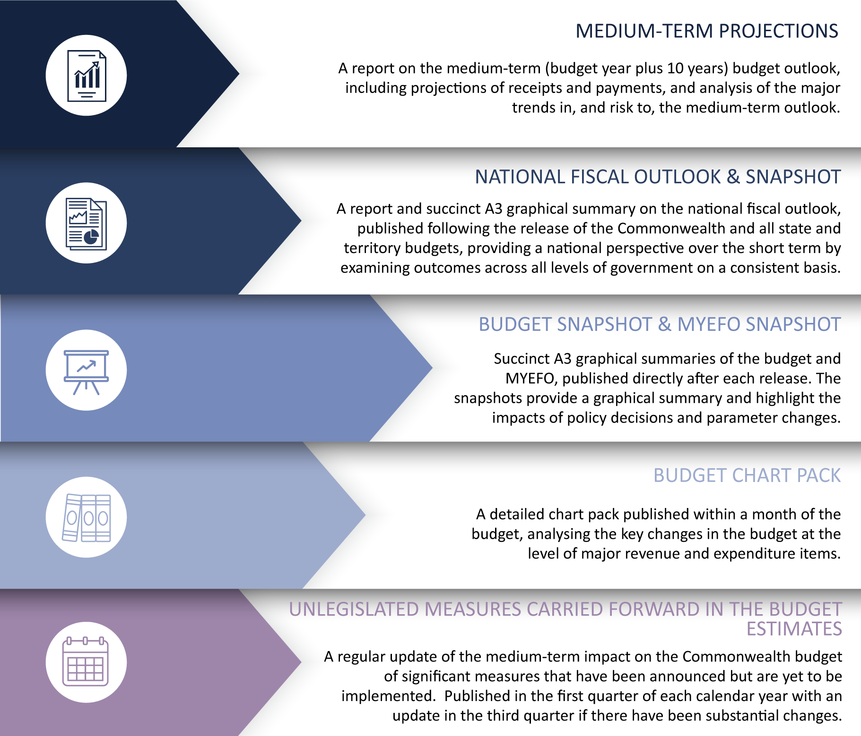

Other research reports

In addition to the PBO’s regular publications, we undertake other research work with a view to improving public understanding of specific budgetary issues. We prioritise other research projects using criteria including the strength of the relationship with the PBO’s mandate and the contribution the PBO could make by publishing on the topic.

We plan to undertake the following research and related activity in 2020–21:

* continue our analysis of the effect of COVID-19 and the associated policy response on the Commonwealth’s fiscal position
* analysis on net financial worth and fiscal sustainability to inform public debate on the medium-term budget outlook
* examine the nature and size of discretionary budget spending compared to ongoing spending to improve public understanding of the extent to which decisions about revenue and expenditure require the approval of parliament
* further develop the online budget glossary and data portal.

The PBO retains flexibility within its research program to add additional research topics to its work program over the course of the year, including in response to emerging issues or requests from parliamentary committees.

Information papers

The PBO publishes information papers to explain the concepts and methodologies that we use in preparing policy costings and budget analyses. We also publish guidance notes to provide parliamentarians with information on processes and procedures relating to policy costings and budget analyses, and, in relevant years, the preparation of the election commitment report.

In 2020–21 we intend to update our election-related guidance notes. Prior to the finalisation of this plan, on 10 August 2020, we published a guidance note for parliamentarians on the submission of budget analysis requests against COVID-19 medium-term fiscal scenarios.

Election commitment report

The Parliamentary Budget Officer is required to prepare a report on the budget impacts of the election commitments of each parliamentary party that had five or more members in the Parliament immediately before the commencement of the caretaker period. Minor parties may choose to opt in to have the budget impacts of their election commitments included in the report.

The election commitment report must be published either within 30 days after the end of the caretaker period or seven days before the first sitting day of Parliament.

It is anticipated that the majority of this work for the PBO will occur in 2021–22.

Our operating context

External environment

The PBO holds a unique position in supporting the Australian Parliament. For our Parliament to work effectively, it is important that our parliamentarians, whether in government or not, are   
well-informed about the policy choices they make. Similarly, a well-informed public is important in a well-functioning democracy.

We contribute by providing the Parliament and the general public with information about the budget and fiscal policy settings; important information for making sound policy choices and ensuring fiscal impacts are carefully considered.

While our purpose remains constant from one election cycle to the next—informing the Parliament and the public on budget and fiscal policy matters—the demand for our policy costing services peaks at different times through the election cycle. The most significant increase in the demand for our services occurs in the lead-up to a general election and the period immediately following the election when we prepare our election commitment report. However, given the delayed budget to October 2020 and the current uncertainty associated with costings as a result, a peak period is also anticipated following the release of the 2020–21 Budget.

We operate within the broad public governance and accountability arrangements which apply across the public sector and work closely with the other parliamentary departments.

The PBO’s environment is affected by a number of factors over which we have varying levels of influence. We have greater influence over our accountability to the Parliament and the public, our relationships with key stakeholders, the quality of our work, the capability of our staff and systems, and our management of risks. We have partial influence over the demand for our services and the provision of information from Commonwealth agencies. While we have less influence over how our information is used, we are able to clarify and correct references to PBO work, if required.

Internal operating environment

The PBO’s internal operating environment is underpinned by five elements:

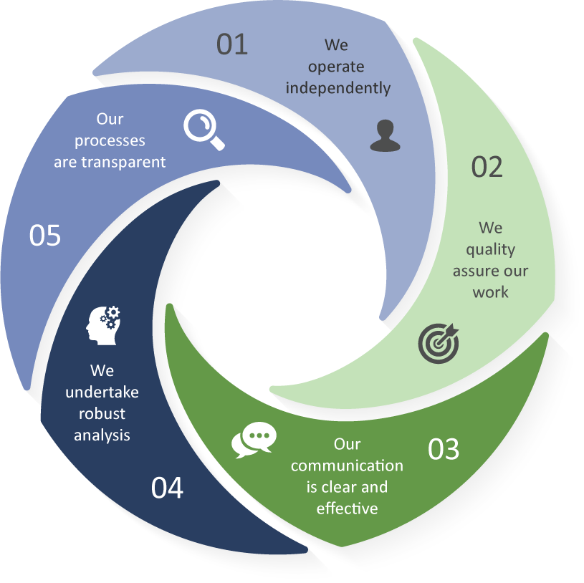

We operate independently

* The independence of the PBO is enshrined in the Parliamentary Service Act. The Parliamentary Budget Officer reports to the Presiding Officers of the Parliament on the operation and administration of the PBO. However the Parliamentary Service Act provides that the Parliamentary Budget Officer is not subject to a direction by a Presiding Officer in relation to the performance of their functions.
* At our own initiative, we conduct research in areas that we consider will enhance transparency and improve the public’s understanding of the budget and fiscal policy settings.

We quality assure our work

* Our focus on quality assurance has been embedded across our internal policies and procedures.
* Outcomes from our quality assurance activities are used to refine our internal processes, identify current and future training needs, and prioritise model and capability development.
* Our quality assurance processes for costings and budget analysis are backed up by a program of evaluations, which examine our past work to identify improvements in data, methodologies and assumptions that we can apply to future work.

Our communication is clear and effective

* Our information is presented clearly and coherently, in a manner that is designed to be accessible to a broad audience.
* Independent reviewers are asked to review our draft research papers to ensure messages are conveyed effectively and accurately. These reviewers may be members of our panel of expert advisors, selected for their economic, fiscal and public finance expertise, or other specialists.

We undertake robust analysis

* Our costing advice is comparable to the costing estimates contained in the government’s budget papers. We prepare our costing advice based on the same costing conventions, standards and definitions used by the government, using the most recent official budget estimates as a baseline and the most recent budget economic parameters and forecasts in our models.
* Using our best professional judgement, we independently determine the most appropriate modelling methodology, data and assumptions to use to estimate the fiscal cost of policy proposals.
* In the preparation of our research reports, we engage with external reviewers to seek feedback on the quality of our analysis and the clarity of its presentation.

Our processes are transparent

* We publish information papers setting out details of how we work to provide a greater understanding of key factors which influence our work.
* We publish guidance notes in the lead-up to an election period to provide transparency around our approach to the preparation of the election commitment report.
* Our costing advice to parliamentarians sets out the financial impacts of their proposals and provides details of the key assumptions made in the analysis, the methodology and data sources used, and any issues that may affect the reliability of the estimates provided. Our budget analysis advice similarly provides comprehensive details on the methodology, data and information we have used.
* Where our advice is provided publicly, or we are advised by a parliamentarian that a request they have made is no longer to be treated as confidential, we publish our response to the parliamentarian on our website.
* In our research papers, we provide detailed information on the methodologies that we have used, and publish the data underlying our analysis on our website.

Our capability

Building organisational capability, through continual improvement and learning and development, is a key priority. Our current strengths and future needs are detailed below, linked to our four core capabilities.

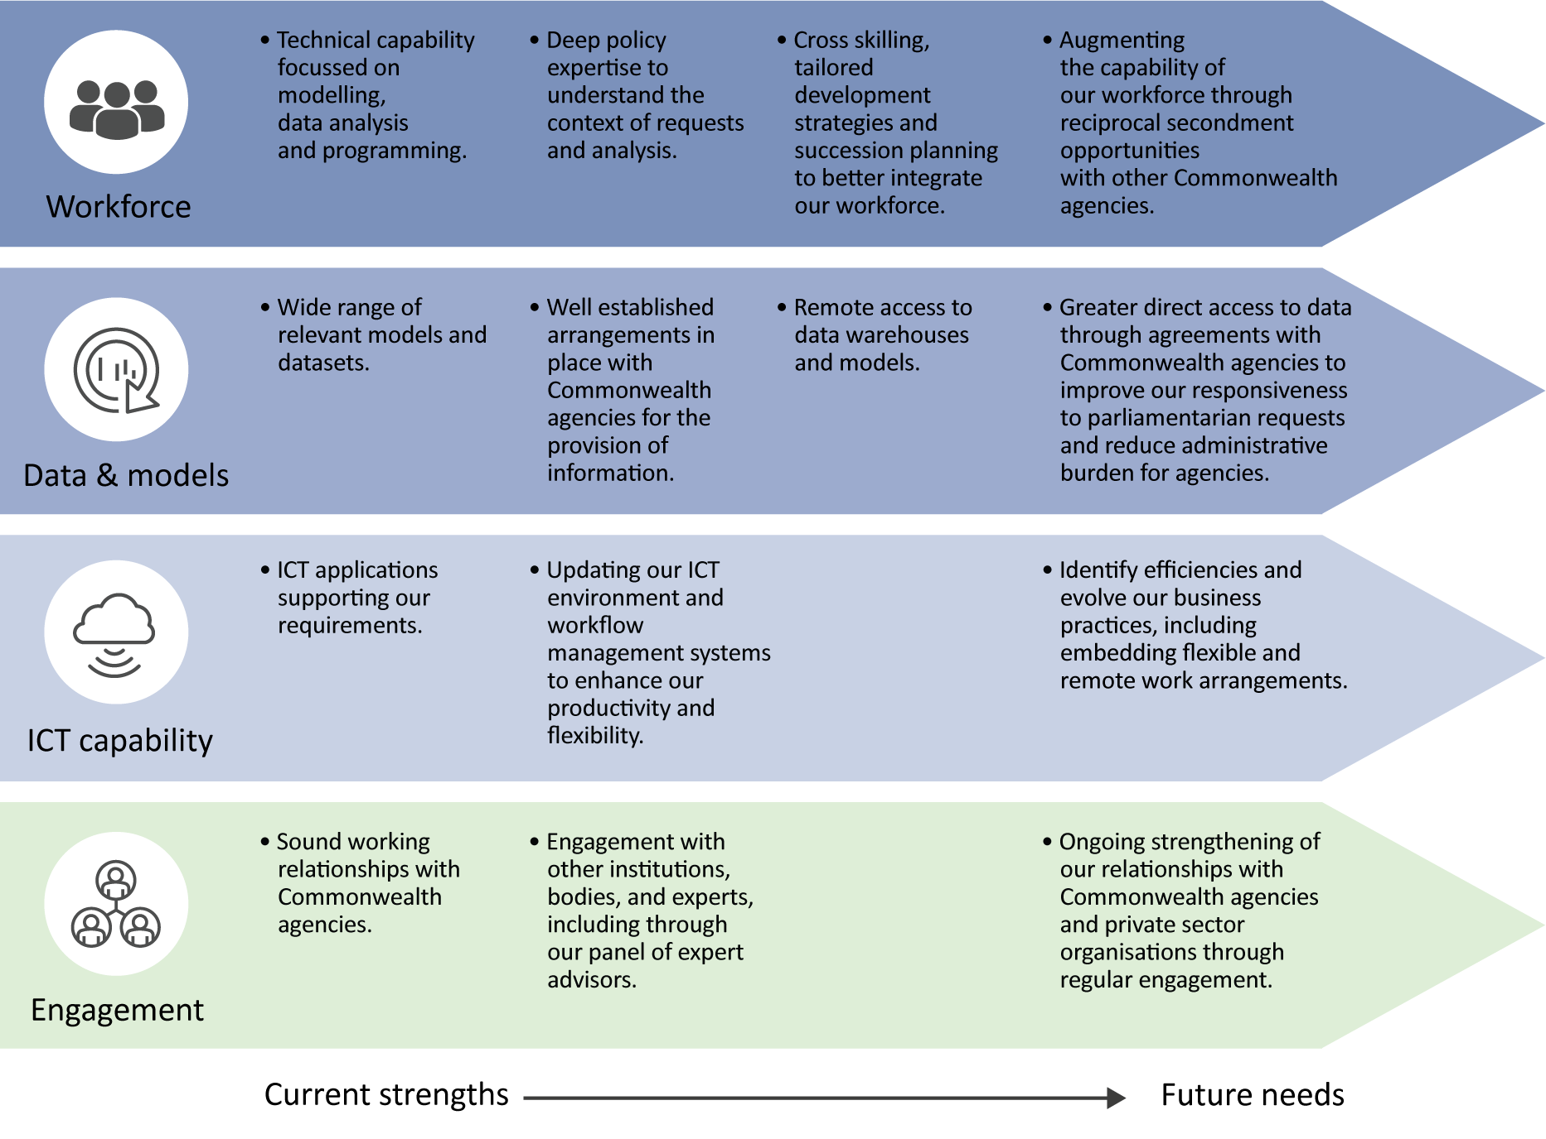

Workforce allocation and capability[2]

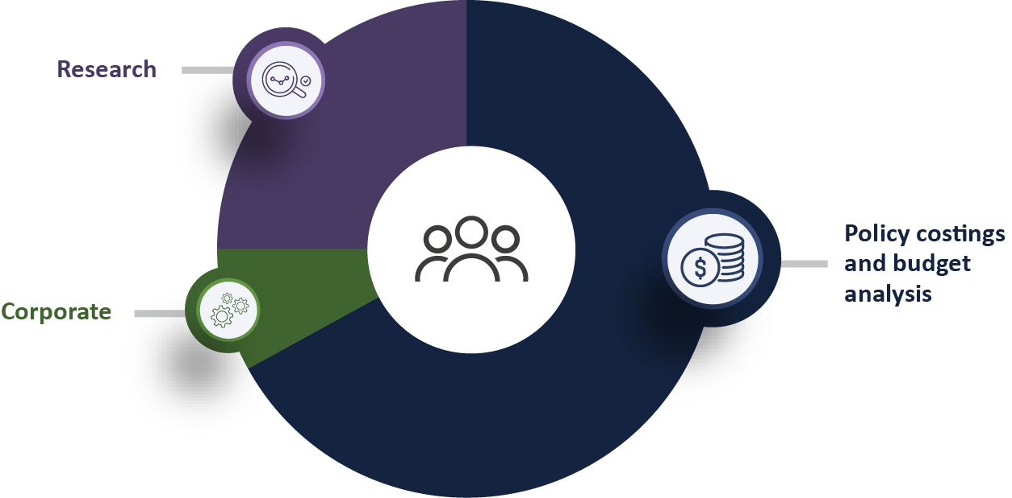

With a small dedicated workforce of around 45 people, we adopt an efficient and flexible operating model to enable us to meet the demand for our services and maximise our research impact.

Around two-thirds of our employees are allocated to the preparation of costings and budget analysis as this is the most resource-intensive element of our functions. Our published research program and related activities account for approximately one quarter of our employees. A small team of employees is dedicated to managing our corporate service delivery and compliance functions, including our outsourced payroll, financial transactions and ICT services.

During and immediately after a general election period, all PBO employees along with a number of secondees assist with costings and the preparation of the election commitment report.

The PBO workforce includes ongoing employees, secondees from other Commonwealth agencies and external organisations and graduates under the Parliament of Australia Graduate Program.

In the coming year, focus will be on cross skilling in the lead up to the next general election, identifying and developing top talent, tailored development strategies, recruitment, and succession planning – to better integrate workforce and organisational capability. The PBO will also continue to support staff to further embed flexible and remote working practices and enhance key enablers such as resilience.

Data and models

The PBO develops and maintains a wide range of models and datasets. Access to the data held by various Commonwealth agencies is critical for us to estimate the budget impact of policy proposals and analyse key budget issues through our research program.

We have well established arrangements in place with agencies to facilitate the provision of information. This includes agreements with several agencies for remote access to data and model warehouses. Remote access enables us greater access to the information required for us to efficiently respond to costing requests and reduces the administrative burden on agencies.

As we commence preparation for the next general election, we will continue to work with Commonwealth agencies for greater direct access where we can, to improve our responsiveness.

In 2020–21 we will be updating our analytical software to enhance the flexibility and efficiency of our models.

Information and communication technology (ICT) capability

The PBO, in collaboration with our outsourced ICT provider, is updating our standard operating environment and information and workflow management systems to enhance our productivity and flexibility. Naturally the initial stages of the upgrade are resource intensive, but we anticipate that this will result in organisational benefits such as:

* further improving the efficiency of our operations
* enhancing our flexible and remote working practices
* providing further cost effectiveness in terms of ongoing maintenance and support, and
* providing us with additional flexibility to scale-up when our resources increase around general election periods
* adaptability to meet our future ICT needs.

Any substantial change to an ICT environment will require change to internal processes. The PBO has developed plans to ensure we continue to operate effectively and to ensure staff are supported through this significant transition.

External engagement and cooperation

The PBO engages with a wide range of organisations and people, including our panel of expert advisors, as part of our ongoing operations. These engagements contribute to us achieving our purpose through enhancing our capability, improving the quality of our analysis and improving the relevance of our research.

We regularly liaise with Commonwealth agencies to maintain our strong relationships with them and, where appropriate, we share with agencies the model development and analysis we conduct, to contribute to strengthening capability across the public service.

Our research program benefits from engagement with external stakeholders at all stages of the research process, including consultation on priority areas for research, peer review of our research by experts and post-publication presentations to disseminate our analysis.

The Joint Committee of Public Accounts and Audit (JCPAA) has an important oversight role in relation to the PBO. We engage with the JCPAA on a regular basis on our work plan, resourcing and performance.

Risk oversight and management

The PBO’s risk management framework consists of a collection of policies, processes and plans that are embedded into business-as-usual practices at all levels. The framework captures how the PBO manages risk through a considered and systematic process that takes into account its legislative obligations pursuant to the *Public Governance, Performance and Accountability Act 2013* and the Commonwealth Risk Management Policy.

Individual risk management plans are developed to operationalise the PBO’s risk policy and strategy at various levels, including: strategic risks; divisional/branch operational risks; specialist risks—including security and fraud; and project risks.

The key areas of strategic risk for the PBO and a summary of mitigation strategies are outlined in the table below.

|  |  |  |
| --- | --- | --- |
| **Strategic risk** | | **Mitigating strategies** |
| 1 | **Impartiality and independence**  The PBO is seen to be an instrument of a particular political party or is not perceived to be an independent, credible organisation. | Our outputs contain factual reporting and objective analysis, undertaken with documented assumptions.  We are transparent in our workflow management and prioritisation processes.  We actively engage with external stakeholders, including parliamentarians, Commonwealth agencies and our expert panel. |
| 2 | **Relevance and influence**  The PBO is not seen to be relevant or influential. | We undertake regular consultation with external stakeholders, including the JCPAA, our expert panel, parliamentary committees and external peers.  We actively seek and respond to feedback. |
| 3 | **Relationships with Commonwealth agencies**  The PBO fails to maintain productive and collaborative relationships with agencies which provide information, data and models to the PBO. | Our liaison and data provision arrangements are tailored with Commonwealth agencies, and are underpinned by active and regular engagement. |
| 4 | **Confidence in deliverables**  PBO deliverables are convincingly and publicly challenged. | We regularly monitor media and public references to PBO outputs to ensure accurate reporting.  Our research publications are peer reviewed prior to release. |
| 5 | **Sensitive information**  Sensitive information held by or provided to the PBO is inadvertently released because of accidental or intentional disclosure, or cyber-attack. | We assess our maturity and annually review against the Protective Security Policy Framework.  We regularly and systematically engage with our outsourced ICT provider at both an operational and strategic level. |

Our performance

The outcome objective against which our overall performance is assessed is:

Informing the Parliament by providing independent and non-partisan analysis of the budget cycle, fiscal policy and the financial implications of policy proposals.

Our performance is judged by:

* the relevance, quality and timeliness of our outputs, and
* the independence, transparency and integrity of our processes.

Together, our range of performance measures provides the narrative of how we achieve our purpose. The output targets provide a measurement of the delivery of our outputs and are supported by targets of quality and efficiency. The impact targets seek to provide information on how outputs contribute to improving public understanding of budget and fiscal policy issues.

Performance framework

|  |  |  |  |  |  |  |  |  |  |
| --- | --- | --- | --- | --- | --- | --- | --- | --- | --- |
| Our outcome | Inform the Parliament by providing independent and non-partisan analysis of the budget cycle, fiscal policy and the financial implications of proposals | | | | | | | | |
| **Our purpose** | * Providing policy costing and budget analysis services to all parliamentarians to enable fiscal impacts to be considered during policy development. * Conducting and publishing research to improve public understanding of budget and fiscal policy issues. * Publishing a report on the budget impacts of the election commitments of parliamentary parties after each election to enhance transparency around election commitments. | | | | | | | | |
| **What we do** |  | Policy costings and budget analysis | |  | Conduct and publish research | |  | | Publish the election commitment report |
| **How we do it** | Robust, quality-assured analysis | | Independence | | | Transparency | | Clear and effective communication | |
| **Our core capabilities** | Employees | | Data and models | | | Systems | | Relationships | |

The table below set out our performance criteria and targets and provides information on what we expect to achieve in the next four years. Our framework includes both qualitative and quantitative targets across measures of our performance in terms of our outputs, the quality and/or efficiency in the delivery of our outputs and their impact. We will review our performance criteria and targets annually to ensure they remain relevant and appropriate.

|  | Measure | Rationale | Methodology | Target | | | |
| --- | --- | --- | --- | --- | --- | --- | --- |
| 20–21 | 21–22 | 22–23 | 23–24 |
| Output | | | | | | | |
|  | Level of demand for and completion of policy costing and budget analysis requests. | Stable demand for services, particularly from repeat clients, suggests that the PBO’s outputs are relevant, of high quality and timely. | The system used for workflow management records the relevant data that will be used to assess the performance target. This includes the number of requests/options, date received, date completed and/or date withdrawn. | Equal to or greater than historical levels in the election cycle | Equal to or greater than historical levels in the election cycle | Equal to or greater than historical levels in the election cycle | Equal to or greater than historical levels in the election cycle |
|  | Number of PBO research publications. | The PBO, through our research publications, seeks to improve budget transparency and promote a better public understanding of the budget and fiscal policy settings. | The number of research publications on the PBO website. | Seven regular | Seven regular | Seven regular | Seven regular |
| Four non-regular | Two non-regular | Four non-regular | Four non-regular |
|  | Publication of the election commitment report within the legislated timeframe | The PBO measures the timeliness of the election commitment report to provide evidence of compliance with its legislative obligations. | The formal approval to publish by the Parliamentary Budget Officer and publication date of the election commitment report on the PBO website. | NA | Less than 30 days of the end of the caretaker period or seven days before the first sitting day of Parliament | NA | NA |
|  |  |  |  |  |  |  |  |
| Quality and/or efficiency | | | | | | | |
|  | Median time to complete policy costing and budget analysis requests. | Results are interpreted to provide evidence of the PBO’s performance in terms of efficiency of outputs as assessed by time to completion against our targets. | The system used for workflow management records the relevant data that will be used to assess the performance target. This includes the number of requests/options, date received, date completed and/or date withdrawn. | Fewer than 15 business days | Fewer than 15 business days | Fewer than 15 business days | Fewer than 15 business days |
| Impact | | | | | | | |
|  | Percentage of publicly released costings referenced in the public debate. | The reference of PBO outputs in public debate suggests that PBO’s outputs are relevant. The independence, transparency and integrity of the PBO’s processes may be inferred from mentions. | Assessment of the number and nature of mentions from:   * + - daily media monitoring     - speeches/media releases/interviews     - other sources, as appropriate. | 100% | 100% | 100% | 100% |
|  | Number of downloads for each PBO research publication. | Increasing downloads of PBO research reports suggests that PBO’s research is relevant and of high quality and that demand remains similar. | Website analytics report for number of research report downloads from the PBO website. | 1,500 of regular reports | 1,500 of regular reports | 1,650 of regular reports | 1,650 of regular reports |
| 3,000 of non-regular reports | 3,000 of non-regular reports | 3,300 of non-regular reports | 3,300 of non-regular reports |
|  |  |  |  |  |  |  |  |
|  | Number of downloads of the election commitment report within six months of publication. | Results are interpreted as evidence of PBO’s contribution to the public debate. | Website analytics report for number of election commitment report downloads from the PBO website. | NA | 2,500 | NA | NA |
| Feedback | | | | | | | |
|  | Feedback from stakeholders indicates our outputs are relevant, high quality and timely, and/or our work is undertaken with independence, transparency and integrity. | Feedback from stakeholders measures satisfaction, perception and may inform all other measures of performance. | Assessment of the nature of mentions and/or feedback from:   * + - daily media monitoring     - meetings/private briefings/speeches     - PBO stakeholder survey     - written feedback provided to [feedback@pbo.gov.au](mailto:feedback@pbo.gov.au)     - other sources, as appropriate. | 90% of mentions are positive or neutral | 90% of mentions are positive or neutral | 90% of mentions are positive or neutral | 90% of mentions are positive or neutral |

# 

www.pbo.gov.au

1. *Key activities* serve as the *priorities* for the PBO’s work plan, as required by sub-section 64Q(3)(a) of the Parliamentary Service Act.
2. *Workforce capability* serves as the *allocation of resources* for the PBO’s work plan, as required by sub-section 64Q(3)(b) of the Parliamentary Service Act.