PARLIAMENTARY BUDGET OFFICE
CORPORATE PLAN
2019–20

© Commonwealth of Australia 2019
ISSN 2209-766X (Online)
Copyright notice
This work is licensed under the Creative Commons Attribution-NonCommercial-NoDerivs
3.0 Australia License http://creativecommons.org/licenses/by-nc-nd/3.0/au/
Attribution
This publication should be attributed as follows:
Parliamentary Budget Office Corporate Plan 2019–20.
Use of the Coat of Arms
The terms under which the Coat of Arms can be used are detailed on the following website: https://www.pmc.gov.au/government/commonwealth-coat-arms
Feedback
If you found this publication useful, or have suggestions for improvement, please provide feedback to feedback@pbo.gov.au.

Contents
Foreword 1
Our purpose 2
What we do 2
How we work 3
Our environment 5
Our priorities 6
Our resources 9
Our capability 10
Our management of risk 10
Our performance 11

Foreword
The Parliamentary Budget Office (PBO) assists the Parliament by providing independent, high quality and non-partisan analysis of budgetary issues and the fiscal cost of policy proposals.

During the past year, there was a significant increase in requests for policy costings as parliamentary parties refined and announced their election platforms in the lead-up to the 2019 general election. The PBO worked closely with non-government parliamentary parties during this period to ensure that our resources were focussed on the policy proposals that were of highest priority and we engaged effectively with Commonwealth agencies to ensure we could deliver accurate, high quality and timely advice to parliamentarians.
After the election, the PBO put significant resources into the preparation of the election commitment report that summarises the financial implications for the Commonwealth budget of the election commitments of all major parties. To deliver the additional costing services and produce the election commitment report, the PBO diverted resources from our research program and expanded our operations by temporarily seconding additional staff from other Commonwealth agencies and parliamentary departments.
Over the year ahead we expect the demand for costings and budget analysis to return to levels usually experienced outside election periods. This will allow us to focus on our published research program, further enhance the services we provide to parliamentarians, expand our costing evaluation program and continue to enhance and refine our modelling and data analysis capabilities.
In developing this corporate plan we have consulted with parliamentary committees and a wide range of stakeholders to ensure our research topics are of interest to the Parliament and the broader community. The selection of topics has also been informed by our costing and budget analysis work.
As the accountable authority of the PBO, I present the 2019–20 corporate plan, which covers the periods 2019–20 to 2022–23, as required under paragraph 35(1)(b) of the Public Governance, Performance and Accountability Act 2013. This plan has been prepared in accordance with section 16E of the Public Governance, Performance and Accountability Rule 2014. This plan also serves as the PBO’s work plan for 2019–20, as required by section 64Q of the Parliamentary Service Act 1999.
Jenny Wilkinson
Parliamentary Budget Officer
20 September 2019

Our purpose
The purpose of the PBO is articulated in section 64B of the Parliamentary Service Act and comprises three main elements, which are to:
- enable fiscal impacts to be considered during policy development by providing policy costing and budget analysis services to all parliamentarians
- improve public understanding of budget and fiscal policy issues by conducting and publishing research in these areas
- enhance transparency around election commitments by publishing a report on the budget impacts of the election commitments of parliamentary parties after every general election.

What we do
The PBO is an independent and non-partisan institution of the Australian Parliament. We inform the Parliament and the public by providing analysis of the budget cycle, fiscal policy and the financial implications of proposals. We do this through our core functions:
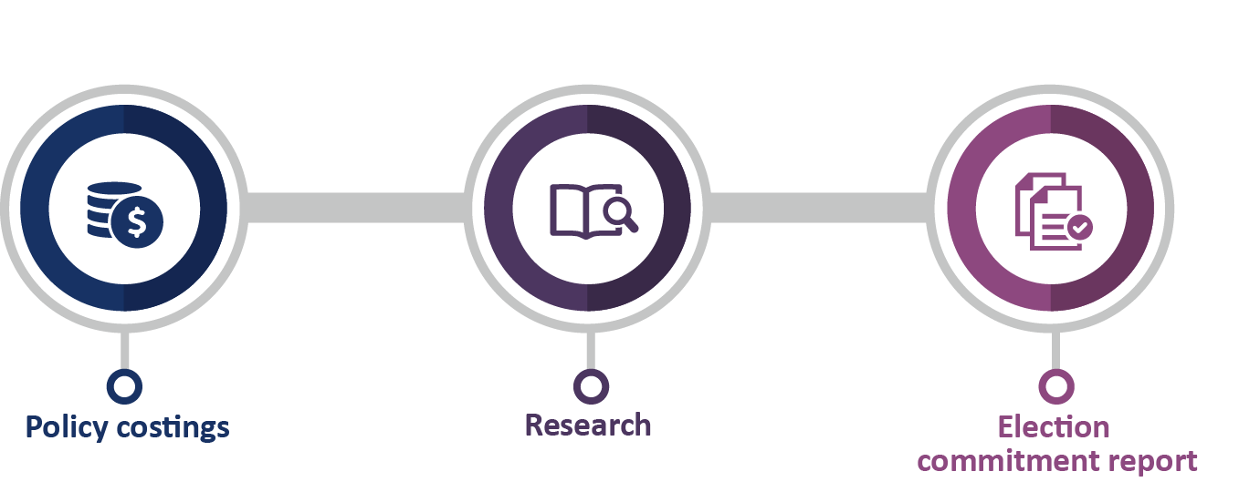

Policy costings and budget analysis
We provide all parliamentarians with access to advice on the financial implications of their policy proposals, based on the policy specifications they provide. Outside of the caretaker period for an election, parliamentarians may submit requests for policy costings on a confidential basis, in which case both the request and our response are kept in confidence.
We provide parliamentarians with access to information relating to the budget, which we may provide on a confidential basis regardless of when the request is made.
We also respond to requests for assistance from parliamentary committees on issues that fall within our mandate.

Research
We publish research which focusses on the fiscal sustainability of the Australian Government budget, particularly over the medium term. We also seek, through our publications, to improve budget transparency and promote a better public understanding of the budget and fiscal policy settings.

Election commitment report
After every general election we publish a report that presents the budget impacts of each of the election commitments of the major parliamentary parties, including their aggregate impact on the fiscal position. Minor parties may choose to opt in to have their election commitments included in this report. The publication of this report serves an important role in encouraging parliamentary parties to announce fully costed election commitments and publish their fiscal position prior to polling day.

How we work
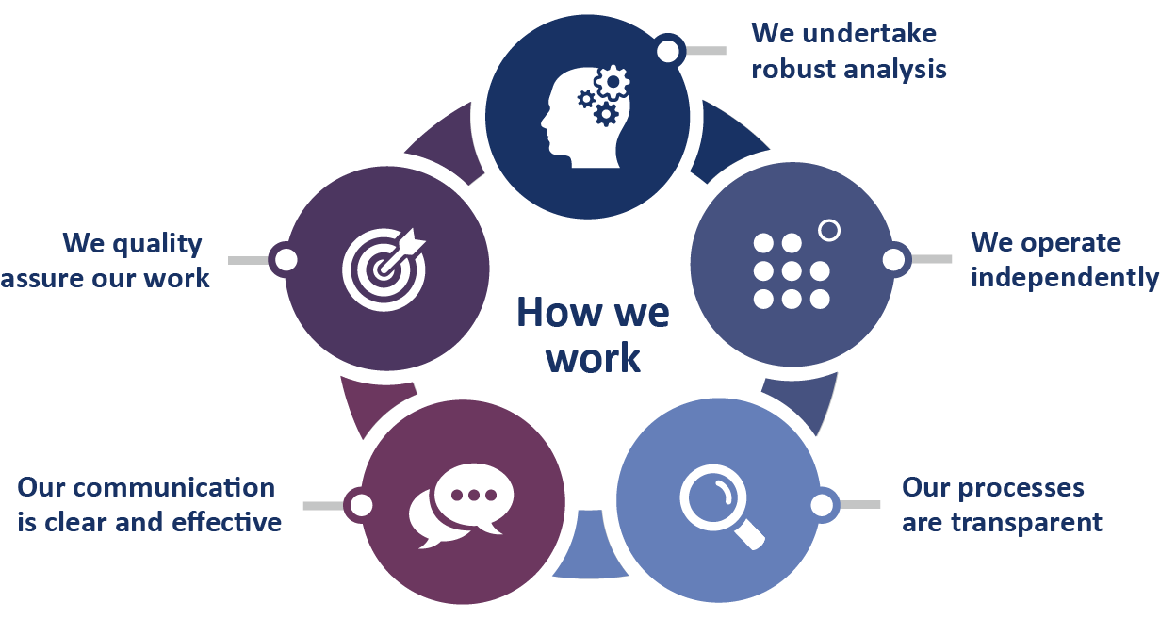

We undertake robust analysis
- Our costing advice is comparable to the costing estimates contained in the government’s budget papers. We prepare our costing advice based on the same costing conventions, standards and definitions used by the government, using the most recent official budget estimates as a baseline and the most recent budget economic parameters and forecasts in our models.
- Using our best professional judgement, we independently determine the most appropriate modelling methodology, data and assumptions to use to estimate the fiscal cost of policy proposals.
- In the preparation of our research reports, we engage with external reviewers to seek feedback on the quality of our analysis and the clarity of its presentation.

We operate independently
- The independence of the PBO is enshrined in the Parliamentary Service Act. The Parliamentary Budget Officer reports to the Presiding Officers of the Parliament on the operation and administration of the PBO. However the Parliamentary Service Act provides that the Parliamentary Budget Officer is not subject to a direction by a Presiding Officer in relation to the performance of their functions.
- At our own initiative, we conduct research in areas that we consider will enhance transparency and improve the public’s understanding of the budget and fiscal policy settings.

Our processes are transparent
- We publish information papers setting out details of how we work to provide a greater understanding of key factors which influence our work.
- We publish guidance notes in the lead-up to an election period to provide transparency around our approach to the preparation of the election commitment report.
- Our costing advice to parliamentarians sets out the financial impacts of their proposals and provides details of the key assumptions made in the analysis, the methodology and data sources used, and any issues that may affect the reliability of the estimates provided. Our budget analysis advice similarly provides comprehensive details on the methodology, data and information we have used.
- Where our advice is provided publicly, or we are advised by a parliamentarian that a request they have made is no longer to be treated as confidential, we publish our response to the parliamentarian on our website.
- In our research papers, we provide detailed information on the methodologies that we have used, and publish the data underlying our analysis on our website.

Our communication is clear and effective
- Our information is presented clearly and coherently, in a manner that is designed to be accessible to a broad audience.
- Independent reviewers are asked to review our draft research papers to ensure messages are conveyed effectively and accurately. These reviewers may be members of our panel of expert advisors, selected for their economic, fiscal and public finance expertise, or other specialists.
- Our published documents meet accessibility requirements.

We quality assure our work
- Our focus on quality assurance has been embedded across our internal policies and procedures.
- Outcomes from our quality assurance activities are used to refine our internal processes, identify current and future training needs, and prioritise model and capability development.
- Our quality assurance processes for costings and budget analysis are backed up by a program of evaluations, which examine our past work to identify improvements in data, methodologies and assumptions that we can apply to future work.

Our environment
The PBO holds a unique position in supporting the Australian Parliament. For our Parliament to work effectively, it is important that our parliamentarians, whether in government or not, are
well-informed about the policy choices they make. Similarly, a well-informed public is important in a well-functioning democracy.
We contribute by providing the Parliament and the general public with information about the budget and fiscal policy settings; important information for making sound policy choices and ensuring fiscal impacts are carefully considered.
While our purpose remains constant from one election cycle to the next—informing the Parliament and the public on budget and fiscal policy matters—the demand for our policy costing services peaks at different times through the election cycle. The most significant increase in the demand for our services occurs in the lead-up to a general election and the period immediately following the election when we prepare our election commitment report.
We operate within the broad public governance and accountability arrangements which apply across the public sector and work closely with the other parliamentary departments.
The PBO’s environment is affected by a number of factors over which we have varying levels of influence. We have greater influence over our accountability to the Parliament and the public, our relationships with key stakeholders, the quality of our work, the capability of our staff and systems, and our management of risks. We have partial influence over the demand for our services and the provision of information from Commonwealth agencies. While we have less influence over how our information is used, we are able to clarify and correct references to PBO work, if required.

Our priorities
Our priorities in 2019–20 and beyond are:
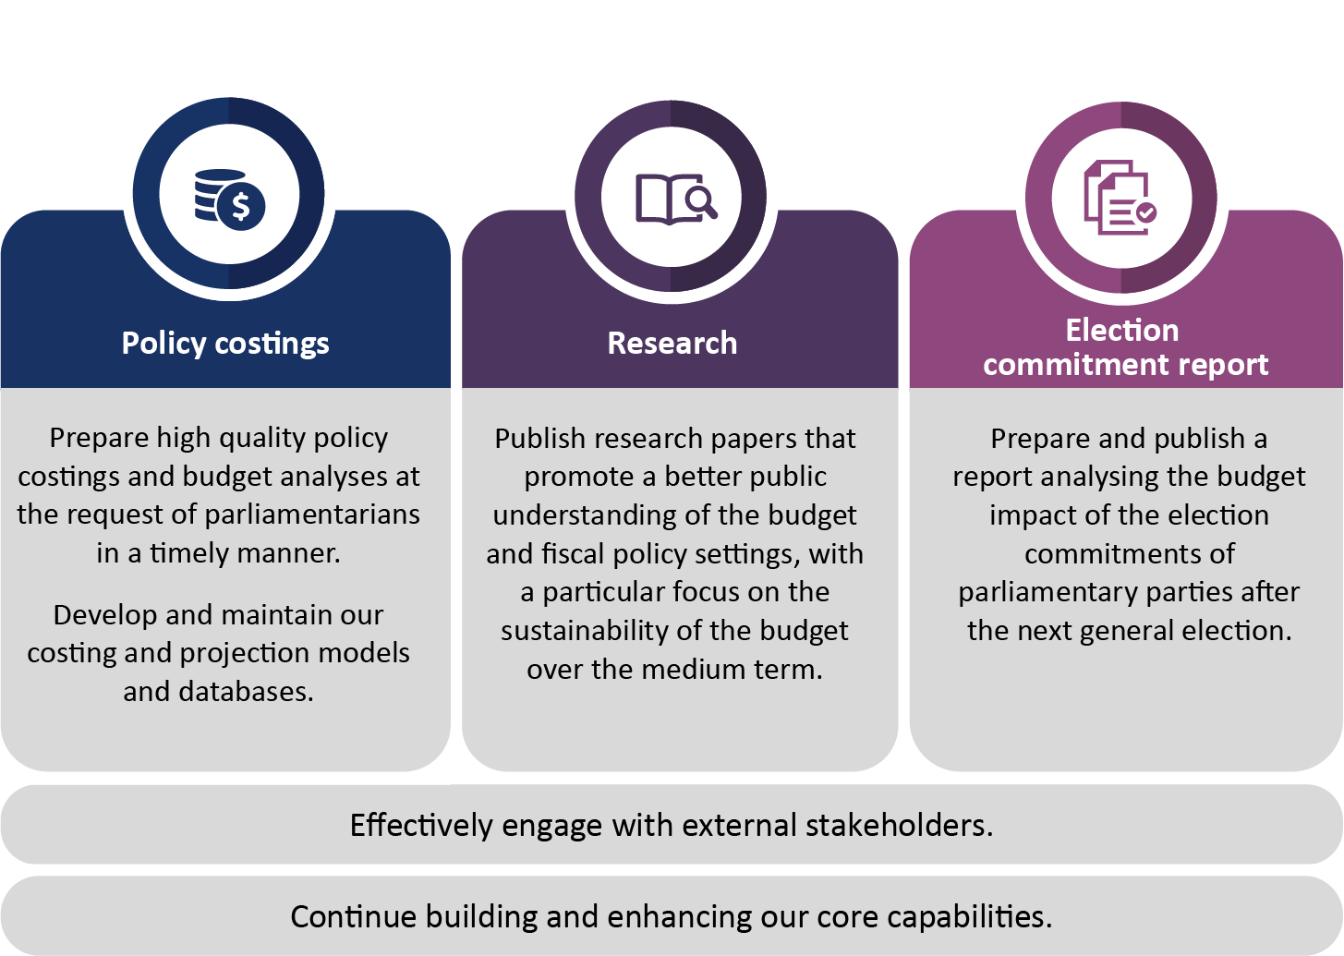

Policy costings and budget analysis
The provision of policy costing and budget analysis advice to parliamentarians continues to be our highest priority.
In 2019–20 we will:
- liaise regularly with parliamentarians and parliamentary committees to ensure that their requests are given appropriate priority
- build on our analysis services by providing parliamentarians with summary information on the costings and analysis they have requested from the PBO, to enable them to understand the combined impacts on the budget of policies they have requested
- liaise regularly with Commonwealth agencies to facilitate the timely provision of information that underpins our advice, including continuing to expand the standing information provision and remote access arrangements that we already have with several agencies
- provide transparency, through our regular reporting, on the demand for our services, timeliness of our responses and use of advice in policy announcements
- provide straightforward and searchable access on the PBO website to all costings that are publicly released by a party or parliamentarian
- continue to develop new costing models and evaluate the performance of existing models in light of new requests, including liaising with Commonwealth agencies on these models, where appropriate.

Research
The PBO research program is focussed on analysis that improves and informs assessments of the medium-term trends and pressures facing Australia’s fiscal position. It also seeks to improve budget transparency and promote a better public understanding of the budget and fiscal policy settings. The research program is aligned with, and helps build the capacity of, our costing work by improving estimates of the baselines against which medium-term costings are compared. It is also informed by questions that arise in the course of our costings and budget analysis work.

Regular publications
The PBO publishes the following regular publications each year:

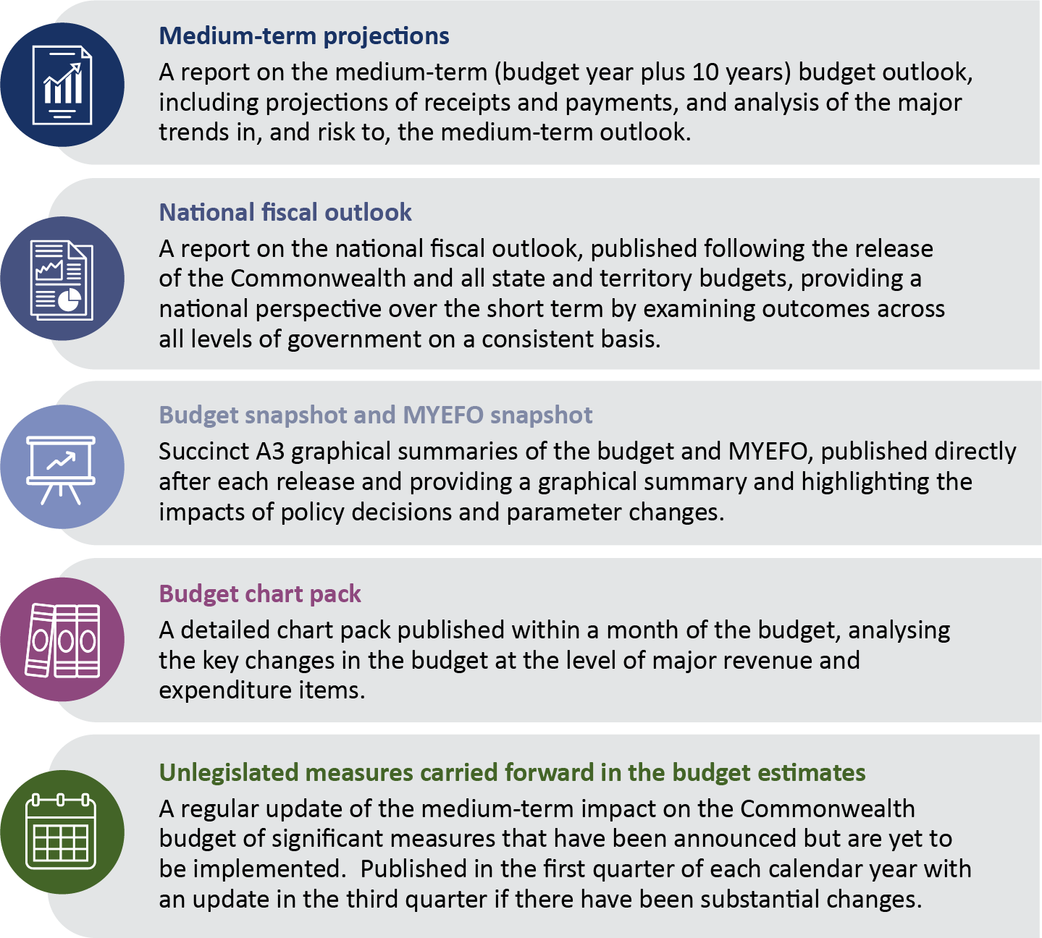

Other research reports
In addition to the PBO’s regular publications, we undertake other research work with a view to improving an understanding of specific budgetary issues. We prioritise other research projects using criteria including the strength of the relationship with the PBO’s mandate and the contribution the PBO could make by publishing on the topic.
We plan to undertake the following research in 2019–20:
- an examination of the accounting and budget impact of alternative financing mechanisms such as concessional loans and equity injections
- historical analyses of expenditure on Newstart and how observed trends in recipients could affect medium-term expenditure projections
- analysis of the impact of longer-term trends in consumption (such as shifting consumption patterns towards GST-free goods and services and the use of more fuel efficient vehicles) on medium-term revenue projections
- shorter ‘explainer’ pieces to improve the public understanding of key budget concepts and data, including concepts such as the contingency reserve and conservative bias allowance.
The PBO retains flexibility within its research program to add additional research topics to its work program over the course of the year, including in response to emerging issues or requests from parliamentary committees.

Information papers
The PBO publishes information papers to explain the concepts and methodologies that we use in preparing policy costings and budget analyses. We also publish guidance notes to provide parliamentarians with information on processes and procedures relating to policy costings and budget analyses, and, in relevant years, the preparation of the election commitment report.
In 2019–20 we intend to release an information paper outlining our approach to estimating behavioural responses in policy costings and presenting the nature, source and rationale for our key behavioural assumptions.

Election commitment report
After the 2019 election, we conducted a review of our preparedness to produce the 2019 election commitment report which identified good practices to be carried forward to future election periods and areas for improvement. Overall we assessed that we were very well prepared, with the flexible management of our resources working particularly effectively. During 2019–20 we will ensure that the arrangements we implemented are well documented for future reference.
The review identified a number of improvements to our ICT environment and workflow management systems that we intend to implement during 2019–20. Implementing these during the next year will ensure that they are well embedded before we produce the next election commitment report, towards the end of the period covered by this plan.

External engagement
The PBO engages with a wide range of organisations and people, including our panel of expert advisors, as part of our ongoing operations. These engagements enhance our capability, improve the quality of our analysis and improve the relevance of our research.
Our research program benefits from engagement with external stakeholders at all stages of the research process, including consultation on priority areas for research, peer review of our research by experts and post-publication presentations to disseminate our analysis.
The Joint Committee of Public Accounts and Audit (JCPAA) has an important oversight role in relation to the PBO. We engage with the JCPAA on a regular basis on our work plan, resourcing and performance.
We regularly liaise with Commonwealth agencies to maintain our strong relationships with them and, where appropriate, we share with agencies the model development and analysis we conduct, to contribute to improvements in capability across the public service.

Our resources
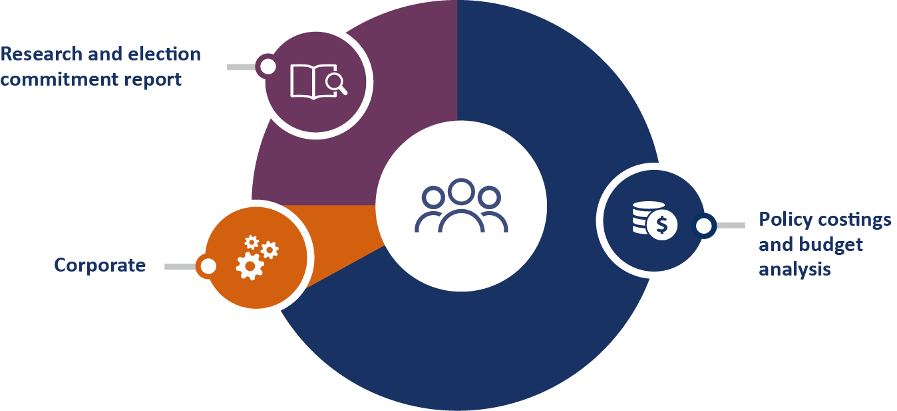

With a small dedicated workforce of around 45 people, we adopt an efficient and flexible operating model to enable us to meet the demand for our services and maximise our research impact.
Around two thirds of our employees are allocated to the preparation of costings and budget analysis as this is the most resource-intensive element of our functions.
Our published research program and related activities account for approximately one quarter of our employees. During and immediately after a general election period, these employees assist with costings and with the preparation of the election commitment report.
A small team of employees is dedicated to managing our corporate service delivery and compliance functions, including our outsourced payroll, financial transactions and ICT services.
The PBO workforce includes ongoing employees, secondees from other Commonwealth agencies and external organisations and graduates under the Parliament of Australia Graduate Program.

Our capability
Building organisational capability, through continual improvement and learning and development, is a key priority. Our current strengths and future needs are detailed below, linked to our four core capabilities.
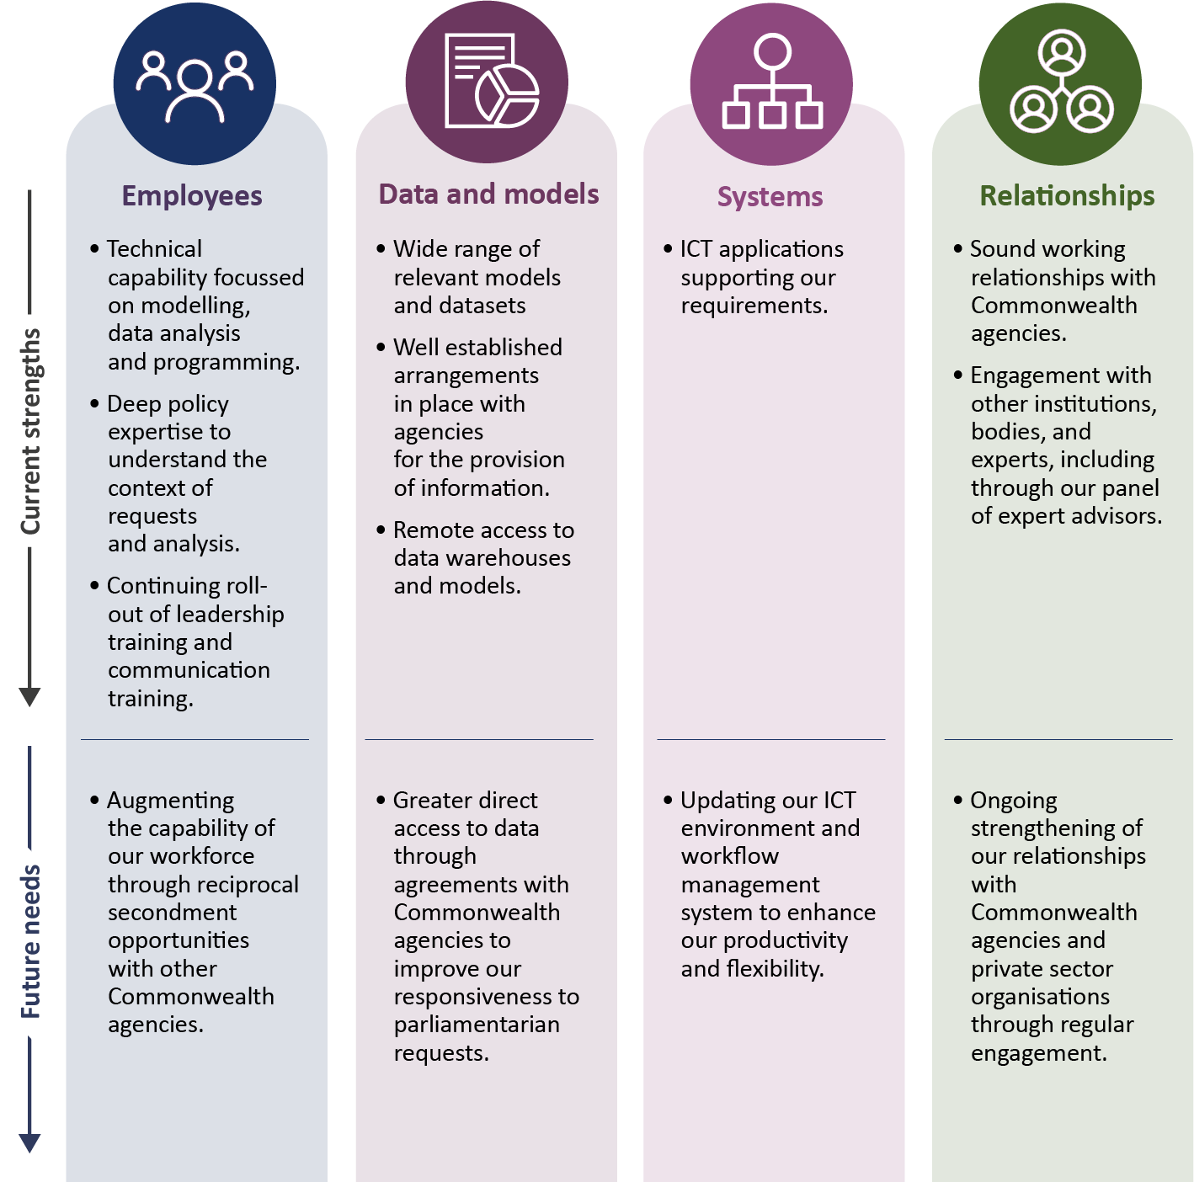

Our management of risk
The PBO’s risk management is embedded into business-as-usual practices at all levels. We have a comprehensive framework and policy to develop, implement, monitor and review risks. We undertake risk assessments at various levels, including: strategic risks; divisional/branch operational risks; specialist risks—including security and fraud; and project risks.
The risks that really matter to us, given the nature of our organisation and the work that we do, are maintaining our reputation and the quality of our work, maintaining our relationships with agencies which provide us with information, and ensuring the confidentiality of the information we hold. Our key strategies for dealing with our risks are to proactively monitor and manage our risks and quickly respond to emerging risks by changing the way we operate, without compromising the quality of the work we do.

Our performance
The outcome objective against which our overall performance is assessed is:
Informing the Parliament by providing independent and non-partisan analysis of the budget cycle, fiscal policy and the financial implications of policy proposals.

As outlined in the PBO’s Portfolio Budget Statements 2019–20, our performance is judged by the relevance, quality and timeliness of our outputs and the independence, transparency and integrity of our processes. A range of indicators inform the assessment of our performance, including: the extent of the demand for, and efficiency in the provision of, PBO services; the PBO’s contribution to the public policy debate; the transparency of PBO processes and data; and feedback from stakeholders.
The tables below set out our performance framework, criteria and targets. While the quantitative targets are important, they naturally do not paint the full picture, particularly in relation to the impact of our research program. Our work has value for our key audiences by shining a light on budget issues that are difficult to understand when relying solely on information published in the budget papers. Over time this information may lead to an increase in transparency in the budget or changes in budget treatments.

Performance framework
Our outcome | Inform the Parliament by providing independent and non-partisan analysis of the budget cycle, fiscal policy and the financial implications of proposals.
Our purpose | - To enable fiscal impacts to be considered during policy development by providing policy costing and budget analysis services to all parliamentarians.  - To improve public understanding of budget and fiscal policy issues by conducting and publishing research in these areas.  - To enhance transparency around election commitments by publishing a report on the budget impacts of the election commitments of parliamentary parties after each election.
What we do | Policy costings and budget analysis |  |  | Conduct and publish research |  |  | Publish election commitment report
How we do it | Robust, quality-assured analysis |  | Independence |  |  | Transparency |  |  | Clear and effective communication
Our core capabilities | Employees | Data and models |  |  | Systems |  |  | Relationships

Performance measure 1 – PBO’s outputs are relevant, high quality and timely

Performance criteria | Target
What we did (output)
PBO costing advice is sought by and provided to parliamentarians | Demand for policy costing and budget analysis services remains significant in line with historical levels
The election commitment report is published within the legislated timeframe | Less than 30 days of the end of the caretaker period or seven days before the first sitting day of Parliament
Publication of PBO research | All six regular research publications and at least four additional research reports are published over the course of the year
How well we did (quality and/or efficiency)
Costing services to parliamentarians are provided efficiently | Median time to complete policy costing and budget analysis requests is 15 business days or less
 | 95 per cent of non-caretaker requests are completed within 60 business days
 | 95 per cent of caretaker requests are completed within five business days
Feedback from stakeholders, including parliamentarians and our panel of expert advisors, is positive | Overall high levels of satisfaction with the role and work of the PBO
What the benefits were (impact)
The public is better informed by our contributions to the public debate | All PBO research reports are reported by major media outlets
 | Downloads of regular PBO reports are maintained at least at the same level as the previous year’s report
 | Average downloads of other PBO research reports are maintained at least at the same level as the previous year’s average
 | Publicly released PBO costing and budget analysis advice is referenced by parliamentarians
 | PBO research reports are the subject of at least ten external speeches or presentations each year

Performance measure 2 – PBO’s work is undertaken with independence, transparency and integrity

Performance criteria | Target
What we did (output)
Publication of information supporting PBO processes and methodologies supports the transparency and integrity of our outputs | All information papers, guidance material and general information about the PBO are available on the website
 | Three activity reports outlining PBO performance, including information about ongoing evaluation of our models and approaches, are published each year
Data underpinning our published research is available on our website in an accessible and consolidated form | The PBO website includes a data portal where all research report-related data is available
 | Data is available on the website on the same day as report publication
 | A glossary of budget terms is available on the website
How well we did (quality and/or efficiency)
All confidentiality legislative obligations are complied with | The confidentiality of all requests, advice and information is maintained
Feedback from stakeholders, including parliamentarians and our panel of expert advisors, is positive | We are perceived as independent, transparent and act with integrity
What the benefits were (impact)
The nature of mentions about the PBO from stakeholders, media and other sources, demonstrates that we are perceived as independent, transparent and act with integrity | We are perceived as independent, robust and/or non-partisan

www.pbo.gov.au

