parliamentary budget office
Corporate plan 2018–19

© Commonwealth of Australia 2018
ISSN 2209-7651 (Print)
ISSN 2209-766X (Online)
Copyright notice
This work is licensed under the Creative Commons Attribution-NonCommercial-NoDerivs
3.0 Australia License http://creativecommons.org/licenses/by-nc-nd/3.0/au/
Attribution
This publication should be attributed as follows:
Parliamentary Budget Office, Corporate Plan 2018–19.
Use of the Coat of Arms
The terms under which the Coat of Arms can be used are detailed on the following website: www.itsanhonour.gov.au/coat-arms

Contents
Foreword 1
Our purpose 2
What we do 2
How we work 3
Our environment 5
Our priorities 6
Our resources 9
Our capability 10
Our management of risk 11
Our performance 11

Foreword
The Parliamentary Budget Office (PBO) holds a unique position in supporting the Parliament by providing independent, authoritative and
non-partisan analysis of budgetary issues and the fiscal cost of policy proposals.
In preparing high quality policy costings and budget analysis for parliamentarians, we support the development of policy proposals. Through our research we contribute to the broader public policy debate, improve budget transparency, and promote a better understanding of budget and fiscal policy matters.
Over the past year the PBO has implemented a broad range of initiatives in response to recommendations from the independent review of the PBO completed in March 2017. These initiatives focussed on four main themes: improving transparency around internal processes and procedures; increasing external engagement and consultation; enhancing evaluation and feedback mechanisms; and increasing the focus of the research and publication program on medium-term fiscal issues. We also reviewed and strengthened how we measure our performance to achieve the PBO’s purpose.
In the year ahead a general election will occur. As a consequence, we expect there to be an increase in demand for our policy costing services and we will put significant resources into the preparation of the post-election report on the financial implications of election commitments. More broadly, we will continue to work with parliamentarians and parliamentary parties, Commonwealth agencies and other key stakeholders to continue to enhance our operations.
In developing this corporate plan we have consulted with parliamentary committees to ensure our research topics are of interest to the Parliament and we have offered to provide briefings to committees on the outcomes of our research.
As the accountability authority of the PBO, I present the 2018–19 corporate plan, which covers the periods of 2018–19 to 2021–22, as required under paragraph 35(1)(b) of the Public Governance, Performance and Accountability Act 2013. This plan has been prepared in accordance with section 16E of the Public Governance, Performance and Accountability Rule 2014. This plan also serves as the PBO’s work plan for 2018–19, as required by section 64Q of the Parliamentary Service Act 1999.
Jenny Wilkinson
Parliamentary Budget Officer
29 August 2018

Our purpose
The purpose of the PBO is articulated in section 64B of the Parliamentary Service Act and comprises three main elements, which are to:
- enable fiscal impacts to be considered during policy development by providing policy costing and budget analysis services to all parliamentarians
- improve public understanding of budget and fiscal policy issues by conducting and publishing research in these areas
- enhance transparency around election commitments by preparing a post-election report on the budget impacts of the election commitments of parliamentary parties.

What we do
The PBO is an independent and non-partisan institution of the Australian Parliament. We inform the Parliament and the public by providing analysis of the budget cycle, fiscal policy and the financial implications of proposals. We do this through our core functions:
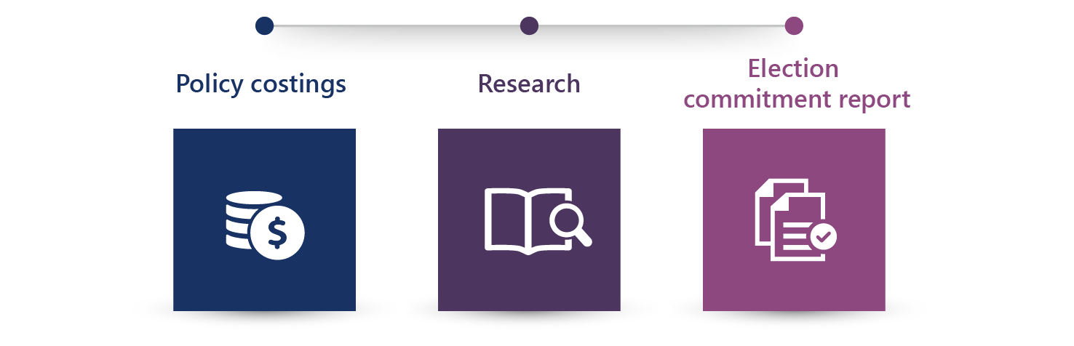

Policy costings and budget analysis
We provide all parliamentarians with access to advice on the financial implications of their policy proposals, based on the policy specifications they provide. Outside of the caretaker period for an election, parliamentarians may submit requests for policy costings on a confidential basis, in which case both the request and our response are kept in confidence.
We provide parliamentarians with access to information relating to the budget, which we may provide on a confidential basis regardless of when the request is made.
We also respond to requests for assistance from parliamentary committees on issues that fall within our mandate.

Research
We publish research which focusses on the fiscal sustainability of the Australian Government budget, particularly over the medium term. We also seek, through our publications, to improve budget transparency and promote a better public understanding of the budget and fiscal policy settings.

Report on election commitments
Within 30 days after the end of the caretaker period for a general election, we publish a report that presents the budget impacts of each of the election commitments of the major parliamentary parties, including their aggregate impact on the fiscal position. Minor parties may choose to opt in to have their election commitments included in an addendum to this report.

How we work
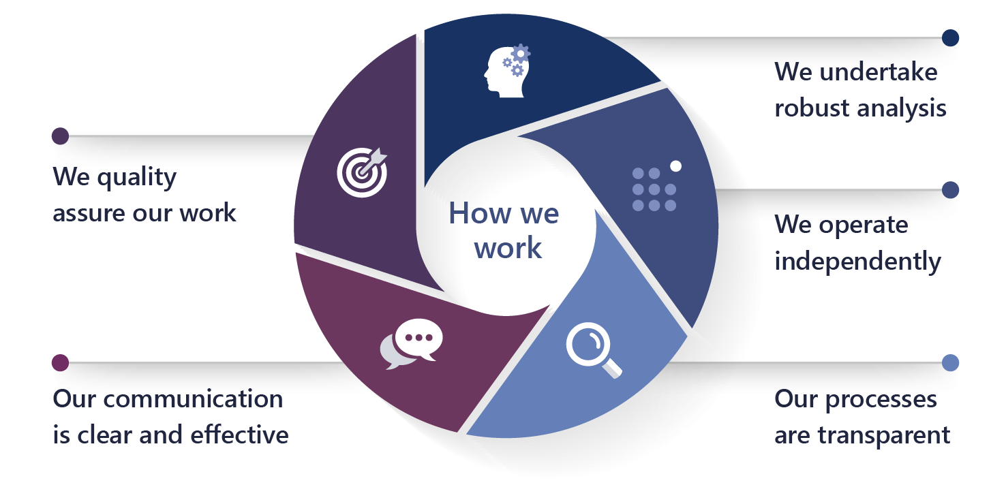

We undertake robust analysis
- Our costing advice is comparable to the costing estimates contained in the government’s budget papers. We prepare our costing advice based on the same costing conventions, standards and definitions used by the government, using the most recent official budget estimates as a baseline and the most recent budget economic parameters and forecasts in our models.
- Using our best professional judgement, we independently determine the most appropriate modelling methodology, data and assumptions to use to estimate the fiscal cost of policy proposals.
- In the preparation of our research reports, we engage with external reviewers to seek feedback on the quality of our analysis and the clarity of its presentation.

We operate independently
- The independence of the PBO is enshrined in the Parliamentary Service Act. The Parliamentary Budget Officer reports to the Presiding Officers of the Parliament on the operation and administration of the PBO. However the Parliamentary Service Act provides that the Parliamentary Budget Officer is not subject to a direction by a Presiding Officer in relation to the performance of their functions.
- At our own initiative, we conduct research in areas that we consider will enhance transparency and improve the public’s understanding of the budget and fiscal policy settings.

Our processes are transparent
- We publish information papers setting out details of how we work to provide a greater understanding of key factors which influence our work.
- Our costing advice to parliamentarians sets out the financial impacts of their proposals and provides details of the key assumptions made in the analysis, the methodology and data sources used, and any issues that may impact on the reliability of the estimates provided. Our budget analysis advice similarly provides comprehensive details on the methodology, data and information we have used.
- Where our advice is provided publicly, or we are advised by a parliamentarian that a request they have made is no longer to be treated as confidential, we publish our response to the parliamentarian on our website.
- In our research papers, we provide detailed information on the methodologies that we have used, and publish the data underlying our analysis on our website.

Our communication is clear and effective
- Our information is presented clearly and coherently, in a manner that is designed to be accessible to a broad audience.
- Our panel of expert advisors, selected for their economic, fiscal and public finance expertise, along with other specialists, review our draft research papers to ensure messages are conveyed effectively.
- Our published documents meet accessibility requirements.

We quality assure our work
- Our focus on quality assurance has been embedded across our internal policies and procedures.
- Outcomes from our quality assurance activities are used to refine our internal processes, identify current and future training needs, and prioritise model and capability development.

Our environment
The PBO holds a unique position in supporting the Australian Parliament. For our Parliament to work effectively, it is important that our parliamentarians, whether in government or not, are well informed about the policy choices they make. Similarly, a well-informed public is important in a well-functioning democracy.
We contribute by providing the Parliament and the general public with information about the budget and fiscal policy settings; important information for making sound policy choices and ensuring fiscal impacts are carefully considered.
While our purpose remains constant from one election cycle to the next—informing the Parliament and the public on budget and fiscal policy matters—the demand for our policy costing services peaks at different times through the election cycle. The most significant increase in the demand for our services occurs in the lead-up to a general election and the period immediately following the election when we prepare our post-election report on election commitments.
We operate within the broad public governance and accountability arrangements which apply across the public sector and work closely with the other parliamentary departments.
The PBO’s environment is affected by a number of factors over which we have varying levels of influence. We have greater influence over our accountability to the Parliament and the public, our relationships with key stakeholders, the quality of our work, the capability of our staff and systems, and our management of risks. We have partial influence over the demand for our services and the provision of information from Commonwealth agencies. While we have less influence over how our information is used, we are able to clarify and correct references to PBO work, if required.

Our priorities
Our priorities in 2018–19 are:
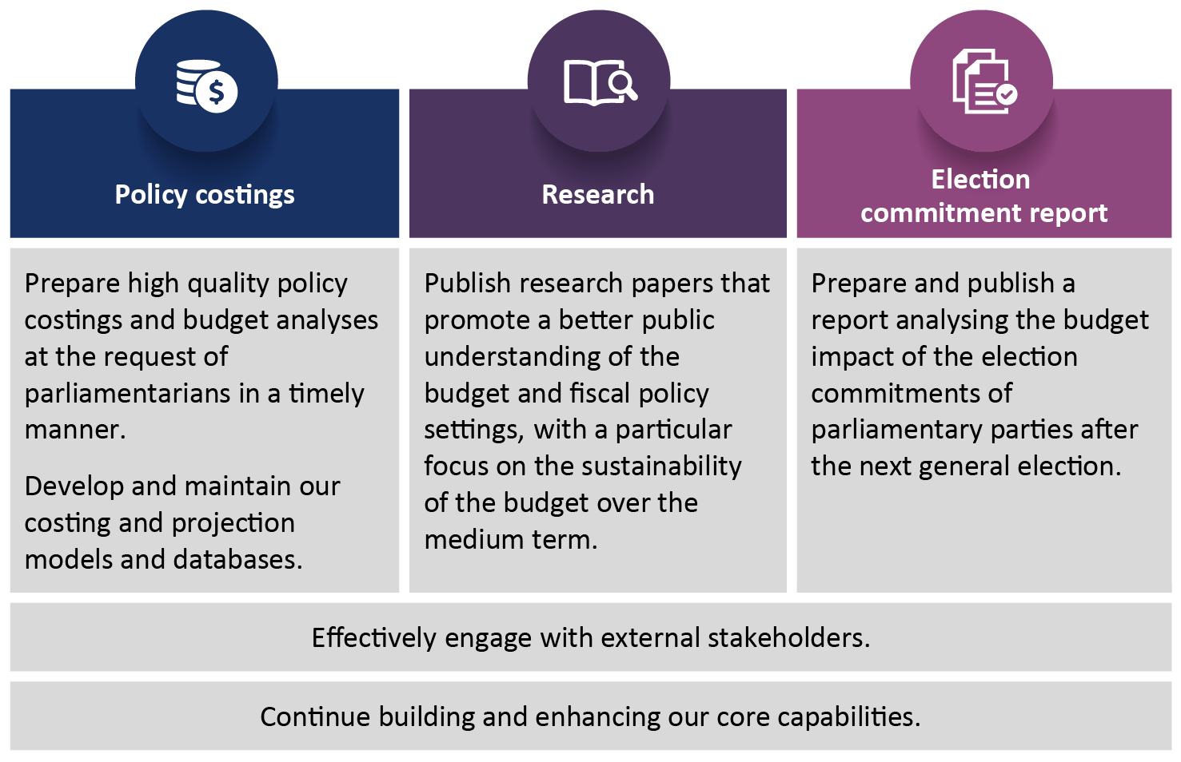
Beyond 2018–19, we will continue to focus on meeting the demand for our services from parliamentarians and parliamentary committees, while maintaining our program of published research.

Policy costings and budget analysis
The provision of policy costing and budget analysis advice to parliamentarians continues to be our highest priority and we expect particularly strong demand for this advice during 2018–19 in the lead-up to the next general election.
In 2018–19 we will:
- liaise regularly with parliamentarians and parliamentary committees to ensure that their requests are given appropriate priority
- liaise regularly with Commonwealth agencies to facilitate the timely provision of information that underpins our advice, including continuing to expand the standing information provision arrangements that we already have with several agencies
- provide transparency, through our regular reporting, on the demand for our services, timeliness of our responses and use of advice in policy announcements
- provide straightforward access to all costing response documents that are released by a party or parliamentarian through the PBO website
- explore further opportunities to establish remote access to data and model warehouses held by Commonwealth agencies
- continue to develop new costing models and evaluate the performance of existing models in light of new requests, including liaising with Commonwealth agencies on these models, where appropriate.

Research
The PBO research program is focussed on analysis that improves and informs our assessment of the medium-term trends and pressures facing Australia’s fiscal position. It also seeks to improve budget transparency and promote a better public understanding of the budget and fiscal policy settings. The research program is aligned with, and helps build the capacity of, our costing work by improving estimates of the baselines against which medium-term costings are compared.
During the year ahead, some of our research resources will be redirected towards costing work in the lead-up to the general election and the preparation of the post-election report immediately following the election. This is likely to reduce our capacity to publish research compared to other periods.

Regular publications
We plan to release the following regular publications each year:
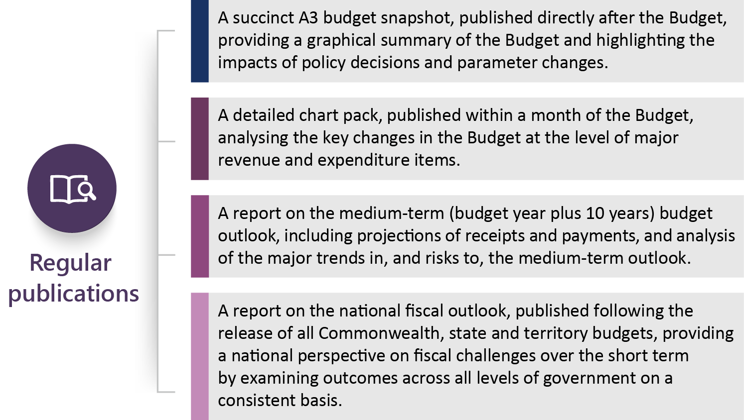

Other research reports
Our other research work is selected with a view to improving understanding of the budget over the medium term and understanding broader fiscal sustainability issues. Topics are chosen, in part, on the basis of their significance to the budget position and the need for detailed analysis to more accurately project the growth of major areas of revenue and expenditure.
We plan to undertake the following research in 2018–19 and 2019–20, depending on the availability of resources:
- an analysis outlining the impact of ageing on the budget over the medium term
- historical analyses of expenditure on Newstart and the carer’s allowance, including assessments of the implications for our medium-term projections
- an examination of the accounting and budget impact of alternative financing mechanisms.

Information papers
The PBO publishes information papers to explain the concepts and methodologies that we use in preparing policy costings and budget analyses. We also publish guidance notes to provide parliamentarians with information on processes and procedures relating to policy costings and budget analyses, and the preparation of the post-election report.
During 2018–19, several guidance notes will be published to ensure that parliamentarians are well informed about how they may need to engage with us in the lead-up to, and following, the general election.

Report on election commitments
The Parliamentary Budget Officer is required, within 30 days after the end of the caretaker period for a general election, to prepare a post-election report on the budget impacts of the election commitments of each parliamentary party that had five or more members in the Parliament immediately before the commencement of the caretaker period.
In the next post-election report, we plan to extend the reporting on the financial impact of commitments from the forward estimates period to the medium term. That is, 10-year projections of the financial impact of each election commitment and the full election platform will be provided. This will enable greater transparency in terms of identifying those policy proposals that have a materially different impact beyond the forward estimates and provide a greater focus on the sustainability of the budget position over the medium term.

Minor parties may choose to opt to have the budget impacts of their election commitments included in the post-election report. The opt in arrangements and implications for minor parties is detailed in PBO Guidance 01/2018 – Allowing minor parties to opt in the PBO’s post-election report of election commitments.

External engagement
The Joint Committee of Public Accounts and Audit (JCPAA) has an important oversight role in relation to the PBO. We engage with the JCPAA on a regular basis on our work plan, resourcing and performance.
We engage with a wide range of institutions and bodies as part of our ongoing operations, including with the panel of expert advisors that was established during 2017–18, to enhance our capability and improve the quality of our analysis.
We regularly liaise with Commonwealth agencies to maintain our strong relationships with them and, where appropriate, we share with agencies the model development and analysis we conduct, to contribute to improvements in capability across the public service.

Our resources

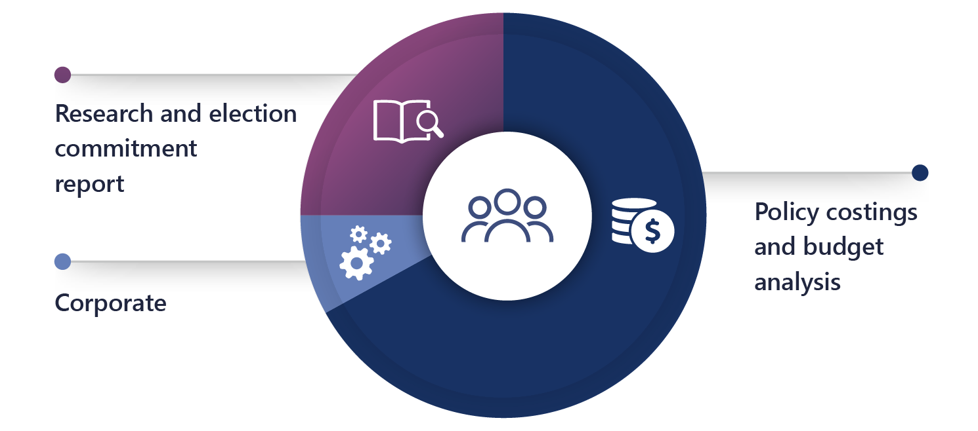
With a small dedicated workforce of approximately 40 people, we adopt an efficient and flexible operating model to maximise our ability to meet the demand for our services.
Approximately two thirds of our employees are allocated to the preparation of costings and budget analysis as this is the most resource-intensive element of our functions. Resources for this function are augmented in the lead-up to a general election to meet the increased demand for these services.

Our published research program and related activities account for approximately one quarter of our employees. During and immediately after a caretaker period, these employees assist with costings and with the preparation of the post-election report.
A small team of employees is dedicated to managing our corporate service delivery and compliance functions, including our outsourced payroll, financial transactions and ICT services.
The PBO workforce includes ongoing employees, secondees from other Commonwealth agencies and graduates under the Parliament of Australia Graduate Program.

Our capability
Building organisational capability, through continual improvement and learning and development, is a key priority. Our current strengths and future needs are detailed below, linked to our four core capabilities.
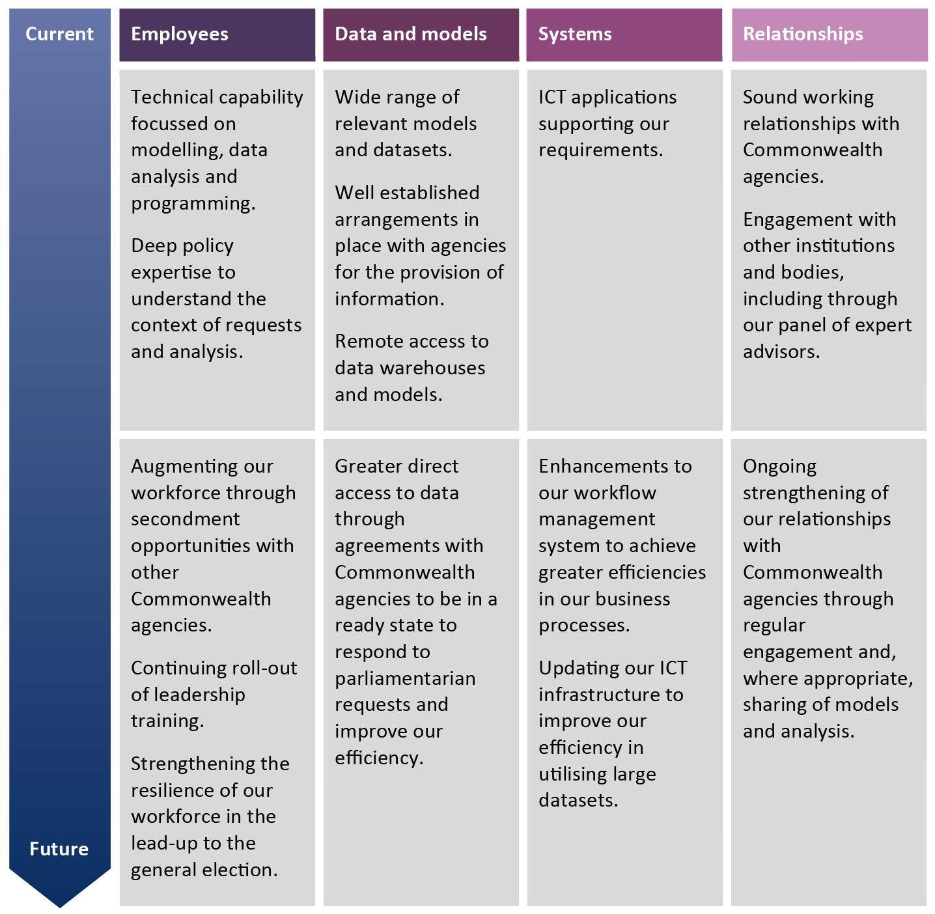

Our management of risk
The PBO’s risk management is embedded into business-as-usual practices at all levels. We have a comprehensive framework and policy to develop, implement, monitor and review risks. We undertake risk assessments at various levels, including: strategic risks; divisional/branch operational risks; specialist risks – including security and fraud; and project risks. In 2018–19, we are implementing a rolling risk management and review process.
The risks that really matter to us, given the nature of our organisation and the work that we do, are maintaining our reputation, maintaining our relationships with agencies which provide us with information, and ensuring the confidentiality of the information we hold. Our key strategies for dealing with our risks are to proactively monitor and manage our risks and quickly respond to emerging risks by changing the way we operate, without compromising the quality of the work we do.

Our performance
The outcome objective against which our overall performance is assessed is:
Informing the Parliament by providing independent and
non-partisan analysis of the budget cycle, fiscal policy and
the financial implications of policy proposals.
As outlined in the PBO’s Portfolio Budget Statements, our performance will be judged by the relevance, quality and timeliness of our outputs, as assessed via feedback from key parliamentary and external stakeholders. The independence, transparency and integrity of our processes will be another important indicator of performance.

Performance framework
Our outcome | Inform the Parliament by providing independent and non-partisan analysis of the budget cycle, fiscal policy and the financial implications of proposals.
Our purpose | - To enable fiscal impacts to be considered during policy development by providing policy costing and budget analysis services to all parliamentarians.  - To improve public understanding of budget and fiscal policy issues by conducting and publishing research in these areas.  - To enhance transparency around election commitments by preparing a post-election report on the budget impacts of the election commitments of parliamentary parties.
What we do | Policy costings and budget analysis |  |  | Conduct and publish research |  |  | Post-election report on election commitments
How we do it | Robust, quality-assured analysis |  | Independence |  |  | Transparency |  |  | Clear and effective communication
Our core capabilities | Employees | Data and models |  |  | Systems |  |  | Relationships

 | Performance assessment will be informed by stakeholder feedback and other indicators on an annual basis
Our performance criteria | The PBO’s outputs are relevant, high quality and timely  - Demand for our services by parliamentarians remains significant.  - Costing services to parliamentarians are provided efficiently.  - Feedback from stakeholders, including parliamentarians and our panel of expert advisors, is positive.  - The public is better informed by our contributions to the public debate through media mentions, mentions in Parliament and report downloads.  The PBO’s work is undertaken with independence, transparency and integrity  - Publishing and confidentiality legislative obligations are complied with.  - The nature of comments about the PBO from stakeholders and in media and other mentions, demonstrates that we are perceived as independent, transparent and act with integrity.  - All datasets that underpin the charts in our published research are available on our website in an accessible format, concurrent with the publication.  - Publication of information that clearly describes PBO processes and approaches increases public understanding of our outputs.

Measure | Assessment
Demand for, and efficiency of, our costing services | - PBO costing advice is sought by non-government major parties for their policy proposals with significant budget impacts.  - Median time to completion of policy costing and budget analysis requests is less than 15 business days.  - 95 per cent of non-caretaker requests are completed within 60 business days.  - 95 per cent of caretaker requests are completed within five business days.
Legislative obligations are met | - The post-election report is published within 30 days of the end of the caretaker period.  - The confidentiality of all requests, advice and information is maintained.
Feedback from stakeholders | - Overall high levels of satisfaction with the role and work of the PBO  - The PBO is widely perceived to be non-partisan and independent.  - Feedback mechanisms are available on PBO website.
Media mentions | - All PBO research papers are reported by major media outlets  - Media references to the PBO suggest we are perceived as independent, robust and/or non-partisan.
Mentions in Parliament | - All PBO research papers are referenced in Parliament.  - Publicly released PBO costing and budget analysis advice is referenced in relevant parliamentary debates.
Report downloads | - Downloads of PBO reports are maintained at least at current levels.
Data availability | - Datasets underpinning charts are available on the same day of the report publication and are published in an accessible format.
Publication of information | - All information papers, guidance material and general information about the PBO are available on the website.  - Three activity reports outlining PBO performance, including information about ongoing evaluations of our models and approaches, are published each year.  - The website is structured to facilitate ease of access to information and reports.

www.pbo.gov.au

