Consultation paper: PBO costing processes, timeframes and

prioritisation framework
Date issued: 27 November 2017

© Commonwealth of Australia 2017
ISBN 978-0-9953836-7-8 (Online)
This work is licensed under the Creative Commons Attribution-NonCommercial-NoDerivs 3.0 Australia License.
The details of this licence are available on the Creative Commons website: http://creativecommons.org/licenses/by-nc-nd/3.0/au/
Use of the Coat of Arms
The terms under which the Coat of Arms can be used are detailed on the following website: www.itsanhonour.gov.au/coat-arms
Parliamentary Budget Office
Parliament House
PO Box 6010
CANBERRA ACT 2600
Phone: (02) 6277 9500
Email: pbo@pbo.gov.au

Contents
Consultation process v
Request for feedback and comments v
Closing date for submissions and contact details v
1 Context vi
2 Our costing process 1
2.1 A step-by-step guide to the costing process 1
2.2 Engagement with parliamentarians on requests 2
3 Factors that affect response timeframes 4
4 Our priority setting framework 6
Criterion 1: The relevance of the request to matters before the Parliament 6
Criterion 2: The level of priority given to the request by the parliamentarian’s political party and/or the parliamentarian 7
Criterion 3: The level of representation of the party in the parliament 7
Criterion 4: The extent to which the parliamentarian or party has made use of the PBO’s services 7
Criterion 5: Length of time that a request has been with the PBO 8

Consultation process

Request for feedback and comments
The Parliamentary Budget Office Review 2016–17 — Report of the Independent Review Panel (the PBO review) reported that there is a lack of understanding of the factors that determine how long it takes the Parliamentary Budget Office (PBO) to complete a costing and of the principles that the PBO uses to determine the relative priority of requests we receive. It recommended that the PBO should, in consultation with political parties and individual parliamentarians, develop and publish the principles used to prioritise costing requests to provide greater transparency around the PBO’s processes.
This consultation paper provides information on the costing process, the factors that affect the time it takes for the PBO to respond to costing requests and the framework that the PBO applies to prioritise competing demands for costing resources. It seeks feedback from parliamentarians and their staff, as well as other interested stakeholders, on these matters.
The PBO will consider feedback from this consultation process and will publish an information paper in early 2018 that provides transparency on these processes.

Closing date for submissions and contact details
Submissions are requested by 15 December 2017. Submissions can be e-mailed to PBO@pbo.gov.au and will be made public unless otherwise requested. Enquiries can be directed to Gareth Tunks on 6277 9550.

Context
The purpose of the PBO is to inform the Parliament by providing independent and non-partisan analysis of the Budget cycle, fiscal policy and the financial implications of proposals. In particular, the PBO aims to help level the playing field for all parliamentarians by providing access to publicly funded costing and budget analysis services.
Demand for PBO costings and budget analysis has grown rapidly over the years and is expected to remain strong into the future.
The range of subject matter that these requests cover and their level of complexity have also increased over time.
As the demand for our services has increased, the approach to setting priorities across competing work has become increasingly important in order to manage our resources and ensure that parliamentarians have an equitable level of access to policy costings and budget analysis services.
We have released this consultation paper in order to provide additional transparency around, and seek feedback on:
- the costing process, including how we keep Parliamentarians informed of timeframes around their costing requests
- the factors that affect the time it takes for us to respond to costing requests
- the framework that we apply to prioritise competing demands for costing resources.
We welcome feedback on the specific questions posed in this consultation paper and on any other matters concerning the costing process that stakeholders consider significant.
This paper focusses on the processes involved in responding to a costing or budget analysis request. The PBO is in the process of publishing a suite of information papers that explain other aspects of a policy costing:
- What is a Parliamentary Budget Office costing? (2017) provides a conceptual explanation of what a costing is, what it is designed to capture and how a costing estimate is generated (expected to be published in the week commencing 27 November 2017)
- Including broader economic effects in policy costings (2017) discusses the challenges associated with incorporating broader economic effects in policy costings and the PBO’s approach (expected to be published in the week commencing 27 November 2017)
- Factors influencing the reliability of policy proposal costings (2017) provides an explanation of the factors that affect the reliability of costing estimates and how these are reflected in PBO costing advice (published on 13 September 2017).

Our costing process

A step-by-step guide to the costing process
The PBO costing process involves a number of steps. These are depicted in Figure 1 and discussed further below.
Figure 1 – Parliamentary Budget Office costing process
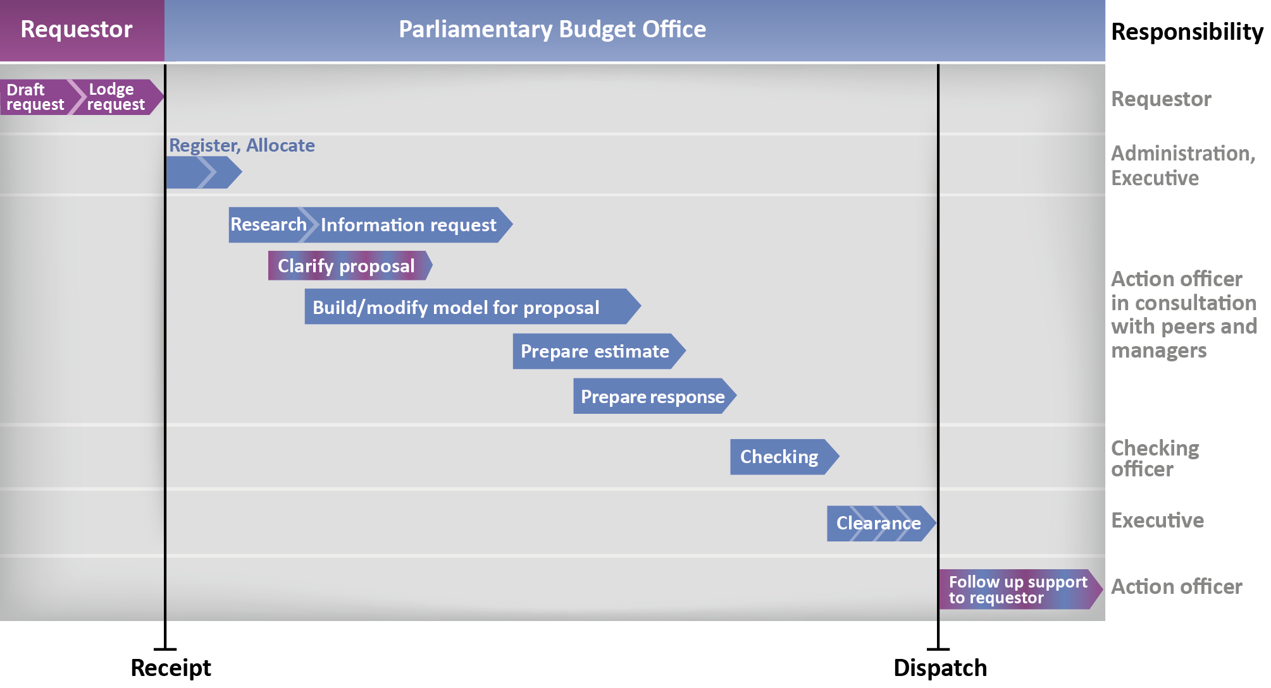
- Parliamentarians making costing requests are encouraged to discuss their requests with the PBO on a confidential basis before formally lodging their request. This helps ensure that requests which are lodged formally with the PBO are clearly and comprehensively specified.
- Formal requests are registered on the PBO workflow management system (WMS) and allocated to a costing team and to an action officer. Registration and allocation of requests are generally completed within one working day of receipt, and confirmation of receipt is provided to the requestor.
- The action officer undertakes some initial research to:
  - determine whether the costing is properly specified and, if necessary, engage with the requestor to clarify aspects of the request
  - check whether the request is a re-costing of a previous proposal or is a new piece of work
  - check whether the PBO has all the data needed to complete the request or whether information needs to be requested from agencies.
- The priority allocated to the request is then determined. This involves applying the PBO’s priority setting framework that is outlined in Section 4, below.
- Once the priority is determined, we estimate the indicative timeframe it is likely to take to complete the costing.
- If information is required from Commonwealth agencies, the action officer will prepare an information request. Those relating to non-urgent costings are requested within 10 working days. Information is sought within 5 working days for urgent costings. Some complex requests, however, may take agencies longer than 10 days to complete.
- The action officer will commence work on building or updating the costing model. The timing of this will depend on the priority of the request and how much work can be done in advance of receiving responses to any information requests.
- Once the information request response is received and the model is prepared, the action officer will complete the budget or costing analysis for inclusion in the response and will draft the written response.
- All PBO responses are assigned a checking officer who is responsible for checking the estimates and the written response. The checking process can commence early in the costing process and concludes once the costing has been dispatched to the parliamentarian.
- Once a costing has been prepared and checked, it enters the clearance stage where the costing is cleared by senior staff before being submitted to the Parliamentary Budget Officer for review and signature.
  - This stage is usually completed within one or two working days, depending upon whether any issues are identified in the clearance process.
- The final step involves dispatching the response to the requesting parliamentarian, and being available to explain any aspects of the costing response and, where relevant, discuss issues to do with the public release of this analysis.

Engagement with parliamentarians on requests
Throughout the costing process, the PBO recognises the importance of keeping Parliamentarians informed of progress that is being made on their requests and the likely timeframes for responses. We are endeavouring to do this as follows:
- as soon as a costing or budget analysis request is received, we acknowledge receipt in writing and provide a PBO reference number that can be used to track progress with that request
- within a week of receiving a request, or earlier for high priority requests, we provide an indicative timeframe for completion to the requesting parliamentarian
- on at least a fortnightly basis, we provide an update to each requesting party or parliamentarian on progress that is being made across all costing and budget analysis requests they have submitted and seek feedback on any changes in priorities or key dates that we should be aware of (whether we have this discussion with an individual member or a party depends on whether the request has been submitted on behalf of a party or on behalf of an individual member)
- when close to completion, we provide a likely date for the completion of the costing request
- when urgent and high priority requests are presented to the PBO, we provide more frequent (often daily or intradaily) updates on progress and estimates of completion timeframes.
For this process to work efficiently, requestors are asked to advise the PBO of the priority of their requests and specify whether there are any critical dates that the PBO should take into account in setting the timeframes for completing requests. These could include expected policy announcement dates, parliamentary committee reporting timeframes or expected timeframes for legislative debates. In some cases, requestors are also asked to consider refining the number of options they would like the PBO to analyse in order to have their highest priority responses completed in a timelier manner.

Consultation questions
- Would any additional information be useful to provide transparency around the PBO’s costing and budget analysis processes?
- Do you have any suggestions for how the PBO could improve its engagement with requestors around the timeframes for completing requests?

Factors that affect response timeframes
The PBO endeavours to provide responses to requests as soon as possible. As highlighted above, once each request’s priority relative to other requests has been determined, the timeframe for responding to that request is estimated.
This timeframe will depend on the:
- complexity of the request
- availability of information
- analysis and model development required to meet the request
- extent to which different steps in the costing process can be undertaken concurrently
- available resources given competing priorities across all requests.
Simple requests and updates of previous requests can be completed more quickly than complex requests or requests that have not been costed before. Simple requests are those which do not require the construction of models, substantial research and analysis, or information to be sought from agencies.
Complex requests require more time for completion due to a number of different factors. Generally, requests that involve making significant changes to a complex area or areas of the tax or outlays systems will require more resources in order to:
- understand the baseline policy and the details of the policy proposal, including interactions with other policies and programs
- request and receive detailed information from Commonwealth agencies
- build a model to undertake the costing, including making judgements about behavioural responses and interactions, where relevant
- provide follow up support to the requestor, explaining details of the response.
Resource constraints may arise both within the PBO and in agencies from which information needs to be obtained.
Complex high priority requests may be completed after simple lower priority requests in situations where the PBO is dependent on data or significant model development to complete the more complex request.
Allocating resources to develop models to respond to more complex requests will increase average response times for all other requests.
From time to time, some requests are put ‘on hold’ by the PBO which implies that no resources are allocated to progressing the request. This occurs when either:
- the PBO requires a clarification of the specification included in a request and has sought that clarification but has not yet received a response
- the requesting parliamentarian advises that the request should be afforded a low priority relative to other requests and there are a significant number of outstanding requests.
We will not proceed with the request until either the parliamentarian advises that the priority afforded that costing has increased or where the requested policy clarification has been received. The PBO reviews the status of on-hold requests with the parliamentarian or party concerned on a regular basis. The period when a costing request is ‘on hold’ is not captured in PBO statistics that capture response timeframes.

Consultation questions
- Would any additional information be useful to provide transparency around the factors that affect PBO response timeframes?

Our priority setting framework
As the PBO has limited resources to complete its work it is important to prioritise requests that are submitted. Setting priorities requires judgment, and involves decisions being made about which pieces of work will receive the most resources. Amongst a set of requests involving of a similar level of complexity, this determines which requests will be completed first.
The PBO seeks to remove the subjectivity from the priority decision making process by consistently applying a priority setting framework at the time at which a costing is received and then reviewing this on an ongoing basis through the process of the costing being completed.
The PBO’s priority setting framework applies the following criteria in the order set out below.

Priority setting framework criteria
- Relevance of the request to matters before the Parliament or soon to be before the Parliament
- Level of priority given to the request by the parliamentarian’s political party and/or the parliamentarian
- Level of representation of the requesting political party in the Parliament
- Extent to which the parliamentarian or party has recently made use of the PBO’s services
- Length of time that a request has been with the PBO

Note that at the time of an election, whether a request is a non-caretaker or caretaker request is also an important factor in determining the completion timing. During the caretaker period the PBO prioritises caretaker costings over non-caretaker requests that were lodged prior to the start of the caretaker period.
The rest of this section works through each of the criterion, providing additional detail on how these are applied. It is important to emphasise at the outset that these criteria and the framework we apply does not limit what can be requested by a member of Parliament, rather, it affects the timing of when requests may be completed.

Criterion 1: The relevance of the request to matters before the Parliament
The highest priority is placed on requests relating to matters before the Parliament, or soon to be before the Parliament.
This criterion ensures that the PBO’s priority work is consistent with its mandate. The PBO informs the Parliament by providing independent and non-partisan advice which aims to level the playing field for all Parliamentarians. Our priority setting process must recognise the importance of requests that are closely linked to current parliamentary debates, relate to upcoming Bills or relate to current Parliamentary committee inquiries. Critical dates for these parliamentary matters are identified and we work backwards from these in planning our costing processes to ensure that, wherever possible, advice is provided in a timely manner.

Criterion 2: The level of priority given to the request by the parliamentarian’s political party and/or the parliamentarian
The second criterion is the level of priority given to the request by the parliamentarian’s political party and/or the parliamentarian. This principle seeks input from the requestor as to the priority of the request relative to their other requests.
This criterion is particularly important for major non-Government parties or independent members who make significant use of the PBO. It enables the PBO to effectively prioritise within the set of requests received from a given party and to make adjustments from time to time within these requests when priorities change.
The highest priority requests from parties that do not directly relate to Parliamentary business, usually relate to internal party priorities around policy announcements. While the PBO will always endeavour to complete costing requests in the timeframes required for policy announcements, it is not always possible given the complexity of requests and competing priorities. Consistency in prioritisation, clear communication around critical dates and close engagement through the costing process increases the likelihood that PBO costing and budget analysis requests can be completed in desired timeframes.

Criterion 3: The level of representation of the party in the parliament
To provide equitable access to PBO resources across the Parliament, our judgement is that the level of resources allocated across Parliamentary parties should broadly reflect their representation in the Parliament. This implies that the larger non-government parties should generally receive the majority of the PBO’s costing resources.
Given that Government Senators and Members have access to the public service to undertake costing analysis on their behalf, the PBO considers it appropriate to prioritise non-government parliamentary requests where there are competing priorities, although we recognise the value that PBO costings play in internal policy debates within all parties.

Criterion 4: The extent to which the parliamentarian or party has made use of the PBO’s services
This seeks to ensure an equitable sharing of our services among members of Parliament over time. It takes into account the extent to which the parliamentarian or party has made use of our services.
The application of this criterion implies that requests from infrequent users of the PBO’s services will be prioritised. This criterion is important because it means that if a minor Party or individual Parliamentarian makes a number of requests of the PBO at a point in time, after having not used the PBO very much before, there is a preference to complete these requests as a high priority.

Criterion 5: Length of time that a request has been with the PBO
The PBO aims to complete all requests in a timely manner, but as discussed above, competition for resources makes this challenging. The final element of the prioritisation framework is to prioritise requests that have been with us for some time over requests which are afforded a similar priority by Parliamentarians which have only just been received.

Consultation questions
- Do you have any comments on the framework that the PBO uses to set priorities amongst competing requests?
- Do you agree with the ranking of criteria as outlined above?
- Are there any additional criteria you consider the PBO should take into account in determining priorities? In particular, do you consider the PBO should take into account an assessment of the likelihood that the policy proposal will be announced by the requestor and adopted as policy? Do you consider that the PBO should take any account of the likelihood that a particular policy proposal will be legislated?

www.pbo.gov.au

These timeframes reflect the Memorandum of Understanding between the Parliamentary Budget Office and the Heads of Commonwealth Bodies in relation to the Provision of Information and Documents.

