APPLICATION TO USE FORMAL GARDENS [YY/XXX]
Please complete and return in a typed Word Doc format
All requests will be acknowledged within 3 working days

I have read and understand the attached information sheet, Wedding Ceremonies and Other Private Events Held in the Eastern Formal Gardens (Attachment A)

EVENT NAME
EVENT DATE
TIME
START – FINISH
REQUEST/EVENT NAME
REQUEST/EVENT DATE(S)
REQUEST/EVENT TIME(S)
START – FINISH
REQUEST/EVENT CONTACT(S)
NAME/TEL/EMAIL
DESCRIPTION OF REQUEST/EVENT
PURPOSE OF EVENT
NUMBER OF PEOPLE INVOLVED
# ORGANISERS AND # VISITORS
OTHER RELEVANT INFORMATION
MEDIA ATTENDANCE, INVITED MP’S/SENATORS
DO YOU HAVE AN EVENT LOG/RUNNING PLAN
DEPARTMENTAL CONTACT | APH Catering and Events  Department of Parliamentary Services | Email: aphevents@aph.gov.au  Telephone: 02 6277 8000

If filming/photography will be conducted, please complete APPLICATION TO FILM AND PHOTOGRAPH on page 3.

ADVICE TO APPLICANT

VENUE CONDITIONS OF USE
- The privacy of Members of Parliament, staff and visitors should be respected at all times.
- No decorations of any kind are to be placed around the venue.
- No food or drinks are to be brought onto the premises.
- No tables or chairs are to be brought onto the lawn and grounds unless separate approval is requested (this approval does not automatically give approval for the use tables and chairs).
- You will be responsible for all damage to Australian Parliament House lawn and grounds.
- The Formal Gardens are a public place and public access must be maintained during your event.
- You are responsible for the removal of all rubbish that may be left from your event.
- The site has public toilets available for use.
- As Parliament Drive is a one-way road, parking is not permitted adjacent to the Gardens. Passengers can be dropped off, and then all vehicles parked within the public car park at Parliament House.

DEPARTMENTAL USE ONLY
APPROVED/NOT APPROVED
DATE
Approval granted in accordance with
- Policies and Procedures No 16: Protests and Other Assemblies in the Parliamentary Precincts; and
- Guidelines for Filming and Photography in Parliament House and its Precincts.
APPLICATION REVIEWED
AND APPROVED
DEPARTMENTAL CONTACT | APH Catering and Events  Department of Parliamentary Services | Email: aphevents@aph.gov.au  Telephone: 02 6277 8000

APPLICATION TO FILM AND PHOTOGRAPH
APPLICANT DECLARATION
I have read and understand the Rules for Media Related Activity in Parliament House and its Precincts prior to submitting this form.

LOCATION(S) OF FILIMING OR PHOTOGRAPHY
PURPOSE OF FILMING OR PHOTOGRAPHY
(INCLUDING PUBLICATION/ PRINTING OF IMAGERY)
EQUIPMENT TO BE USED
DEPARTMENTAL USE ONLY
RESTRICTIONS
- SPECIAL APPROVAL
- Where the terms ‘film’ or ‘filming’ appear in this application and the Guidelines, they encompass video recording, other filming technologies and still photography including the use of digital technology.
- The privacy of Members of Parliament, staff and visitors to the building should be protected and the specific permission of any person being filmed should be sought.
- Filming should not interfere with the operations of the Parliament and/or the people who work in the building.
- No filming is to be conducted in Private areas unless prior approval has been granted.
- Security facilities and arrangement must not be filmed (i.e. the screening processes at entrances).
- Equipment must not be placed on the mosaic pavement on the Forecourt.
- Approval given subject to filming/photography being confined to the function, its participants and identified area only.
- You must enter the building through the Main Front Public Entrance, all your Filming and photography equipment must be security screened prior to entry.
- Cameras must be handheld or on a handheld pole, no tripods will be allowed to be set up for use in the Marble Foyer. No extra large Filming equipment including satellite dishes are permitted to be set up in the Marble Foyer these will only be permitted to be set up and used in the (AAA) area.
DEPARTMENTAL USE ONLY
APPROVED/NOT APPROVED
DATE
Approval granted in accordance with
- Policies and Procedures No 16: Protests and Other Assemblies in the Parliamentary Precincts; and
- Guidelines for Filming and Photography in Parliament House and its Precincts.
APPLICATION REVIEWED
AND APPROVED
DEPARTMENTAL CONTACT | APH Catering and Events  Department of Parliamentary Services | Email: aphevents@aph.gov.au  Telephone: 02 6277 8000

ATTACHMENT A
INFORMATION SHEET
WEDDING CEREMONIES AND OTHER PRIVATE EVENTS HELD IN THE EASTERN FORMAL GARDENS

  - The following parameters are the guidelines for wedding ceremonies and other private functions held in the Eastern Formal Gardens:
    - Parliament House does not make special facilities or alternative venues available for events in the case of inclement weather. It is the responsibility of the applicants requesting use of the Gardens to make these arrangements.
    - The Gardens are only available during daylight hours (after hours security lighting does not provide adequate illumination for functions held after dark).
    - The Gardens are open to all members of the public and all bookings will be made on the understanding that they are for the non-exclusive use of the client.
    - Parking is not allowed on Parliament Drive. Guests should use the public underground car park at the northern end of the building.
    - As Parliament Drive is now restricted to one way traffic, please note that vehicles must stop on the opposite side of the road to the Gardens. There is a set down time of up to 10 minutes, providing a person stays with the vehicle.
    - Confetti and/or rice must not be used within the Parliamentary Precincts, (this is an offence under the Litter Act 2004). Rose petals are also not permitted.
    - Clients must respect the gardens by leaving them untouched. Particular care should be taken while posing for wedding photographs.
    - The Gardens must be left clean and tidy at the end of an event.
    - All areas of the Eastern Formal Gardens may be used. However, the viewing platform on the upper level may not be used for wedding ceremonies.
    - Toilet facilities for able-bodied persons are available on the lower level of the Gardens. However, the closest facilities for disabled persons are situated within the Public Underground Car Park at the northern end of Parliament House. Refer attached plan for details.
    - The floral displays in the Gardens are normally changed at least twice a year. The summer display is planted approximately mid to late October and the winter display in approximately mid to late March of each year. Notification of change of plans or cancellation of the event would be appreciated as this will allow others to use the space.

ATTACHMENT B
LAYOUT OF EXTERNAL PRECINCTS
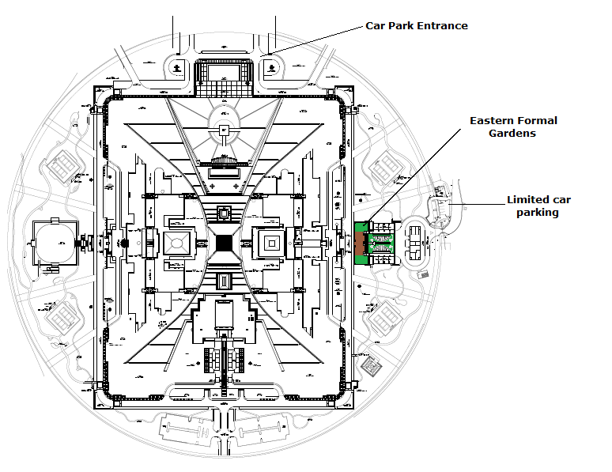

LAYOUT OF FORMAL GARDENS EAST

